Elton Cheng
ME333
Final Project
3/12/2017
28.4.1
1. SPI Channel 4. Uses pins F4, F5, B14 and B8
2. I used pin B0 as ADC input AD1.
3. I will be using the motor, current sensor, and battery. Pin D0 will be responsible for sending the PWM signal, and D3 will be a digital output pin to control direction.
4. Use Timer3 for the 5kHz ISR and Timer4 for the 1kHz ISR. Current control will have a higher priority over position control, so current control will be at priority 5, and position at 4.
5.
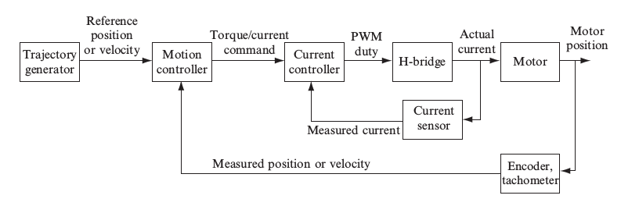
Trajectory Generator:
Reference Position:
Motion Controller:
Torque/Current Command:
Current Controller:
PWM Duty:
H-Bridge:
Actual Current:
Current Sensor:
Measure Current:
Motor:
Motor Position:
Encoder/Tachometer:
Measured Position/Velocity:

6. See attached drawing.

28.4.7
2. 6.4 V on battery voltage. 16 R of the motor. Therefore, Imax = .8 A
3. .012 V
4. R2/R1 = 137; Chose 100 kOhm and 1kOhm to get 100 gain
5. 10 kOhm Resistor and 10 nF Capacitor
6.
R0 | Expected I (mA) | Measured I (mA) | Sensor (V) | ADC (counts)
10 (to RS+) | 600 | 347.4 | 2.18 | 681
20 (to RS+) | 300 | 221.5 | 1.96 | 616
40 (to RS+) | 150 | 127.7 | 1.81 | 565
Open Circuit | 0 | .14 | 1.61 | 503
40 (to RS-) | -150 | 125.9 | 1.40 | 434
20 (to RS-) | -300 | 218.9 | 1.25 | 393
10 (to RS-) | -600 | 341.3 | 1.05 | 331

28.4.9
See attached drawing.

28.4.10
Attach plot of ITEST

28.4.12
Attach plot of TRACk

