**Analysis of “R2 < 0.7 = 0 flux” rule**

1. **Impact of assuming flux = 0 if R2 < 0.7**

CON: 10.14% of all calculated fluxes turned to 0 (7/69)

MSD: 14.49% of all calculated fluxes turned to 0 (10/69)

AWD: 39.13% of all calculated fluxes turned to 0 (27/69)

CH4 plot:

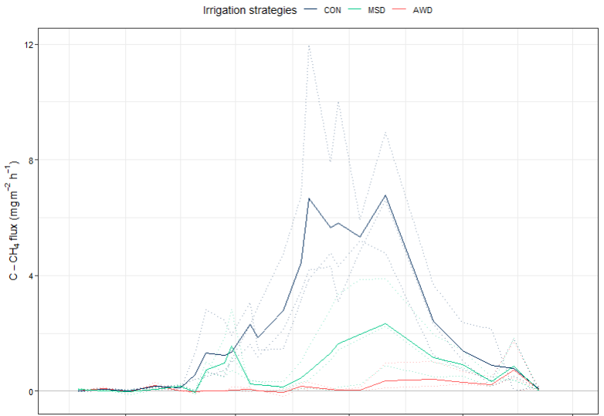

Cumulative CH4 with the rule:

1. **Creating a “noRule” data frame where R2 < 0.7 are removed**



CH4 plot:

Cumulative CH4 without the rule:

