Hong Kong Institute of Vocational Education (ST)
Department of Information Technology
HD in Software Engineering

ITP4511Enterprise Systems Development
AY 19 / 20

Assignment – Attendance System

Date: 21 DEC 2019

Student | Work breakdown
Ng Yee Ching | - System design  - UI Design  - Apply plugin (jquery datatable & full calendar)  - Implementation
Chan Ngai Chin | - Database design  - Documentation  - Implementation

We declare that this is a group project and that no part of this submission has been copied from any other student’s work or from any other source except where due acknowledgement is made explicitly in the text, nor has any part been written for us by another person.

Table of Content
Table of Content 1
1 Introduction 2
2 Assumption 2
2.1 User Requirements 2
2.2 System Requirements 3
2.2.1 Functional Requirement 3
2.2.2 Hardware Requirements 3
2.2.3 Software Requirements 4
3 Site map 4
4 System Structure 4
5 Database Structure 6
6 Design description 7
7 Conclusions 9
8 Skill Checklist 9

Introduction
Attendance is the basic requirement for a student in school. A teacher is responsible for recording the attendance for the students. A class attendance system is one of the most important things to keep track of a student who attends classes regularly. If the class attendance of a student is less than 60%, then he would be failed in this semester and excluded from taking an examination. In the past, a teacher needs to mark the student attendance on a paper sheet and count the attendance manually. However, this method can be inefficient and inaccuracy. A computer system can improve the accuracy of the records and generate real-time statistic reports.
A student attendance monitoring system provides monitoring, tracking and reporting student attendance in a class. This system will be a web-based system with a user-friendly GUI. The system will handle the process of recording student attendances by teacher inputs. Every morning, teachers use the attendance system to take a roll call. The attendance data will be stored in the database.
In addition to the functionalities mentioned above, the web-based system provides account management, analytics and reporting function for monitoring student attendance.

Assumption
- Teacher record student attendance during every lesson.
- If the class attendance of a student is less than 60%, then he would be failed in this semester and excluded from taking an examination.

User Requirements
User Role | Access Right
System Administrator | - to create / modify / delete teachers’ and students’ profile; and  - to create / modify modules information; and  - to create / modify / delete courses; and  - to assign lesson’s date and time; and  - to view and update student attendance record of each lesson; and  - to export report of student attendance rate less than 60%; and  - to export report of individuate student’s attendance; and  - to manage events in school calendar; and  - to search and view calendar of all classes; and  - to update his login password.
Teacher | - to view students’ profile; and  - to view modules information; and  - to create / modify / delete his courses; and  - to assign lesson’s date and time; and  - to view and update student attendance record of each lesson; and  - to export report of student attendance rate less than 60%; and  - to export report of individuate student’s attendance; and  - to search and view calendar of all classes; and  - to view his schedule on calendar; and  - to update his login password and name in the system.
Student | - to view modules information; and  - to view his courses’ information; and  - to view lesson’s date and time; and  - to view his attendance record of each lesson; and  - to export report of his overall attendance record; and  - to view his schedule on calendar; and  - to update his login password and name in the system.

System Requirements

Functional Requirement
Class Management Functions
  - Setup class data
  - Schedule school day
Attendance Functions
  - Show class schedule
  - Record attendance for students per class
  - Edit/view attendance history
  - Generate attendance sheet for each class
Analytic/Report
  - Calculate attendance rate for each student by class
  - Generate report for attendance rate less than 60%
  - Generate report for class schedule
Account Management
  - Create different account/user
  - Register student according to class
  - Modify account information
  - Manage the user role

Hardware Requirements
Client Computers
  - Mac and Window client computers
Network
  - No specific requirement on network infrastructure

Software Requirements
Client Operating Systems
  - MAC OS
  - Windows
Client Application
  - Google Chrome

Site map
- Home  - Teacher  - Add Teacher Account  - Teacher’s Account Information  - Teacher’s courses  - Teacher account setting  - Remove account  - Student  - Add Student Account  - Student’s Account Information  - Student’s class  - Student’s courses  - Student account setting  - Remove account | - Module  - Add Module  - Edit Module  - Course  - Add course  - Course Information  - Lesson List  - Student Attendance List  - Remove course  - Add lesson  - Calendar  - Edit School Day  - Search Class Calendar  - Account Setting

System Structure
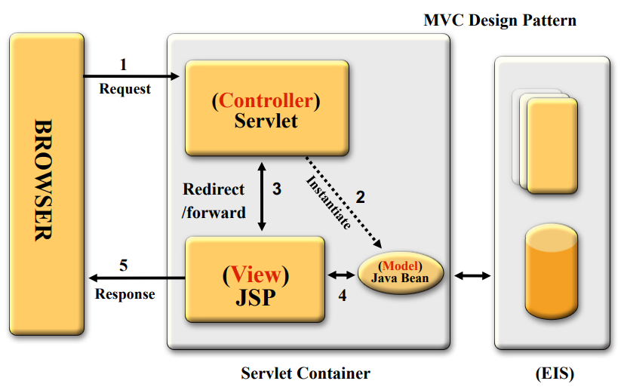
Servlet Container | File Name
Servlet  (C – Controller) | - ClassInfo.java  - HandleAttendance.java  - HandleCalendar.java  - HandleCourse.java  - HandleLesson.java  - HandleModule.java  - HandleStudent.java  - HandleTeacher.java  - HandleUser.java  - StudentInfo.java  - TeacherInfo.java
JSP  (V – View) | - addCourse.jsp  - addLesson.jsp  - addModule.jsp  - addStudent.jsp  - addTeacher.jsp  - adminSetting.jsp  - classRecord.jsp  - courseRecord.jsp  - courses.jsp  - handleSchoolDay.jsp  - index.jsp  - lessonRecord.jsp  - login.jsp  - modules.jsp  - showCalendar.jsp  - studentRecord.jsp  - students.jsp  - teacherRecord.jsp  - teachers.jsp
Java Bean  (M – Model) | - Attendance.java  - Course.java  - Event.java  - Lesson.java  - Module.java  - Student.java  - Teacher.java  - User.java

Database Structure
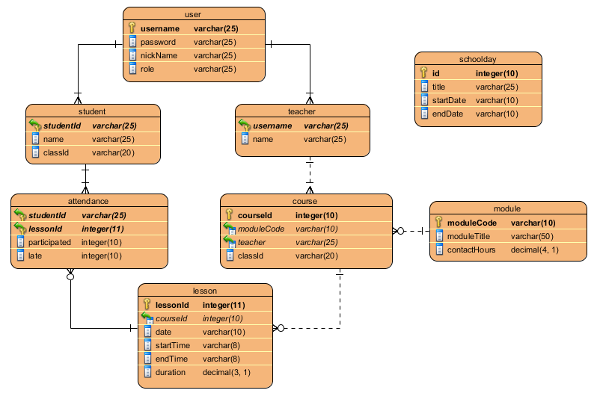

Table |  | User
Description |  | This table stores the login information and user role
Column | Data Type | Null Value | Description
username | varchar(25) | NOT NULL | PK – The login username
password | varchar(25) | NOT NULL | The login password
nickname | varchar(25) | NOT NULL | User nick name
role | varchar(25) | NOT NULL | User role. i.e. “admin”, “student” or “teacher”

Table |  | Student
Description |  | This table stores student information
Column | Data Type | Null Value | Description
studentId | varchar(25) | NOT NULL | PK – Student ID  FK – refers to user.username
name | varchar(25) | NOT NULL | Student’s name
classId | varchar(20) | NOT NULL | Student’s class

Table |  | Teacher
Description |  | This table stores teacher information
Column | Data Type | Null Value | Description
Username | varchar(25) | NOT NULL | PK – Teacher username  FK – refers to user.username
name | varchar(25) | NOT NULL | Teacher’s name

Table |  | Module
Description |  | The module provided by the school
Column | Data Type | Null Value | Description
moduleCode | varchar(10) | NOT NULL | PK – module code
moduleTitle | varchar(50) | NOT NULL | The title of the module
contactHours | double(4,1) | NOT NULL | The total contact hours of the module

Table |  | Course
Description |  | This table stores course information
Column | Data Type | Null Value | Description
courseId | integer(10) | NOT NULL | PK – course id
moduleCode | varchar(10) | NOT NULL | FK – refers to module.moduleCode
teacher | varchar(25) | NOT NULL | FK – refers to teacher.username
classId | varchar(20) | NOT NULL | The course belongs to the class

Table |  | Lesson
Description |  | This table stores lesson information
Column | Data Type | Null Value | Description
lessonId | integer(11) | NOT NULL | PK – lesson id
courseId | integer(10) | NOT NULL | FK – refers to course.courseId
date | varchar(10) | NOT NULL | Date of the lesson
startTime | varchar(8) | NOT NULL | Starting time of the lesson
endTime | varchar(8) | NOT NULL | Ending time of the lesson
duration | double(3,1) | NOT NULL | Hours of the lesson

Table |  | Attendance
Description |  | This table stores student attendance record
Column | Data Type | Null Value | Description
studentId | varchar(25) | NOT NULL | PK – student id of the attendance record  FK – refers to student.studentId
lessonId | integer(11) | NOT NULL | PK – lesson of the attendance record  FK – refers to lesson.lessonId
participated | integer(10) | NOT NULL | Student participated minutes of the lesson
late | integer(10) | NOT NULL | Student late minutes of the lesson

Design description
- Apply auto layout. Navigation bar will hide according to screen size.
- Most of the lists are able to search.
- Most of the lists can order by a selected column alphabetically.
- Apply breadcrumbs to show the user’s location.
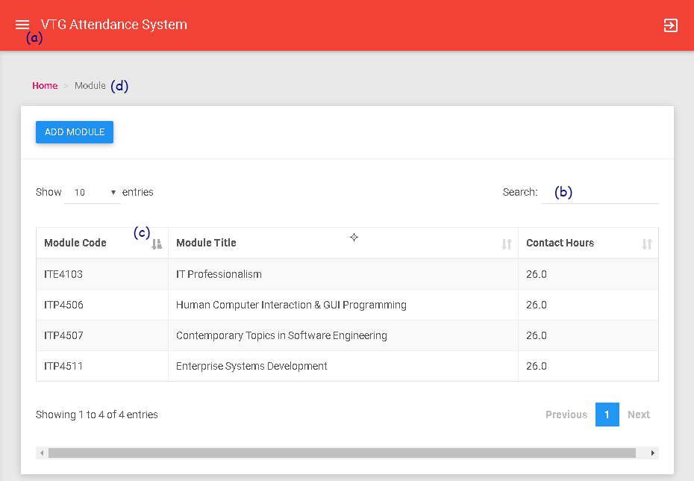
- Use consistent format. Most of the page using the same design pattern.
- For student attendance rate less than 60%. They will be separated from the student list. They can export to CSV / Excel / PDF report.
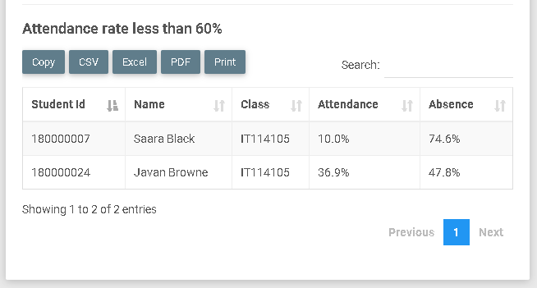
- When adding new lesson, user can view teacher’s and class’s schedule on the calendar. Therefore, user can arrange the date and time of the lesson easily.
- User can decide whether the lesson is repeating weekly, and the repeating times during adding lesson.
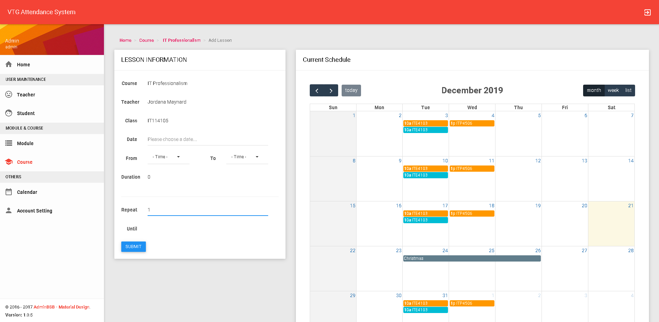
- Administrator and teacher can view all classes’ schedule by searching the correspondent class.
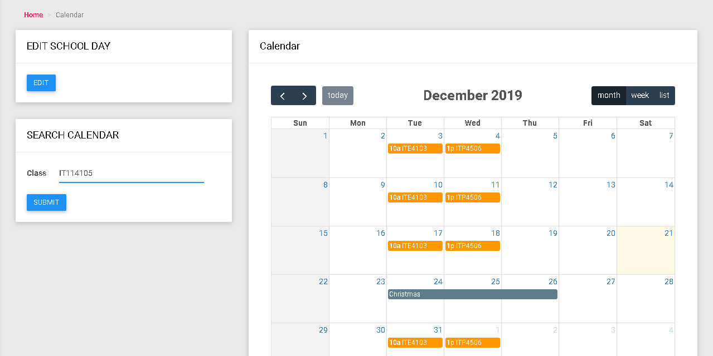

Conclusions
This report introduces the attendance system according to the requirements, system structure, database structure and design.
To conclude, this attendance system can handily keep track and generate reports of students’ attendance with the appealing user interface design. The system can also improve the accuracy of the records and generate real-time statistic reports.

Skill Checklist
Skill | Page Applied Example | Description
Use JSP/servlets to dynamically generate HTML pages | students.jsp | Only admin can see the “ADD STUDENT” button
Use JSP to accept user inputs from browser | handleSchoolDay.jsp
Use servlets to accept user inputs from browser | HandleUser.java
Use JSP Action | handleSchoolDay.jsp | Use bean & set property
Use Custom Tag (taglib) | NavTag.java | The left navigation
Use JavaBean | User.java
Use JDBC for database connection | SystemDB.java
Use session checking | index.jsp | Get the User bean saved in session to control login.
Use login control | index.jsp | Get the User bean saved in session to control login.
Apply MVC model | M – Course.java  V – courseRecord.jsp  C – HandleCourse.java
Other skills applied
Use java servlet to print JSON | LessonEventJSON.java

- END -

