CRP City of Decatur Hobo temps_ August 2023

## Read in data

Stationary HOBO U23 sensor data from interior and exterior/edge of Lullwater Forest and the Outdoor Activity center - late June - early Aug 2021.

## Plotting across dates

using code from <https://rpubs.com/cgb-grupstra/moorea-hobo-20190314>

## Warning: Removed 8 rows containing missing values (`geom_point()`).

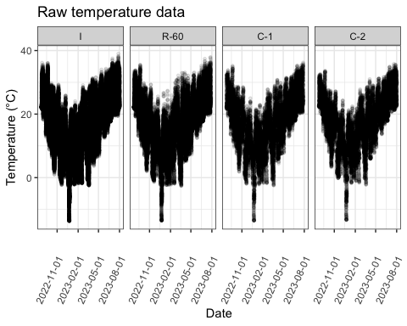

## Daily temps

Calculating mean temp for each date

hobofullmean <- hobofull %>%  
 group_by(year,month, day,type,location,longdate)%>%  
 summarise(meantemp = mean(Ch.1...Temperature.....C.))

## `summarise()` has grouped output by 'year', 'month', 'day', 'type', 'location'.  
## You can override using the `.groups` argument.

head(hobofullmean)

## # A tibble: 6 × 7  
## # Groups: year, month, day, type, location [6]  
## year month day type location longdate meantemp  
## <chr> <chr> <chr> <fct> <fct> <date> <dbl>  
## 1 2022 08 24 Sun I 2022-08-24 22.8  
## 2 2022 08 25 Sun I 2022-08-25 23.8  
## 3 2022 08 25 Shade R-60 2022-08-25 23.6  
## 4 2022 08 26 Sun I 2022-08-26 26.0  
## 5 2022 08 26 Sun C-1 2022-08-26 25.8  
## 6 2022 08 26 Sun C-2 2022-08-26 26.0

## Plotting mean temps

## `geom_smooth()` using method = 'loess' and formula = 'y ~ x'

## Warning: Removed 4 rows containing non-finite values (`stat_smooth()`).

## Warning: Removed 4 rows containing missing values (`geom_point()`).

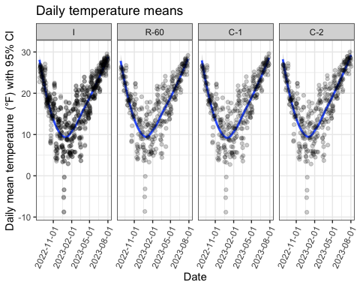

## Calculating daily temp ranges and min/max

hobofullrange <- hobofull %>%  
 group_by(year, month, day, type, location, longdate)%>%  
 summarise(min_temp = min(Ch.1...Temperature.....C.), max_temp = max(Ch.1...Temperature.....C.))%>%  
 mutate(range = max_temp-min_temp)

## `summarise()` has grouped output by 'year', 'month', 'day', 'type', 'location'.  
## You can override using the `.groups` argument.

head(hobofullrange, digits=5)

## # A tibble: 6 × 9  
## # Groups: year, month, day, type, location [6]  
## year month day type location longdate min_temp max_temp range  
## <chr> <chr> <chr> <fct> <fct> <date> <dbl> <dbl> <dbl>  
## 1 2022 08 24 Sun I 2022-08-24 22.3 23.7 1.48  
## 2 2022 08 25 Sun I 2022-08-25 21.9 31.3 9.43  
## 3 2022 08 25 Shade R-60 2022-08-25 22.0 31.2 9.16  
## 4 2022 08 26 Sun I 2022-08-26 21.7 33.7 12   
## 5 2022 08 26 Sun C-1 2022-08-26 21.6 32.0 10.4   
## 6 2022 08 26 Sun C-2 2022-08-26 22.3 31.3 9.02

## Plotting temp ranges

## Warning: Removed 4 rows containing missing values (`geom_point()`).

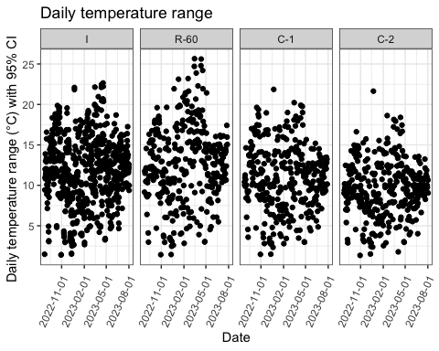

## Plotting max and min

## `summarise()` has grouped output by 'year', 'month', 'day', 'type', 'location'.  
## You can override using the `.groups` argument.

## Warning: Removed 4 rows containing missing values (`geom_point()`).  
## Removed 4 rows containing missing values (`geom_point()`).

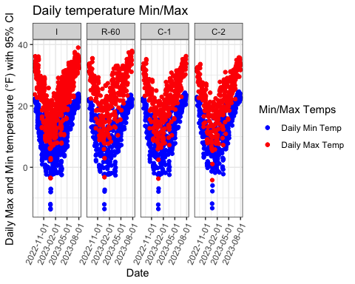

## Boxplots - temps per moth by location and type

median, 25%, 75%, and min and max

## Warning: Removed 4 rows containing non-finite values (`stat_boxplot()`).

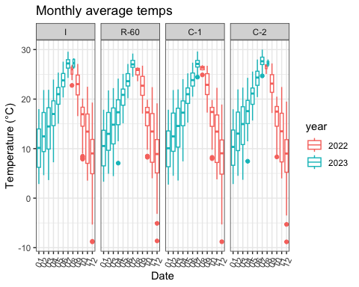

# Heat Index  
  
ls(hobotemplongdate)

## [1] "Ch.1...Temperature.....C." "Ch.2...RH......"   
## [3] "Dew.Point.....C." "location"   
## [5] "longdate" "time"   
## [7] "type" "X."

hobotemplongdate$HI_uncorrected <- -42.379 + 2.04901523* hobotemplongdate$Ch.1...Temperature.....C.+ 10.14333127*hobotemplongdate$Ch.2...RH...... - .22475541*T*hobotemplongdate$Ch.2...RH...... - .00683783*hobotemplongdate$Ch.1...Temperature.....C.*hobotemplongdate$Ch.1...Temperature.....C. - .05481717*hobotemplongdate$Ch.2...RH......*hobotemplongdate$Ch.2...RH...... + .00122874*hobotemplongdate$Ch.1...Temperature.....C.*hobotemplongdate$Ch.1...Temperature.....C.*hobotemplongdate$Ch.2...RH...... + .00085282*hobotemplongdate$Ch.1...Temperature.....C.*hobotemplongdate$Ch.2...RH......*hobotemplongdate$Ch.2...RH...... - .00000199*hobotemplongdate$Ch.1...Temperature.....C.*hobotemplongdate$Ch.1...Temperature.....C.*hobotemplongdate$Ch.2...RH......*hobotemplongdate$Ch.2...RH......

# Heat Index Uncorrected  
  
HIgraph <- ggplot(data=hobotemplongdate,   
 aes(x=longdate,   
 y=HI_uncorrected)) +  
 geom_point(size=1, alpha = 1/10)+ theme_bw()+  
 facet_grid(cols=vars(location))+   
 theme(axis.text.x = element_text(angle=65, margin = margin(t=20, r=100)))+  
 labs(title="Heat Index Uncorrected", y="Heat Index", x="Date")+  
 guides(x = guide_axis(angle=65))+  
 scale_x_date(date_breaks = '3 months')  
HIgraph

## Warning: Removed 8 rows containing missing values (`geom_point()`).

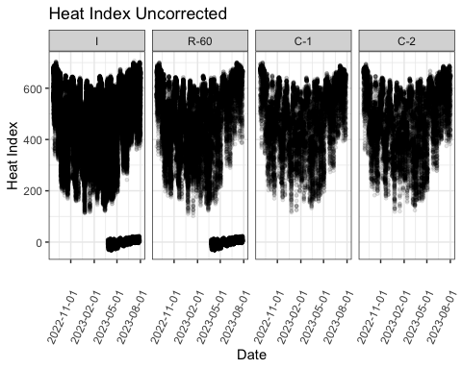

#HI mean  
hobofull <- hobotemplongdate %>%  
 tidyr::separate('longdate',  
 into = c('year', 'month', 'day'),  
 sep= '-',  
 remove = FALSE)  
head(hobofull)

## X. longdate year month day time Ch.1...Temperature.....C.  
## 1 1 2023-02-14 2023 02 14 09:28:42 11.53  
## 2 2 2023-02-14 2023 02 14 09:58:42 15.01  
## 3 3 2023-02-14 2023 02 14 10:28:42 16.42  
## 4 4 2023-02-14 2023 02 14 10:58:42 17.40  
## 5 5 2023-02-14 2023 02 14 11:28:42 18.02  
## 6 6 2023-02-14 2023 02 14 11:58:42 18.18  
## Ch.2...RH...... Dew.Point.....C. type location HI_uncorrected  
## 1 61.06 4.29 Sun I 427.2377  
## 2 50.65 4.87 Sun I 394.2939  
## 3 42.33 3.60 Sun I 349.2061  
## 4 40.85 3.98 Sun I 343.8565  
## 5 35.51 2.54 Sun I 308.1420  
## 6 35.16 2.54 Sun I 306.2155

hobofullHI <- hobofull %>%  
 group_by(year,month, day,type,location,longdate)%>%  
 summarise(meanHI_uncorrected = mean(HI_uncorrected))

## `summarise()` has grouped output by 'year', 'month', 'day', 'type', 'location'.  
## You can override using the `.groups` argument.

head(hobofullHI)

## # A tibble: 6 × 7  
## # Groups: year, month, day, type, location [6]  
## year month day type location longdate meanHI_uncorrected  
## <chr> <chr> <chr> <fct> <fct> <date> <dbl>  
## 1 2022 08 24 Sun I 2022-08-24 558.  
## 2 2022 08 25 Sun I 2022-08-25 586.  
## 3 2022 08 25 Shade R-60 2022-08-25 589.  
## 4 2022 08 26 Sun I 2022-08-26 616.  
## 5 2022 08 26 Sun C-1 2022-08-26 621.  
## 6 2022 08 26 Sun C-2 2022-08-26 613.

HImeanplot <- ggplot(hobofullHI, aes(x=longdate, y=meanHI_uncorrected))+  
 geom_smooth(aes())+  
 geom_point(aes(),alpha = 1/5)+  
 facet_grid(cols=vars(location))+  
 theme_bw()+  
 labs(title= "Daily HI mean", y="Daily mean HI with 95% CI", x="Date")+  
 guides(x = guide_axis(angle=65))+  
 scale_x_date(date_breaks = '3 months')  
   
   
HImeanplot

## `geom_smooth()` using method = 'loess' and formula = 'y ~ x'

## Warning: Removed 4 rows containing non-finite values (`stat_smooth()`).

## Warning: Removed 4 rows containing missing values (`geom_point()`).

