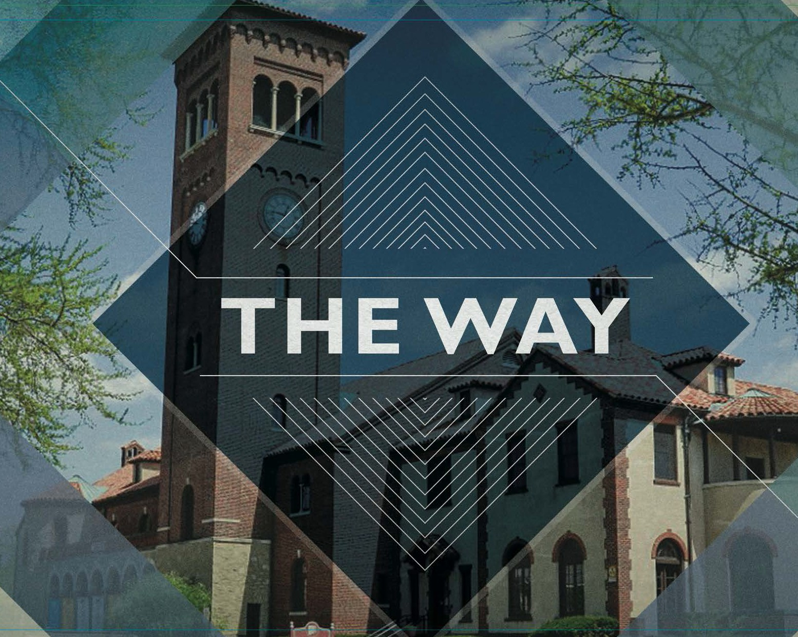

**WE ARE MARIEMONT CHURCH**

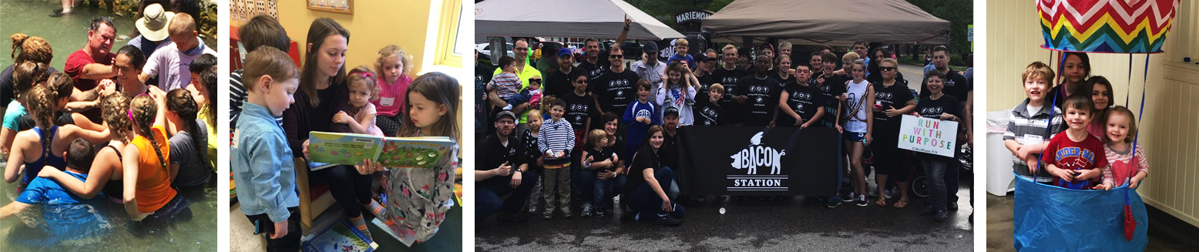

This guide was created to help you get to know us, learn what we are all about, and to connect with what is going on here in a way that fits best with your spiritual journey.

**Learning to live and love in Jesus  
as we follow him together.**

**FIRST, WE’RE ALL ABOUT JESUS.**

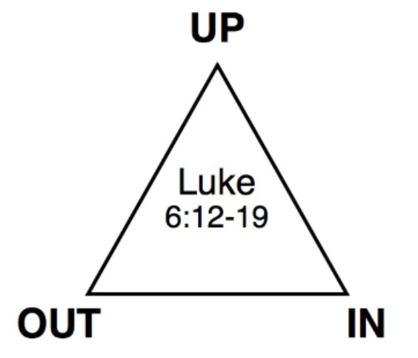He's the key leader around here, and the reason we exist. He came to save us from our self-centered ways, our sin, and our rebellion. He is the unique and awesome God who laid his life down for us, and took our punishment on himself. We believe it is only through him that we can experience real life now and forever.

We saw what Jesus did, we turned from our ways, and we believed this good news – the Gospel of the Kingdom.

**Then we started living as his disciples** (followers, students, apprentices). This looks like pursuing a deepened relationship with God and with other followers of Jesus, and bringing the message of love to our families, neighborhoods, and workplaces.

##### Whatever you think about Jesus,

**the Bible, or Church, you’re   
welcome here.**

Our hope is to be all-in together, learning to follow Jesus together and bringing his message to as many people as we can.

**WHAT WE BELIEVE**

(We actually try doing this stuff)

**Jesus.** We believe that Jesus is the Son of God—that we can follow him and be like him.

**Holy Spirit.** We believe in the person of the Holy Spirit and that he plays an active role in our everyday life.

**The Bible.** We believe the Bible is God’s authoritative letter to us, teaching us to live a life worth living now and forever.

**Surrender.** Jesus gave up his life for us, therefore we should give up our life for him.

**Spiritual Growth.** Growing spiritually is a part of our church life. This means we take steps daily toward spiritual maturity. **Shepherding.** Every family has a shepherd to give care and coaching.   
**Intimacy.** We believe prayer and worship are the foundation of our intimacy and relationship with a Father who loves us. **Multiplication.** We believe in spiritual reproduction. This looks like disciples making disciples that know how to make disciples. **Community.** We believe in community and do not go it alone. Jesus insists on one another-ing. (Yes, that’s a word now)   
**Serving.** We believe in laying down our lives. This looks like serving our family, friends, and those in need.

**Kingdom.** We believe in a global commission and investing in Kingdom efforts around the world by praying, giving, and going.

**FOLLOWING JESUS**

We look at the Bible together to learn who Jesus is, what he did and why it matters. The Holy Spirit helps us walk out these things in our everyday life–at home, in the workplace, and every area of our lives.

Everything we do as we follow Jesus is designed to honor his Father, who adopted us into his family through the power of the Holy Spirit.

**So we worship a 3-in-1 God – Father, Son and Spirit.**

They created the church and so they run it together, using ordinary folks like us to get involved in extraordinary things like rescuing children, feeding the poor, healing people and restoring relationships. This is what we mean by living and loving in Jesus.

**THE REAL MEANING OF CHURCH**

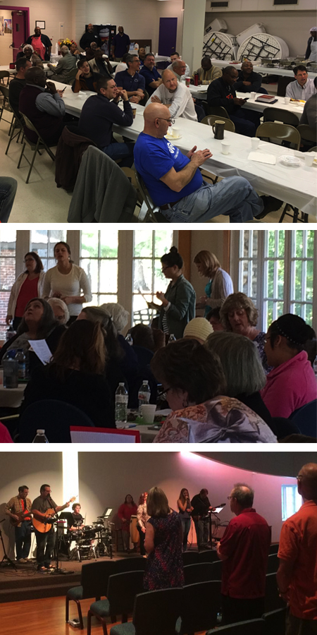Most people think the Church is the building. That's an accident of history and translation. When Jesus used the word he meant "people called out"—that is, people called out of normal life to follow Him in an extraordinary adventure.

SO, WE ARE THE CHURCH.

We are the people who have found the most important message in history and we love to share it. We are the people who have been given new life by God and who now carry his Holy Spirit in us wherever we go.

We believe we are all priests according to God. So we are learning to be priests in our families, workplaces and communities. We shepherd and take care of each family as they grow into this very important work. We also work with and invest in other churches—because there is only one church.





**THE GATHERINGS**

We have meetings on Sunday so that a variety of gifted Visit us every Sunday at 9:00am and 11:00am // 3908 Plainville Rd

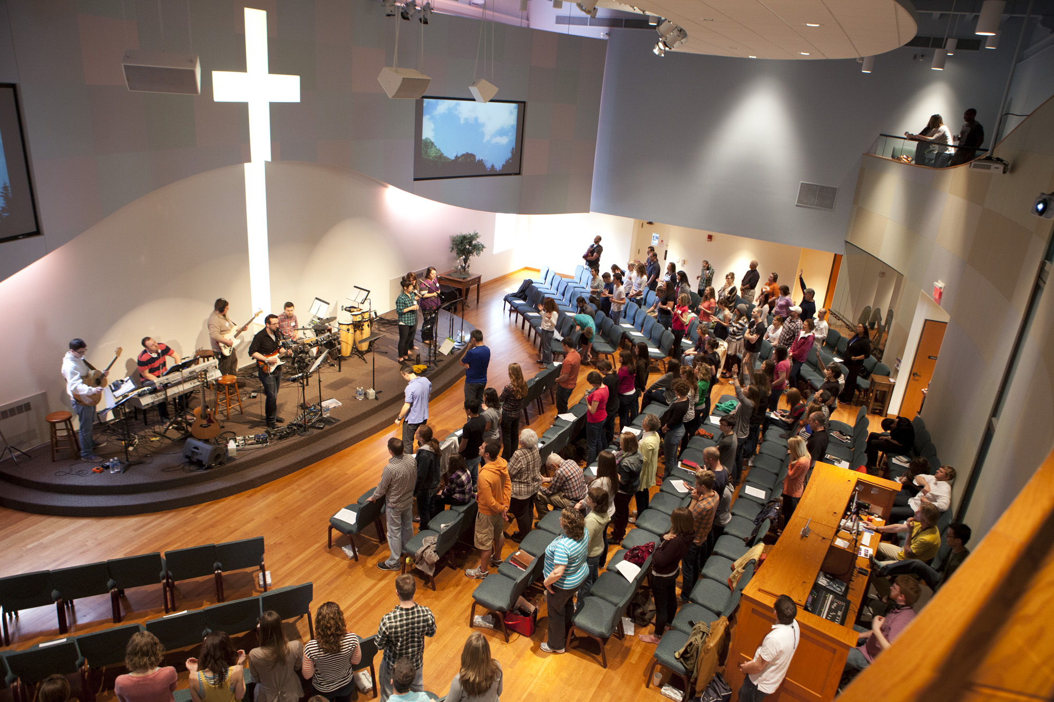people can lead us in worship, stories, and the study of God's Word. We also have similar age-appropriate time for our kids so they can connect with God in a language they can understand.

**The rest of our meetings happen Monday–  
Saturday, most often in our homes.**

We believe the core building block of following Jesus is in our families. We have families of all shapes and sizes, but we follow a common way of doing family—centered on Jesus. We also believe in small church gatherings throughout the week with smaller numbers of disciples gathering to go deeper, share life and keep each other sharp   
and well cared for.

**OUR FOOTPRINT**

**We see our spiritual footprint at Mariemont Church mostly through our lifestyle and our generosity.**

One of the ways we do this is to remember that we can store up treasures in heaven as Jesus commanded us to in Luke 12:33. We have coined the term "L-1233 account" as a way to help us remember that there is something eternal that goes beyond our typical "401K". At MCC,   
we desire to build what we call "global kingdom disciples"—folks who live for Jesus and his Kingdom worldwide.



**FINANCIAL STEWARDSHIP**

(God owns it all, we take care of it, and pray for a spiritual return on investment)



### SPIRITUAL FOOTPRINT

###### LOCAL & GLOBAL MISSIONS

**Our missions program is reaching dozens of nations globally with the Good News of Jesus’ love. This represents about 20% of our budget.**



THOUSANDS REACHED IN NIGERIA,

MEXICO, INDONESIA, NEPAL, ISRAEL AND INNER-CITY CINCINNATI EACH YEAR.

NIGERIA

In the past 7 years, believers in Jesus in the Dukawa tribe in Nigeria have grown from 1,000 to 10,000. We are involved in various stages of five more languages with significant potential.

STUDENTS

Our U.S.-based missionaries reach thousands of college students nationally.

PRE-SCHOOL

Our self-funding pre-school reaches 100 children for Jesus weekly, and the before and after school program extends to 30-40 children.

LOCAL COMMUNITY

We host dozens of community groups––including Scouts and AA that all point people to Jesus. Our Family Shop provides a bi-monthly used clothing store that serves dozens in our local community. The proceeds go to help women meet Christ in prisons and transition to healthy lives in society, and other community needs.

MULTIPLICATION

One of our missionaries is training believers and growing church planting movements that extend to thousands in several cities.

###### OUR CHURCH FAMILY

**Every week we help over 120 families disciple their nearly 100 children and students.**

30 new believers baptized (2014–2016)

Dozens more learned how to grow and walk in the Spirit, while 75 people have moved into deeper discipleship with Jesus by traveling to Israel in the past three years.

Our congregation regulars help give leadership to 20 local and national ministries.

We pray for and are deeply connected to other churches in our city.



**50% SERVE ON SUNDAYS**

**50% IN A SMALL GROUP**

(Numbers based on regular attendees. We would like to see this at 100%.)



**THIS SUMS IT ALL UP:**

**WE MAKE DISCIPLES;**

Who make disciples (that’s called multiplication). Who obey the teachings of Jesus.

Who are building strong families.

We do a survey annually to see how we can do this better.

**GET CONNECTED**

Weekly worship services

Where we gather on Sundays and worship together. Join us at 9:00am and 11:00am every Sunday.

Small Groups

Weekly home gatherings where we grow in following   
Jesus in practical ways.

Contact: chefbelanger@hotmail.org

Connect Desk

Take the next step to deepen your faith:   
serve, give, become a member.

Serving Teams

Opportunities to use your talents in music, hospitality, smiles, and more.

Contact: mark@mariemontchurch.org

**TAKING MY NEXT STEP**



**SEEKER**

I'm not sure. I'm asking questions, and taking steps to learn.

**BELIEVER**

I've placed my faith in Jesus. I've asked for the forgiveness of my sins.

**DISCIPLE**

I'm taking steps to organize my life around Jesus and his word.

**DISCIPLER**

I'm learning to help others become disciples who can help others.



Pray - Receive prayer  
Attend Services  
Serve

Read Mark and Romans  
Get a mentor

Join a small group

Receive deliverance prayer

Serve—Invite a friend—Give  
Read the Bible in one year

Be baptized, membership  
Join a small group

30 mins/week in prayer room

Train for Prayer Team

Invite a friend to follow Jesus  
Discern spiritual gifts

Give 10% or more

Be filled with the Holy Spirit  
Apprentice group leader

Be released to ministry   
Speak in services  
Make disciples

Lead/start a small group

Serve as a deacon

Serve as an elder

**MOSTLY, WE’RE**

**JUST GLAD YOU  
CAME.**

If you have any questions or want to get better connected, please contact us at mark@mariemontchurch.org

**TAKE SOME NOTES…**

**Making disciples that multiply,  
obey Jesus, and build strong families.**

