Supporting Information for Stress concentration in the Central and Southeastern US seismic zones due to upper mantle heterogeneities

Contents of this file: Figures S1 to S6
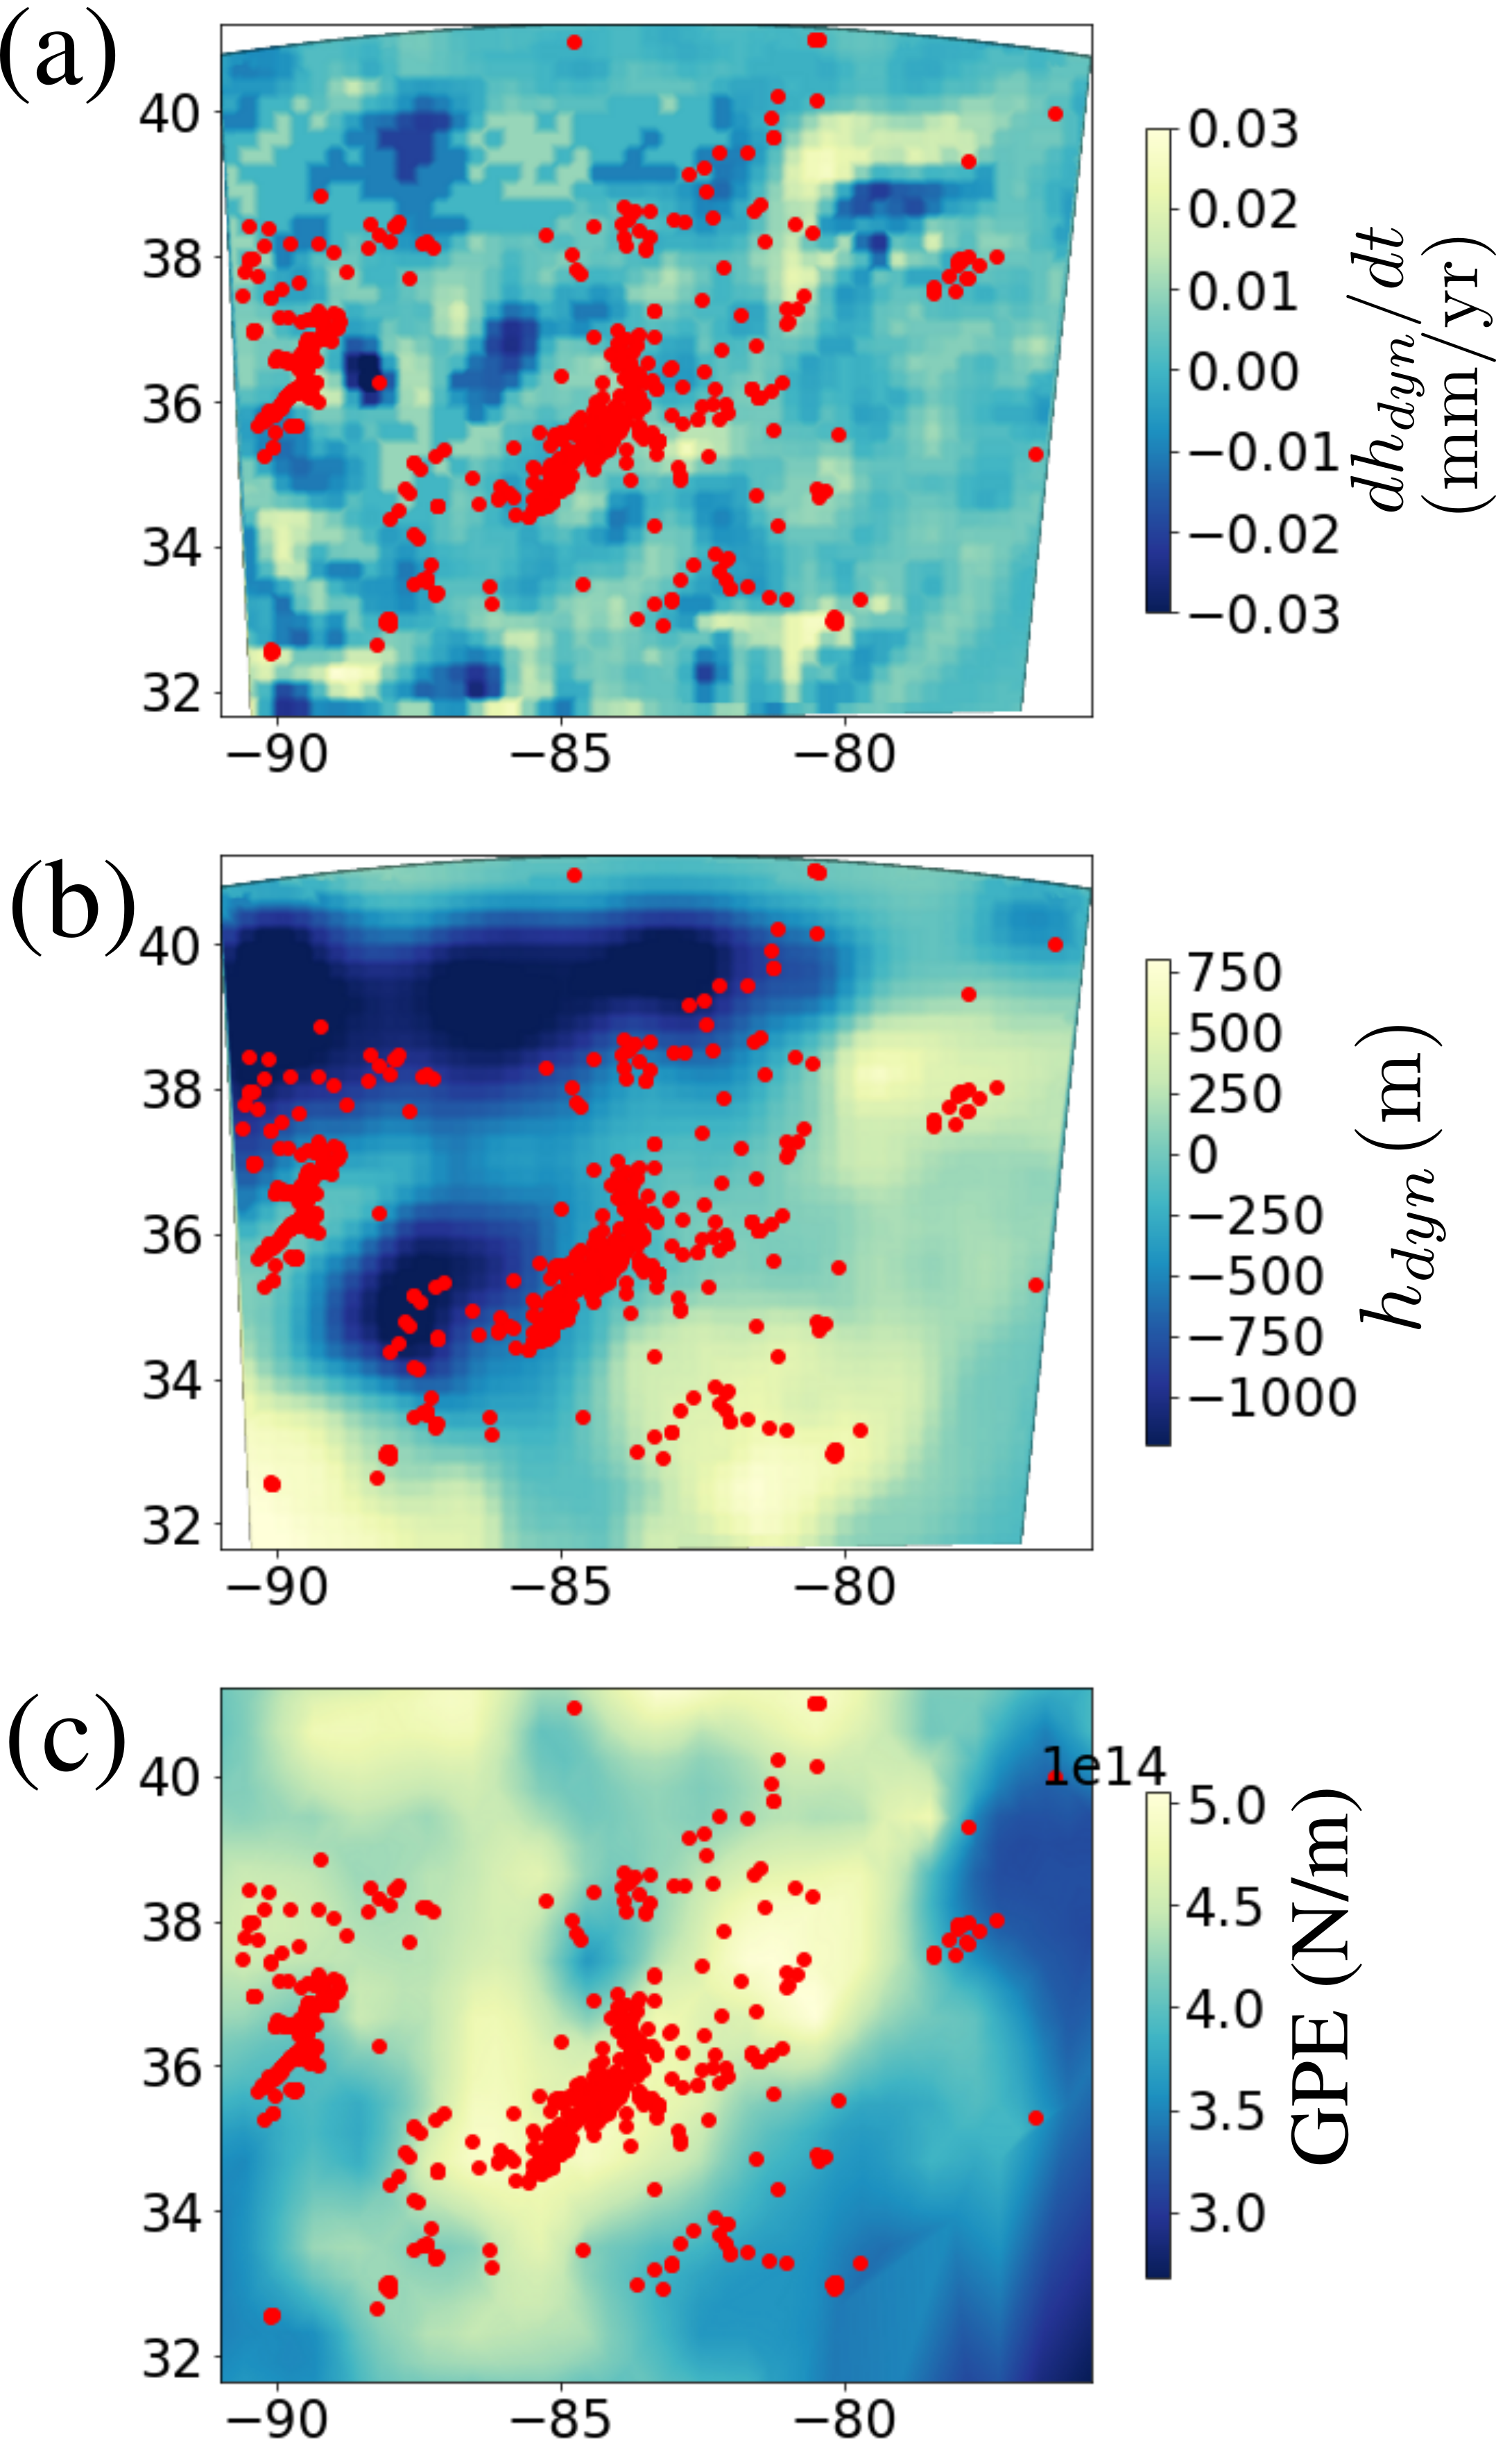

Fig. S1: (a) Rate of dynamic topography change, (b) Dynamic topography, and (c) Gravitational potential energy, computed for the HT model.

Differential stresses

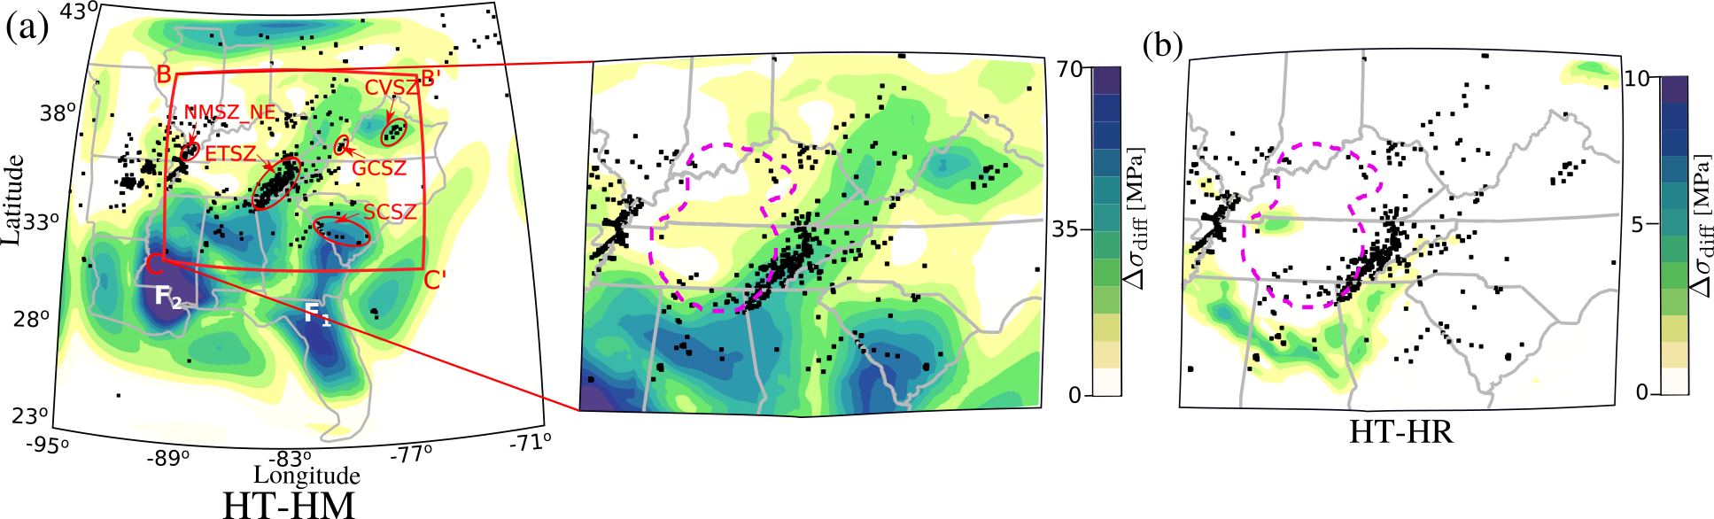
Fig. S2: (a) Differential stress changes in the HT−HM case (∆σ diff) at a depth of 15 km. Black dots are earthquake epicenters from USGS data between 2011-2018. Gray lines denote the US state boundaries. Seismic zones investigated in this study are the northeastern arm of the New Madrid Seismic Zone (NMSZ NE), Eastern Tennessee Seismic Zone (ETSZ), South Carolina Seismic Zone (SCSZ), Giles County Seismic Zone (GCSZ) and Central Virginia Seismic HT−HM Zone (CVSZ). F1 and F2 indicates the areas of anomalously high values of ∆σdiff. Dashed magenta line marks the boundary of the foundering at 605 km depth. The box BB’CC’ indicates HT−HR the region enlarged in subsequent figures. (b) Differential stress change for HT−HR (∆σdiff) in a region centered on the ETSZ.

Coulomb stresses at observed fault geometries:

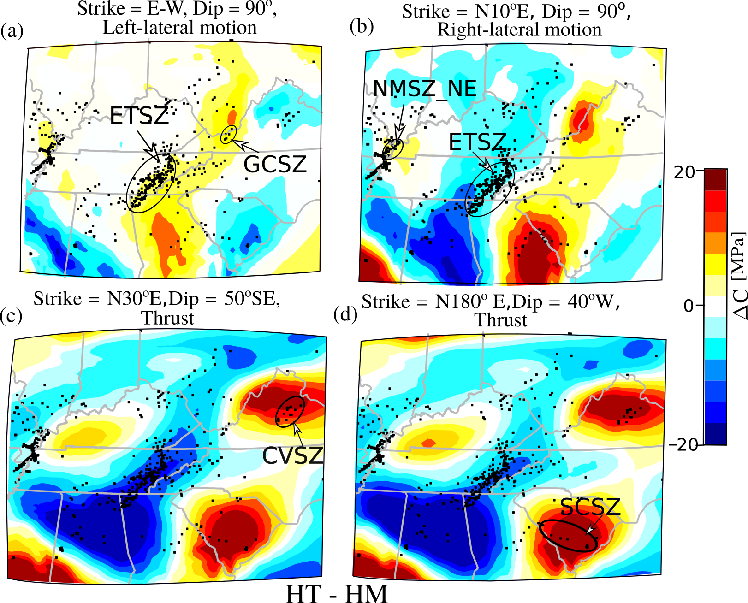
Fig. S3: Coulomb stress change (∆C) for HT−HM calculated for different fault orientations
in Table A.1) at 15 km depth. Seismic zone(s) and their corresponding optimal fault geometries
are mentioned for each subplot: (a) Eastern Tennessee Seismic Zone (ETSZ) and Giles County
Seismic Zone (GCSZ), left lateral vertical fault striking EW, (b) ETSZ and North-eastern arm of
the New Madrid Seismic Zone (NMSZ NE) and right lateral vertical fault strikingt N10◦E, (c)
Central Virginia Seismic Zone (CVSZ) and thrust fault dipping 50◦SE striking N30◦E, (d) South
Carolina Seismic Zone (SCSZ) and thrust fault dipping 40◦W striking N-S.

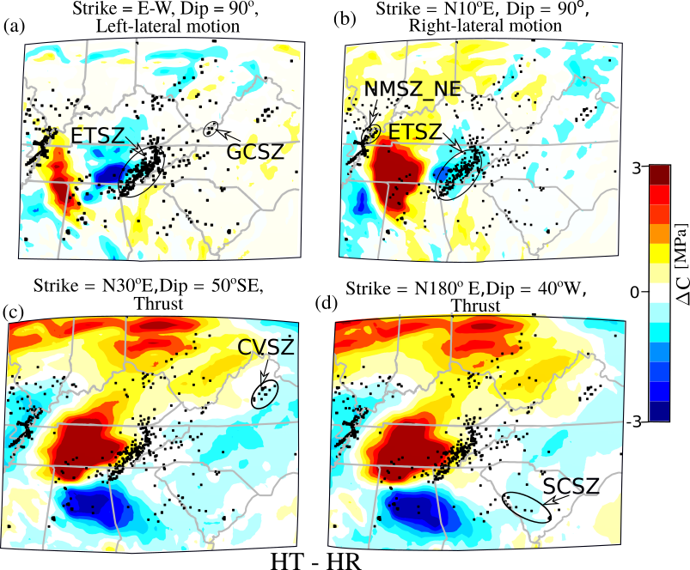
Fig. S4: Same as Fig. S3 but for HT-HR

Optimal Coulomb stresses:

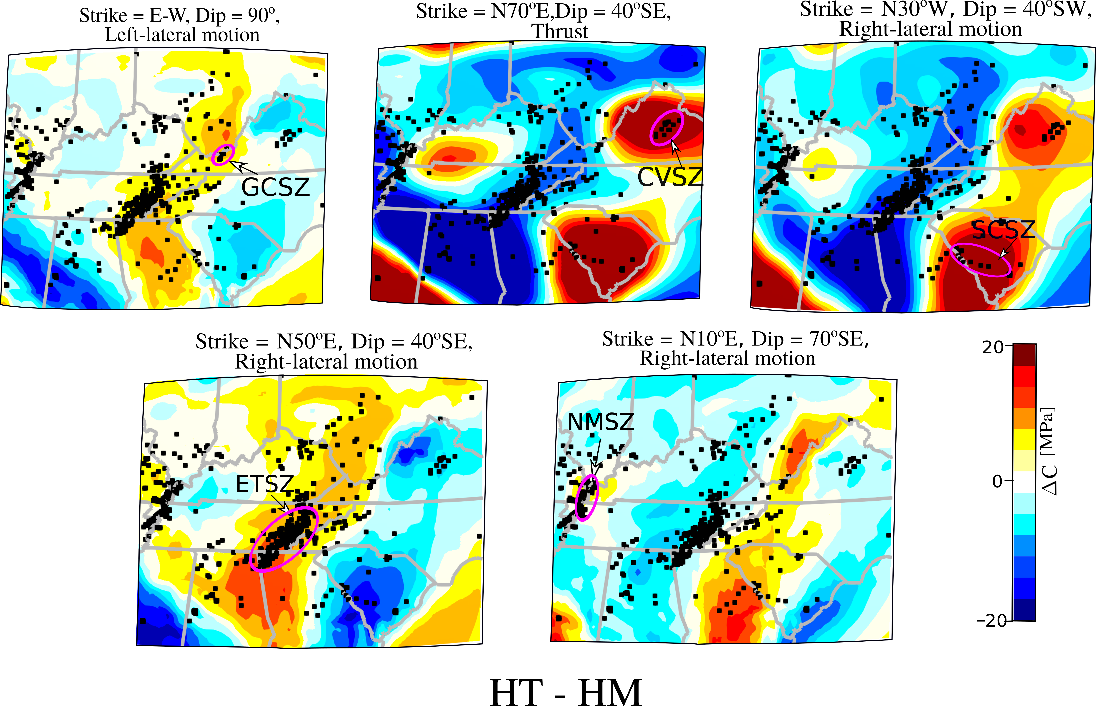
Fig S5. Coulomb stress change, ΔC, for HT - HM at their optimal fault orientations. Seismic zones (magenta) and their corresponding optimal fault geometries are mentioned for each subplot.

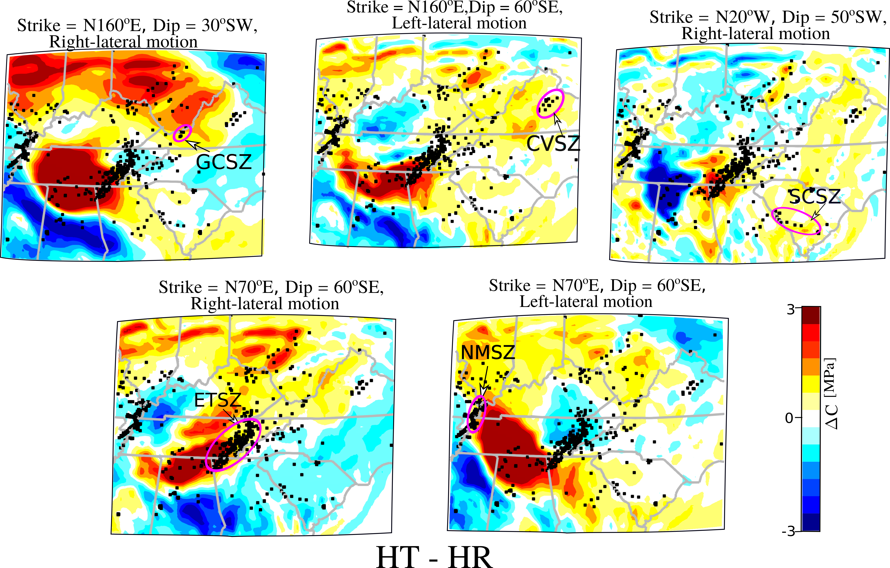
Fig S6: Same as in Fig. S5 but for HT – HR.

