Supplementary Files

Figure S1. Lung cancer screening eligibility (i.e., sensitivity) by race.
Figure S2. Lung cancer screening eligibility by Asian ethnicity
Figure S3. Lung cancer screening eligibility by region of Asian origin

Table S1. Patient and tumor characteristics among Asian Americans by site
Table S2. Lung cancer eligibility by race
Table S3. Reasons screening ineligibility among lung cancer patients by race
Table S4. Reasons screening ineligibility among lung cancer patients by race and acculturation

Figure S1. Lung cancer screening eligibility (i.e., sensitivity) by race.

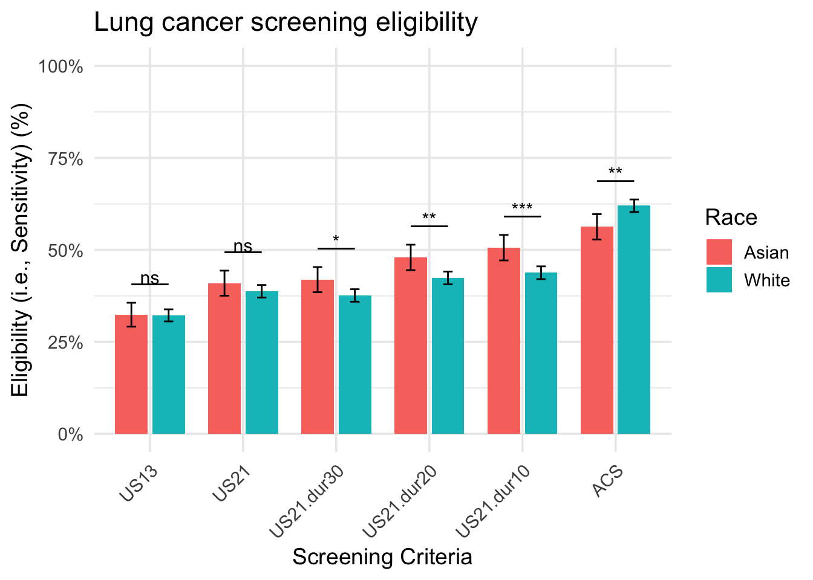

The percent eligible, along with the number of eligible and ineligible cases, is presented in Supplementary Table 2.
Abbreviations: US13, The USPSTF 2013 recommendation criteria (Age: 55-80, Pack-year≥30, Quit year within 15 years); US21, The USPSTF 2021 criteria (Age: 50-80, Pack-year≥20, Quit year within 15 years); US21.dur30, The USPSTF 2021 criteria replacing pack-year with 30-year smoking duration (Age: 50-80, Smoking duration≥30 years, Quit year within 15 years); US21.dur20, The USPSTF 2021 criteria replacing pack-year with 20-year smoking duration (Age: 50-80, Smoking duration≥20 years, Quit year within 15 years); US21.dur10, The USPSTF 2021 criteria replacing pack-year with 10-year smoking duration (Age: 50-80, Smoking duration≥10 years, Quit year within 15 years); ACS, American Cancer Society (Age: 50-80, Pack-year≥20 years, No quit-year restrictions)

Figure S2. Lung cancer screening eligibility (i.e., sensitivity) by Asian ethnicity

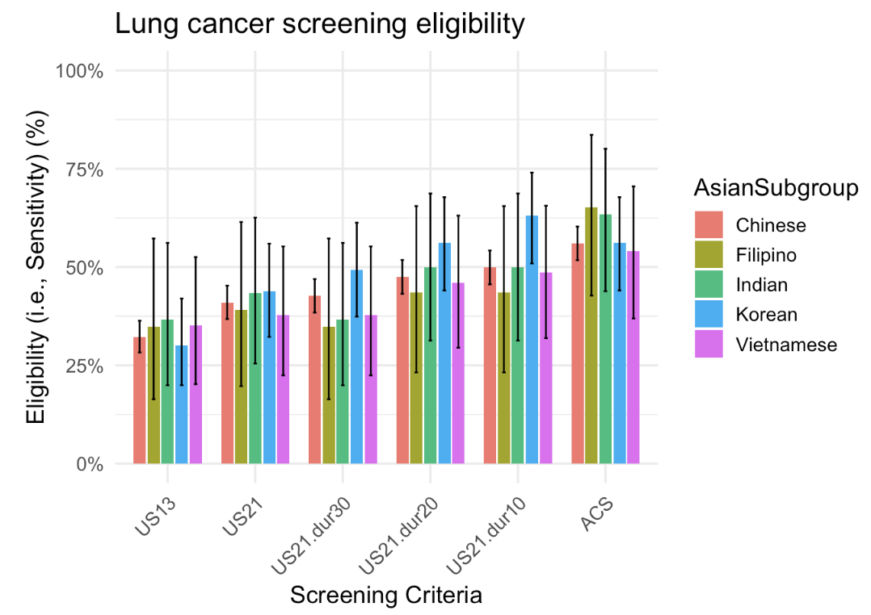

Figure S3. Lung cancer screening eligibility (i.e., sensitivity) by region of Asian origin

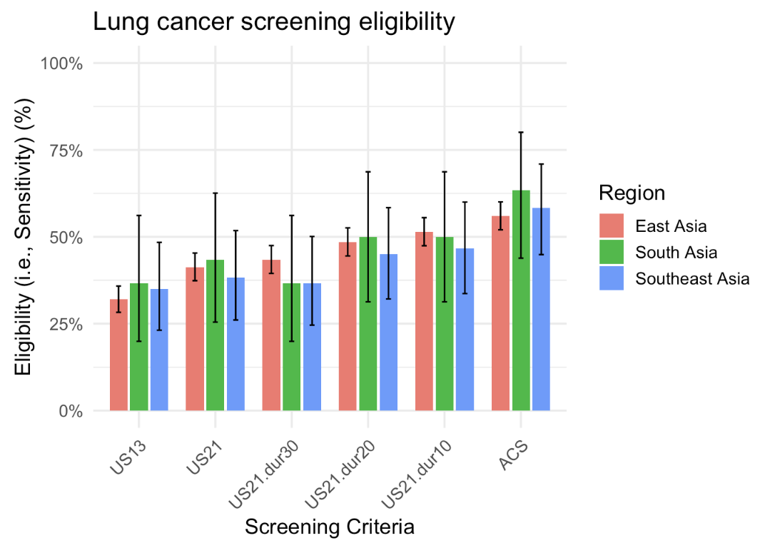

Supplementary Table 1. Characteristics among Asian American patients by site
 | Total | Jefferson Health | Weill Cornell Medicine | P-value
 | No. 826 | No. 242 | No. 584
Age dx
Mean (SD) | 68.6 (±10.9) | 69.0 (±10.9) | 68.4 (±10.8) | 0.45
Sex
Female | 85 (10.3%) | 32 (13.2%) | 53 (9.1%) | 0.079
Male | 741 (89.7%) | 210 (86.8%) | 531 (90.9%)
Asian Ethnic subgroup
Chinese | 537 (65.0%) | 99 (40.9%) | 438 (75.0%) | < 0.0001
Korean | 73 (8.8%) | 27 (11.2%) | 46 (7.9%)
Vietnamese | 37 (4.5%) | 33 (13.6%) | 4 (0.7%)
Indian | 30 (3.6%) | 12 (5.0%) | 18 (3.1%)
Filipino | 23 (2.8%) | 10 (4.1%) | 13 (2.2%)
Other Asians | 126 (15.3%) | 61 (25.2%) | 65 (11.1%)
Region of Asian origin
East Asian | 615 (74.5%) | 131 (54.1%) | 484 (82.9%) | < 0.0001
Southeast Asian | 87 (10.5%) | 68 (28.1%) | 19 (3.3%)
South Asian | 43 (5.2%) | 19 (7.9%) | 24 (4.1%)
Other Asian | 81 (9.8%) | 24 (9.9%) | 57 (9.8%)
Preferred language
English | 210 (25.4%) | 56 (23.1%) | 154 (26.4%) | 0.38
Other | 616 (74.6%) | 186 (76.9%) | 430 (73.6%)
smoking status
Current | 195 (23.6%) | 78 (32.2%) | 117 (20.0%) | 0.0003
Former | 631 (76.4%) | 164 (67.8%) | 467 (80.0%)
Pack-year
Mean (SD) | 34.0 (±29.1) | 37.3 (±28.0) | 32.7 (±29.5) | 0.005
Missing | 10 (1.2%) | 7 (2.9%) | 3 (0.5%)
Duration
Mean (SD) | 33.0 (±16.9) | 35.7 (±17.1) | 32.0 (±16.7) | 0.005
Missing | 12 (1.5%) | 7 (2.9%) | 5 (0.9%)
PPD
Mean (SD) | 0.9 (±0.5) | 1.0 (±0.6) | 0.9 (±0.5) | 0.24
Missing | 24 (2.9%) | 1 (0.4%) | 23 (3.9%)
Year since quitting smoking
Mean (SD) | 8.5 (±12.3) | 8.0 (±11.5) | 8.8 (±12.7) | 0.57
Missing | 131 (15.9%) | 25 (10.3%) | 106 (18.2%)
Year of dx
2010-2014 | 158 (19.1%) | 0 (0.0%) | 158 (27.1%) | < 0.0001
2015-2019 | 344 (41.6%) | 107 (44.2%) | 237 (40.6%)
2020-2024 | 324 (39.2%) | 135 (55.8%) | 189 (32.4%)
Stage
Advanced | 251 (30.4%) | 102 (42.1%) | 149 (25.5%) | < 0.0001
Early | 528 (63.9%) | 123 (50.8%) | 405 (69.3%)
Unknown | 47 (5.7%) | 17 (7.0%) | 30 (5.1%)
Histology
NSCLC | 677 (82.0%) | 197 (81.4%) | 480 (82.2%) | 0.18
OTH | 73 (8.8%) | 29 (12.0%) | 44 (7.5%)
SC | 54 (6.5%) | 16 (6.6%) | 38 (6.5%)
Missing | 22 (2.7%) | 0 (0.0%) | 22 (3.8%)
Death event
Alive | 618 (74.8%) | 194 (80.2%) | 424 (72.6%) | 0.022
Dead | 208 (25.2%) | 48 (19.8%) | 160 (27.4%)
Family history of LC
No | 756 (91.5%) | 228 (94.2%) | 528 (90.4%) | 0.076
Yes | 70 (8.5%) | 14 (5.8%) | 56 (9.6%)
COPD
No | 745 (90.2%) | 205 (84.7%) | 540 (92.5%) | 0.001
Yes | 81 (9.8%) | 37 (15.3%) | 44 (7.5%)

Supplementary Table 2. Lung cancer eligibility by race
 | Total | Asian | White | P-value
Total eligible (n) | No. 4,001 | No. 826 | No. 3,175
Screening criteria
US13
Ineligible | 2,712 (67.8%) | 559 (67.7%) | 2,153 (67.8%) | 0.97
Eligible | 1,289 (32.2%) | 267 (32.3%) | 1,022 (32.2%)
US21
Ineligible | 2,433 (60.8%) | 488 (59.1%) | 1,945 (61.3%) | 0.26
Eligible | 1,568 (39.2%) | 338 (40.9%) | 1,230 (38.7%)
US21.Dur30
Ineligible | 2,461 (61.5%) | 480 (58.1%) | 1,981 (62.4%) | 0.025
Eligible | 1,540 (38.5%) | 346 (41.9%) | 1,194 (37.6%)
US21.Dur20
Ineligible | 2,260 (56.5%) | 430 (52.1%) | 1,830 (57.6%) | 0.004
Eligible | 1,741 (43.5%) | 396 (47.9%) | 1,345 (42.4%)
US21.Dur10
Ineligible | 2,193 (54.8%) | 408 (49.4%) | 1,785 (56.2%) | 0.0005
Eligible | 1,808 (45.2%) | 418 (50.6%) | 1,390 (43.8%)
ACS
Ineligible | 1,567 (39.2%) | 361 (43.7%) | 1,206 (38.0%) | 0.003
Eligible | 2,434 (60.8%) | 465 (56.3%) | 1,969 (62.0%)
Abbreviations: US13, The USPSTF 2013 recommendation criteria (Age: 55-80, Pack-year≥30, Quit year within 15 years); US21, The USPSTF 2021 criteria (Age: 50-80, Pack-year≥20, Quit year within 15 years); US21.dur30, The USPSTF 2021 criteria replacing pack-year with 30-year smoking duration (Age: 50-80, Smoking duration≥30 years, Quit year within 15 years); US21.dur20, The USPSTF 2021 criteria replacing pack-year with 20-year smoking duration (Age: 50-80, Smoking duration≥20 years, Quit year within 15 years); US21.dur10, The USPSTF 2021 criteria replacing pack-year with 10-year smoking duration (Age: 50-80, Smoking duration≥10 years, Quit year within 15 years); ACS, American Cancer Society criteria (Age: 50-80, Pack-year≥20 years, No quit-year restrictions)

Table S3. Reasons screening ineligibility among lung cancer patients by race
 | Total | Asian American | White | P-value
Total ineligible (n) | 2,433 | 488 | 1,945
Reasons for ineligibility
Younger age <50 | 97 (4.0%) | 37 (7.6%) | 60 (3.1%) | < 0.0001
Older age >80 | 646 (26.6%) | 103 (21.1%) | 543 (27.9%) | 0.002
Pack-years < 20 | 1,053 (43.3%) | 270 (55.3%) | 783 (40.3%) | < 0.0001
YSQ > 15 | 1,339 (55.0%) | 159 (32.6%) | 1,180 (60.7%) | < 0.0001
Smoking duration
< 30 years | 1,277 (52.5%) | 244 (50.0%) | 1,033 (53.1%) | 0.33
< 20 years | 702 (28.9%) | 160 (32.8%) | 542 (27.9%) | 0.024
< 10 years | 289 (11.9%) | 77 (15.8%) | 212 (10.9%) | 0.003
Abbreviation: YSQ, year since quitting.

Table S4. Reasons screening ineligibility among lung cancer patients by race and acculturationª
 | Total | Asian Americans  (English) | Asian Americans  (Other language) | White | P-value
Total ineligible (n) | 2,433 | 131 | 357 | 1,945
Reasons for ineligibility
Younger age <50 | 97 (4.0%) | 17 (13.0%) | 20 (5.6%) | 60 (3.1%) | < 0.0001
Older age >80 | 646 (26.6%) | 21 (16.0%) | 82 (23.0%) | 543 (27.9%) | 0.002
Pack-years < 20 | 1,053 (43.3%) | 77 (58.8%) | 193 (54.1%) | 783 (40.3%) | < 0.0001
YSQ > 15 | 1,339 (55.0%) | 45 (34.4%) | 114 (31.9%) | 1,180 (60.7%) | < 0.0001
Smoking duration
< 30 years | 1,277 (52.5%) | 77 (58.8%) | 167 (46.8%) | 1,033 (53.1%) | 0.034
< 20 years | 702 (28.9%) | 48 (36.6%) | 112 (31.4%) | 542 (27.9%) | 0.035
< 10 years | 289 (11.9%) | 27 (20.6%) | 50 (14.0%) | 212 (10.9%) | 0.002
a Acculturation was defined based on preferred language, with patients preferring English categorized as having high acculturation and those preferring other languages as having low acculturation.
Abbreviation: YSQ, year since quitting.

