**TOPS/AB/AN/REN/8/04/2025**

FEBRUARY 07, 2025.

The Managing Director

**MAINSTREAM GLOBAL INSURANCE BROKERS LIMITED**

**${ADDRESS}**

**NOTIFICATION OF RENEWAL**

This is to bring to your notice that the under mentioned policy will fall due for renewal on the date stated below.

**INSURED** : OFFICE OF THE ACCOUNTANT GENERAL OF THE FEDERATION

**POLICY NO** : ABJ/ABUJ/ALR/45186

**RENEWAL DATE :** 45754

**SUM INSURED** :~~N~~ 39367800

**ANNUAL PREMIUM**  : **~~N~~ 6750000**

**PREMIUM DUE : ~~N~~ 6750000**

**POLICY TYPE** : All Risk

You may wish to re-value your property, in order to ensure that you are adequately indemnified should a claim arise, bearing in mind present day values.

Any other alterations affecting the risk should be brought to our notice in writing.

Whilst thanking you for your continued patronage, kindly let us have your firm instruction to renew, otherwise the policy will lapse

Yours faithfully,

For: **NSIA INSURANCE LIMITED**

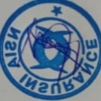  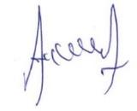

Anayo. M Abayomi Adeagbo

**Technical Operations Authorized Signatory**