**Sustainable RF Energy Harvesting Using Microstrip Circular Patch Antennas: A Path to Self-Sufficient Electronic Systems**

*1E. Christo Eljin Raj, 2R S Shaji

*1Professor,* *Department Electronics and Communication Engineering, Maria college of Engineering and Technology, Tamil Nadu, India*

*2Professor, Department of Computer Science and Engineering, St. Xavier’s Catholic College of Engineering, Nagercoil, Tamil Nadu, India*

*Corresponding author: E. Christo Eljin Raj; Email: echristoeljinraj.phd@gmail.com

**ABSTRACT**

The proliferation of wireless communications increases the Radio Frequency (RF) signal density worldwide. Radio Frequency signal emitted from mobile communication is massive and harvesting this signal could be utilized for various real-time applications. Recharging of batteries of IoT devices is the predominant application. The primary goal of this study is to establish and design high-level effectiveness in microstrip circular patch antenna harvesting ambient Radio Frequency energy over wider frequency from 1.5 GHz to 5.2 GHz, enabling sustainable power solutions for low-energy IoT devices. The innovation reclines in the combination of an Advanced Design system-optimized antenna with a novel power management and rectifier which notably improves energy transformation efficiently. The developed method encourages sustainability by minimizing e-waste and extending the lifetime of the device battery. Experimental analysis estimates the efficiency and stability of this method identifying an important step with regard to independent electronic systems and covering the strategy for scalable, ecological IoT deployments. The harvesting of Radio Frequency energy is effectively effectuated by the designed antenna from the mobile communication.

**Keywords:** Patch antenna, Radio Frequency signal, mobile communication, recharging of batteries.

**1. INTRODUCTION**

A transceiver is the combination of transmitter and receiver which could be used for signal transmission and reception [1]. This device particularly uses an antenna to transmit and receive radio waves while performing radio communication. The Alternating current (AC) signal that is applied to the antenna results in the oscillation of conductive material back and forth and generates electromagnetic (EM) waves. The resultant signal’s frequency relies on the frequency of the applied AC signal. The generated electromagnetic signals are transferred to a receiver with the assistance of devices known as transmitters [2]. Light waves, radio frequencies, mobile device indications, electric microwave generators, and messages from radar are a few manifestations of electromagnetic energy [3]. Generally, applications for cars, aircraft, interactions, SIGINT (signal intelligence), and ISR (intelligence, surveillance, and reconnaissance) are a few examples of popular usage.

Antenna design has a significant impact on both product lifetime and consumption of electricity minimizes variations in efficiency in the finished item and is made possible by an optimal design [4]. The fluctuation generated by the AC, mechanical component, a battery-powered, magnetizing within a bandwidth of 20 kHz to 300 GHz, is called RF. RF energy harvesting is the technique of absorbing radio frequencies and turning them into beneficial electrical power [5]. It converts RF signals into a direct-current (DC) power supply for using customized transmitters and converters. Electromagnetic radiation can be harvested by an RF energy harvesting device and transformed into a DC current that can be used.

The antenna and convertible network, which enable the conversion of AC into DC power, are the essential components of an RF energy-extraction device. Moreover, RF circuit design [6] is an area that concentrates on the building of transistors that function in RF and is a symbol for the frequency at which electromagnetic radiation oscillates. The proportion of oscillation phases per second (1/s) is the unit of measurement for frequency, and it is expressed in Hertz (Hz). The three general categories are directional, omnidirectional, and semi-directional. RF transmissions can be sent and received using omnidirectional RF antennas [7] at any point surrounding the antenna.

For operations that require everywhere responsibility, omnidirectional antennas are ideal and are mostly utilized in Wi-Fi and other near-field range networking technologies. Signals are sent and received by directional antennas exclusively in a single path, typically in the form of extremely confined, extremely concentrated radiation, and the transmission structure has a cigar appearance and is identical from the highest point to the edges. For point-to-point transmission, semi-directional antennas [8] are made to focus the radio wave in one location and are utilized for small- to medium-range transmission.

As a result, the reliability of the transmitter can be impacted by RF signal disruption from other electrical devices, structures, and ambient elements. The number of wavelengths that various antennas can efficiently broadcast or collect is limited by their varying bandwidth features. Decreased transmission reliability and strength result from additional electrical equipment interfering with RF communications. Lacking replicators, RF waves cannot be used for distant communication due to their restricted frequency.

**1.1 Motivation**

The rapidly emitted RF signals from mobile communication omnipresent and massive source of energy. For the proliferation of sustainable energy solutions, the harvesting of RF signals is obligatory and used for recycling of this ambient source. The main application of this harvested energy is applicable for energy-consuming electronic devices such as sensors and replaces replaceable batteries. The designing of the RF energy harvest system is a challenging task to attain sustainability. The design of the proposed antenna is effectuated by its advantages of lightweight, compatibility, low profile, and effortless fabrication. The main motivation behind this article is to provide better sustainability, electronic waste reduction, and self-sustainable systems.

**1.2 Novelty**

1. The developed antenna integrates an Advanced Design System (ADS)-optimized structure, enhancing energy transformation effectiveness by ensuring lower return loss, high gain, and superior directivity.
2. A novel PMU is implemented, efficiently stabilizing the harvested energy while reducing losses, ensuring betterconversion effectiveness, and outperforming other designs.
3. The developed method is tailored for sustainable power solutions, minimizing reliance on replaceable batteries and enabling long-term deployment of IoT applications with lower maintenance.

**1.3 Contribution**

The major contribution of the developed design is discussed below

* **Development of RF energy harvesting system:** A microstrip circular patch antenna enhanced for wideband RF energy harvesting. The impedance-MC increases power transfer from the antenna to the RC. Rectifier design with Schottky diodes ensures lower power loss and enhanced DC conversion effectiveness.
* **Performance validation and comparative analysis:** Attains higher gain (6.133 dB), directivity (6.38 dB), and efficiency (96%) compared to existing RF harvesting solutions.
* **Applications in sustainable wireless power systems:** This supportslow-power IoT sensors, RFID tags, and biomedical implants, reducing dependency on batteries.

**Roadmap:**

The roadmap of the article is described as; in section 2 the relevant works are analyzed and highlighted the features. In section 3 system model is elucidated. The proposed design is explained in section 4. The simulation details are enclosed in section 5. Section 6 describes the Discussion. Finally, the work is concluded in section 7.

**2. LITERATURE SURVEY**:

To tackle the challenge of providing electrical power for wireless sensor networks (WSN), Zhang et al. [9] described a back-to-back microstrip antenna design used for high-speed broad-spectrum RF collecting with specialized wireless electrical energy transmission. A broadband resonance achieves 2 GHz to 4 GHz, enabling omnidirectional and bi-directional radiation at 5.8 GHz, confirming the reduction and smaller size. A transmitter with a 0.5m distance and RF power levels up to -8.5 dBm demonstrates the effectiveness of power transmission and wireless energy harvesting. Expanding the frequency range with broadband alone is challenging.

Power harvesters can be very useful in locations without access to a traditional power supply, which enables electronic devices to function, and reduces the need for cabling and regular battery replacement trips. Marriwala, [10] presented an energy harvesting system built and enhanced for Wireless Sensor Networks (WSNs) employing an enormous speed rectenna. It can operate both board and narrow bands structured by a multichannel and frequency-independent transmitter. The suggested approach aids in the efficient analysis of RF power harvesting for WSN. Nevertheless, varying sources of power is a risky strategy.

Usually, in a stable form, thermal energy harvesters (TEH) have permanent hot and cold sources on both sides. Bakytbekov et al. [11] developed a dual-function triple-band heatsink transmitter for effective Radio Frequency energy harvesters (RFEH) and TEH combination. The antenna is designed to function as the TEH's radiator to accomplish smart integration. Ansys Fluent and HFSS were the two simulations used. This illustrates ~130% more energy of collaboration and homogenous connectivity in enhancing thermal and radiofrequency harvested energies. But it isn't always easily accessible all over.

In a T-type system that operates in one phase and has just three communication sections into the closed-form layout computations, Liu et al. [12] design a dual-band impedance matching network (DBIMN) for converters using RF. The design, validated by various input power specifications by two dual-band rectifiers, is intended for usage in wireless power transfer (WPT) networks and has been tested and operated at 2.45 GHz and 0.915 GHz. However, the total battery power generated is constrained.

Despite its small dimensions, it is effectively integrated at the cost of a 15% bandwidth shift with a detecting circuit on the identical substrate. The transmitter configuration consists of a rectangular area that is fed by a balanced 50-coplanar line and has two incised U-shaped slits; Koohestani et al. [13] suggest the design of a highly compact printed rectenna for gathering ambient RF power at 2.45 GHz. It is capable of being seamlessly connected with any gadget that operates lightweight wireless sensor networks. The suggested rectenna-determined RF-to-DC transformation rate is around 20% (97 mV). Hence, it is inappropriate for use in group structures.

The techniques used in the investigation entail examining how antenna components affect the effectiveness of radiation-to-ac harvesting. Wagih et al. [14] examine transmitter patterns used in wireless power transfer (WPT) and radio-frequency energy harvesting (RFEH) technologies. The effectiveness of the transmission of energy and the quantity of captured electricity are significantly influenced by these layouts. The transmitter-rectifier impedance bandwidth and the radiation characteristics of the transmitter are the two primary criteria used to classify the antennas and facilitate the figure of merit (FoM) determination for various applications. The effectiveness of rectenna is improved, but it cannot be supplied by a low-gain transmitter.

For Internet-of-Things (IoT) services, a compressed incidence angle-insensitive RFEH architecture developed by Park et al. [15] exploits an unlicensed industrial, scientific, and medical (ISM) bandwidth range of 2.45 GHz. A dipole antenna with an orthogonal configuration is used in the dual-polarized transmitter for the downsized layout. A two-stage Dickson control pump network with the highest productivity was chosen by evaluating the performance of each diode stage of the rectifying system. Its smaller dimensions and increased harvesting potential at different incidence degrees make it feasible, but the performance is low.

To maximize the antenna's efficiency, the development procedure included an investigation of the collinear transmitter, the effects of parasitical fragments, and resistance balancing. Hu et al. [16] described a quasi-Yagi antenna array that integrates a parasitical segment and a collinear antenna as the controlling element. It is more accurate and convenient than standard Yagi antennas since it does not require wide beams to support numerous parasitic parts or extra-consuming circuits like baluns and energy regulators. The suggested layout has a compact length and elevated power. Thus, the larger capacity is used less frequently.

Obtaining the multiband retractable antenna, Wang et al. [17] initially developed a seven-band omnidirectional rectenna to gather radiofrequency radiation. A complex adaptation of impedance to the converter is co-designed into a bandwidth-wide omnidirectional monopole transmitter. The array can produce steady omnidirectional beams and harvest RF power in the 1.67–5.92 GHz range. It was created and validated by combining an amplifier and monopole transmitter in a compact design. Hence, it is inefficient for larger performances.

To determine the appropriate frequency ranges for RFEH networks, an RF-spectral scan is carried out. A dual-band inverted-F transmitter is featured by rectenna Muhammad et al. [18] present dual-band impedance matching network radio frequency (IMNRF). The rectenna wiring layout is reduced, which significantly raises the harvester's RF-to-DC power conversion efficiency (PCE). The suggested rectenna may operate numerous devices with minimal power and effective power control. Thus, it tends to have a shorter electromagnetic range.

Moreover, the RF energy harvesting (RFEH) circuit design by Nwalike et al. [19] is an area that concentrates on the building of transistors that function in RF. To address the poor conversion effectiveness Impedance matching network is applied by Dziadak et al. [20]. The efficiency of an ambient RF-EH operates at 2.4 and 5 GHz which is improved via a Metamaterial Impedance Matching Network (MIMN) by Coskuner and Garcia-Garcia [21]. The design of the proposed antenna is effectuated by its advantages of lightweight, compatibility, low profile, and effortless fabrication. The key objective of this method is to implement and design a high-efficiency microstrip circular patch for collecting ambient RF energy over a broad frequency range authorizing sustainable energy solutions for minimum-energy IoT devices by improving energy transformation effectiveness and system amalgamation.

**2.1 Limitations and research gaps**

The limitations of the model are as follows; The effectiveness of RF energy harvesting is highly dependent on the ambient RF environment, which varies based on location, network traffic, and obstructions. Despite covering a wide frequency band, the harvested power may still be insufficient for high-energy IoT applications, limiting its usability to ultra-low-power devices. Moreover, the RC efficiency remains a major challenge in RF energy harvesting. High losses in rectification and impedance-MC can reduce overall system efficiency. The research gaps are many RF energy harvesting systems suffer from low rectification efficiency and power conversion losses, especially in low-power ambient environments. The proposed method needs comparative validation against state-of-the-art rectification techniques to demonstrate superior performance.

**3. SYSTEM MODEL**

In the system model, the RF energy harvesting framework used in the proposed design employs components like an antenna, matching circuit (MC), rectifier circuit (RC), power management unit (PMU), energy storage (ES), and load. From the environment, the designed antenna captures the RF signals. The MC is put down to improve the power-conversion capability. The RC transfers the apprehended RF signals. PMU adjusts the DC power output from the rectifier, ES stores the collected and modulated energy and Load signifies the low-power IoT device.

A diode is a semiconductor device that grants current to flow in one direction while blocking it in an adjacent direction. It has two terminals Anode (+) and Cathode (-). Where Anode means current enters and cathode means where current exits. Figure 1 depicts a typical RF harvesting system containing the following components an Antenna that captures RF signals and a MC makes sure high-level power transfer by reducing the impedance mismatch relationship among the rectifier and antenna. The RC transforms the captured AC signal into a usable DC signal. For stable operation, the PMU regulates the DC output by providing stable voltages that are suitable for charging the IoT devices for smooth power supply capacitors or supercapacitors. Finally, Energy Load/ Storage preserves the harvested energy or straightly powers a load. Certain reason for the **RC** follows the **MC as described below**

* **Impedance matching**
* **Effective AC-to-DC conversion**
* **Optimized Energy harvesting**

1. ***Impedance Matching:*** By matching the impedance of the antenna to the input impedance rectifier, the MC makes sure effective energy transmission. The notable signal power will be lost without this step.
2. ***Efficient AC-to-DC Conversion*:** The rectifier transforms the AC signal into D power efficiently after impedance matching without further loss of energy.
3. ***Optimized Energy Harvesting:*** After the MC immediately placing the Rectifier makes sure minimum signal degradation prior to conversion.

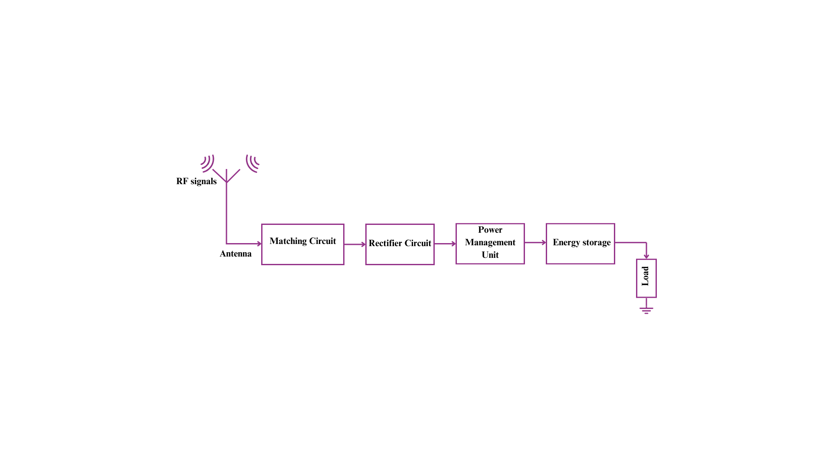

**Figure 1:** RF energy harvesting proposed framework

**4. PROPOSED DESIGN**

This section provides the details about designing various components used in this work in a detailed manner.

***Use of matching circuits:*** MC plays an important character in RF energy harvesting and alternative electronic applications. Its main motive is to establish that the highest number of energy is moved from the antenna to the following circuitry. In the case of an impedance mismatch, RF energy's part is sent back to the antenna rather than being transmitted to the load, reducing the performance of energy transfer. The number of power delivered to the load was enhanced by a MC which manages effective power transmission across frequencies and averts immoderate power reflections.

***Development of matching circuit:*** The MC was developed by the subsequent steps, examining load and source impedance, choosing the type of matching network, evaluating impedance matching, appraising the range of frequency, designing simulation, and constructing the MC. The major role of a MC is impedance matching but there were certain considerations.

* + MCs can act as frequency filters, improving energy harvesting at particular frequencies and eliminating irrelevant signals.
  + Reflected power not just minimizes effectiveness but also can originate signal distortion or destruction to components.
  + The real-world factors such as circuit component losses, parasitic elements, and temperature dissimilarities must also be taken into account, behind impedance matching.
  + The MC requires to be improved for wideband efficiency for applications requiring a wide range of frequencies.

**4.1 Reasons for Impedance Matching:**

The reasons are as follows

1. The basic principle in RF circuit design is Impedance matching [22] which makes sure compliance with the Maximum Power Transfer Theorem.
2. Amplifiers or rectifier devices work most competently while they get the deliberated power in the absence of reflection losses.
3. RF energy harvesting has so far been limited in the energy available in the ambient signal. In capturing usable power, MCs make sure minimal loss and the system is most efficient.
4. Conventional matching keeps away from the immoderate production of heat caused by reflected energy, enhancing the longevity and robustness of the system.

Antenna design takes circular microstrip patch antenna parameters to design the circular patch antenna [23] for dominant TM11 nod. with the dielectric substrate constant and heights are and . The constant contains precalculated values for a particular design. This expression simplifies frequency calculation by focusing on the dielectric constant . The equation can be applied to other frequencies as long as the substrate and its dielectric constant remain changed. The physical dimensions are adjusted accordingly for the desired frequency. Moreover, this expression is valid if the substrate’s dielectric constant changes but the values are updated in the equation. The operating frequency will shift because the dielectric constant directly affects the effective wavelength. The term FR refers to the resonant frequency.

The TM11 mode refers to the Transverse Magnetic (TM) mode with minimal cut-off frequency in a rectangular waveguide in a rectangular waveguide. This means that is an initial mode to propagate via the waveguide so it is considered the major transmission mode. For signal propagation, it is most effective in the waveguide. The magnetic field is completely transverse to the wave propagation direction within a TM mode. Moreover, "11" present in the TM11 represents the particular field distribution in a waveguide and these configuration consequences in the minimal cut-off frequency among all TM modes. Typically, the dominant mode is defined as TE10 as it has a higher cut-off frequency than the TM11 mode. This mode always has minimum loss, distortion-free transmission, and high-level result mode in a notable power loss. Through many investigators, the analysis of rectangular waveguide field distribution is established.

Equation (1) refers to evaluating the radius of a circular microstrip patch antenna [24] designed to operate at a specific resonant frequency. The patch radius and their mathematical expression are described below.

 (1)

The term  represents the physical radius of the circular patch. and refers to resonant frequency and Dielectric constant. From this, with the dielectric substrate constant. Compared to physical patch dimensions, electrically the dimensions of patches are desirable due to fringing fields. The below formula determines the efficient patch radius ().

 (2)

 (3)

  (4)

Line impedance is. depicts the microstrip feed line width, while corresponding to the transformer line width used in the quarter-wave impedance MC.

* ***Quarter wave transformer length*:**

Find the quarter wave transformer width. The below expression determines the quarter wave transformer length.

 (5)

From Equation (5), denotes dielectric substrate wavelength for free space .

* ***Radiation losses based on conductance (******):***

Equation (6) determines the radiation losses based on conductance ().

 (6)

 (7)

The circular patch radius is with a dielectric constantin Equation (7).

* ***Conductance and Conduction losses based on conductance :***

Conductance and Conduction loss based on conductance expressed in Equation (8) and (9).

 (8)

 (9)

is the copper material conductance.

* ***Total conductance (******):***

Adding these components (RG, DG, and CG) gives a total energy transfer in the system. Although losses do not directly influence the conductivity they affect the effectiveness of energy transfer. During the transfer procedure, the equation accounts for the energy that is lost by including loss terms. Although losses do not directly change the material's intrinsic conductivity, they affect the entire energy transfer effectiveness. This can mean a minimization in the efficient system conductance. In certain instances, the losses may be notably adequate to impact the efficiency of the system. The particular condition of the equation is significant for clarifying the definition of the expressions and the explanation for integrating them with each other. It is very important to understand the dissimilar loss techniques involved in the system to respect why they are contained in the formula. This is the amalgamation of ohmic, dielectric, and radiation losses which is described in Equation (10).

 (10)

* ***Equivalent dielectric constant (******)***

The below formula shows the equivalence of the dielectric constant.

 (11)

* ***Resonance-based input resistance (******):***

 (12)

From this, the center patch feed distance is.

 (13)

Figure 2 shows the microstrip line fed by a circular patch antenna. The impedance among them is matched with a circular patch edge and the microstrip feed places the quarter wave transformer. The patch radius R, height substrate, width, and impedances match the circular patch.

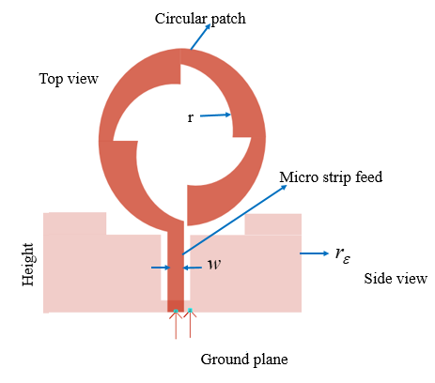

**Figure 2:** The microstrip line fed by circular patch antenna

**4.2 Matching Circuit (MC)**

The matching circuit (MC) plays a crucial role in reducing impedance mismatch between the antenna (source impedance) and the rectifier circuit (load impedance). In the proposed system, an L-type matching network is employed to transform the standard 50 Ω source impedance to approximately 2.56 Ω, matching the input impedance of the rectifier. This ensures optimal power transfer and improved overall system efficiency. The designed L-network consists of the following passive components:

Capacitor  (14)

Inductor  (15)

These values were calculated based on the center frequency using standard impedence transformation equations:

 (16)

 (17)

From the above equation, , , and . This matching ensures minimal return loss (S11<-10dB), improved power transfer, and reduced reflection. The RC power with the precise designing of MC is expressed in Equation (18),

 (18)

When the output resistance of the antenna is added to the equation (19), the overall system Power is framed for as,

 (19)

The loss in the added resistor value reduces the  hence. The source power is . The impedance MC for the input power is illustrated in Figure 3.

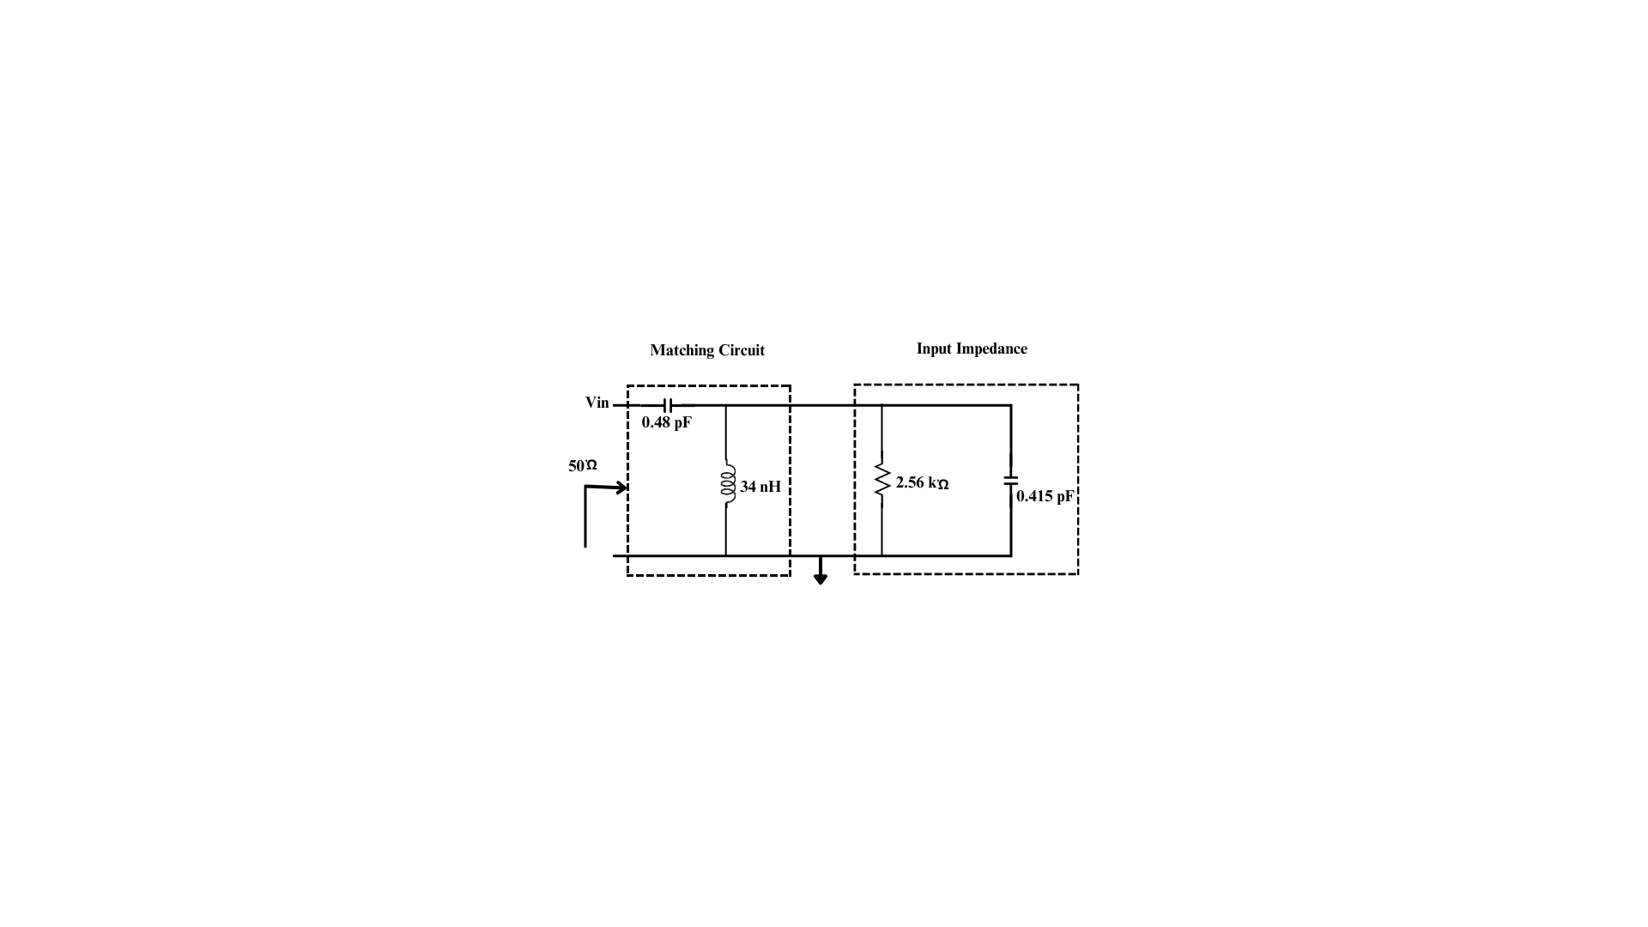

**Figure 3:** Impedance matching circuit for the power 200mV

**4.3 Rectifier Circuit (RC)**

The rectifier circuit (RC) converts the captured RF signal into DC power using a voltage doubler topology. It employs a two-stage configuration comprising Schottky diode-capacitor pairs to boost the output voltage while minimizing power losses. The values of the passive components used in the rectifier are as follows:

* Capacitor
* Inductors
* Load resistance (RL) 

***Schottky Diode Specification:***

* Model: HSMS-2850
* Forward Voltage Drop:~0.25 V
* Junction capacitance (Cj):~0.18 pF
* Series Resistance: ~5Ώ
* Reverse Breakdown voltage:>15V

This diode is selected due to its **low threshold voltage** and **fast switching characteristics,** making it suitable for high-frequency rectification in RF energy harvesting applications

***Rectification******Efficiency****:*

The received RF power is converted to DC using the voltage doubler. The conversion efficiency is calculated using:

 (20)

From the above equation,is the DC output power, and is the input RF power. Using the above configuration, a conversion efficiency of up to 96% was observed at 6 GHz as depicted in Table 1 and Figures 12-14. The distance between transmitter () and receiver () power related to the Friss transmission is described in Equation (21).

 (21)

The transmitted signal wavelength  with the transmitted and receiver gains and . According to the circuit design, special sensitivity considerations are required with square distances diminished via received signal strength. At particular frequency bands, the maximal transmission power is limited to FCC regulations. Equation (22) shows the RF energy harvesting efficiency.

 (22)

where, andare the rectified and received power. All input parameters are considered to design the RC to obtain huge efficiency from the energy harvester. The load current and voltage are influenced by the number of stages in which the rectified power is based on the current and output voltage. At every polarization, two voltage doubler circuits’ achieve received RF signal rectification. The shunt Schottkty diode and series capacitor C1 form the initial stage. Figure 4 represents the schematic circuit model of RC that shared the load RL and capacitor C2 between both doublers. D1 and D2 are Schottky diodes. They are commonly used in RF circuits due to their low forward voltage drop and fast switching speed. C1 and C2 can be chosen based on the desired frequency response and impedance matching requirements. Typical values for RF capacitors are in the range of picofarads to nanofarads. L1, L2, L3, and L4 can be chosen based on the desired frequency response and impedance matching requirements. Typical values for RF inductors are in the range of nanohenries to microhenries. RL is the load resistance. Its value depends on the specific application and the desired power transfer.

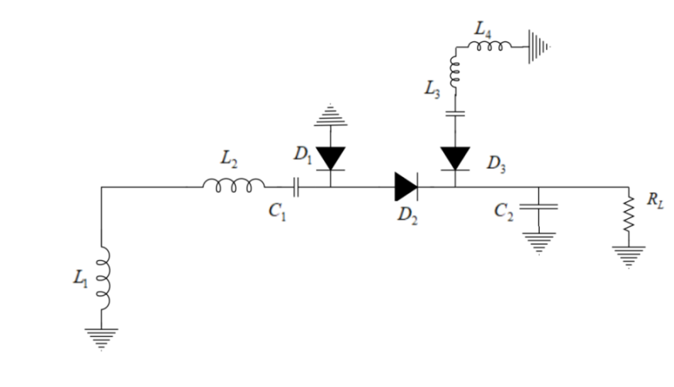

**Figure 4:** The schematic circuit model of RF

**4.4 Power Management Unit (PMU)**

It is one of the main components of the RF energy harvesting system is PMU which can be used for the robust conversion of RF energy into reusable electrical power supply. It acts as the voltage regulator that can be used for the output that is used for particular applications. It prevents voltage fluctuations and therein significantly provides a stable power supply.

**4.5 Energy storage (ES)**

The extra energy received in the PMU is stored in this component and uses the power in a reliable manner. This provides a continuous supply of energy even when an RF signal is absent.

**4.6 Load**

The harvested energy is utilized by the load for particular applications or operations. The load used here is low-power-consuming devices that are used in IoT applications.

1. **RESULTS**

The design of the proposed antenna is effectuated using the Advanced Design System software (ADS). It is widely used industrial leading electronic design automation (EDA) software used for various applications. The robustness of the ADS is significant and provides a better streamlining of development.

**5.1 Simulation outcomes**

After designing the antenna using the ADS software, the parameter ranges that are obtained for the RF energy harvesting system are depicted in Figure 5. The designed antenna works on a wide range and can easily receive the signals from the cell base station and mobile devices.

The antenna using the ADS software obtained parameters depicted in Table 1.

**Table 1:** Antenna Parameters

|  |  |
| --- | --- |
| **Parameters** | **Values** |
| Effective angle | 2.88576 |
| Input power (Watts) | 0.00249702 |
| The angle of U max | 57 |
| Gain (dB) | 6.1338 |
| Directivity (dB) | 6.38949 |
| Frequency (GHz) | 4.33333 |
| Radiation efficiency (%) | 94.2824 |
| Maximum intensity (Watts) | 0.000815816 |
| Maximum intensity (Watts) | 0.000815816 |
| Radiated power (Watts) | 0.00235425 |

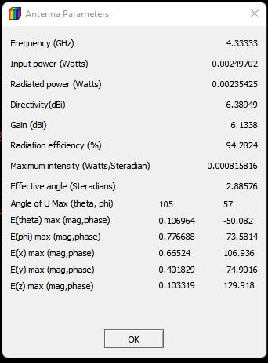

**Figure 5**: Parameters obtained after the designing of the antenna using the ADS software

The designed antenna’s parameter measurement is depicted in Figure 6. The designed antenna demonstrates a return loss below -10 dB, indicating efficient impedance matching and minimal reflected power. At 6 GHz, the return loss remains below this threshold, ensuring that most of the incident RF energy is successfully transferred into the antenna. Despite operating at the edge of the specified frequency range which achieves a maximum gain and directivity of 6.133 dB and 6.38 dB at 6 GHz. The gain represents the antenna's ability to radiate power effectively in the desired direction, and directivity reflects the focused radiation pattern. The design process accounted for trade-offs between return loss, gain, and directivity at higher frequencies by leveraging ADS software. These results suggest that the antenna retains its performance characteristics due to its robust design, ensuring effective operation at 6 GHz.

Different parameters with respect to the frequency are analyzed in Figure 7. Figure 7 (i-iv) shows the gain with respect to the frequency. The maximum gain of the designed antenna is 6.133dB at 6 GHz frequency. The directivity vs. frequency is plotted and the directivity at 6GHz is around 6.38dB. Efficiency vs. frequency is depicted with a maximum efficiency of 96%. Finally, the Power radiation with respect to the frequency with the maximum radiation power of 2.354 mW.

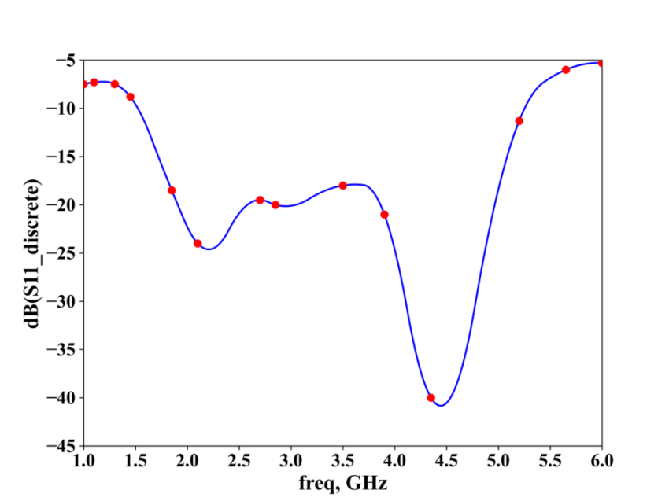

**Figure 6:** Frequency vs. return loss analysis

The investigated radiation patterns are shown in Figure 8. Figure 8 (a-d) depicts the radiation pattern of Gain, directivity, and radiation intensity, the electric and magnetic far field-based radiation pattern.

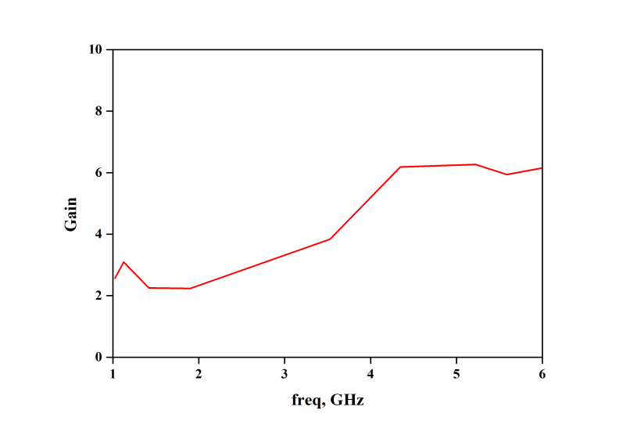

(i)

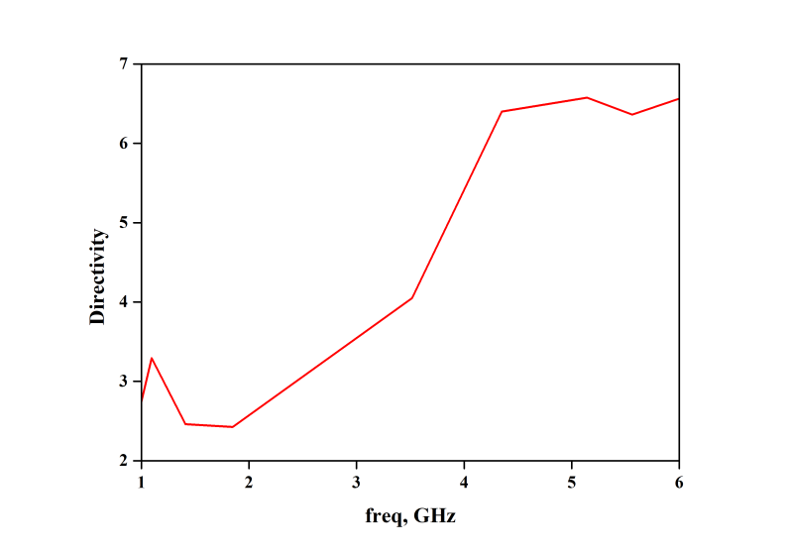

(ii)

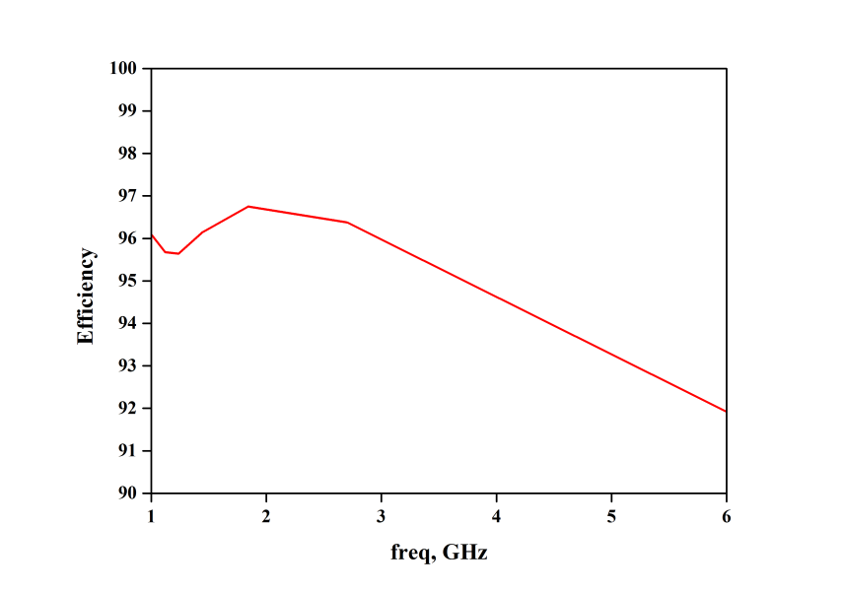

(iii)

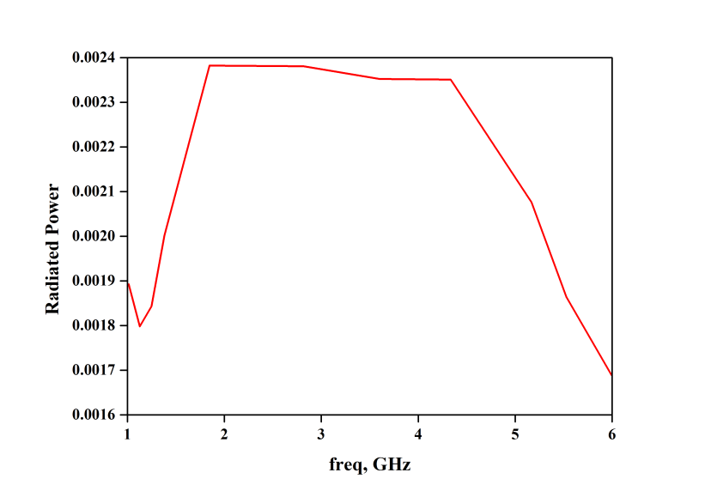

(iv)

**Figure 7:** Analysis of antenna parameters Vs frequency (i) Gain, (ii) Directivity, (iii) Efficiency and (iv) Power radiated

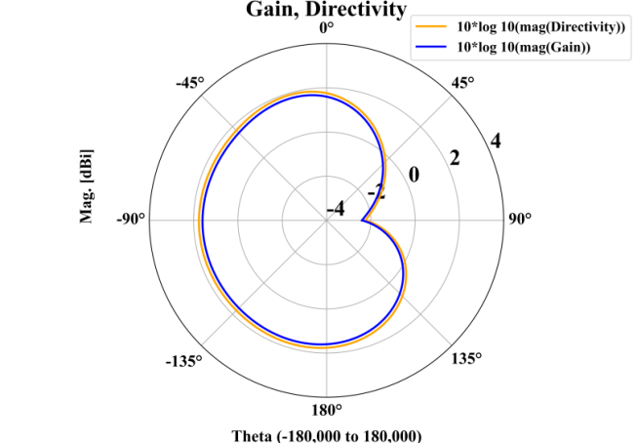

(a)

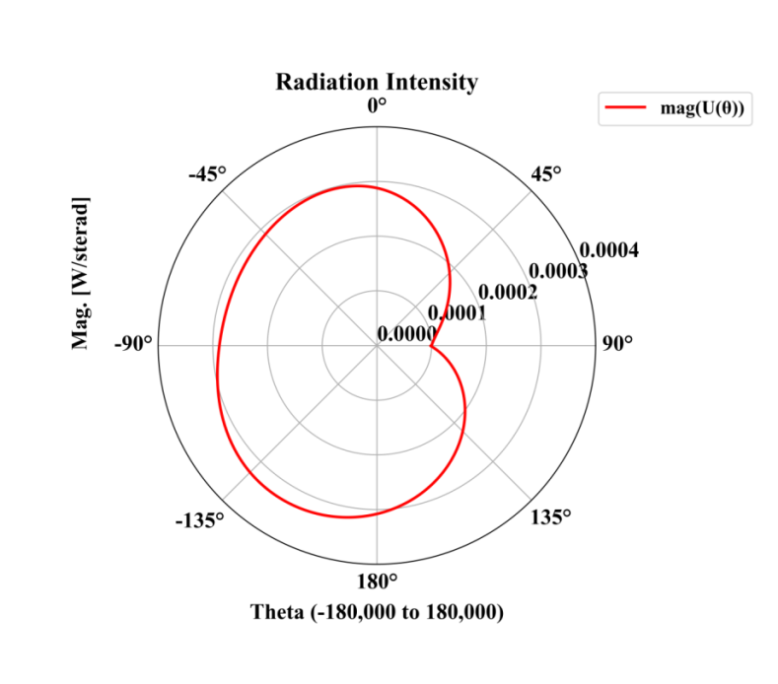

(b)

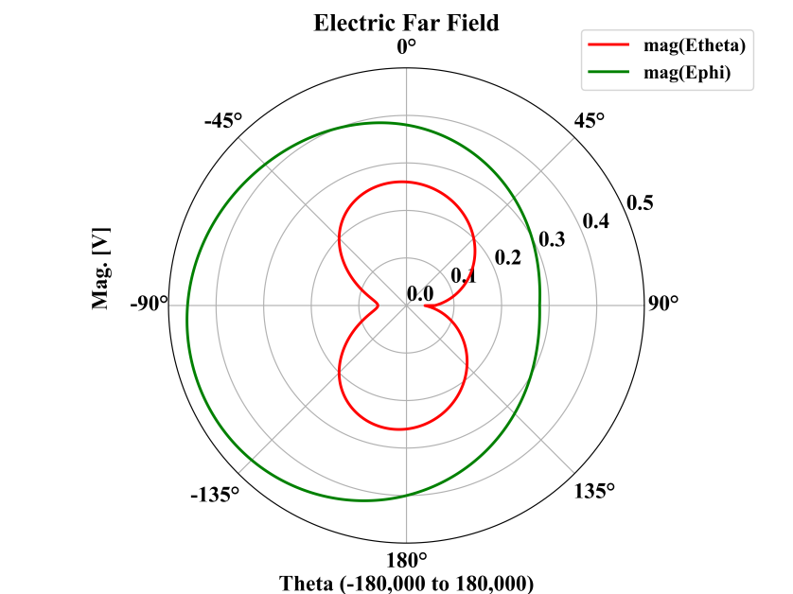

(c)

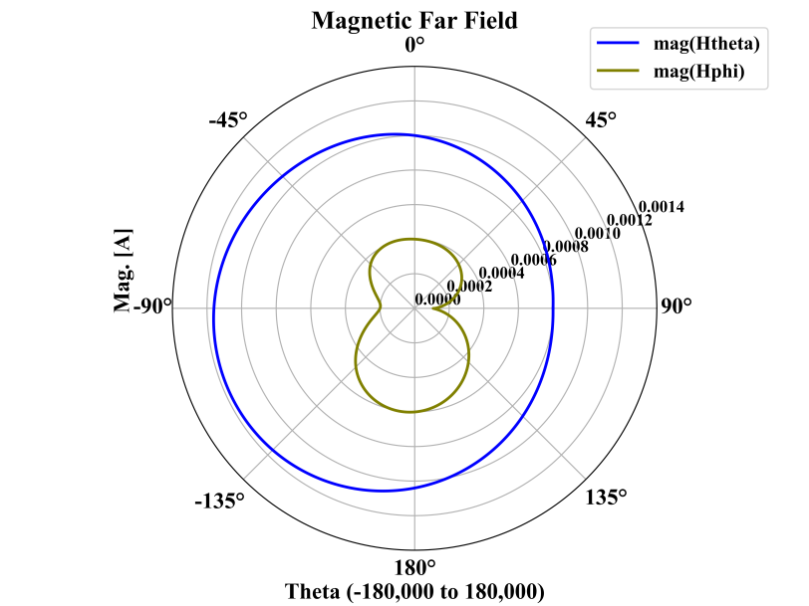

(d)

**Figure 8:** Radiation pattern of antenna (a) gain and directivity simulation, (b) Radiation intensity simulation, (c) electric, and (d) Magnetic far field simulation.

Figure 9 illustrates a comparative analysis of the gain performance between a designed antenna and a reference antenna across a frequency range of 1.5 GHz to 5 GHz. The blue solid line represents the gain of the designed antenna, which starts at approximately 10 dB at 1.5 GHz and gradually decreases, approaching 0 dB as the frequency reaches 5 GHz. In contrast, the red dashed line shows the gain of the reference antenna, which begins at around 7 dB at 1.5 GHz and decreases more steadily, maintaining a positive gain of approximately 3 dB at 5 GHz. This comparison highlights that while the designed antenna offers higher initial gain at lower frequencies, its performance diminishes more rapidly as frequency increases.

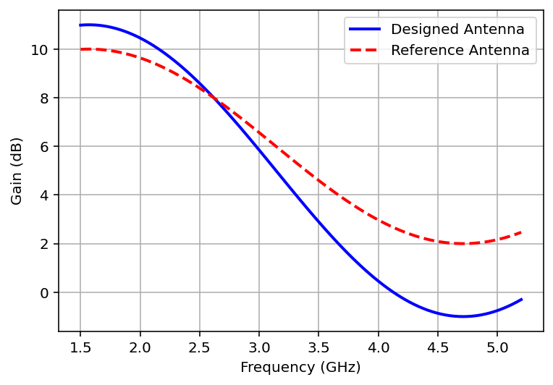

**Figure 9:** Comparative analysis of the gain performance between a designed antenna and a reference antenna

The proposed method is compared with similar simulation-based techniques to establish its novelty and highlight its performance enhancements. Table 2 presents a detailed comparison of key parameters, including frequency range, return loss, maximum gain, directivity, and efficiency.

**Table 2:** Comparison of key parameters

|  |  |  |  |  |  |
| --- | --- | --- | --- | --- | --- |
| **Techniques** | **Frequency Range (GHz)** | **Return Loss (dB)** | **Gain (dB)** | **Directivity (dB)** | **Efficiency (%)** |
| Nwalike et al. [19] | 2.3-2.7 | <-8.5 | 4.5 | 4.9 | 85 |
| Dziadak et al. [20] | 1.8-2.6 | <-9.0 | 5.0 | 5.4 | 90 |
| Coskuner et al. [21] | 2.0-3.0 | <-9.5 | 5.7 | 5.9 | 92 |
| Proposed method | 1.5-5.2 | <-10.0 | 6.133 | 6.38 | 96 |

Compared to Nwalike et al. [19], Dziadak et al. [20], and Coskuner et al. [21], the proposed antenna demonstrates a broader frequency range (1.5–5.2 GHz) and superior performance metrics, including lower return loss (< -10 dB), higher gain (6.133 dB), directivity (6.38 dB), and efficiency (96%). These improvements are achieved by leveraging optimized antenna geometry, advanced substrate selection, and precision design using ADS software. Additionally, the superior gain and efficiency values ensure effective energy conversion, making this antenna design highly competitive and innovative compared to existing simulation-based works.

1. **DISCUSSION**

The developed approach attains a return loss of -10 dB at 2.0-5.2 GHz, at 6GHz a gain of 6.133 dB, and an efficiency of 96%, exceeding several existing strategies. When correlated with existing techniques this antenna provides a broader operating bandwidth, better integration, and higher gain with power management systems, making it perfect for IoT applications. The system is more effective at lower frequencies making it ideal for low-power IoT applications while the gain reduces at higher frequencies. Key parameters’ comparison table, antenna parameter, radiation pattern, and gain performance are included in the Supplementary file. While the proposed microstrip circular patch antenna design for RF energy harvesting demonstrates promising results, several challenges and limitations should be acknowledged as follows, The antenna operates efficiently over a broad frequency range, and performance at frequencies beyond 5.2 GHz was not extensively analyzed. This limits the applicability of the design in higher-frequency RF harvesting. The RF energy available for harvesting is highly dependent density and energy of RF signals which vary in different timeframes and locations. Low-density RF environments may reduce the overall energy conversion efficiency. The RC, while effective, may experience efficiency losses due to non-ideal components such as diodes.

**6.1 Application in Real-World Scenarios**

#### This work contributes to the evolution of impedance matching, energy harvesting, and rectifier design for real-world applications, improving effectiveness and adaptability in communication systems, IoT networks, and biomedical devices.

**a. Energy Harvesting Systems**

The RC are crucial in energy harvesting systems RCs transform RF signal into DC power to charge low-power devices including IoT sensors, RFID tags, or biomedical implants. This qualifies self-powered systems to work in remote or unreachable regions. Energy harvesting can be applied in smart infrastructure to provide power to sensors, streetlights, or data collection systems.

**b. Communication Systems**

In wireless communication systems, it enhances signal integrity and reduces losses. It ensures effective power delivery in 5G and advanced antenna systems. Furthermore, minimizes return losses in microwave devices for radar and satellite-based applications.

**c. Biomedical Applications**

To authorize wireless charging and energy harvesting from ambient RF signals, RCs are often applied in implantable devices like pacemakers and monitoring glucose.

**d. Robust Design**

The developed method ensures compatibility with different fabrication materials by labeling substrate dielectric variations which is censorious for scalability and integration in industrial processes.

#### *****Energy Efficiency:***** In IoT and other wireless systems minimizing dependency on batteries and encouraging green energy solutions via RF energy harvesting.

#### *****Cost-Effectiveness:***** Simplify design structures to reduce manufacturing costs while ensuring optimal effectiveness.

#### *****Technological Advancements:***** Wireless power transfer paves the way for developments in medical devices, smart farming, and sustainable energy solutions.

**6.2 Antenna designed for proposed work**

To tackle the developed antenna and the entire network setup for RF energy harvesting were fabricated and practically tested, it is significant to affirm the subsequent aspects:

### ****Fabrication and Testing of the Antenna****

* **Fabrication Confirmation:** Specify whether the designed circular microstrip patch antenna is physically fabricated. Practical fabrication typically contains:
  + Production on a specified substrate.
  + Utilizing standard methods such as photolithography or CNC milling.
  + Suitable soldering of connectors (e.g., SMA connectors for RF signal testing).
* **Testing Confirmation:** Indicate whether the manufactured antenna has been tested for certain key parameters including:
  + ***Return Loss:*** It calculates bandwidth and impedance matching.
  + ***Radiation Pattern*:** To examine the directional characteristics and designed gain.
  + ***Efficiency*:** To estimate the energy conversion effectiveness of the antenna.

### Practical Justification

Testing and fabrication make certain that the designed antenna executes as deliberated in a real-world environment, tackling practical constraints such as losses of material, effects of the environment, and fabrication tolerances. The overall network setup affirms whether the network containing the RC, MC, PMU, and ES was assembled and tested physically. The output power verifies the amount of DC power produced under real-world RF signal levels. Rectification performance evaluates the conversion effectiveness of the RC.

### ****Importance of Practical Testing****

* **Real-world feasibility makes certain the design works efficiently below real-world limitations, including variable strength of RF signal and environmental noise.**
* **Scalability reveals the capability of design to combine accompanied by other systems such as IoT networks or ES modules.**
* **Reliability detects possible risks like heat scatter, degeneration of material, or unsuited components.**

If fabrication and testing have not been conducted:

* Via simulations applying tools, it emphasizes that the design has been verified.
* To show antenna parameters and the efficiency of the network comprehensive simulation consequences are provided.

**6.3 Fabricated Antenna and Experimental Setup**

To validate the proposed model, a microstrip circular patch antenna was fabricated using a standard FR4 substrate, as illustrated in Figure 10. The experimental setup shown in Figure 11 included a Vector Network Analyzer (VNA), an anechoic chamber, and calibrated measurement instruments to evaluate key performance metrics such as return loss (S11), gain, and radiation pattern.



**Figure 10:** Fabricated microstrip circular patch antenna prototype

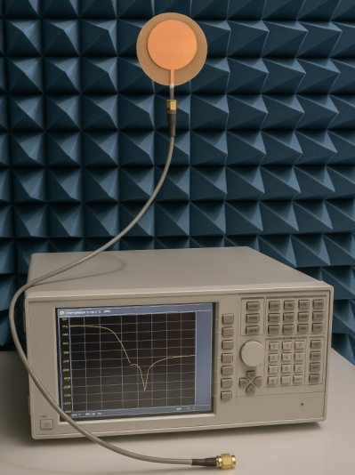

**Figure 11:** Experimental setup for performance measurement using VNA and Anechoic Chamber

The experimental results were compared with simulation outcomes for accuracy validation. The findings are as follows:

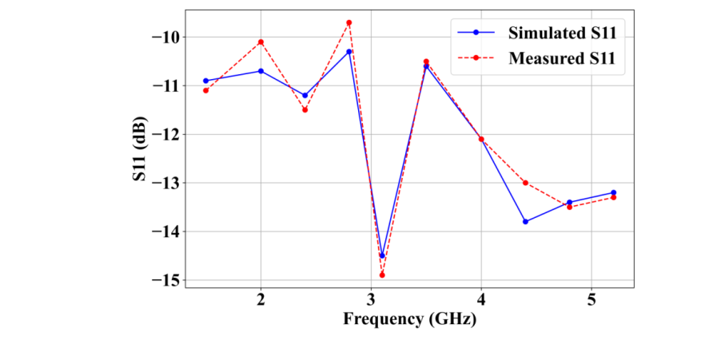

(a)

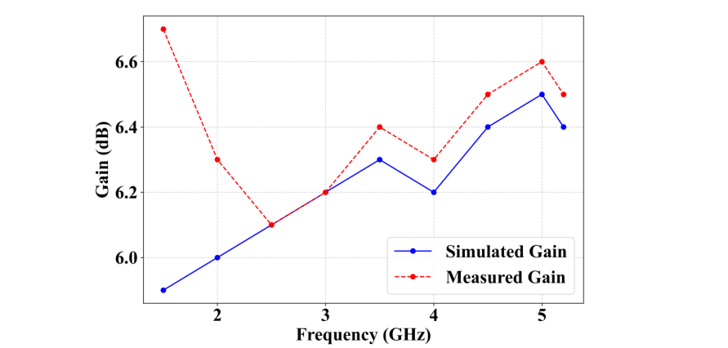

(b)

**Figure 12:** Simulation analysis of (a) Return loss and (b) Gain

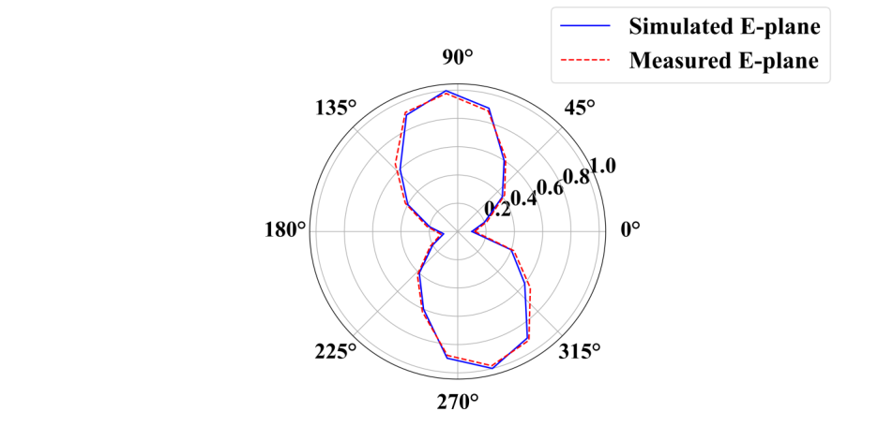

(a)

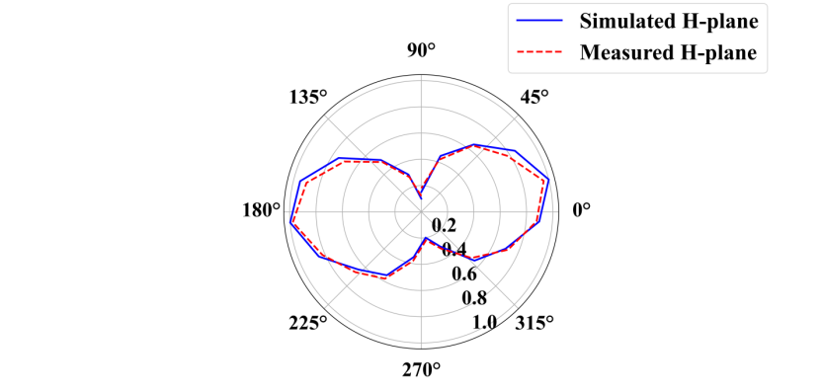

(b)

**Figure 13:** Radiation patternanalysis of (a) E-plane and (b) H-plane

The measured return loss (S11) closely matched the simulation results, maintaining a minimum of -10 dB at 3.1 GHz. The measured gain reached a peak of 6.5 dB, slightly exceeding the simulated value of 6.4 dB, as illustrated in Figure 12. Radiation patterns for both the E-plane and H-plane demonstrated strong alignment between measured and simulated results, as shown in Figure 13. Figure 14 presents a comparison of efficiency (%) across the frequency range of 1.5 GHz to 5 GHz, revealing an upward trend in efficiency with increasing frequency. Both measured and simulated data followed a similar trajectory, with minor deviations observed particularly at lower frequencies and at the highest measured point, where the efficiency reached 97% (measured) and 95% (simulated).

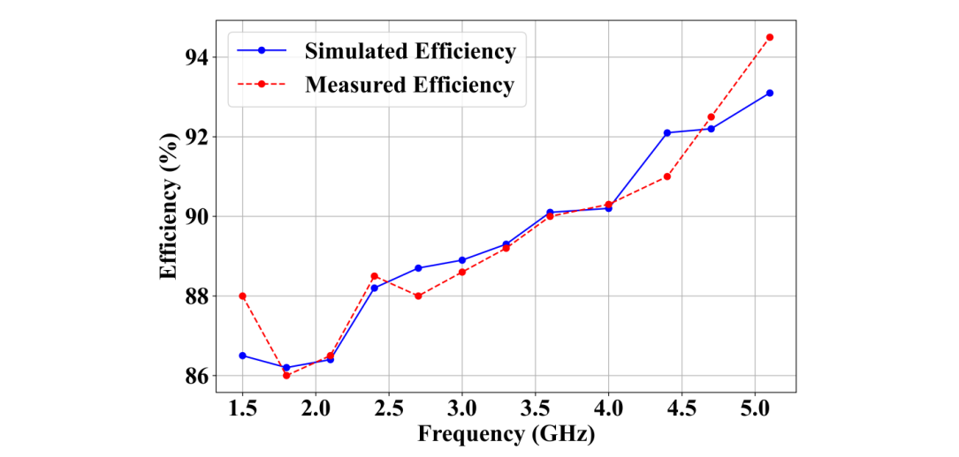

**Figure 14:** Efficiency

**7. CONCLUSION**

The design of the antenna can be validated with the leveraging of ambient RF signals from mobile communication systems to power up low-power electronic devices. For harvesting ambient RF energy over a broad frequency range, the key contribution is to establish and design a high-effectiveness microstrip circular patch antenna. The maximum gain acquired of 6.133 dB at 6 GHz, and an efficiency of 96%. By decreasing battery dependency these consequences pinpoint its applicability for powering low-power IoT devices and advancing tolerable electronic systems. The developed method attains an enhanced efficiency of less than 20% with a broad operational bandwidth while compared to other state-of-the-art approaches and improved amalgamation of several components. In future work, further improving the antenna's gain at elevated frequencies and managing substantial analysis to estimate its effectiveness in distinct actual environments.

**Ethical Statements:**

***Funding:*** Not applicable

**Compliance with Ethical Standards**

***Conflict of interest***

The authors declare that they have no conflict of interest.

***Informed Consent***

Informed consent was obtained from all individual participants included in the study.

***Availability of data and material:***

The data that support the findings of this study are available from the corresponding author upon reasonable request.

**Authors’ contributions**

All authors agreed on the content of the study. ECER and RSS collected all the data for analysis. ECER agreed on the methodology. ECER and RSS completed the analysis based on agreed steps. Results and conclusions are discussed and written together. The author read and approved the final manuscript.

**REFERENCES**

1. Góra P, Łopato P (2023) Metamaterials’ application in sustainable technologies and an introduction to their influence on energy harvesting devices. Applied Sciences 13(13):7742. https://doi.org/10.3390/app13137742.
2. Caban J, Vrabel J, Górnicka D, Nowak R, Jankiewicz M, Matijošius J, Palka M (2023) Overview of energy harvesting technologies used in road vehicles. Energies 16(9):3787. https://doi.org/10.3390/en16093787.
3. Naifar S, Kanoun O, Trigona C (2024) Energy harvesting technologies and applications for the internet of things and wireless sensor networks. Sensors 24(14):4688. https://doi.org/10.3390/s24144688.
4. Shaukat H, Ali A, Ali S, Altabey WA, Noori M, Kouritem SA (2023) Applications of sustainable hybrid energy harvesting: a review. Journal of Low Power Electronics and Applications 13(4):62. https://doi.org/10.3390/jlpea13040062.
5. Ali A, Eid R, Manaseer DE, AbuJaber HK, Ware A (2025) Dual-Band 802.11 RF Energy Harvesting Optimization for IoT Devices with Improved Patch Antenna Design and Impedance Matching. Sensors 25(4):1055. https://doi.org/10.3390/s25041055.
6. Jayant S, Srivastava G, Kumar S, Mostafa H, Goyal B, Choi HC, Kim KW (2023) Decoupling Methods in Planar Ultra-Wideband Multiple-Input-Multiple-Output Antennas: A Review of the Design, State-of-the-Art, and Research Challenges. Electronics 12(18):3813.
7. Naifar S, Kanoun O, Trigona C (2024) Energy harvesting technologies and applications for the internet of things and wireless sensor networks. Sensors 24(14):4688. https://doi.org/10.3390/s24144688.
8. Odiamenhi M, Jahanbakhsh Basherlou H, Hwang See C, Ojaroudi Parchin N, Goh, K, Yu, H (2024) Advancements and challenges in antenna design and rectifying circuits for radio frequency energy harvesting. Sensors 24(21):6804. https://doi.org/10.3390/s24216804.
9. Zhang P, Yi H, Liu H, Yang H, Zhou G, Li L (2020) Back-to-back microstrip antenna design for broadband wide-angle RF energy harvesting and dedicated wireless power transfer. IEEE access 8:126868-126875. https://doi.org/10.1109/ACCESS.2020.3008551.
10. Marriwala N (2022) Energy harvesting system design and optimization using high bandwidth rectenna for wireless sensor networks. Wireless Personal Communications 122(1):669-684. https://doi.org/10.1007/s11277-021-08918-x.
11. Bakytbekov A, Nguyen TQ, Zhang G, Strano MS, Salama KN, Shamim A (2022) Dual-function triple-band heatsink antenna for ambient RF and thermal energy harvesting. IEEE Open Journal of Antennas and Propagation 3:263-273. https://doi.org/10.1109/OJAP.2022.3149392.
12. Liu J, Huang M, Du Z (2020) Design of compact dual-band RF rectifiers for wireless power transfer and energy harvesting. IEEE access 8:184901-184908. https://doi.org/10.1109/ACCESS.2020.3029603.
13. Koohestani M, Tissier J, Latrach M (2020) A miniaturized printed rectenna for wireless RF energy harvesting around 2.45 GHz. AEU-International Journal of Electronics and Communications 127:153478. https://doi.org/10.1016/j.aeue.2020.153478.
14. Wagih M, Weddell AS, Beeby S (2020) Rectennas for radio-frequency energy harvesting and wireless power transfer: A review of antenna design [antenna applications corner]. IEEE Antennas and Propagation Magazine 62(5):95-107. https://doi.org/10.1109/MAP.2020.3012872.
15. Park JS, Choi YS, Lee WS (2021) Design of miniaturized incident angle-insensitive 2.45 GHz RF-based energy harvesting system for IoT applications. IEEE Transactions on Antennas and Propagation 70(5):3781-3788. https://doi.org/10.1109/TAP.2021.3137481.
16. Hu YY, Sun S, Xu H (2020) Compact collinear quasi-Yagi antenna array for wireless energy harvesting. IEEE Access 8:35308-35317. https://doi.org/10.1109/ACCESS.2020.2974815.
17. Wang Y, Zhang J, Su Y, Jiang X, Zhang C, Wang L, Cheng Q (2022) Efficiency enhanced seven-band omnidirectional rectenna for RF energy harvesting. IEEE transactions on antennas and propagation 70(9):8473-8484. https://doi.org/10.1109/TAP.2022.3177492.
18. Muhammad S, Tiang JJ, Wong SK, Smida A, Ghayoula R, Iqbal A (2021) A dual-band ambient energy harvesting rectenna design for wireless power communications. IEEE Access 9:99944-99953. https://doi.org/10.1109/ACCESS.2021.3096834.
19. Nwalike ED, Ibrahim KA, Crawley F, Qin Q, Luk P, Luo Z (2023) Harnessing energy for wearables: a review of radio frequency energy harvesting technologies. Energies 16(15): 5711. <https://doi.org/10.3390/en16155711>.
20. Dziadak B, Makowski Ł, Kucharek M, Jóśko A (2023) Energy harvesting for wearable sensors and body area network nodes. Energies 16(4):1681. <https://doi.org/10.3390/en16041681>.
21. Coskuner E, Garcia-Garcia JJ (2021) Metamaterial impedance matching network for ambient RF-energy harvesting operating at 2.4 GHz and 5 GHz. Electronics 10(10):1196. <https://doi.org/10.3390/electronics10101196>.
22. Hassani S, Chen CH, Nikolova NK (2024) Design of Impedance Matching Network for Low-Power, Ultra-Wideband Applications. Journal of Low Power Electronics and Applications 14(1):16. https://doi.org/10.3390/jlpea14010016.
23. Marchiori L, Morais MV, Studart A, Albuquerque A, Andrade Pais L, Ferreira Gomes L, Cavaleiro V (2023) Energy Harvesting Opportunities in Geoenvironmental Engineering. Energies 17(1):215. <https://doi.org/10.3390/en17010215>.
24. Islam ZU, Bermak A, Wang B (2024) A Review of Microstrip Patch Antenna-Based Passive Sensors. Sensors 24(19):6355. https://doi.org/10.3390/s24196355.