LTS PostgreSQL Data Model
Legislature.TrackingSystem (LTS) - Data Model Documentation
This document describes the current PostgreSQL persistence model for the LTS application. It is generated from the EF Core migration chain and the single-file idempotent DDL (docs/database/lts-postgresql-ddl.sql). The diagrams below summarize the physical foreign keys, the core work product model, the legislative/fiscal/executive model, and the package/template/reporting/user/migration model.

1. Physical Foreign Keys
This diagram shows relationships currently enforced by PostgreSQL foreign-key constraints.

2. Core Work Product Model
This diagram shows the work task aggregate and the primary app-level references around it. Relationships marked as references are logical ID links in the current schema, not physical PostgreSQL foreign keys.
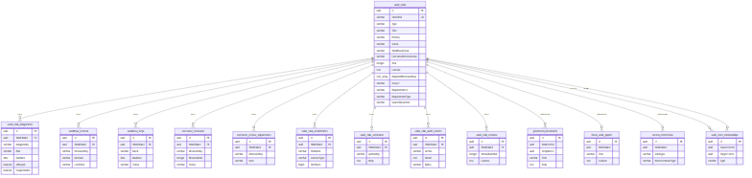

3. Legislative, Fiscal, and Executive Model
This diagram groups bill tracking, fiscal analysis, implementation, correspondence, and executive discussion tables. Several links are logical references only in the current DDL.
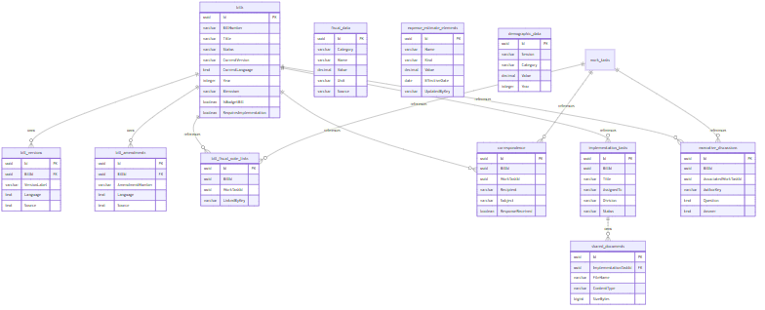

4. Package, Template, Reporting, User, and Migration Model
This diagram covers package organization, generated document support, users, reports, notifications, productivity records, and migration batches.
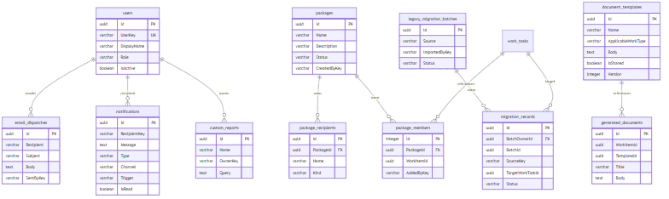

5. Physical Index Summary
The generated DDL includes 36 indexes (33 non-unique and 3 unique). Notable unique indexes:
- IX_users_UserKey
- IX_work_tasks_Identifier
- IX_demographic_data_Session_Category
Frequently queried fields with non-unique indexes include:
- bills.BillNumber
- work_tasks.Type
- work_tasks.Status
- work_tasks.Year
- notifications.RecipientKey
- custom_reports.OwnerKey
- email_dispatches.SentAt
- fiscal_data.Category, Name
- expense_estimate_elements.Name, Kind
- child-table owner IDs such as WorkTaskId, BillId, PackageId, and ImplementationTaskId

6. Modeling Notes
- Owned collections are physically represented as separate tables with cascade deletes from their aggregate root.
- work_tasks embeds source trace columns directly: StoryId, RequirementId, RequirementType, and SourceDocument.
- work_tasks.RequiredReviewerKeys is a PostgreSQL text[] column.
- document_templates.Version tracks the current template version (incremented on each body update).
- notifications.Channel and notifications.Trigger model the delivery channel and the cause of each notification.
- Several application-level references are indexed but not enforced as PostgreSQL foreign keys in the current EF model, including generated_documents.WorkItemId, generated_documents.TemplateId, correspondence.BillId, correspondence.WorkTaskId, implementation_tasks.BillId, bill_fiscal_note_links.BillId, bill_fiscal_note_links.WorkTaskId, package_members.WorkItemId, work_item_relationships.SourceItemId, and work_item_relationships.TargetItemId.

Generated 2026-09-06 from docs/database/lts-data-model-diagrams.md

