DOR Legislative Tracking System
High-Level Architecture Design
Custom Developed Solution in the DOR AWS Solution Space
Architecture Basis | Exhibit A Business Requirements and Exhibit B Technical Requirements backlog
Hosting Posture | DOR-operated AWS solution space
Scope Rule | Must Have business requirements and Mandatory / Mandatory Scored technical requirements
Excluded as Architecture Drivers | Business Nice-to-Have items and technical Scored-only preferences
Document Type | High-level architecture design for proposal / planning use

Architecture discipline
This design does not adopt optional or scored-only technology preferences as requirements. It also incorporates explicit project architecture directions provided for the DOR AWS hosting posture, the Microsoft engineering toolchain, and preservation of existing external interface contracts. Where the mandatory requirements or explicit project directions do not specify a product, language, framework, database engine, compute service, or infrastructure-as-code tool, the document identifies the needed architectural capability and leaves the product decision for detailed design within DOR standards.

Executive Summary
The proposed solution is a custom developed, modular web application deployed into the DOR AWS solution space and operated by DOR. The architecture is designed around the mandatory business capabilities for legislative tracking, fiscal work products, collaboration, review and approval, document handling, integration, search, reporting, historical retention, and executive access. It also incorporates the mandatory and mandatory-scored technical controls for security, identity, accessibility, backup and recovery, performance, observability, API integration, source control, CI/CD, testing, documentation, ownership, and knowledge transfer.
The architecture uses a layered and API-centric style with a responsive web user interface, a stateless application compute tier, modular business components, a structured transactional data store, SharePoint as the required document repository, and integration adapters for legislative sources, DOR fiscal systems, Microsoft 365, and approved external recipients. Existing external interface contracts will be preserved at implementation to avoid requiring changes to external systems solely because LTS is modernized. A future versioned API integration pattern can be defined for controlled transition over time. The compute service, programming language, application framework, database engine, and infrastructure-as-code product are intentionally not named because the supplied mandatory requirements do not prescribe them.
Because the production hosting posture is DOR-operated AWS, vendor personnel are not given access to DOR infrastructure. Development uses an approved Microsoft engineering and delivery environment with synthetic or de-identified data. Azure DevOps is assumed for Agile work management, Git source control, CI/CD, and test management, while GitHub Copilot may provide approved AI-assisted coding and test assistance. These engineering tools are not runtime dependencies of LTS. Source code, pipeline definitions, release artifacts, documentation, and knowledge are transferred to DOR using DOR-approved methods, and DOR personnel perform deployment and validation activities in DOR AWS.

Architecture Scope Basis
Basis | Treatment
Business scope included | All Exhibit A Must Have requirements, including common requirements, RFA, L&P Must Have, Executive Must Have, Budget Office, and B&FS Financial requirements.
Business scope excluded as drivers | The L&P and Executive Nice-to-Have requirements are not used to justify architecture components.
Technical scope included | Technical backlog requirements marked M, MS, M occurrence, or MS occurrence.
Technical scope excluded as drivers | Technical requirements marked S are not used to select technologies or add architecture features.
Hosting input | DOR AWS solution space, using the DOR-operated posture required by the current architecture direction.
Engineering toolchain direction | Microsoft engineering tools may be used for Agile management, source control, CI/CD, test management, developer tooling, and approved AI assistance. These are SDLC tools, not LTS runtime components.
External interface compatibility direction | Existing external feeds, files, structures, and interface contracts are preserved for initial implementation. Exact current interfaces must be confirmed from the current-state inventory. A future versioned API pattern may be introduced only through an approved transition.

Architecture Decision Summary
Decision | High-Level Direction | Requirement Rationale
Architecture style | Modular layered custom web application with documented versioned APIs | Supports broad business scope without introducing a microservices requirement that is not present in the mandatory inputs.
Production hosting | DOR-operated AWS | Directly follows the user-provided hosting direction and the DOR-operated controls in TR-206, TR-208, TR-1404, and TR-1406.
Application compute | Stateless, horizontally scalable AWS compute tier; exact AWS compute service TBD | Supports high availability and autoscaling requirements without assuming VM, Kubernetes, containers, or serverless where none is mandated.
Structured data | Managed relational system of record; database engine TBD | Supports linked work products, workflow state, version history, fiscal data, querying, and reporting.
Documents | DOR Microsoft 365 SharePoint | Explicitly required for tracked-legislation document storage and retrieval.
Identity | DOR Entra ID using OIDC preferred or SAML | Mandatory technical identity requirement; no application-specific staff credential store.
API security | OAuth 2.0 | Mandatory for API authentication.
Availability | Single-region high availability across multiple Availability Zones | Meets no-single-point-of-failure and 99.9% availability requirements without adding unrequired multi-region complexity.
Engineering toolchain | Microsoft Azure DevOps and approved Microsoft developer tooling | Supports Agile planning, Git source control, CI/CD, test management, and developer productivity without changing the AWS runtime architecture.
AI-assisted engineering | Approved GitHub Copilot use for coding and test assistance; no AI runtime dependency | No business requirement requires AI in LTS. AI-assisted engineering remains outside the production application and is subject to disclosure, data-boundary, review, testing, and DATA-04 obligations.
External interface compatibility | Preserve current external feed contracts at implementation | Avoids forcing external system changes. Current files, structures, protocols, and schedules remain in place where confirmed by the current-state inventory; future versioned APIs can be adopted through controlled transition.

1. Overall Architecture Style
The proposed architecture is a modular, layered, API-centric custom web application. It is not defined as a microservices architecture because microservices are not required by the mandatory business or technical requirements. The application is partitioned into cohesive business components behind a versioned application API so that functionality can evolve while retaining a manageable operational model for DOR.
- Presentation layer: responsive web user interface for DOR staff and executives, including rich-text authoring, work queues, review views, reporting, and a consolidated Executive bill view.
- Application/API layer: documented and versioned application interfaces using RESTful APIs or equivalent and OAuth 2.0 for API authentication.
- Business component layer: work management, workflow and review, legislative data and versioning, fiscal analysis, documents and templates, reporting/search, and administration/security.
- Integration layer: compatibility adapters preserve confirmed current external feed contracts, including existing files, structures, protocols, and schedules, while isolating the internal application model from source-specific details. A future versioned API integration pattern can be introduced without requiring immediate changes to external systems.
- Data layer: structured relational system of record for business data and metadata, with DOR SharePoint as the tracked-legislation document repository.
- Cross-cutting controls: Entra-based authentication, least-privilege RBAC, centralized logging/auditing, monitoring/alerts, encryption, accessibility, backup/recovery, and CI/CD.
- Engineering and delivery plane: Azure Boards, Azure Repos Git, Azure Pipelines, Azure Test Plans, Visual Studio or Visual Studio Code, and approved GitHub Copilot AI assistance support delivery but are logically separate from the AWS runtime architecture.

Requirement Fit
This style directly supports the business requirements for collaboration, linked records, task assignment, multiple reviewers, work-in-progress, templates, fiscal analysis, document history, reporting, legislative-source integration, migration, and secure role-based access. It also supports the technical requirements for versioned APIs, Entra ID, OAuth 2.0, CI/CD, centralized logs, high availability, horizontal scaling, and operational transfer to DOR.
Not introduced
No architecture dependency on microservices, Kubernetes, serverless computing, a native mobile application, multi-region deployment, an AI runtime service, or a proprietary commercial application platform is introduced because those items are not required by the supplied mandatory requirements. Approved AI-assisted engineering tools may be used during planning, development, testing, and documentation, but successful operation of LTS does not depend on an AI service.

2. Deployment Approach
Production and DOR-controlled non-production environments are deployed in the DOR AWS solution space. The deployment model follows the DOR-operated posture. DOR owns and controls the AWS environments, while the delivery team develops and tests in an approved Microsoft engineering environment using synthetic or de-identified data. DOR personnel execute deployment and validation in DOR AWS with vendor guidance and documentation, but without vendor access to DOR infrastructure.
- Development: approved Microsoft engineering environment using Azure Boards for Agile work management, Azure Repos Git for source control, Azure Pipelines for CI/CD, Azure Test Plans for formal test management, and Visual Studio or Visual Studio Code for development, with synthetic or de-identified data only.
- AI assistance: GitHub Copilot may be used for approved coding, refactoring, documentation, and test assistance. AI output is treated as proposed engineering work and remains subject to human review, source control, automated testing, security checks, and acceptance criteria.
- Source and artifact handoff: secure DOR-approved transfer of source, commit history when required, branches, tags, pipeline definitions, release artifacts, and documentation.
- DOR non-production/UAT: logically separated from production; DOR deploys and performs UAT with synthetic or de-identified data.
- Production: DOR AWS, high availability within one region, with no single point of failure in the production application path.
- Release control: all builds and deployments occur through CI/CD except documented emergency procedures; production releases include release notes.
- Knowledge transfer: continuous throughout delivery, with architecture, code, deployment, runbook, and troubleshooting walkthroughs before go-live.

3. Architecture Diagrams

3.1 System Context Diagram
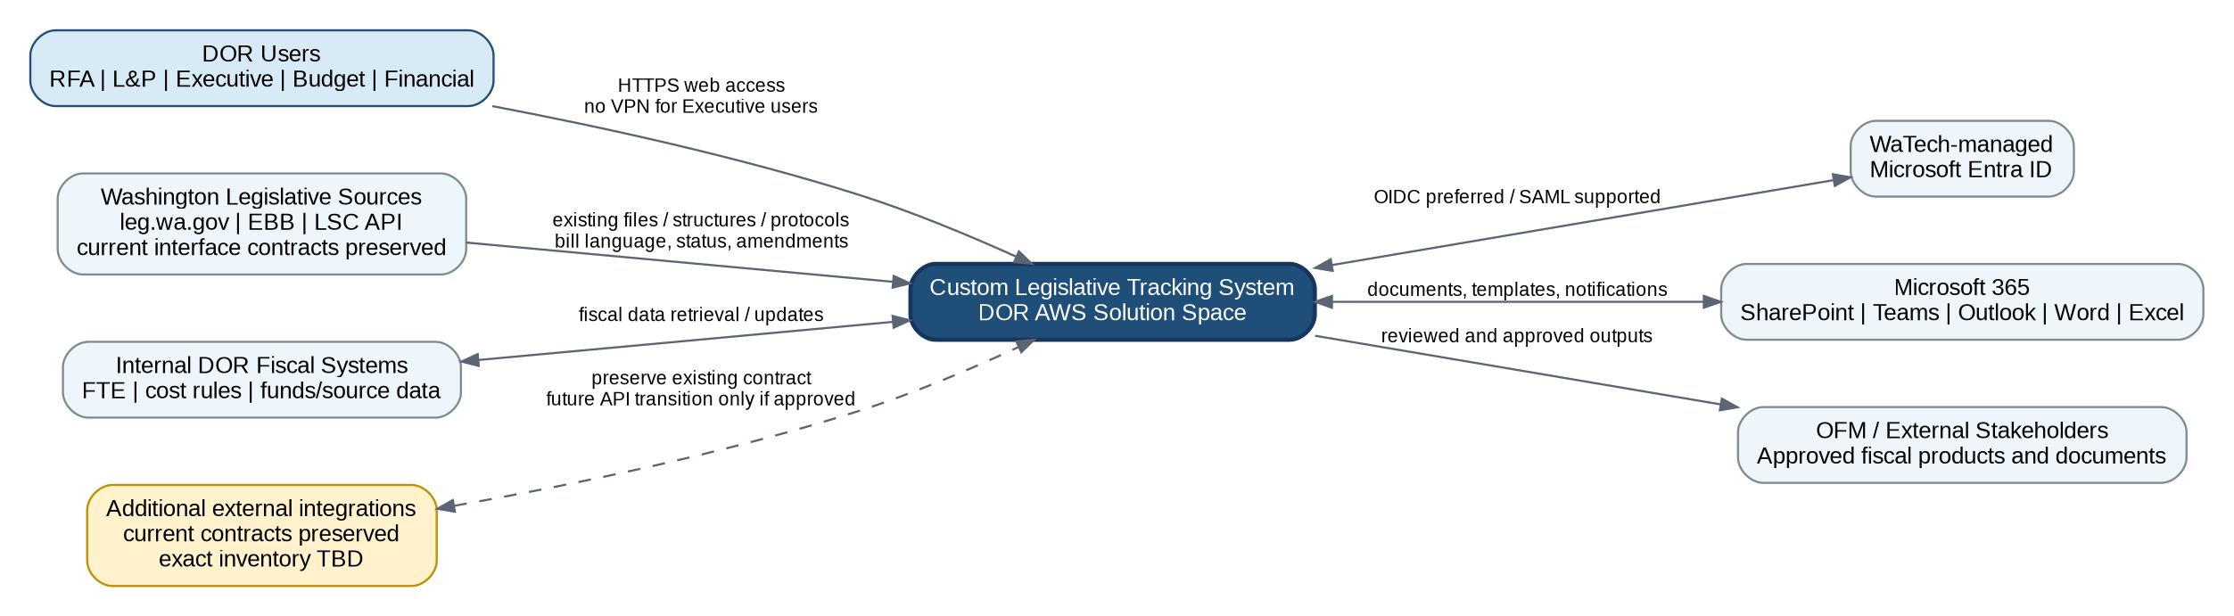
Figure 1. System context and principal external data flows
The system context shows only named or explicitly implied business and technical interfaces. Existing external interface contracts are preserved at implementation to avoid external system changes. The exact current files, layouts, structures, protocols, schedules, and endpoints are not provided in the supplied requirements and therefore must be confirmed from the current-state System Integration Inventory. No additional external systems or interface details are invented in this architecture.

3.2 Component Diagram
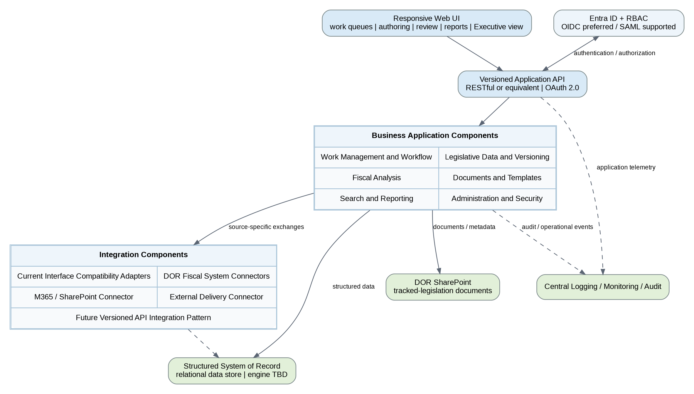
Figure 2. Logical application components and cross-cutting services
The component structure is logical rather than a commitment to separate physical deployments. Components may be packaged together or separately during detailed design as long as the resulting design meets the availability, performance, security, supportability, and ownership requirements.

3.3 Deployment Diagram
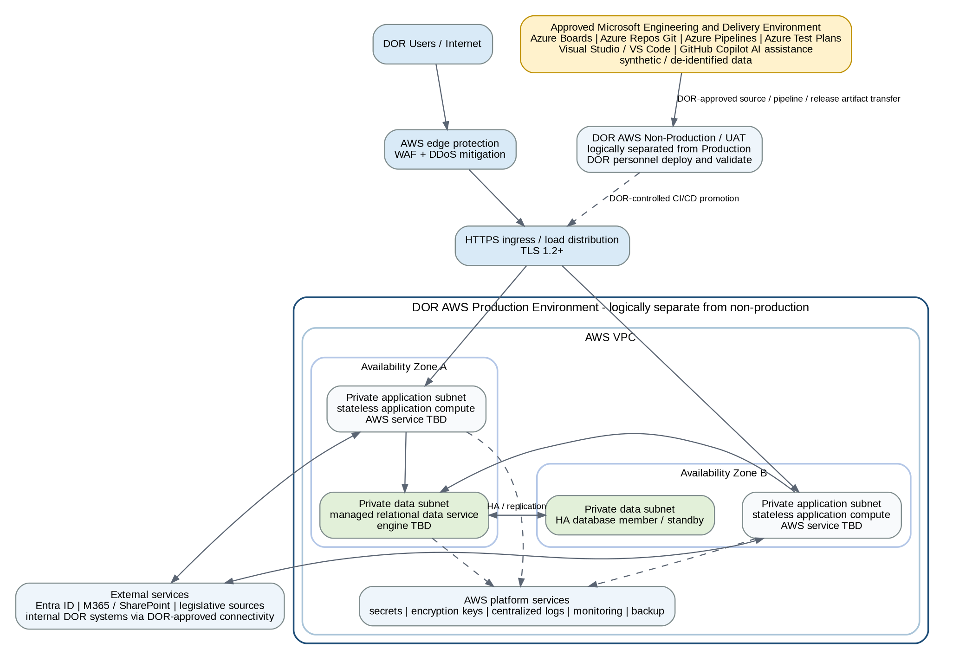
Figure 3. DOR-operated AWS deployment model
The production design uses at least two Availability Zones within one AWS region to remove single points of failure. Exact AWS compute and database products are left open because mandatory requirements define outcomes, not those product choices. Public application access is protected by WAF and DDoS controls, while application and data resources reside in private network segments. The Microsoft engineering and delivery environment is outside the DOR AWS runtime boundary and transfers controlled source, pipeline, test, and release artifacts through DOR-approved methods.

4. Security and Compliance Architecture

4.1 Authentication and Authorization
- DOR staff authenticate using the WaTech-managed Microsoft Entra ID tenant.
- OpenID Connect is the preferred sign-in mechanism; SAML is supported as allowed by the requirement.
- The solution does not create or maintain a separate staff credential store.
- Application authorization uses least-privilege RBAC across all application roles, including preparation, approval, delivery, read-only, Executive Review, and restricted portions of work products.
- Role and permission provisioning is automated and consistent across environments.
- API authentication uses OAuth 2.0.
MFA is not separately specified as a mandatory application requirement in the supplied technical backlog. The application delegates staff authentication to DOR Entra ID so that DOR enterprise identity policies can apply without creating a second application-specific authentication mechanism.

4.2 Encryption and Secrets
- All data in transit uses TLS 1.2 or higher.
- Data at rest uses AES-256 or another NIST-validated cryptographic module.
- Credentials, keys, and secrets are not hardcoded and are not committed to source control.
- The exact AWS key and secrets services are a detailed design selection within DOR standards.

4.3 Web and Network Protection
- All applicable solution components are protected by a web application firewall.
- DDoS mitigation protects internet-facing application endpoints.
- Application and data tiers are placed in private subnets; public exposure is limited to the protected HTTPS ingress path.
- Firewall/security-group rules are least privilege and are finalized during detailed design based on approved data flows and integration endpoints.

4.4 Logging and Auditing
- Application and infrastructure logs are centralized and directly accessible to DOR in the DOR-operated model.
- Authentication events and authorization failures are captured in audit logs.
- Changes to Category 3 or higher data are logged as required, subject to confirmation of the data-classification cross-reference in the technical source.
- Audit records support troubleshooting, security review, and accountability for workflow and data changes.

4.5 Compliance Frameworks
Framework / Standard | Status | Architecture Treatment
WaTech cybersecurity policy | Required | Architecture and hosting must comply with the referenced Washington cybersecurity requirements.
WCAG 2.2 Level AA | Required | Web UI and user-facing functions must conform; current ACR/VPAT is required before go-live.
ISO/IEC 27001, FedRAMP Moderate, or CSA STAR Level 2 | At least one required for hosting | TR-310 requires the hosting environment to maintain at least one of these recognized certifications.
SOC 2 | Not established as mandatory by supplied M/MS requirements | No additional SOC 2 architecture control is assumed.
PCI | Not identified | No payment-card architecture is introduced.
HIPAA | Not identified | No HIPAA architecture is introduced.
IRS Safeguards | Conditional in the technical source | Relevant only if the conditions in TR-402 are triggered; the selected DOR-operated posture does not assume vendor access to live DOR data.

4.6 AI-Assisted Engineering Governance
Approved AI-assisted engineering may be used within the Microsoft delivery toolchain, but AI is not a required runtime capability of the Legislative Tracking System. GitHub Copilot may assist with coding, code explanation, refactoring, documentation, and test creation when approved by DOR.
- Human accountability: AI-generated code, tests, documentation, or recommendations are treated as proposed engineering work and must pass the same peer review, automated testing, security checks, traceability, and approval controls as manually produced work.
- Data boundaries: synthetic or de-identified data is used for development and test activities outside DOR AWS. Project teams must not provide production DOR data to AI services unless DOR explicitly approves that use.
- Disclosure and governance: AI tooling and any interaction with DOR information are documented as required by the technical requirements, including applicable DATA-04 obligations.
- Production separation: AI tooling has no inherent direct access to production DOR AWS resources or production data. Any access would require separate DOR authorization and architecture review.

5. Hosting and Infrastructure Requirements

5.1 Cloud Provider
Cloud provider: AWS, using the DOR AWS solution space as directed. DOR owns and operates the production environment.

5.2 On-Premise Environment Requirements
No on-premise application hosting requirement is identified in the supplied mandatory requirements. The solution does require secure connectivity to internal DOR fiscal systems. The network path, private connectivity method, and routing between DOR AWS and those internal systems must be defined by DOR networking and the System Integration Inventory during detailed design.

5.3 Compute Model
The compute tier is designed as stateless and horizontally scalable. The mandatory requirements do not prescribe VMs, containers, Kubernetes, or serverless computing. Therefore, the exact AWS compute service is intentionally left as a detailed design decision. The selected service must support automated deployment, autoscaling, high availability across Availability Zones, centralized logging, and DOR operational control.

5.4 Networking
- DOR AWS VPC with protected internet ingress for users who must access the solution without VPN.
- At least two Availability Zones for production application and data resources.
- Private application subnets and private data subnets.
- WAF and DDoS protection on the public application path.
- DOR-approved egress/connectivity to Entra ID, Microsoft 365, Washington legislative sources, internal DOR systems, and approved external recipients.
- Firewall/security-group allow lists and route details to be defined from the approved integration inventory and security review.

5.5 Storage and Backup
- Structured business data is stored in a managed relational data service. The exact database engine is not specified by the mandatory requirements and remains TBD.
- Tracked-legislation documents are stored and retrieved through DOR Microsoft 365 SharePoint.
- Automated backups must support an RPO of no more than 4 hours and an RTO of no more than 24 hours.
- DOR data is stored, processed, and replicated only within the continental United States unless DOR gives prior written approval otherwise.
- Historical data and migrated legacy data remain available to support year-to-year bill history and at least 10 years of work-product access for the identified financial use case.

6. Scalability and Performance Model
The production architecture is sized for the technical benchmark of approximately 100 simultaneous users, which envelops the business requirement for more than 60 concurrent users. The architecture uses stateless application compute, load distribution, connection-pool controls, and horizontal autoscaling to respond to session peaks.
Measure | Current Requirement / Target | Architecture Treatment
Concurrent users | Approximately 100 simultaneous users | Technical benchmark; also covers business requirement for more than 60 concurrent users.
Availability | At least 99.9% | Mandatory technical requirement; business also requires 24/7 availability and support during November through June.
Standard API reads | p95 <= 500 ms; p99 <= 1,500 ms | Technical source labels these as placeholder targets; retain as current design targets pending confirmation.
Web page rendering | LCP <= 2.5 seconds under typical network conditions | Test conditions still require definition.
Normal throughput | At least 50 transactions per second | Must be sustained without violating applicable latency targets.
Burst throughput | 3x normal throughput for at least 5 minutes | No burst-related errors or data loss.
External API rate limit | At least 100 requests/minute per consumer by default | Over-limit response is HTTP 429 with Retry-After.

Horizontal scaling is the primary scaling mechanism because the compute tier is stateless. Vertical scaling remains available as an infrastructure tuning option, but the architecture does not depend on vertical scaling to meet peak demand. Minimum and maximum scaling bounds, connection limits, database pool sizes, and downstream timeouts are established during performance testing and production sizing.

7. Integration Architecture

7.1 API Types
- Documented, versioned RESTful APIs or equivalent for system integrations.
- OAuth 2.0 for API authentication.
- Application APIs are separated from source-specific integration adapters so external changes can be contained without rewriting business components.

7.2 Current Interface Preservation and Future Integration Pattern
Initial implementation will preserve the confirmed current external interface contracts so external systems are not required to change solely because LTS is modernized. Where the current system exchanges files, messages, or other structured feeds, the replacement solution will accept or produce the same confirmed file formats, field structures, naming conventions, transfer protocols, and schedules unless DOR and the external system owner approve a coordinated change.
Compatibility adapters isolate each current external contract from the internal application data model. This allows the LTS internals to modernize while maintaining existing external behavior. The supplied requirements do not provide the current interface specifications, so the exact contracts must be inventoried and validated during detailed design rather than assumed in this high-level architecture.
For eventual modernization, the integration layer exposes a documented, versioned API pattern. External interfaces can migrate to that pattern incrementally through explicit DOR and partner approval. Until a transition is approved and completed, the current interface remains the supported contract.

7.3 Integration Protocols
The technical requirement states that each integration must use the protocol and data contract defined in the System Integration Inventory. That inventory has not been provided. For the initial modernization, the architecture preserves each confirmed current external protocol and data contract rather than changing external systems. For named legislative sources, the current supported files, structures, and interfaces used by DOR remain the baseline once confirmed. For Microsoft 365 and SharePoint, the solution uses DOR-supported Microsoft 365 interfaces. Internal DOR fiscal system protocols remain TBD. The future versioned API pattern is available for controlled migration but does not replace an existing external contract without approval.

7.4 Integration Data Flow Diagram
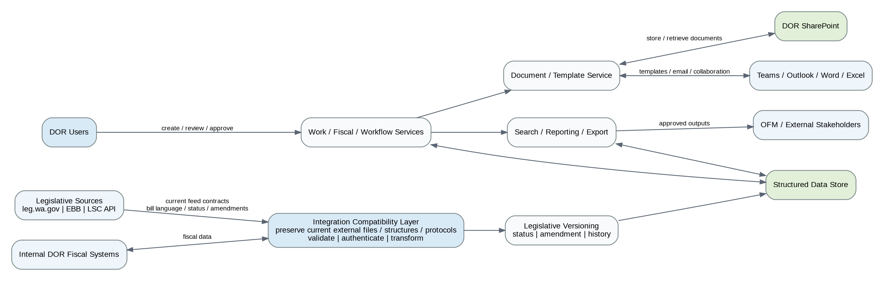
Figure 4. High-level integration and data flow

7.5 Frequency and Latency Expectations
- Bill language and bill status changes must be identified, pulled, and updated in real time as required by the business requirements. The modernization preserves the current external exchange cadence and mechanism where they already satisfy that requirement; any change in mechanism is coordinated with the external owner rather than imposed by the LTS replacement.
- Proposed and unadopted amendments are imported and tracked from legislative sources.
- The exact implementation of real-time exchange, including push, polling, or another supported source mechanism, is not defined in the requirements and must be confirmed per source system.
- Synchronous dependencies use documented timeouts and defined fallback/error behavior so downstream failures do not block the application indefinitely.
- External APIs are rate limited per consumer and return standards-based retry information when limits are exceeded.

8. Data Architecture
The data architecture separates structured legislative/fiscal/workflow data from documents while preserving explicit relationships between them. The authoritative structured system of record is a relational transactional store. Tracked-legislation documents are held in DOR SharePoint and referenced by stable metadata from the application database.
- Core entities include bill/draft identifiers, bill versions, amendments, statuses, work products, tasks, assignments, workflow steps, due dates, priorities, packages, fiscal data, reports/query definitions, document metadata, correspondence tracking, and audit context.
- Bill proposals, drafts, formal bills, fiscal notes, fiscal estimates, data requests, sponsor letters, staff emails, and hearing reports can be linked through topic, document type, legislative identifier, or package as required.
- Prior bill and work-product versions are retained rather than overwritten, supporting history, comparison, and year-to-year reuse.
- Legacy data is migrated into the new structured model with relationships preserved or reconstructed. Detailed migration mappings require source-system inventories and data profiling.
- Fiscal data from DOR systems is retrieved, calculated, and updated through the integration layer while retaining traceability to supporting fiscal work papers and historical products.
- Authorized search, saved queries, standard reporting, custom reporting, and full database analysis needs are supported through the reporting/query component. Whether B.COM.40 requires direct database connectivity or a governed full-data query layer must be confirmed.
- DOR retains unrestricted ownership of all entered and generated DOR data. Any proprietary component must not impair data portability or DOR ownership rights.

9. Reliability, Availability, and Disaster Recovery
Area | Requirement | Architecture Response
Uptime | At least 99.9% availability | Production architecture has no single point of failure within the selected AWS region.
Peak operating period | 24/7 availability and support November through June | Architecture and operational monitoring must support legislative deadlines outside normal business hours.
RPO | No more than 4 hours | Automated backups and database protection mechanisms are configured to meet the maximum data-loss window.
RTO | No more than 24 hours | Runbooks and recovery procedures are designed to restore service within the required window.
Availability-zone design | Multiple Availability Zones | Application and data paths are distributed to survive an individual component or Availability Zone failure where supported by the selected AWS services.
Multi-region | Not required by supplied mandatory requirements | No multi-region architecture is introduced solely as a preference.

Backup and failover architecture uses automated backup, point-in-time or equivalent recovery capabilities of the selected DOR-approved data service, redundant application compute, health-checked load distribution, and documented deployment, rollback, incident-response, and troubleshooting procedures. The exact AWS services are selected during detailed design.

10. Maintainability and Support

10.1 Agile and Engineering Work Management
Azure DevOps is the assumed engineering work-management platform for the delivery effort. This is an SDLC assumption and not a production LTS runtime dependency.
- Azure Boards maintains Epics, Features, User Stories, tasks, defects, acceptance criteria, sprint plans, backlog status, and delivery traceability.
- Azure Repos Git maintains source code, branches, commit history, and pull requests with peer review.
- Azure Test Plans maintains formal test cases, suites, plans, manual test execution, and UAT traceability.
- GitHub Copilot may provide approved AI assistance for coding, documentation, refactoring, and candidate test generation, subject to human review and AI governance controls.

10.2 CI/CD Pipelines
- Azure Pipelines is the assumed CI/CD orchestration platform for builds, automated test gates, and production-ready release artifacts.
- All builds and deployments are automated through CI/CD.
- Manual production deployment is prohibited except documented emergency procedures.
- Development, test/UAT, and production are logically separated.
- Where DOR operates the pipeline, pipeline definition and automated test gates are delivered as code compatible with the DOR environment.
- Production releases include release notes and advance notice when functionality, security, or data handling could be affected.

10.3 Automated Testing
- Test strategy covers unit, integration, system, and regression testing.
- Azure Test Plans provides formal test management and requirements-to-test traceability. Automated tests execute through CI/CD quality gates using frameworks selected with the application technology during detailed design.
- GitHub Copilot may assist developers and testers with candidate unit tests, test scenarios, code explanation, and test-failure analysis, but AI-generated test assets require human review and execution through the controlled test process.
- Automated unit-test coverage is measured against a proposed threshold and reported during development.
- DOR conducts UAT in a suitable non-production environment using synthetic or de-identified data, with vendor defect triage and remediation support.
- Accessibility validation supports WCAG 2.2 AA and production of a current ACR/VPAT before go-live.

10.4 Monitoring and Alerting
- Centralized application and infrastructure monitoring tracks critical system-health indicators.
- Alerts are generated for critical conditions and are configurable by DOR in the DOR-operated environment.
- Operational thresholds include availability, error rates, compute utilization, connection/pool pressure, integration failures, and backup/recovery status as appropriate to the selected services.

10.5 Logging Services
- Centralized application logs and infrastructure logs are retained in a DOR-accessible logging service.
- Security audit logging captures authentication events, authorization failures, and required sensitive-data changes.
- The exact AWS logging products are detailed design selections because the mandatory requirements prescribe capabilities rather than product names.

10.6 Operational Independence and Documentation
- DOR receives editable system architecture, data model/ER diagrams, API documentation, deployment and operations runbooks, security documentation, user documentation, and administrator documentation.
- Knowledge transfer occurs throughout the engagement, not only at closeout.
- Before go-live, DOR receives formal training plus codebase, architecture, deployment, runbook, and troubleshooting walkthroughs as applicable.
- As-built architecture, deployment runbook, rollback runbook, incident-response guidance, and troubleshooting guidance are completed before go-live.

11. Technology Stack Description
The technology stack distinguishes production runtime technologies from the engineering and delivery toolchain. AWS remains the DOR production hosting platform. Microsoft engineering products are explicit project delivery assumptions for Agile management, source control, CI/CD, test management, developer tooling, and approved AI assistance. Remaining runtime implementation selections stay TBD where the mandatory requirements do not prescribe a product.
Stack Area | High-Level Selection | Basis / Constraint
Cloud provider | AWS | Provided project direction: DOR AWS solution space.
Application type | Custom developed responsive web application | Required solution form and business access model.
Identity | Microsoft Entra ID | Mandatory TR-303.
Interactive authentication protocol | OpenID Connect preferred; SAML supported | Mandatory TR-303.
API style | RESTful APIs or equivalent; versioned and documented | Mandatory TR-601.
API authentication | OAuth 2.0 | Mandatory TR-601.
Document repository | DOR Microsoft 365 SharePoint | Mandatory TR-604.
Agile work management | Azure Boards | Project delivery assumption for Epics, Features, User Stories, tasks, defects, sprint planning, and traceability.
Source control | Azure Repos Git | Microsoft engineering toolchain using the mandatory Git approach in TR-701.
CI/CD platform | Azure Pipelines | Project delivery assumption implementing mandatory CI/CD and transferability requirements.
Test management | Azure Test Plans | Project delivery assumption for formal test planning, execution, UAT traceability, and linkage to requirements.
Developer environment | Visual Studio and/or Visual Studio Code | Microsoft engineering toolchain; exact editor may vary with the selected language and framework.
AI development and test assistance | GitHub Copilot, subject to DOR approval | AI-assisted coding, documentation, refactoring, and candidate test generation. Not a production LTS dependency; subject to disclosure and DATA-04 obligations.
Programming language | TBD | No mandatory requirement names a language. Select an actively supported DOR-approved language.
Application framework | TBD | No mandatory requirement names a framework. Select an actively supported DOR-approved framework.
Database engine | TBD | High-level design requires a relational system of record, but no mandatory requirement specifies the engine.
AWS compute service | TBD | Must support stateless scaling, high availability, CI/CD, logging, and DOR operational control. No mandatory requirement selects VM, containers, Kubernetes, or serverless.
Infrastructure as code | TBD | Pipeline/infrastructure definitions must be transferable where DOR operates them, but no mandatory requirement specifies Terraform, CloudFormation, CDK, or another tool.
Secrets/key management | TBD AWS/DOR-approved service | Must prevent hardcoding and support encryption requirements.
Monitoring/logging | TBD AWS/DOR-approved service | Must centralize application/infrastructure logs and support monitoring/alerts and audit access.

12. Requirement Coverage Summary
Requirement Domain | Requirement Basis | Architecture Coverage
Collaboration, tasks, assignments, queues, workflow, review and approval | B.COM.01-B.COM.23; B.RFA.01-B.RFA.06 | Web UI, Work Management, Workflow/Review, RBAC, notifications, structured data store
Documents, templates, versions, reuse and export | B.COM.24-B.COM.35; B.RFA.09-B.RFA.10; B.LNP.04 Must Have | Document/Template component, SharePoint repository, structured version metadata, export capability
Fiscal data and analysis | B.COM.36-B.COM.37; B.RFA.07-B.RFA.08; B.BGT.01 | Fiscal Analysis component, DOR fiscal connectors, structured data model
Search, queries and reporting | B.COM.38-B.COM.40 | Search/Reporting component with authorized access to required structured data
Migration, availability and history | B.COM.41-B.COM.43; B.EXP.01 | Migration tooling, historical data model, backup/recovery, HA AWS deployment
Legislative source integration and comparison | B.COM.31-B.COM.33; B.LNP.01-B.LNP.03 | Legislative connectors, versioning component, API integration layer
Executive remote/mobile access | B.EXEC.01-B.EXEC.03 | Internet-accessible protected web UI, Entra authentication, responsive presentation
Security and identity | TR-201; TR-301-TR-310 M/MS items | Entra ID, RBAC, TLS/AES, WAF/DDoS, centralized audit, security review support
Hosting, data protection and recovery | TR-202; TR-206; TR-208; TR-402-TR-404; TR-1201 | DOR-operated AWS, synthetic development data, CONUS residency, automated backup, RPO/RTO
Accessibility | TR-501-TR-502 | WCAG 2.2 AA design/test and ACR/VPAT
Integration and interoperability | TR-601-TR-602; TR-604; B.COM.30-B.COM.32; B.LNP.01 | Current-interface compatibility adapters, preserved external feed contracts, future versioned OAuth2 API pattern, SharePoint
Engineering, CI/CD and testing | TR-701; architecture M item; environment separation M/MS occurrences; TR-703; TR-801-TR-803; TR-901-TR-903 | Azure Boards, Azure Repos Git, Azure Pipelines, Azure Test Plans, peer review, separate tiers, automated test gates, UAT support, and approved GitHub Copilot assistance
Observability and performance | TR-1001-TR-1004 M items; TR-1101; TR-1103; availability M item; TR-1104; TR-1106-TR-1113 M/MS | Central logs, alerts, audit, multi-AZ HA, scaling, rate limiting, performance testing targets
Ownership, transition and support | TR-1301-TR-1307 M/MS; TR-1401-TR-1406 M/MS; TR-1501-TR-1502; TR-1601-TR-1602 and DATA-04 M item; TR-1701-TR-1702 | DOR data ownership, portable exports, SBOM/FOSS disclosure, governed AI-assisted engineering with required disclosure, continuous KT, editable documentation

13. Open Architecture Items Requiring Detailed Design or Stakeholder Clarification
Open Item | Required Clarification
System Integration Inventory | TR-602 states that the inventory is not yet created. The architecture direction is to preserve current external feeds, files, structures, protocols, and schedules at implementation. The current-state inventory is needed to document those contracts exactly and confirm which are external versus internal.
External interface transition governance | Confirm the approval process for replacing a preserved current external contract with the future versioned API pattern. Until approved, the current interface remains authoritative.
Microsoft engineering environment | Confirm the DOR-approved Azure DevOps organization, licensing, tenant boundaries, access model, and artifact-transfer method for Azure Boards, Azure Repos, Azure Pipelines, and Azure Test Plans.
AI development tooling approval | Confirm DOR approval and tenant configuration for GitHub Copilot, including allowed source-code and project-information access, licensing tier, and any additional DATA-04 controls.
AI data boundaries | Confirm which classifications of requirements, source code, synthetic test data, work items, and documentation may be supplied to approved AI tooling, and identify any information categories that must be excluded.
Data classification reference | TR-201 references a data-classification floor in TR-308, but TR-308 is the WAF/DDoS requirement. DOR must identify the intended data-classification requirement.
Direct database access | B.COM.40 requires access to the entire database for querying. DOR must confirm whether this means direct database access or a governed full-data query/reporting interface.
Performance targets | TR-1104 labels p95/p99 numbers as placeholder targets. DOR must confirm the final benchmarks and test method.
Availability measurement | The 99.9% requirement needs confirmation on whether planned maintenance is included or excluded.
Testing applicability | The testing section introduction is described as DOR-hosted custom build only while TR-903 contains language that also contemplates vendor-hosted staging. The selected DOR-operated posture uses the custom-build testing requirements, but DOR should confirm the source inconsistency.
Environment-separation duplicate | The technical backlog contains duplicate environment-separation requirements with different type markings. The architecture includes logical separation because both occurrences require the same outcome.
Mobile implementation | B.EXEC.02 requires use from a DOR cell phone but does not require a native mobile application. The high-level design uses a responsive web UI; DOR should confirm this is sufficient.
M365 integration details | B.COM.30 names Teams, Outlook, Excel, and Word but does not define the exact integration behavior for each product. Detailed workflows and supported Microsoft interfaces must be confirmed.
Legacy migration scope | B.COM.41 requires migration but source systems, volume, attachments, data quality, and reconciliation thresholds are not specified.

Conclusion
This high-level architecture provides a direct path to implement the DOR Legislative Tracking System as a custom solution within the DOR AWS solution space while meeting the supplied Must Have business requirements and Mandatory / Mandatory Scored technical requirements. It uses a Microsoft engineering and delivery toolchain, including approved AI assistance, without creating an AI runtime dependency or changing the AWS hosting posture. It also preserves confirmed current external feed contracts so that external systems are not forced to change as a consequence of the LTS modernization, while establishing a versioned API pattern for future controlled integration modernization. The next architecture activity should document the current interface inventory, confirm the AI and Azure DevOps governance boundaries, resolve the outstanding performance and data-classification items, select DOR-approved runtime technologies, and convert the logical design into detailed network, security, data, interface, and deployment specifications.

