Project Plan

**Project Name:** TYME (Track Your Money Easily)

**Project Objectives:** Develop a user-friendly app for tracking personal finances that allows users to manage their income, expenses and savings.

**Team Members:**

* Project Manager & Fullstack Developer: Emilian Cinteza
* UI/UX Designer & Front-end Developer: Despina Cojocaru
* Front-end Developer: Dubina Jesica
* Back-end Developer: Anamaria Stan

**Timeline Perspective:** 3 months (12 weeks)

**Milestones:**

* Milestone 1 (Week 4): Completion of UI/UX design.
* Milestone 2 (Week 8): Completion of front-end development.
* Milestone 3 (Week 11): Completion of back-end development and integration with front-end.
* Milestone 4 (Week 12): Final testing, bug fixing, and deployment of the app.

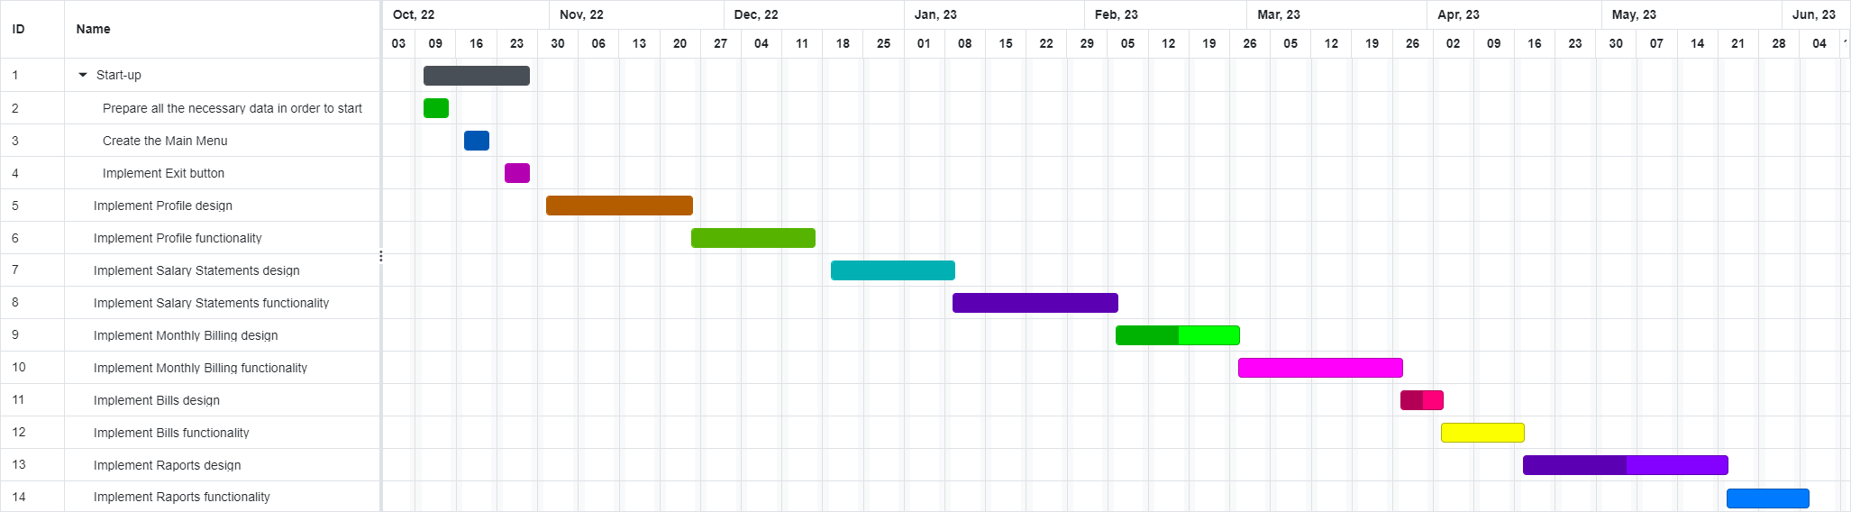**Gantt’s Diagram:**

**Documents Required:**

* Project plan
* Requirements Document
* High Level Design Document
* User Manual
* Risks and Issues document