**User Guide**

The User Interface has six buttons on the main screen: Profile, Salary Statements, Monthly Billing, Bills, Reports and Exit.

By pressing the *Profile* button, the User is able to view and edit their name, age, email, and profile picture; just by filling in the empty boxes and pressing *Update Data*. Also, by pressing *Update Image*, the User can select a new profile picture.

By pressing the *Salary Statements* button, the User is able to enter and track their income. Users can enter their salary and the amount of money they want to save each month.

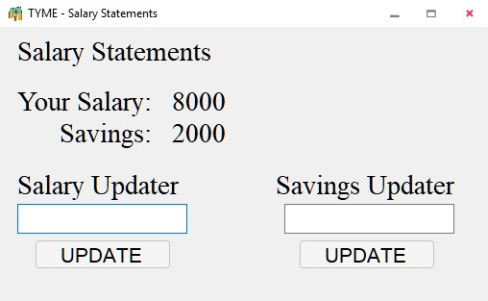

By pressing the *Monthly Billing* button, the User is able to track their recurring monthly bills and see the subscriptions they currently have. The User can add, edit, and delete subscriptions as needed.

By pressing the *Bills* button, the User can track their one-time expenses, and add, edit, and delete bills as needed. It will also provide a summary of total expenses over time. You can also filter the bills as needed.

By pressing the *Reports* button, the User will view a detailed summary of his finances with a pie chart and the ability to choose a specific month or a specific year. If you choose the current year, it will only show available data until the current month.

By pressing the *Exit* button, the User will exit the app.