**MSc Software Engineering**

Award

**MSc**

Start Date

**22/09/2025**

Duration

**12 months**

Mode

**Full-time**

Location

**University of Bolton**

Are you looking to take your programming skills to the next level? The University of Bolton's MSc in Software Engineering offers the advanced skills and knowledge needed to develop your career in this in-demand global industry.

[Apply Now](https://greatermanchester.ac.uk/#howtoapply)[Download Prospectus](https://www.bolton.ac.uk/join-us/download-a-brochure)[Programme Specification](https://programmes.bolton.ac.uk/COM010-F-UOB-MX/current)

**Course Overview**

Our MSc in Software Engineering provides graduates with a background in computing and programming the opportunity to gain a deeper understanding of advanced software methodologies. By studying for your postgraduate degree with the University of Bolton, you can extend your knowledge of software engineering while experiencing life at our supportive, student-focused, multicultural campus in the heart of the North West of England.  
  
This intensely practical course helps hone your creative thinking, problem-solving and decision-making skills through realistic scenarios inspired by the industry experience of our tutors and professional software engineering contacts. You'll have the opportunity to study the latest methodologies and development techniques and deepen your understanding of approaches such as design patterns and contemporary software engineering practices.  
  
We'll support you as you acquire the capacity to adapt and learn new skills, ready to respond as the software engineering industry evolves throughout your career. Since software engineering is an international business unconstrained by geographical area, you'll also explore issues like localisation within application development.  
  
Designed collaboratively with industrial partners, this master's degree supports you to equip yourself with the skills employers seek and understand the ethical and environmental issues you'll encounter in your professional life.  
  
Our coursework is designed to help you develop sophisticated intellectual capabilities, preparing you for your postgraduate career. The course will support you in developing research, critique, synthesis, and innovation skills, and enhance your group working and report writing skills. In addition, lifelong learning skills will help you take ownership of your professional development for the future, maximising your potential for success.  
  
We also offer alternative durations for this course. For details of the full-time 18-month course, please visit our [**full-time 18-month MSc Software Engineering**](https://greatermanchester.ac.uk/course/COM046-F-UOB-MX) course search web page. Alternatively, to find out more and apply for the 2-year part-time course, please visit our [**part-time MSc Software Engineering**](https://greatermanchester.ac.uk/course/COM010-P-UOB-MX) course search web page.

**Read less course overview**

**Highlights**

* Our dedicated staff team have a wide range of professional experience, industry knowledge, technical expertise and academic credentials, offering you a variety of perspectives and broadening your horizons.
* We prefer to keep lecture and practical classes relatively small so that you can ask questions, get help, and benefit from the ideas and support your classmates offer.
* We have well-established links with the software engineering industry. We continually monitor and update the course to ensure the content is industry-relevant and introduces you to the latest thinking and innovations.
* We are committed to helping you develop your employability and career network. You'll be encouraged to attend guest lectures that enhance your learning, help you make contacts in the industry and contribute to your professional development.

**Read less course highlights**

**Key Features**

* We offer a warm and friendly environment for your studies, with relatively small class sizes, purpose-built teaching facilities, and excellent student support and library services.
* We want to work with you as an individual, giving you access to the help and support you need to succeed.
* Our commitment to providing the best possible learning environments has seen us make significant investments in our IT facilities.
* Many of our computing facilities can be accessed across the internet, allowing you to work on your assignments whenever and wherever you choose.
* Our lecturers take time to build strong personal relationships with all students, enabling questions to be answered quickly and easily.
* By choosing to study with us, you'll have the chance to enjoy Bolton's many shops, bars, restaurants and leisure facilities. Manchester, one of the UK's most multicultural and lively cities, is less than 20 minutes away by train. Not forgetting, the North West of England is renowned for its beautiful countryside, coastline and heritage. This makes Bolton an ideal base from which to explore some of the best cultural and outdoor activities the UK offers.

**Read less course key features**

Entry Requirements

* Normally, you should have at least a lower second class (2.2) honours degree in a computer science-related subject or software engineering.
* We'll consider applications where appropriate work experience can be demonstrated in lieu of, or in addition to, the published academic qualifications in line with the University’s Recognition of Prior Experiential Learning (RPEL) procedures.
* You may be required to attend an interview and/or provide a portfolio of work.
* [**If English isn’t your first language, you’ll also need IELTS 6.0 with no less than 5.5 in any band (or equivalent). We also accept a range of other English language qualifications – please visit our English Language Requirements web page for more details.**](https://greatermanchester.ac.uk/international/international-general-entry-requirements)

**Read full course entry requirements**

*Where changes are made to material information contained in this course description or a decision is taken to suspend a course between the offer of admissions and enrolment, we will inform applicants at the earliest possible opportunity and will outline the various options available to the applicant.*

Career Opportunities

The University of Bolton's MSc in Software Engineering is aimed at computer science graduates and experienced professional programmers and investigates complex software systems, methodologies, measures and tools that can be used in the software engineering process. A software engineer's duties can include producing project requirements, writing algorithms, coding, testing, deployment or maintenance.  
  
As a graduate of this programme, you'll possess a wide range of technical skills such as software reuse, agile development, design patterns and software architecture. You'll also be able to demonstrate a range of transferable skills, including advanced IT skills, analytical skills, communication, creativity and innovation, independence, logic, numeracy, project management and organisation.

**What can I do with this qualification?**

As a graduate of this Software Engineering master's degree, you may choose to work in software engineering research or on large-scale software development projects. Directly related jobs include software engineering, software architecture, games development, systems development, web design, web development, search engine optimisation, information systems management, and business analysis.  
  
This course also paves the way for PhD research studies in software engineering and computing-related subjects.

**Alternative career options**

Graduates can also use the qualification as a stepping-stone into a range of other careers. Some of these roles may require relevant experience and/or postgraduate study. Examples of possible careers include:

* Finance
* Software project management
* Commerce
* Electrical engineering
* Quality management
* Research and development
* Teaching and education
* Security
* Consultancy
* Healthcare
* Public services and local government

Fees & Funding

**Home/EU Fees**

Home students starting this course in the first year will be required to pay a Home fee of £8,496 for the academic year 2025/26.

**International Fees**

Overseas students starting this course in the first year will be required to pay a Overseas fee of £17,500 for the academic year 2025/26.

**Bursaries**

[**Click here for more information on our Master's Bursaries.**](https://www.bolton.ac.uk/student-life/fees-and-funding/scholarships-and-bursaries/)

**Important note regarding tuition fees:** EU nationals who meet residency requirements (have settled or pre-settled status) may be eligible for 'Home' fee status. If you do not meet these residency requirements, overseas fees will apply. Irish citizens living in the UK or Ireland will be eligible for 'Home' fee status under the Common Travel Area arrangement. Please read the [**student finance for EU students**](https://www.gov.uk/student-finance/eu-students) web page on www.gov.uk for information.

The fees for a student's course of study will be set for the normal duration of that course subject only to inflationary increases – measured by the Consumer Price Index (CPI) recorded in March each year to take effect for subsequent start dates.

How to apply

**Home Applicants**

**International Applicants**

Teaching & Assessment

We use a blend of learning and teaching methods to give you the best possible chance of success, including online (where appropriate). We'll expect you to participate in lectures, seminars, tutorials and critiques. You'll also experience laboratory and workshop sessions and undertake self-directed learning, e-learning and online sessions.  
  
You'll have the chance to acquire and enhance your practical skills through technical introductions and support, workshop sessions, demonstrations and activity-based assignments.  
  
We'll provide regular written feedback on your work, with assessments usually completed by the end of each module. Assessment is varied and can include methods such as assignments, projects, exams and presentations. Most of your overall grade will be based on coursework.

**Modules**

The modules listed below may be a mixture of compulsory and optional. You may not have the opportunity to study all the modules shown as part of the course.

* Professional Practice
* Research Methods
* Contemporary Software Engineering Practices
* Advanced Software Development
* DevOps
* Data Analysis and Visualisation
* InfoSec
* Project

**Assessment methods**

| **Level** | **Assessment method** |
| --- | --- |
| Level 1 | Coursework 100% |

**Learning Activities**

| **Level** | **Activity** |
| --- | --- |
| Level 1 | Guided independent study 83% Scheduled learning and teaching activities 17% |

*The university will use all reasonable endeavours to deliver your course as described in its published material and the programme specification for the academic year in which you begin your course. The university considers changes to courses very carefully and the university will minimise any changes. Please be aware that our courses are subject to review on an ongoing basis and changes may be necessary due to legitimate staffing, financial, regulatory and academic reasons. The content of course modules and mode of associated assessments may be updated on an annual basis. This is to ensure that all modules are up-to-date and responsive to employment and sector needs. The published course material and the programme specification contain indicative ‘optional modules’ that may be subject to change due to circumstances outside of our control. For this reason, we cannot guarantee to run any specific optional module.*

**undefined at undefined**

To see official information about this course and others visit Discover Uni.

Make an **informed** choice.

[See course info](https://www.discoveruni.gov.uk/" \t "_blank)

**Related Courses**

[**MSc Cloud and Network Security Full-time**](https://greatermanchester.ac.uk/course/msc-cloud-and-network-security-full-time-12-months-university-of-bolton)

University of Bolton

12 Months

[**MSc Software Engineering Part-time**](https://greatermanchester.ac.uk/course/msc-software-engineering-part-time-24-months-university-of-bolton)

University of Bolton

24 Months

[**MSc Data Analytics and Technologies Full-time**](https://greatermanchester.ac.uk/course/msc-data-analytics-and-technologies-full-time-12-months-university-of-bolton)

University of Bolton

12 Months

[**MSc Data Analytics and Technologies: Extended Full-time**](https://greatermanchester.ac.uk/course/msc-data-analytics-and-technologies-extended-full-time-18-months-university-of-bolton)

University of Bolton

18 Months

[**MSc Cloud and Network Security: 18 months Full-time**](https://greatermanchester.ac.uk/course/msc-cloud-and-network-security-full-time-18-months-university-of-bolton)

University of Bolton

18 Months

[**MSc Software Engineering: 18 months Full-time**](https://greatermanchester.ac.uk/course/msc-software-engineering-full-time-18-months-university-of-bolton)

University of Bolton

18 Months

[**MSc Artificial Intelligence Full-time**](https://greatermanchester.ac.uk/course/msc-artificial-intelligence-full-time-12-months-university-of-bolton)

University of Bolton

12 Months

[**MSc Artificial Intelligence: Extended Full-time**](https://greatermanchester.ac.uk/course/msc-artificial-intelligence-full-time-18-months-university-of-bolton)

University of Bolton

18 Months

[**MSc Health Analytics and Technologies Full-time**](https://greatermanchester.ac.uk/course/msc-health-analytics-and-technologies-full-time-12-months-university-of-bolton)

University of Bolton

12 Months

[**MSc Business Analytics and Technologies Full-time**](https://greatermanchester.ac.uk/course/msc-business-analytics-and-technologies-full-time-12-months-university-of-bolton)

University of Bolton

12 Months

[**MSc Business Analytics and Technologies: Extended Full-time**](https://greatermanchester.ac.uk/course/msc-business-analytics-and-technologies-extended-full-time-18-months-university-of-bolton)

University of Bolton

18 Months

[**MSc Health Analytics and Technologies: Extended Full-time**](https://greatermanchester.ac.uk/course/msc-health-analytics-and-technologies-extended-full-time-18-months-university-of-bolton)

University of Bolton

18 Months

**Programme Contacts**

Software Engineering

Email Enquiries

[**SoftEng@bolton.ac.uk**](mailto:SoftEng@bolton.ac.uk)

Francis Morrissey

Programme Leader

[**F.Morrissey@bolton.ac.uk**](mailto:F.Morrissey@bolton.ac.uk)

+44 (0)1204 903530

Enquiry Team

University of Bolton

[**enquiries@greatermanchester.ac.uk**](mailto:enquiries@greatermanchester.ac.uk)

+44 (0)1204 903903

* [Student Policy Zone](https://greatermanchester.ac.uk/student-policy-zone)
* [Accessibility](https://greatermanchester.ac.uk/accessibility-statement-for-university-of-bolton-website)
* [Freedom of Information](https://greatermanchester.ac.uk/freedom-of-information)
* [Privacy & Cookies](https://greatermanchester.ac.uk/governance/privacy-and-cookies)
* [Disclaimer](https://greatermanchester.ac.uk/disclaimer)



University of Greater Manchester  
Deane Road, Bolton, BL3 5AB.

Tel: +44 (0)1204 900 600

Email: [enquiries@greatermanchester.ac.uk](mailto:enquiries@greatermanchester.ac.uk)

Explore

[Getting In Touch](https://greatermanchester.ac.uk/more/getting-in-touch/)

[Governance & Legal](https://greatermanchester.ac.uk/governance/)

[Schools, Faculties & Centres](https://greatermanchester.ac.uk/explore-our-schools/)

[News](https://greatermanchester.ac.uk/news/)

[Events](https://greatermanchester.ac.uk/events/)

[Vacancies](https://jobs.bolton.ac.uk/)

[Policy Zone](https://greatermanchester.ac.uk/student-policy-zone/)

[Transparency Information](https://greatermanchester.ac.uk/governance/transparency-information)

[Access & Participation and Fee Information](https://greatermanchester.ac.uk/more/access-and-participation)

Quick Links

[Charitable Status](https://greatermanchester.ac.uk/charitable-status/)

[Data Protection](https://greatermanchester.ac.uk/governance/documents-and-reports/#dataprotection/)

[Equality & Diversity](https://greatermanchester.ac.uk/equality-and-diversity/)

[Modern Slavery](https://greatermanchester.ac.uk/)

[Environmental Sustainability](https://greatermanchester.ac.uk/governance/policies-and-legal/environmental-sustainability/)

[Help Centre](https://knowledge.bolton.ac.uk/)

Students & Staff

[Staff Area](https://greatermanchester.ac.uk/staff-area/)

[Staff Directory](https://staffsearch.bolton.ac.uk/)

[Students Area](https://greatermanchester.ac.uk/student-area/)

[Webmail Student](https://sso.bolton.ac.uk/adfs/ls/?wa=wsignin1.0&wtrealm=urn%3afederation%3aMicrosoftOnline&wctx=%26LoginOptions%3D2%26wa%3Dwsignin1.0%26wreply%3Dhttps:%252F%252Foutlook.office.com%252Fowa%252F)

[Webmail Staff](https://webmail.bolton.ac.uk/)

* **[](https://andertoncentre.co.uk/)**

* **[](https://www.alliancelearning.com/page/homepage/)**

* 

* 

* **[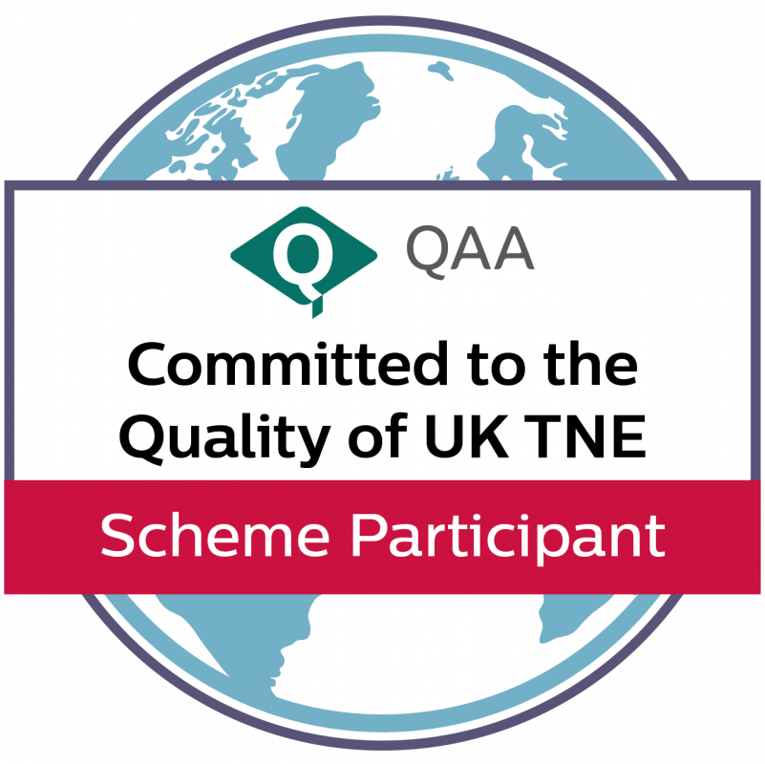](https://www.qaa.ac.uk/en/home/)**

[**[](https://www.tiktok.com/@unigreatermanchester)**](https://www.tiktok.com/@unigreatermanchester)

© 2025 University of Greater Manchester. All rights reserved.