MEMO Return to CM1845

To: Prof. Burchett

From: Team 3/C (Lexi Nutter, Josh Eckels, Carson Stone)

Date: November 10, 2017

Re: Link Design for Crane Device, EM121 Section 01

Results. In this project, we were to design a link that would support a load attached to a crane structure. On test day, our link was assembled to the crane, and then the load was attached. Our link, while although very light, did not pass and failed by fracture at the ends. There are a few reasons that our link could have failed this test. One reason is that our factor of safety was 1.2, which is very risky and assumes we made very accurate models and calculations. While this was not the cause of failure necessarily, our failure could have been prevented with a higher factor of safety. Another reason is that we rounded when taking measurements of the crane and other numbers in our calculations. Some error can be attributed to our own human error. We also didn’t take into account the heating and cooling of the material during cutting, which may have caused it to become brittle or even change some of the material properties.

One other consideration we left out was the stress occurring in the area right around where the screws are connected. As seen in the picture of our link failure below, the fractures occurred right at the ends. This could be due to higher shear stresses in these locations. On the Failure analysis page, (located after the engineering analysis section), we found that the max shear stress is going to be 35.355% of the normal stress we built the link to withstand. The ratio between the normal yield stress and shear yield stress of similar plastics is less than 35.355 %. This finding leads us to believe that perhaps the shear forces occurring at these locations caused greater stresses than the maximum shearing stress of the material. In the analysis, we assumed a fracture angle of 45 degrees, which is where we would expect maximum shear stress to occur, (and from a closer look at our link below, these fracture angles do appear close to 45 degrees.) This along with the fact that the link broke in the places seen below leads us to speculate that the cause for our link to break was fracture due to shear stress. While we cannot prove for certain this is the cause without the maximum shear stress values of the material, this is our best guess for the failure of our link.

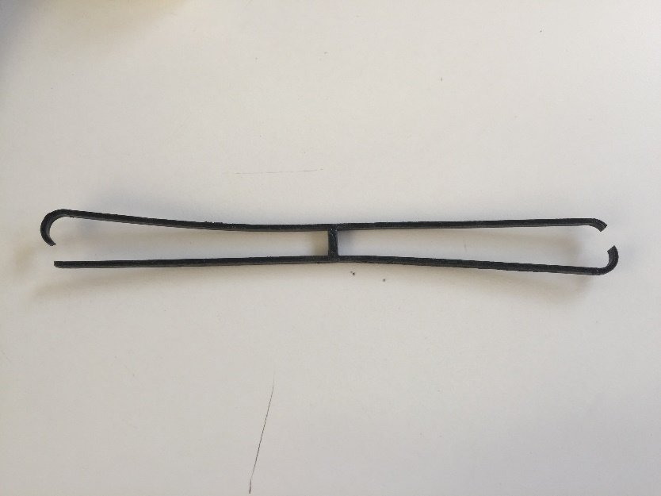

Design Summary. Our link design was an almost hollow band that had a single strip of material in the center for support (see Attachment 2 – Engineering Analysis). In our design, we tried to make the lightest link in the section to maximize the points earned. The total length of our link is 129.46 mm, the hole to hole length is 119.64 mm, the width is 9.82 mm, thickness is 2.3876 mm, and the cross-sectional area is 7.93 squared millimeters. We chose our shape in order to take out as much unnecessary material as possible in the middle of the link. The thickness and cross sectional area were chosen through our calculations (see Appendix A). The material properties that we used in our calculations were density and yield tensile strength with a FOS of 1.2.

Attachment 1 is located in Appendix B.

Attachment 2 is located in the Engineering Analysis section.

Suggested Design Modifications.

If we were to redesign the link, we would start with an approach that it more safe than our current design: we would have a higher factor of safety, less rounding in our calculations, and we would change the shape of our link. The goal of our current design was to go for the lightest mass, and so we used the “rubber-band” shape to take out as much mass as possible. However, if we were to redo our design, we would start with the goal of going for safety. Our design would look more like the “dog-bone” type design used by the groups whose link successfully held the weight. We believe this design would distribute the force more evenly through a cross-section that is not divided into two halves. This design would also incorporate more material and a higher factor of safety around the area where the screws are attached, which is where the failure in our design occurred. Our mistake lead our link to be less safe and eventually snap, which in real life could cause a lot of damage or even injure people working around the crane.

Signatures