|  |  |
| --- | --- |
| *Lab 7 memo* |  |

To: Dr. Cloutier

From: Joshua Eckels

Due date: 1/22/2019

Re: Numerical simulation of a swinging crane weight

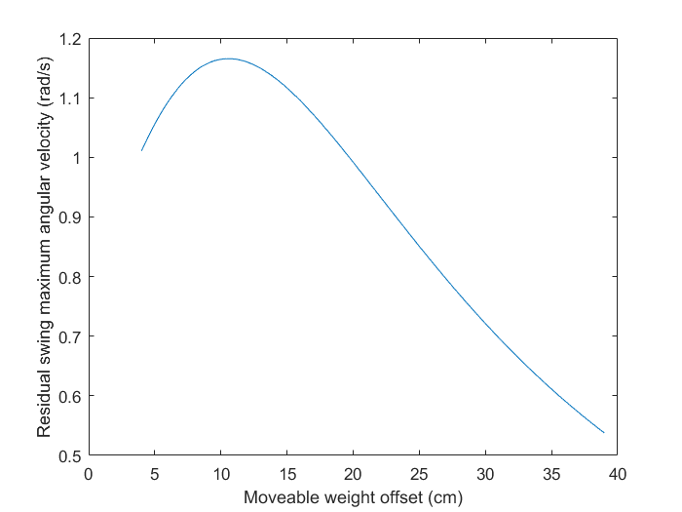The purpose of this lab was to simulate the second-order differential equation modeling the residual swinging of a crane pendulum after its trolley (at the pivot of the pendulum) stopped moving. During the lab, angular velocity (rad/s) was plotted as a function of the offset distance of the weight (cm) in order to find the distance of the weight at which residual angular velocity was minimized. Figure 1 shows the maximum residual angular velocity achieved by the pendulum as a function of the weight’s offset from the pivot for the single move strategy. Figure 2 shows the same plot of angular velocity v. offset distance for the double move strategy.

**Figure 1.** Maximum residual swing angular velocity (rad/s) achieved by pendulum as a function of weight offset distance (cm) for single move strategy of the crane

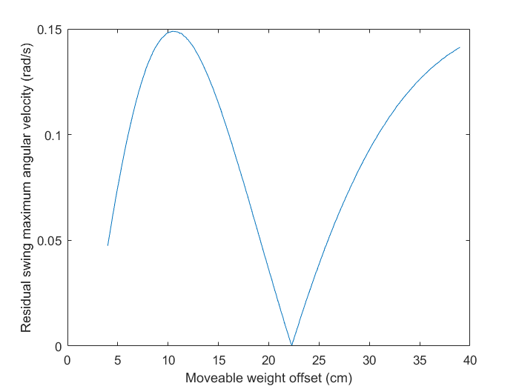

**Figure 2.** Maximum residual swing angular velocity (rad/s) achieved by pendulum as a function of weight offset distance (cm) for double move strategy of the crane

Table 1 shows the location of the circular weight on the pendulum’s rod (the crane) that minimizes the residual swing’s maximum angular velocity for the double move strategy, as well as the corresponding magnitude of the angular velocity at this position. Figure 3 shows the angular velocity of the pendulum over time for this minimum case.

**Table 1.** Pendulum characteristics associated with the minimum residual angular velocity.

|  |  |
| --- | --- |
| Angular velocity of crane rod (rad/s) | Weight location, $L_{w,cg}$ (cm) |
| 0.0004 | 22.3 |

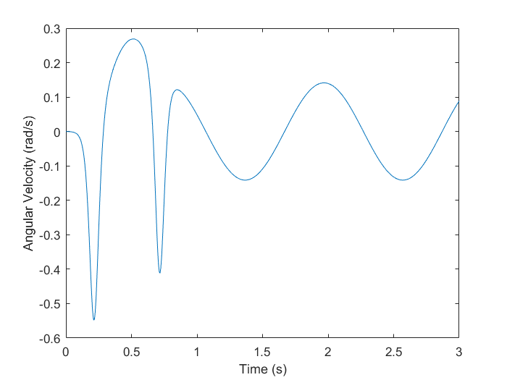

**Figure 3.** Residual swing angular velocity (rad/s) over time for the optimal weight location of the double move strategy

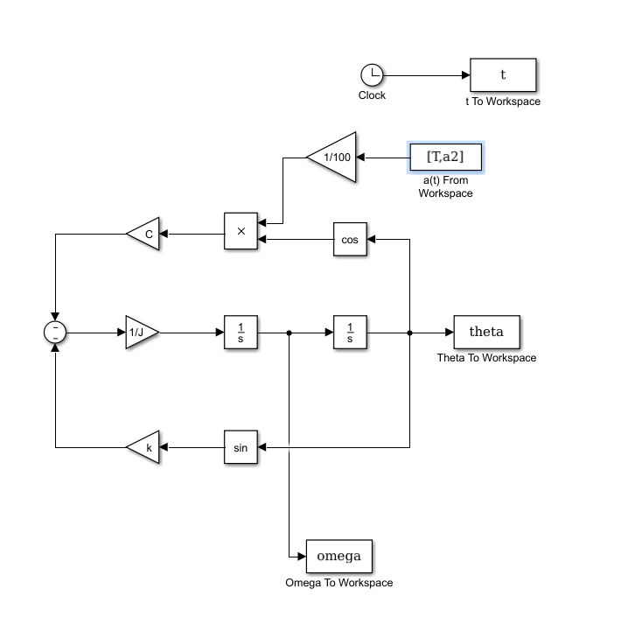The Simulink simulation diagram for the pendulum is shown in Figure 4. Attached to this document is a printout of the Matlab m-file used to run the simulation.

**Figure 4.** Simulink simulation diagram for the motion of the crane pendulum (double move strategy)