**COSPACE MANAGEMENT SYSTEM - (10) QUERIES**

**ANSWER 1**

SELECT OFFICE_ID,OWNERS_ID,TOTAL_COST, SPACE_NAME,COST_OF_EACH_ROOM TYPE_OF_ROOMS FROM office_space ORDER BY cost_of_each_room ASC;

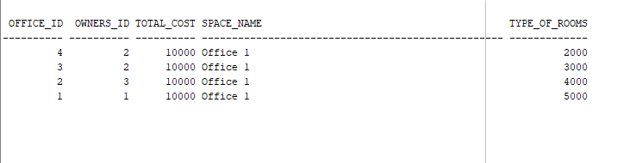

**ANSWER 2**

SELECT COUNT(State) as Punjab_customers FROM customers WHERE State= 'Punjab';

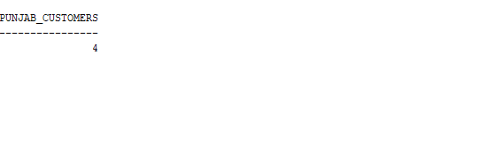

**Answer 3**

SELECT * FROM customers WHERE Created_at > SYSDATE - 21;

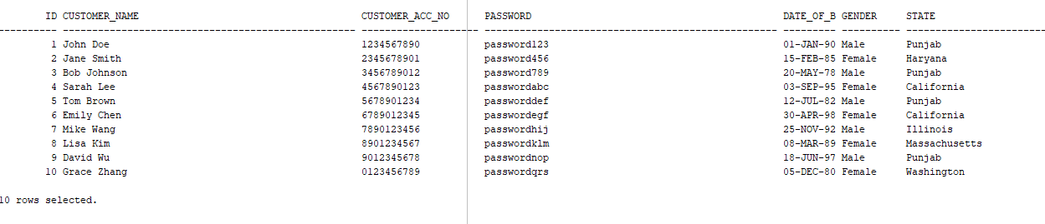

**Answer 4**

SELECT * FROM living_space WHERE shared_space='Yes' AND shared_gender='Both' AND numbers_of_shares='3';

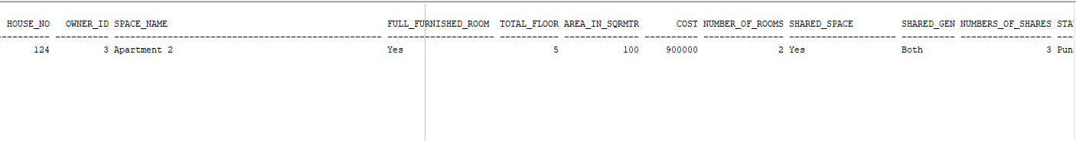

**Answer 5**

SELECT * FROM living_space ORDER BY state DESC;

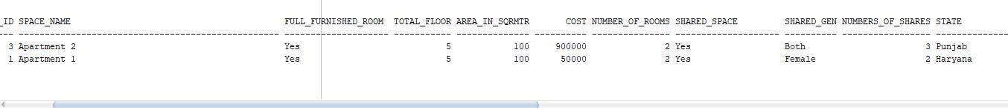

**ANSWER 6**

SELECT state FROM office_space GROUP BY state ORDER BY COUNT(state) DESC FETCH FIRST 1 ROWS ONLY;

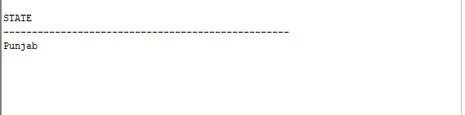

**ANSWER 7**

SELECT owners.name FROM owners INNER JOIN office_space ON owners.owner_id = office_space.owners_id INNER JOIN living_space ON owners.owner_id = living_space.owner_id;

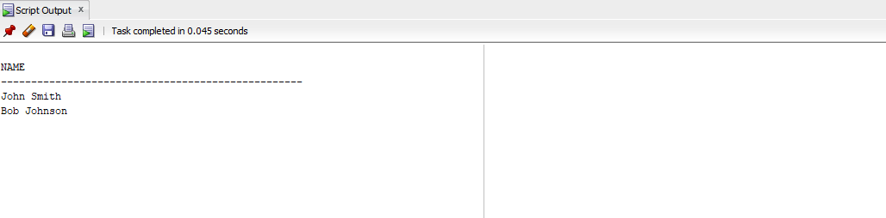

**QUESTION 8**

SELECT DISTINCT owners.name FROM owners INNER JOIN office_space ON owners.owner_id = office_space.owners_id INNER JOIN living_space ON owners.owner_id = living_space.owner_id WHERE owners.owner_id > 1;

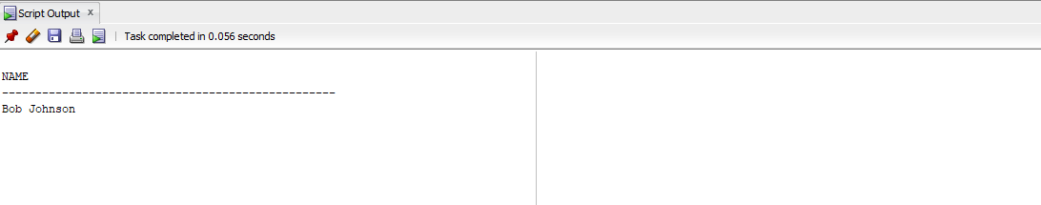

**ANSWER 9**

SELECT office_space.space_name AS office_space_name, living_space.space_name AS living_space_name,

living_booking.status AS living_status, office_booking.status AS office_status, owners.name

FROM owners

INNER JOIN office_space ON office_space.owners_id = owners.owner_id

INNER JOIN living_space ON living_space.owner_id = owners.owner_id

INNER JOIN office_space ON office_space.office_id = office_booking.space_id

INNER JOIN living_space ON living_booking.spaceid = living_space.House_no

WHERE living_space.state = 'ss' AND office_space.state = 'ss';

**ANSWER 10**

UPDATE office_space

SET state = REPLACE(state, 'LL', 'AA')

WHERE monthly_availability <= TO_DATE('2023-12-25', 'YYYY-MM-DD') AND

monthly_availability > ADD_MONTHS(SYSDATE, -5);

