Low-Cost Digital Microfluidics: A Process for Building A Simple Device at Home

Eric Clay

December 16, 2015

**INTRODUCTION**

Microfluidics is hardly a new field, but all of the devices to date have required expensive, specialized equipment that most people are unlikely to have access to. The goal of this project was to demonstrate that it is possible to build a low-cost device using inexpensive, readily available materials.

The system described in this document consists of two parts: a base station, and the device itself. The base station provides programmatic control and power to the device, and the disposable device contains the arrangement of electrodes designed to carry out the desired microfluidic operation.

This document’s home is on github at <https://github.com/eclay42/DMF_EWoD_controller>. The accompanying code project files and STL designs are located in the repository.

**THE DEVICE**

The device itself can be fabricated very quickly using inexpensive, readily available materials. It consists of a sheet of glossy photo paper as the base, a layer of conductive ink for the electrodes, a layer of common cellophane tape as the dielectric, and NeverWet water repellent as the hydrophobic layer. Fabrication time is less than 10 minutes. The most difficult to obtain item is conductive ink, however two companies have recently emerged that provide relatively inexpensive pens/markers with conductive ink for paper-based electronics which is the key breakthrough that has enabled this project. A detailed description of the fabrication process is provided later in this document.

**BASE STATION**

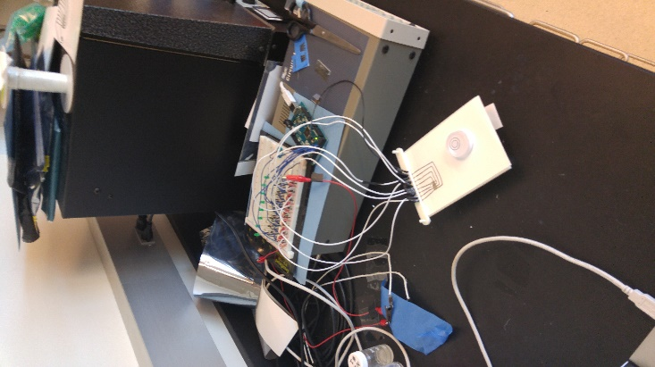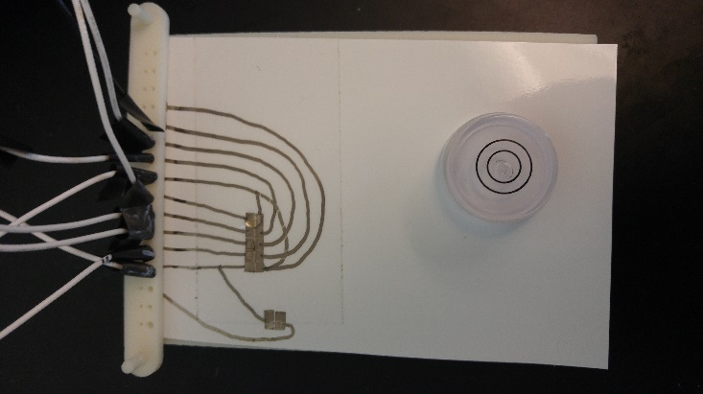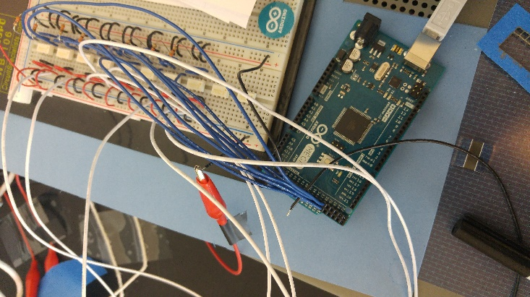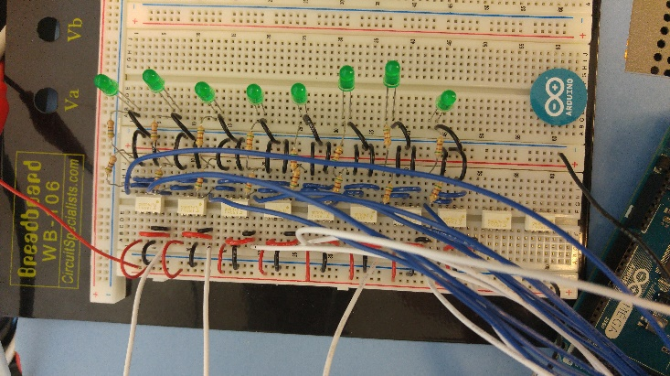

The base station consists of a power supply, Arduino microcontroller, a solid state relay bank, an interface to the device, and a 3D printed rig to hold the device and spring probes. It should be noted that for this project a high voltage lab power supply was used, this was done in the interest of time since it violates the spirit of this project in not needing specialized equipment. However, since the power requirements are so low, there are inexpensive voltage converters and simple power supply designs available that could easily be used instead.

An Arduino Mega handles the relay switching duties since it is an easily obtainable, easily programmable, relatively inexpensive microcontroller with a large amount of digital IO for controlling a large number of relays.

The relay bank utilizes solid state relays due to their robustness over traditional mechanical relays and since there is no risk of internal arcing due to high voltages. This is not a strict requirement, the extremely low current draw means that any relay with sufficient withstanding voltage should work without issue. Each relay device contains an NO/NC relay pair that allows each electrode to be connected to ground when the relay is in the off state, and then be switched over to power with only one IO line from the controller. The worst case switching time of the chosen relays is 3ms

Interfacing with the device is handled via spring probes mounted on a sliding mount on the test rig that can be pressed down onto pads on the device. The test rig is set up as a small table to elevate the device and allow for clamping from the sides if needed. At one end are two posts that guide the sliding portion of the rig. This sliding portion holds the spring probes and uses a combination of gravity and friction to ensure contact with the device. If a new rig is printed using the provided design files, make sure to drill out the spring probe holes using a 1/16” bit.

The Arduino controller is controlled by a PC using simple serial commands. A high baud rate of 115200 is used to allow for rapid communication since the serial protocol is the slowest part of the system. To facilitate more complex PWM style control, the PWM functionality of the Arduino is used rather than the PC explicitly defining each switching operation so the PC can simply tell the Arduino to start and stop PWM at a specified frequency for each electrode.

**DEVICE FABRICATION PROCESS**

**0. Plan out device**

a. Pad location

b. Electrode layout

c. Trace routing

d. If necessary, cut the paper to fit the base station

**1. Draw electrodes, contact pads, and traces**

a. Use razor blade to etch out electrodes

**2. Verify electrical connectivity**

a. Verify electrode isolation

b. Verify pad to electrode connectivity

c. Use the razor blade or more ink to correct any issues

**3. Stick the tape on**

a. Cut out tape to cover electrodes

b. CAREFULLY apply tape in the same way you would a screen protector

c. Firmly press tape down over electrodes

d. Trim off any excess tape

**4. Apply the hydrophobic layer**

a. Clean tape surface using an alcohol wipe

b. Spray NeverWet onto a tissue

c. Wipe the NeverWet onto the portion of the tape covering the electrodes

d. Wait a few minutes for the coating to dry

e. Test coating and repeat all of step 4 if it doesn't work

**5. Test the device**

BEFORE YOU START: Be aware that electrowetting devices can be very finicky and even small things like fingerprints, bubbles in the tape, and airborne particles can be enough to affect the performance of the device. Make sure to wear gloves and work in a reasonably clean environment. Even by following this guide exactly and carefully assembling your device, it probably won't work the first time. This unfortunately is the current state of electrowetting devices, they are very temperamental, and the small inconsistencies that arise from the manual assembly process will probably conspire against you from time to time, especially when you first start building these devices.

**0. Plan out device**

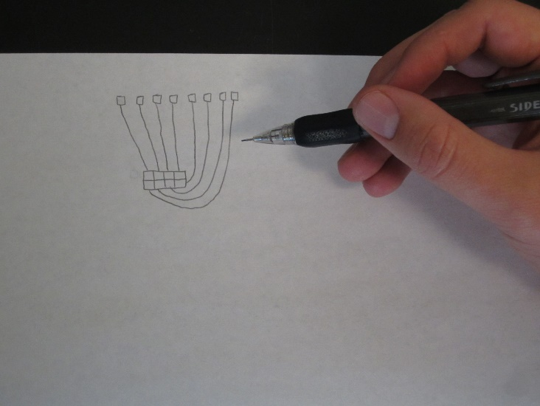 This should be obvious, but before you start you should take a moment to plan your device out in your head, or better yet, sketch it out on a piece of paper. Figure out how many electrodes you want, the desired layout, and especially how you're going to route your traces from the electrodes to the contact pads. You want your electrodes to be smaller than your desired drop size since the electrowetting effect requires the drop to overlap an electrode. Traces should be significantly smaller than the electrode if possible to minimize the drop's attraction to the traces instead of the electrode. Your gaps between the electrodes should be as small as possible to maximize the electrowetting effect (alternatively, increase the voltage but this will likely require higher spec parts in your base station).

**1. Draw electrodes, contact pads, and traces**

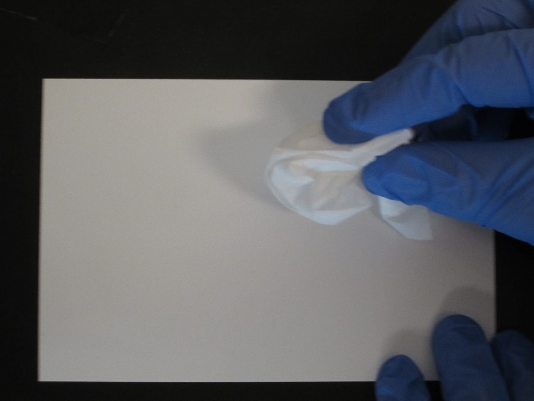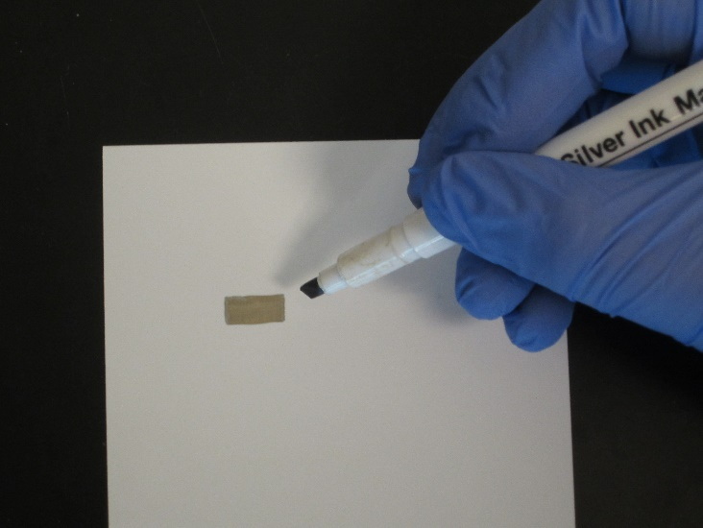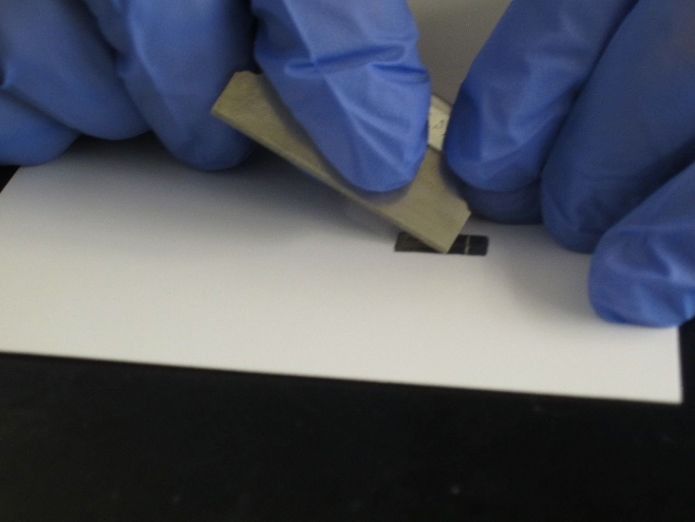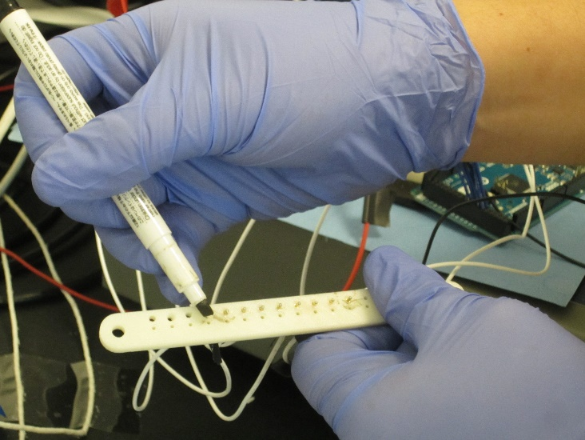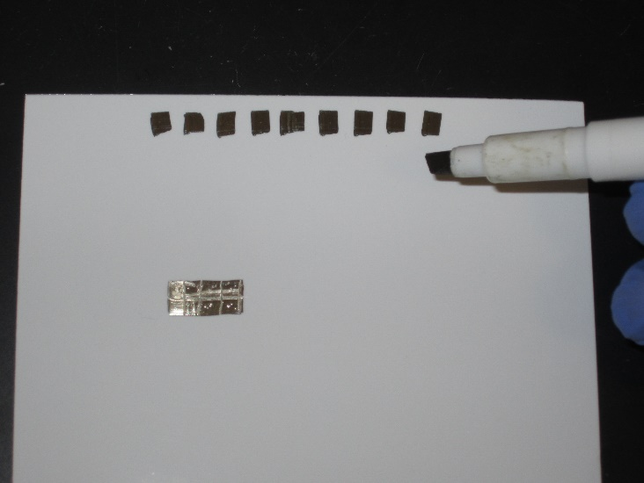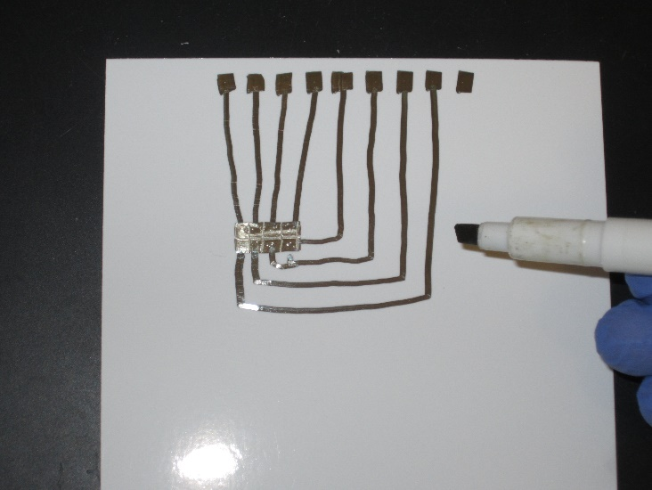

Put gloves on. Wipe the paper off using a tissue to remove fingerprints and dust. Using the conductive ink marker, draw out the design you planned out in the previous step. To get the necessary precision between electrodes, I recommend drawing a solid shape and etching out your electrodes by using the corner of a razor blade to scrape the layer of conductive ink off the paper. It comes off more easily if you let it dry for a minute instead of trying to get it off immediately since you'll end up gouging the paper. A little trick to getting the contact pads into the correct position is to put a little dab of ink onto the end of each pin and press it down onto the paper so you can see exactly where the pins come down.

**2. Verify electrical connectivity**

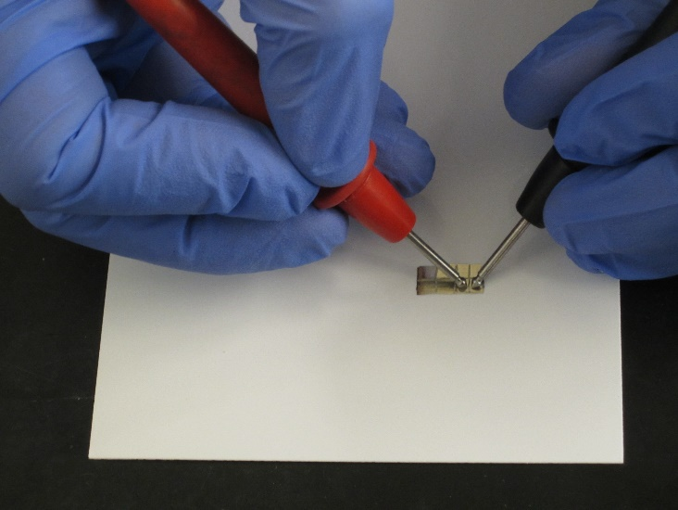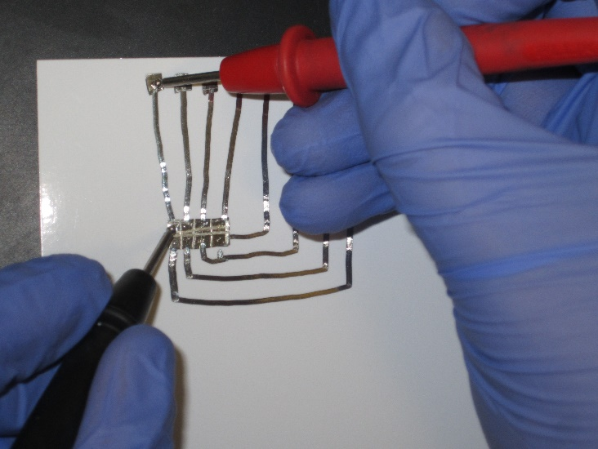

Using a multimeter, ensure that none of the electrodes are shorted to each other. Likewise, ensure that your traces have good connectivity by verifying that the resistance between your electrodes and their corresponding pads isn't too high (<200 ohms for the conductive ink marker). If there are any shorts, clean up the bridges using the razor blade. If the traces aren't making a good connection, add a little more ink to the ends and blend them into the pad/electrode.

**3. Stick the tape on**

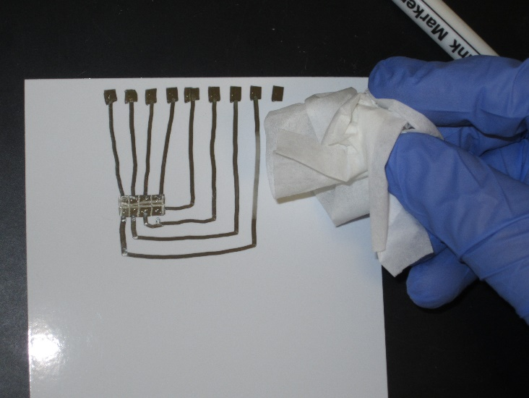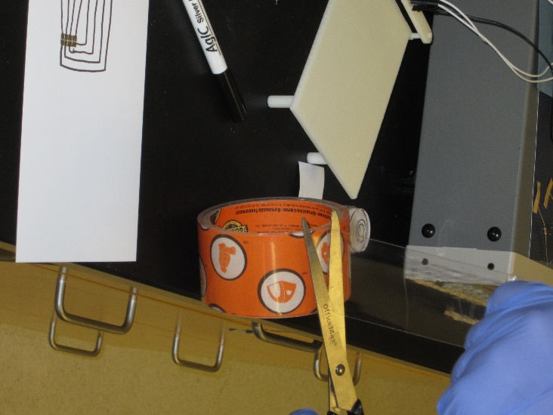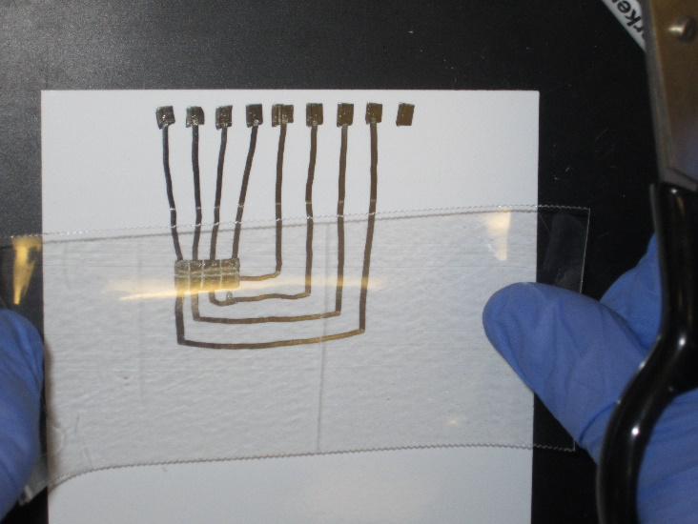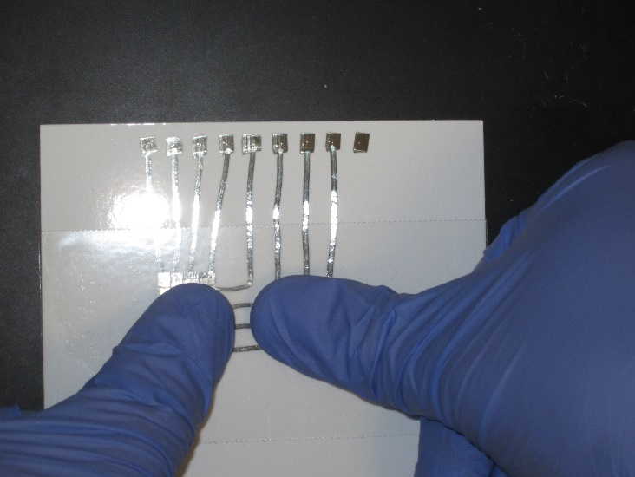

Wipe off the surface of the device to remove any contaminants that may have settled on it during the previous step. Carefully peel off and cut a length of tape long enough to completely cover your electrodes with plenty of room on the sides. Be generous, too much tape is vastly preferable to too little. You can always trim off the extra later. Don't touch the adhesive near the center at all, even with gloves you'll mess it up. Don't overlap tape, if your roll isn't wide enough to cover the smaller dimension of your electrode array, get a wider roll. You want the surface to be as flat and consistent as possible with no seams or overlaps.

This is the point of no return in fabricating your device. Once the tape adhesive touches the paper, you won't be able to get it off without ruining the device. Now, very carefully, starting from the center of the tape and your electrode array, stick the tape onto the device, being careful to avoid getting any bubbles or creases. Using your gloved fingers, press the tape down firmly over the electrodes. Trim off any tape that extends beyond the edge of your paper sheet.

**4. Apply the hydrophobic layer**

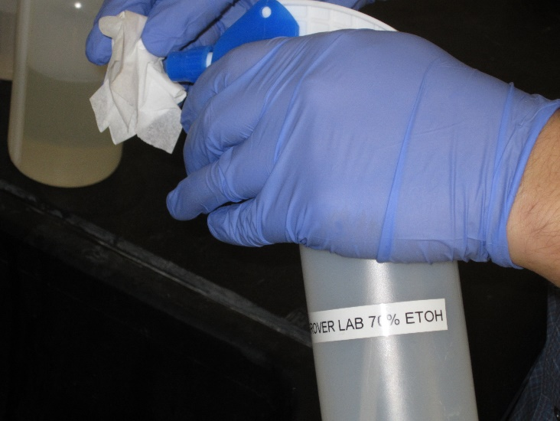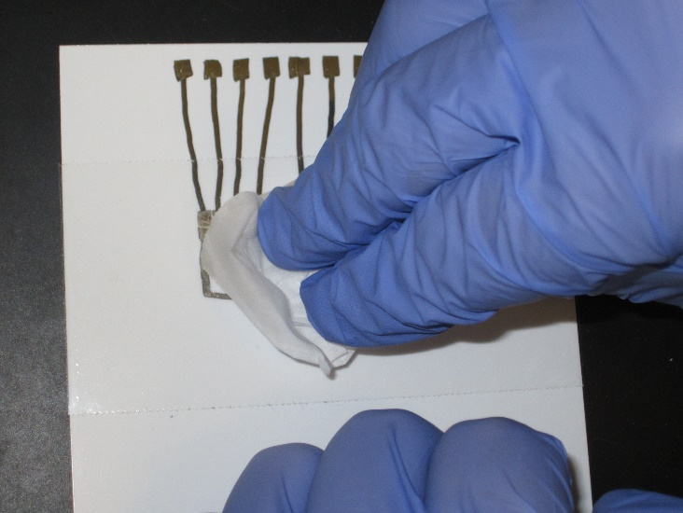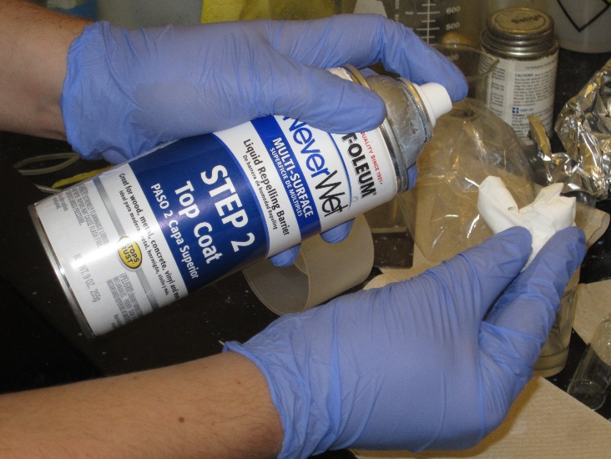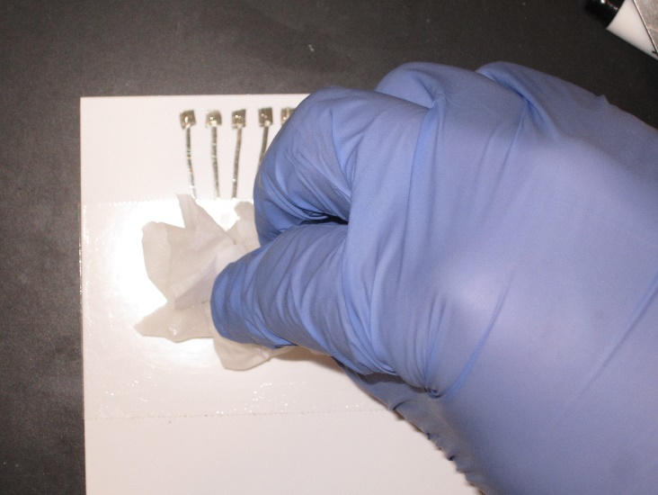

Clean off the surface of the tape using an alcohol wipe (or a tissue soaked with alcohol) to remove any contaminants so the hydrophobic coating will properly adhere. Make sure to let the alcohol fully evaporate before moving onto the next step. The water repellent used in this project (NeverWet) has two parts: the base coat and the top coat. Only the top coat is necessary for the device to function.

The NeverWet product comes in an aerosol spray bottle, but this is not the best way to get a good, consistent coating. What works better is to spray the NeverWet onto a tissue and then use the tissue to wipe it onto the tape on the device. You will need to really saturate the tissue until it is almost dripping to get enough of the NeverWet for a good transfer. A little helpful thing I found is to only apply the NeverWet to the area directly over the electrodes, leaving a portion of the tape around the edges untreated so that a runaway drop will stick to the tape rather than running off and wetting the paper.

When applied as a thin coating via the tissue method, the NeverWet dries much more quickly than the recommended 30 minute time listed on the packaging so you should only need to wait 5 minutes at most. Once the NeverWet has dried, put a test drop on the device using a pipette and verify that it beads up and becomes mostly spherical and slides around easily when you tilt the device, indicating that the hydrophobic coating is working. This is the single most difficult step of the process and will possibly require several attempts to get a good, functional coating. Thankfully you can simply clean the tape off using alcohol and try again without having to fabricate an entirely new device.

**5. Test the device**

At this point you're done building the device so the only thing left to do is to go ahead and test it and see if it works as expected. Some tips for this are provided in the next section.

**PLACING & MOVING THE DROP**

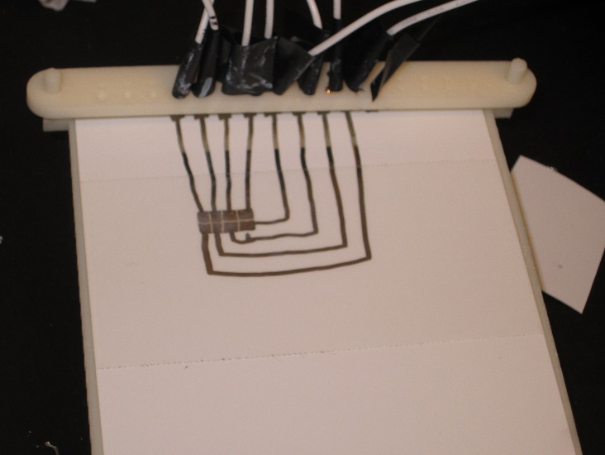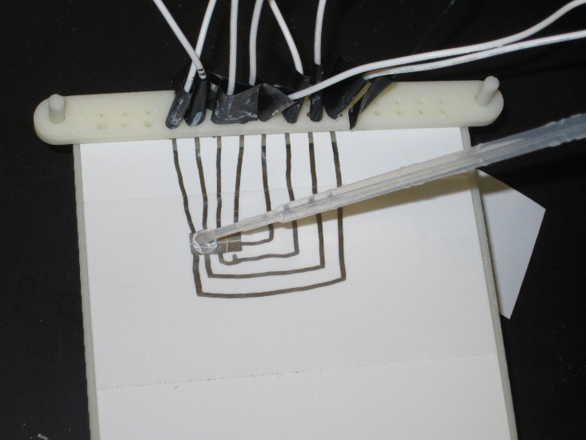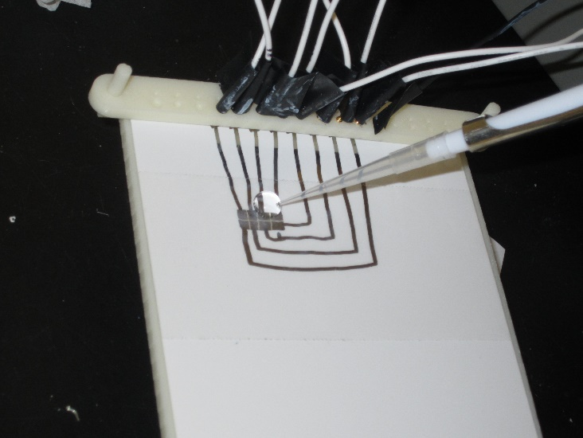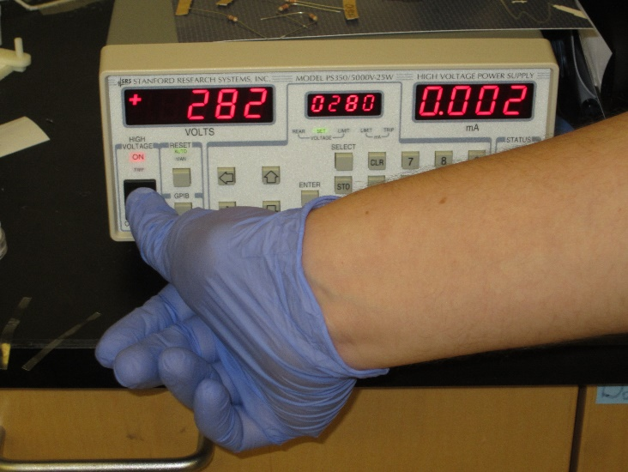

Even if you have a perfectly functional device and base station, you're still not done. The drop size, positioning, and the timing of the electrode switching all affect how it moves.

First, you'll need to get a droplet onto your device. This is actually quite a bit trickier than it sounds since you'll find that due to the hydrophobic treatment, the drop will want to stick to the end of the pipette rather than the surface of your device. Plus, once you do get it off, it may very well go sliding off to a part of your device that doesn't have any electrodes. If you consistently have a problem, use clamps to press the paper substrate down onto the base station to minimize the effect of any dips in the surface. Larger drops are easier to put on since gravity will be strong enough to overcome the surface tension and pull the drop off the end of the pipette.

As a quick rule of thumb, you want your drop to be relatively large compared to your electrodes. The electrowetting effect is generated when a drop overlaps two electrodes, so you want your drop to be large enough that when it is centered on an electrode, it still has a bit of overlap onto the neighboring electrodes. Keep in mind that a larger drop will require more energy to move, so this is a bit of a balancing act to find the perfect droplet size that's not too big or too small. To get the desired drop size, start big and use a micro pipette to slowly pull fluid off of the drop until you reach the desired size.

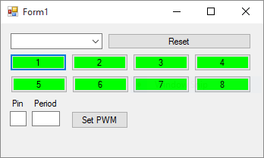 Once you have a drop on the device in an appropriate location overlapping one or more electrodes, turn on the power supply and activate one of the electrodes it's overlapping and verify that you see some movement. The drop will likely move right back to where it started when you turn off the electrode, but it demonstrates that your device at least produces a usable electrowetting effect.

Rapidly toggling an electrode using a PWM scheme can also significantly increase the observed movement without changing any other parameters. The idea is to rock the drop back and forth at its resonant frequency, building up momentum which can be exploited to move the drop much more than it would otherwise.

**TROUBLESHOOTING**

Your devices will likely spend a significant amount of time not working. Since the device itself is passive, there's really only 3 things that can go wrong with the device itself: A bad electrical connection (open/short), too much spacing between the electrodes, or a poor hydrophobic coating. That said, before you throw away your device and start over, make sure that the base station is functioning correctly.

**TROUBLESHOOTING TIPS**

1. Communication

a. Ensure that your PC is connected to the Arduino controller

b. Use a serial terminal to send commands and verify that you're getting a response

c. Ensure that no wires have popped out of the breadboard or the arduino

d. Use a multimeter to verify logic signal is being sent to relays

2. Power

a. Make sure power supply is turned on

b. Verify that the spring probes are lined up with the pads on your device and are making a good connection

c. Check that the power supply current limiter isn't tripping (if it is, DO NOT increase the limit, use a multimeter to check resistances between pads and make sure there isn't a short)

d. Use the multimeter to verify that each pin correctly switches between power and ground on the control signal (if a pin doesn't switch correctly, it could indicate a communication issue or a problem with the relays)

3. Drop movement

a. Verify fixture is level and use shims if needed

b. Test hydrophobic coating on device

c. Build another device (these things are finicky and sometimes refuse to work)

**FURTHER WORK**

The most obvious next step would be to further explore the use of PWM control. Since this is done programmatically, it does not require any modifications to the base station or the device fabrication process.

In terms of improving the process itself, the most obvious improvement would be to use something like an inkjet printer with conductive ink to print the electrical layer. This would provide huge gains in resolution and consistency, and provides further benefits in allowing software to automatically generate and print the electrode arrangement needed for a particular experiment.

While not the most desirable direction, higher voltages are another possibility to overcoming small inconsistencies in the process. Moving to higher voltages will require higher voltage parts, but would provide a stronger electrowetting effect and enable larger drops to be used.

**FINAL WORDS**

It cannot be stressed enough that despite your best efforts, you will likely still build devices that flat out don't work for no obvious reason. There's still a bit of an art to building these devices and any number of small things can happen that can make or break a particular device. Just remember that it took me the better part of a quarter to build a device that worked at all. Hopefully this document serves as a guide and starting point to build from so you don't have to repeat all the trial and error work that I had to do.

**APPENDICES**

**Appendix A: Materials List**

**Device Materials:**

Conductive Ink Marker: AgIC Circuit Marker   
<http://shop.agic.cc/products/circuit-marker>

Paper: HP Advanced Glossy Photo Paper (4x6)  
<http://store.hp.com/us/en/pdp/hp-advanced-glossy-photo-paper-100-sht-4-x-6-in-borderless>

Tape: Gorilla Clear Repair Tape  
<http://www.gorillatough.com/gorilla-clear-repair>

Water Repellent: Rust-Oleum NeverWet  
<http://www.rustoleum.com/en/product-catalog/consumer-brands/neverwet/neverwet-kit>

**Base Station Materials:**

Microcontroller: Arduino Mega  
<https://www.arduino.cc/en/Main/ArduinoBoardMega2560>

Solid State Relay: Toshiba TLP4006G(F)  
<https://www.digikey.com/product-detail/en/TLP4006G(F)/TLP4006GF-ND/1823608>

Spring Probes: Mill-Max 0932-0-15-20-77-14-11-0  
<http://www.digikey.com/product-detail/en/0932-0-15-20-77-14-11-0/ED90345-ND/1873758>

Notification LEDs: Lite-On LTL2R3KGD-EM  
<https://www.digikey.com/product-detail/en/LTL2R3KGD-EM/160-1852-ND/2675131>

Standard lab wire & breadboard (good for up to about 300V)

**High Voltage Supplies (not currently installed)**

1KV Solid State Relay: IXYS CPC1981Y  
<https://www.digikey.com/product-detail/en/CPC1981Y/CLA203-ND/700422>

3KV Wire: CNC Tech 3239-22-1-0500-002-1-TS  
<https://www.digikey.com/product-detail/en/3239-22-1-0500-002-1-TS/CN104W-25-ND/3766917>

Proto Board: Adafruit Perma-Proto Super Pack  
<https://www.adafruit.com/products/591>

**Appendix B: Base Station Circuit Diagrams**

