IMPORT SYSTEM OPERATOR CERTIFICATE
Windows 10
1st STEP:
Search for the “Manage computer certificates” (or “Manage user certificates”) in Start menu.
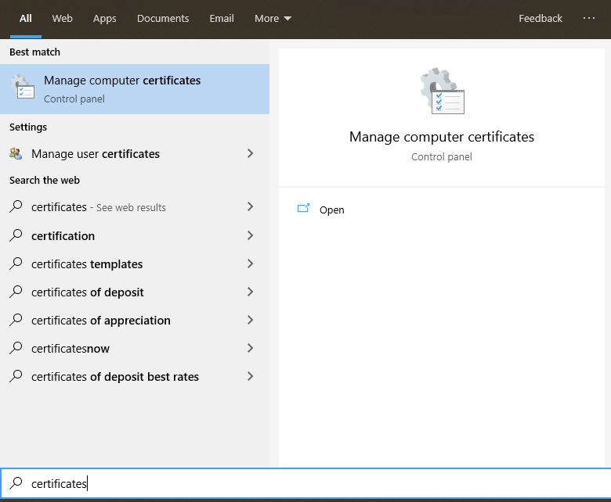

2nd STEP:
Right click on “Personal”, then choose “All Task” -> “Import”
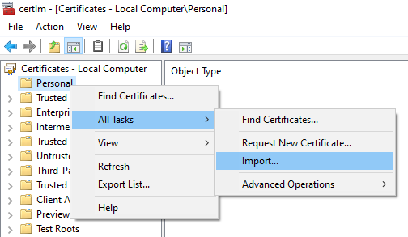

3rd STEP:
Browse your sysop.p12 file, or use the provided one for testing purpose (location: core-java-spring -> certificates -> testcloud2).
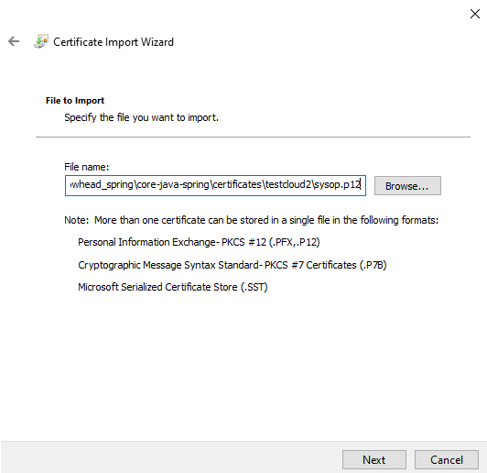
4th STEP:
Enter the password. (Test sysop password: 123456)
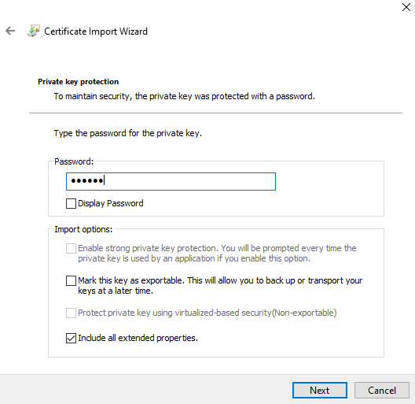
5th STEP:
Select “Personal” certificate store.
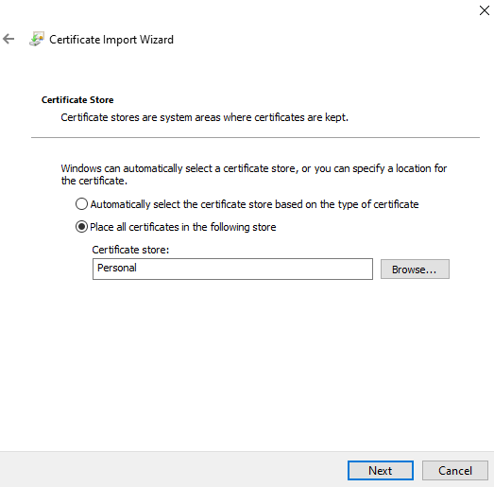
6th STEP:
Hit finish.
