CREATE TRUST STORE
with KeyStore Explorer 5.4.1
KeyStore Explorer is a free GUI tool for managing certificates, which is available for all common operation systems: https://keystore-explorer.org/downloads.html
1st STEP:
Open your cloud p12 certificate file.
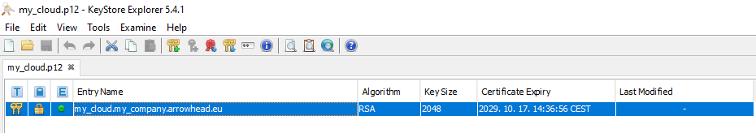

2nd STEP:
Right click on your cloud key pair entry and select “Export Certificate Chain”:


3rd STEP:
Select “Head Only”, “X.509”, tick “PEM” and changed the extension to “.crt”:
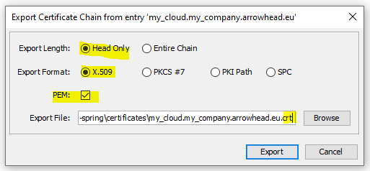

4th STEP:
Go to “File” -> “New” and select “PKCS#12”:
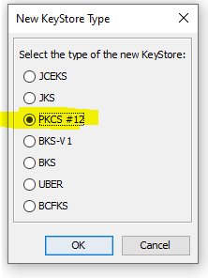

5th STEP:
Click on the “Import trusted Certificate” button and import the “crt” file created just before:
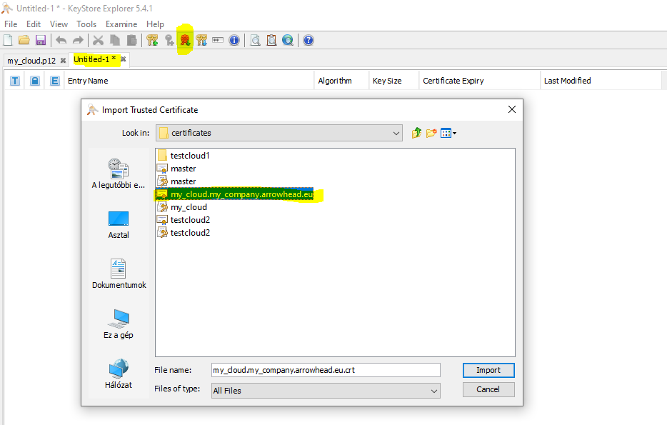

6th STEP:
Set the “KeyStore Password”:
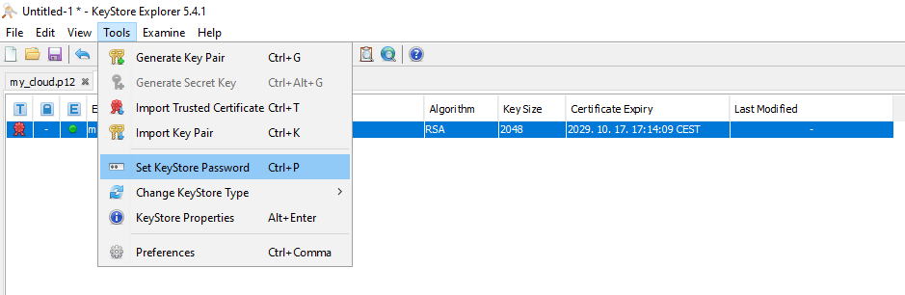

7th STEP:
“File” -> “Saves as” -> truststore.p12

