Import System Operator Certificate

Linux

After starting the Arrowhead Framework in secure mode, while trying accessing the Swagger on <https://localhost:8443> or other secure URL-s you may have faced the following screen:

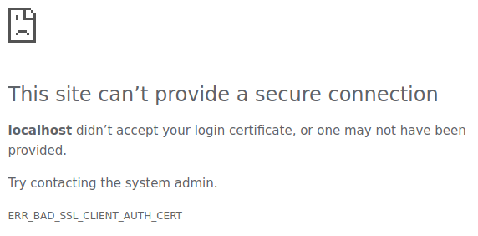

This detailed error message says, you are probably using a wrong certificate, or you are trying to access it without a proper one.

Depending on your settings, you have to use your custom generated certificate or the test certificate. The **sysop.p12** test certificate is found in the **certificates/testcloud2** folder.

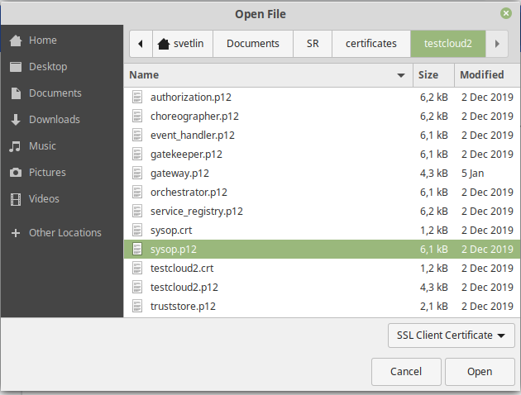

You have to add this certificate to your browser. (Google Chrome is recommended).

In Google Chrome click on the three dots in the upper right corner, then choose Settings -> Advanced -> Manage Certificates.

Or type this in the address bar: chrome://settings/certificates

You will see the following screen, where you have no Arrowhead Certificate installed:

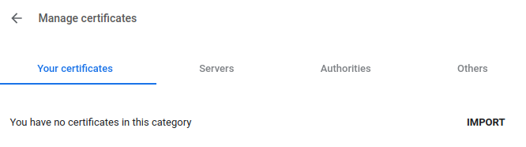

Click on the **Import** button, choose the **sysop.p12** certificate, type in its password, by default is it: 123456.

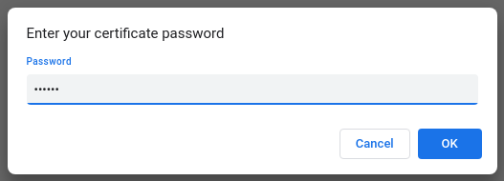

If this step was successful, you will see the imported certificate.

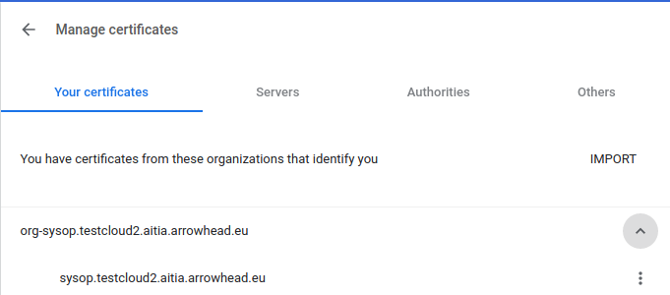

Now try refreshing the browser, in the menu select the sysop one and click OK. The page will now load.

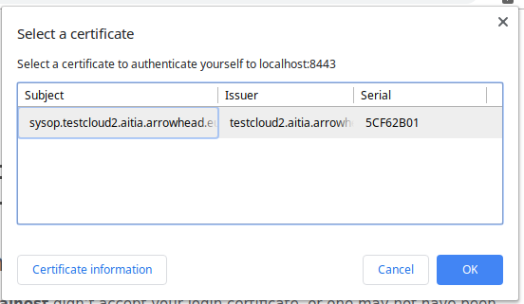

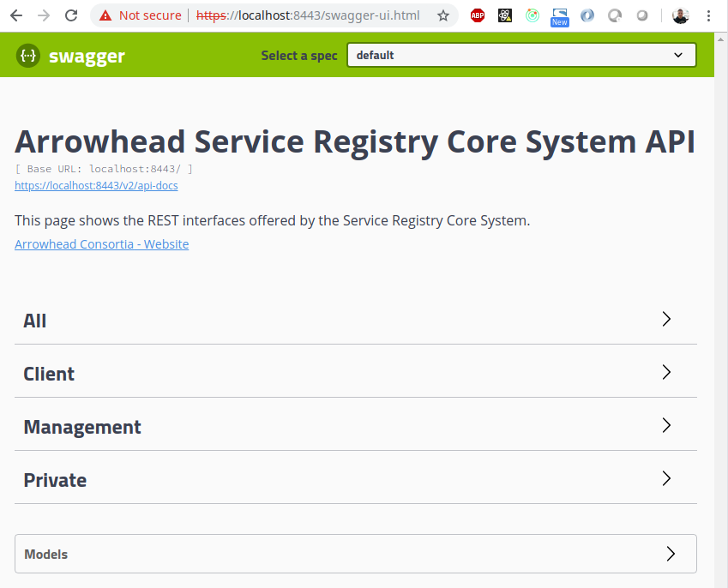

If your common name is invalid, you may face the following screen too:  
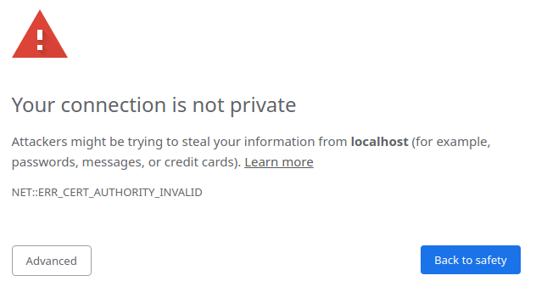

Click on **Advanced** then **Proceed to localhost.**

