Import System Operator Certificate

macOS

After starting the Arrowhead Framework in secure mode, while trying accessing the Swagger on <https://localhost:8443> or other secure URL-s you may have faced the following screen:

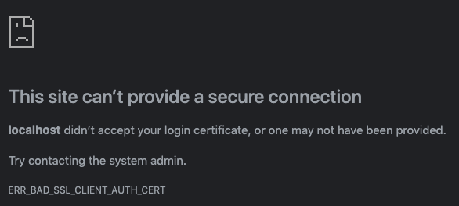

This detailed error message says, you are probably using a wrong certificate, or you are trying to access it without a proper one.

Depending on your settings, you have to use your custom generated certificate or the test certificate. The **sysop.p12** test certificate is found in the **certificates/testcloud2** folder.

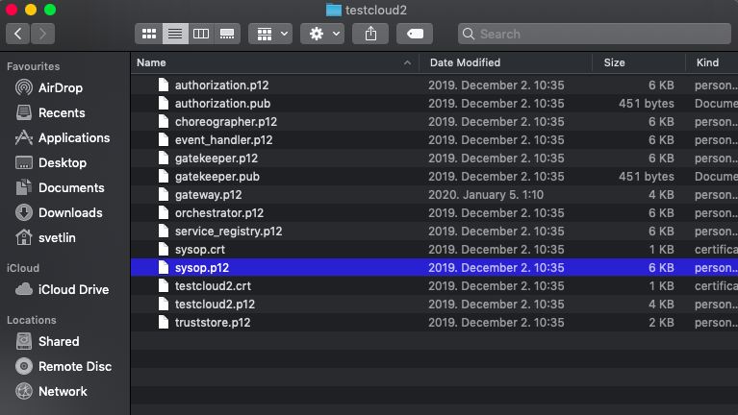

Double click on it. It will ask for its password, by default it is: 123456. It will be imported to your Keychain.

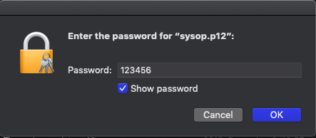

When filtering for arrowhead, you should see the imported certificates:

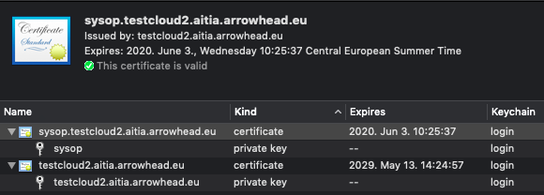

Now try refreshing the browser, in the menu select the sysop one and click OK. The page will now load.

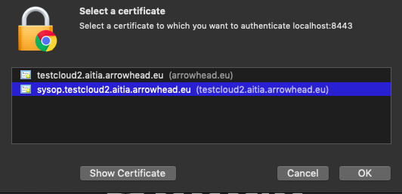

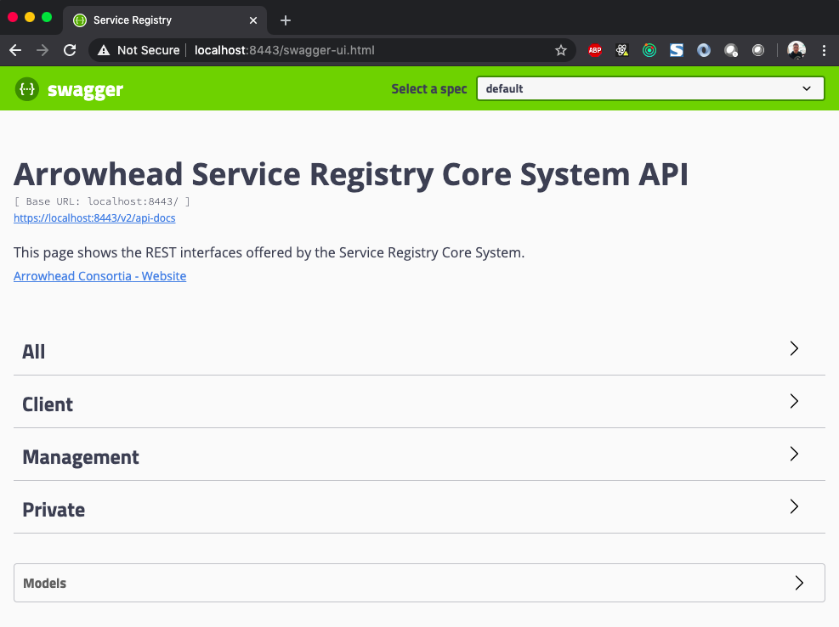

If your common name is invalid, you may face the following screen too:  
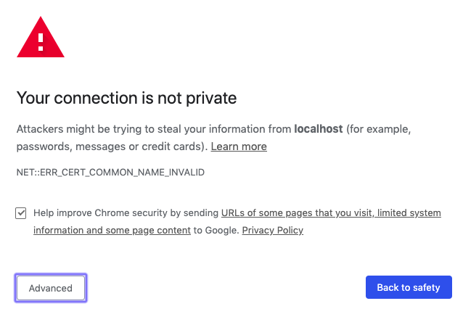

Click on **Advanced** then **Proceed to localhost.**

