# Lab: Functions

Problems for in-class lab for the [Python Fundamentals Course @SoftUni](https://softuni.bg/trainings/2442/python-fundamentals-september-2019). Submit your solutions in the SoftUni judge system at <https://judge.softuni.bg/Contests/1727>

## Grades

Write a function that **receives a grade** between **2.00** and **6.00** and **prints the corresponding grade in words**

* 2.00 – 2.99 - "Fail"
* 3.00 – 3.49 - "Poor"
* 3.50 – 4.49 - "Good"
* 4.50 – 5.49 - "Very Good"
* 5.50 – 6.00 - "Excellent"

### Examples

|  |  |
| --- | --- |
| **Input** | **Output** |
| 3.33 | Poor |
| 4.50 | Very Good |
| 2.99 | Fail |

### Hints

1. Read the grade from the console



1. Then create the function and make the if statements for each case

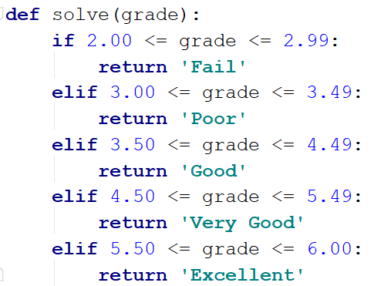

1. Pass the input grade to the function



## Calculations

Create a function that receives three parameters and calculates a result depending on operator. The operator can be '**multiply**', '**divide**', '**add**', '**subtract**' . The input comes as three parameters – two integers and an operator as a string.

### Example

|  |  |
| --- | --- |
| **Input** | **Output** |
| subtract  5  4 | 1 |
| divide  8  4 | 2 |

### Hints

1. Read the input data from the console

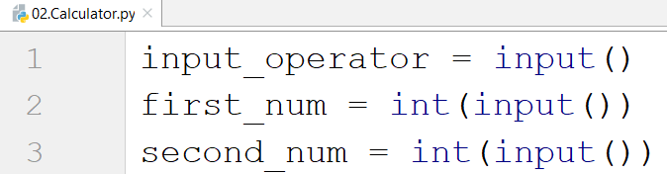

1. Then create the function:

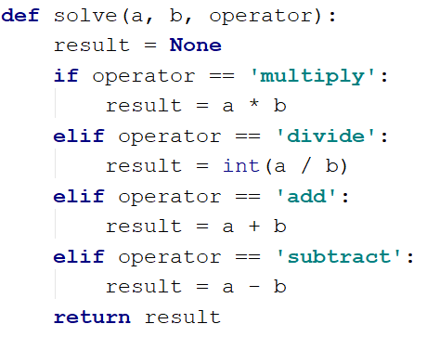

1. Print the result by calling the function and passing it the given parameters
2. **Repeat String**

Write a function that receives a **string** and a **repeat** **count** **n**. The function should return a new string (the old one repeated **n** times).

**Examples**

|  |  |
| --- | --- |
| **Input** | **Output** |
| abc  3 | abcabcabc |
| String  2 | StringString |

**Hints**

1. Read the input data
2. Create the function  
   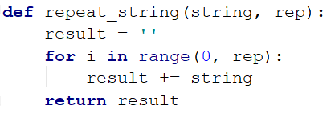
3. Print the result
4. **Orders**

Write a function that calculates the **total** **price** of an order and prints it on the console. The function should receive one of the following products: **coffee, coke, water, snacks**; and a **quantity** of the product. The **prices** for a single piece of each product are:

* coffee - 1.50
* water - 1.00
* coke - 1.40
* snacks - 2.00

Print the result **formatted** to the **second** **decimal** **place**.

**Example**

|  |  |
| --- | --- |
| **Input** | **Output** |
| water  5 | 5.00 |
| coffee  2 | 3.00 |

## Calculate Rectangle Area

Create a function that calculates and **returns** the [area](http://www.mathopenref.com/trianglearea.html) of a rectangle by given width and height:

### Examples

|  |  |
| --- | --- |
| **Input** | **Output** |
| 3  4 | 12 |
| 6  2 | 12 |