IBM
How to Run Lyo OSLC Provider Tests and Generate Assessment Report
Yuhong Yin and Kohji Ohsawa
Last Modified: September 27, 2012
Contents

1. Introduction to the OSLC Test Suite 4
2. Building a RIO Running Environment 5
3. Check out the OSLC Test Suite Code 6
4. Run Tests in the OSLC Test Suite 7
4.1 Run Provider Tests against RIO-CM 7
4.2 Run provider test against RIO-AM 10
4.3 Run provider test against RIO-RM 10
4.4 Run provider test against RTC (a CM Provider) 10
4.5 Run provider test against ClearQuest (a CM Provider) 14
4.6 Run provider test against RQM (a QM Provider) 16
4.7 Run provider test against RAM (a AM Provider) 16
4.8 Run provider test against RRC (a RM Provider) 16
5. Run Tests and Generate OSLC Assessment Report 17
5.1 Set up assessment report working environment 18
5.2 Run the Provider Test using the corresponding xml file 18
5.3 Generate the OSLC Assessment Report 21
5.4 Interpret the OSLC Assessment Report 22
6. Trouble Shooting 23
6.1 Compilation errors in the RIO 23
6.2 Compilation errors in the Test Suite 24
6.3 Run-time errors in the OSLC Test Suite 24
7. How to Search or Report a Test Suite Bug? 26
8. How to Contribute to the OSLC Test Suite? 27
8.1 Process of adding a new test 27
8.2 Process of adding a provider 27

The Open Services for Lifecycle Collaboration (OSLC) is a new approach to solving the problem of integrating lifecycle tools to share data (for example, requirements, defects, test cases, plans, or code) with one another. With more teams within IBM and more companies outside IBM choose to adopt OSLC for integration (either an OSLC service provider or an OSLC service consumer), it is highly desired to have a standard testing solution to assess an OSLC service provider implementation, validate its qualify and accelerate the adoption.

This documentation provides detailed instructions on how to run the OSLC provider JUnit test suite and generate OSLC assessment report.

This documentation will evolve over time.

- Introduction to the OSLC Test Suite
The OSLC test suite is a set of JUnit tests that made available through the Eclipse Lyo project. It is designed to test against an OSLC service provider (in specific domains, such as CM, QM and RM) for its implementation of the OSLC core specification and the corresponding domain specifications.

The roles of the OSLC test suite include:

- As an OSLC assessment assessor
In this role, the test suite will run again a particular OSLC provider and as minimal, make sure the provider passes the OSLC core spec test and the OSLC domain spec test. It provides an assessment report delivering clear and actionable information to be eligible for each OSLC spec.

- As an OSLC quality validator
In this role, the test suite provides functional capabilities to help test an OSLC based solutions, and evolve new or existing OSLC embracing solutions into high quality offerings. It provides reusable test cases to reduce the effort improving the quality of OSLC solution.

- As an OSLC adoption accelerator
In this role, the test suite will consider building canned images for learning OSLC, adding inline comments to test cases, and providing additional documentation.

Read and follow the OSLC test suite wiki page to get the latest updates.
http://wiki.eclipse.org/Lyo/LyoTestSuite

- Building a RIO Running Environment
We recommend that you have a running Reference Implementation (RIO) environment.

Follow the instructions in this wiki page to build a RIO Running Environment.
http://wiki.eclipse.org/Lyo/BuildRIO

Please note that you need to set these Workspace | Preference
Java --> Complier assessment level: set to 1.6
Java --> Installed JRE: point to a Java 1.6 SDK

Please check the “Trouble Shooting” chapter if you run into compilation errors in any of the RIO projects.

- Check out the OSLC Test Suite Code
Follow the instructions in this wiki page to check out the OSLC test suite from the Lyo Git repository.
http://wiki.eclipse.org/Lyo/BuildTestSuite

Please check the “Trouble Shooting” chapter if you run into compilation errors in the test suite project.
- Run Tests in the OSLC Test Suite
Now you are ready to run the OSLC provider tests. Here are some general instructions on running provider tests after you have chosen a provider (domain and test suite).

[1] Make sure the server of that provider is running
[2] Check and verify the parameters specified in the test setup.properties file
[3] Run the tests
[4] Examine the results

It is recommended that you start with running an OSLC provider test against the RIO implementation, with an OSLC domain (CM, QM or RM) that you are interested in.

The following sections start on how to run the RIO provider tests, and then cover basic information about running the provider tests against some Rational Products, such as Rational Team Concert (RTC), ClearQuest, Rational Quality Manager (RQM) and Rational Requirements Composer (RRC).

Run Provider Tests against RIO-CM
This section provides instructions on how to run the provider tests against RIO-CM.

Start the RIO-CM Server
Before running any provider test against the RIO implementation, you must first start the corresponding RIO server.

To start the RIO-CM Server, from “Run” → “Run Configurations …”, find Maven Build | org.eclipse.lyo.rio.cm and click “Run”

After the jetty server started, confirm that you can access Rio-CM server via
http://localhost:8080/rio-cm

The very first time you run this on your machine, you will see the setup page like this:

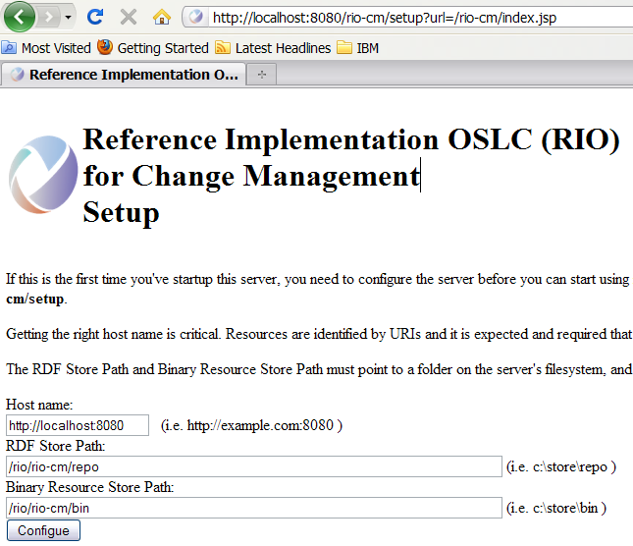

You can enter the defaults for RDF Store Path and Binary Resource Store Path as suggested, and click the “Configure” button.

You will then see a page like the following:

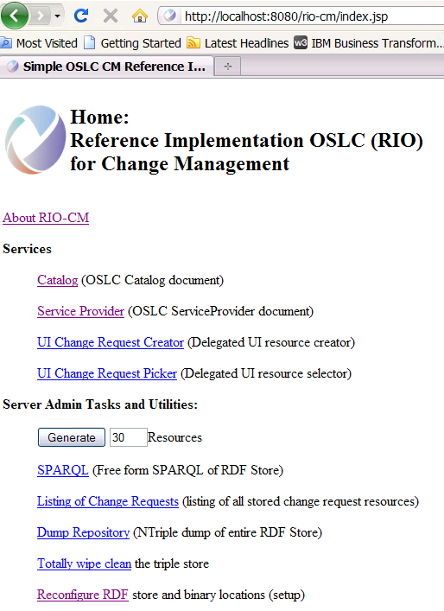

You will use this URL (http://localhost:8080/rio-cm) in OSLC provider test setting later.

Check and verify parameters in the setup.properties file
Refer to the latest update on
http://wiki.eclipse.org/Lyo/BuildTestSuite#Configure_the_OSLC_Test_Suites

Run the Provider Test against RIO-CM Server
Refer to the latest update on
http://wiki.eclipse.org/Lyo/BuildTestSuite#Configure_the_OSLC_Test_Suites

Examine the Test Results
Refer to the latest update on
http://wiki.eclipse.org/Lyo/BuildTestSuite#Configure_the_OSLC_Test_Suites

Run provider test against RIO-AM
To be added.

Run provider test against RIO-RM
To be added.

Run provider test against RTC (a CM Provider)
This section provides instructions on how to run the provider tests against a RTC Server.

Start a RTC Server
First you need to identify a RTC server. You can use your own, or you can use the RTC server hosted on machine “quagmire.rtp.raleigh.ibm.com” if you are an IBM internal user.

Verify that it is running by logining to this URL with user/password of “olsctest/olsctest”
https://quagmire.rtp.raleigh.ibm.com:14443/ccm/admin

It is running milestone versions RTC 4.0.

Check and verify parameters in the setup.properties file
If you want to test out RTC as an OSLC v1 spec provider,
locate config/rtc/rtc-setupv1.properties file and adjust accordingly

If you want to test out RTC as an OSLC v2 spec provider,
locate config/rtc/rtc-setupv2.properties file and adjust accordingly

If you are not using the default configure files/template files because you cannot use the RTC server hosted on “quagmire.rtp.raleigh.ibm.com”, you will need to change parameters in various config files or template files for the server you are testing.

Follow these steps:

- RTC server
  - Submit a defect type work item called “templatedDefect”.

  - Figure out and write down the ID of your RTC project area
To obtain this information, access the work item catalog
https://quagmire.rtp.raleigh.ibm.com:14443/ccm/oslc/workitems/catalog.xml

Look for the <oslc_disc:details ..> entry, for instance
<oslc_disc:details rdf:resource="https://quagmire.rtp.raleigh.ibm.com:14443/ccm/process/project-areas/_YBdMgJhUEeGB3JzLyv0BEg"/>

Also look for <oslc_disc:services ..> entry, for instance
<oslc_disc:services rdf:resource="https://quagmire.rtp.raleigh.ibm.com:14443/ccm/oslc/contexts/_YBdMgJhUEeGB3JzLyv0BEg/workitems/services.xml"/>

  - Figure out and write down the rdf:resource of the rtc_cm:filedAgainst category and the rdf:resource for the rtc_cm:type type.

You can get a list of work items in the project area from this URI
https://quagmire.rtp.raleigh.ibm.com:14443/ccm/oslc/contexts/_YBdMgJhUEeGB3JzLyv0BEg/workitems

Then find one work item from the list, for instance
<rdfs:member rdf:resource="https://quagmire.rtp.raleigh.ibm.com:14443/ccm/resource/itemName/com.ibm.team.workitem.WorkItem/106"/>

Do a “GET” call with these http headers
OSLC-Core-Version: 2.0
Accept: application/rdf+xml
<rtc_cm:type rdf:resource="https://quagmire.rtp.raleigh.ibm.com:14443/ccm/oslc/types/_YBdMgJhUEeGB3JzLyv0BEg/defect"/>

<rtc_cm:filedAgainst rdf:resource="https://quagmire.rtp.raleigh.ibm.com:14443/ccm/resource/itemOid/com.ibm.team.workitem.Category/_YmXa8phVEeGB3JzLyv0BEg"/>

- rtc-setupv2.properties
Here is a list of entries in rtc-setupv2.properties file that you must adjust.

Parameters | Example
baseUri | https://quagmire.rtp.raleigh.ibm.com:14444/ccm/oslc/workitems/catalog
formUri | https://quagmire.rtp.raleigh.ibm.com:14444/ccm/authenticated/j_security_check
userId | ADMIN
Pw | ADMIN

- rtc-template2.xml
Here is a list of entries in rtc-template2.xml file that you must adjust.

<rtc_cm:type rdf:resource="https://quagmire.rtp.raleigh.ibm.com:14443/ccm/oslc/types/_coUGEJhYEeGB3JzLyv0BEg/defect"/>
You obtain this information from step 1.3)

<rtc_cm:filedAgainst rdf:resource="https://quagmire.rtp.raleigh.ibm.com:14443/ccm/resource/itemOid/com.ibm.team.workitem.Category/_dKdw4phYEeGB3JzLyv0BEg"/>
You obtain this information from step 1.3)

- rtc-json-template2.json
Here is a list of entries in rtc-json-template2.xml file that you must adjust.

"dcterms:type":{"rdf:resource":"https:\/\/quagmire.rtp.raleigh.ibm.com:14443\/ccm\/oslc\/types\/_coUGEJhYEeGB3JzLyv0BEg\/defect"}
You obtain this information from step 1.2)

"rtc_cm:filedAgainst":{"rdf:resource":"https:\/\/quagmire.rtp.raleigh.ibm.com:14444\/ccm\/resource\/itemOid\/com.ibm.team.workitem.Category\/_dKdw4phYEeGB3JzLyv0BEg"}
You obtain this information from step 1.3)

Run the Test Suite

If you want to test out RTC as an OSLC v1 spec provider, find and run the OSLC V1 RTC.launch; If you want to test out RTC as an OSLC v2 spec provider, find and run the OSLC V2 RTC.launch.

Here is a screenshot of the “OSLC V2 RTC” junit test launcher.

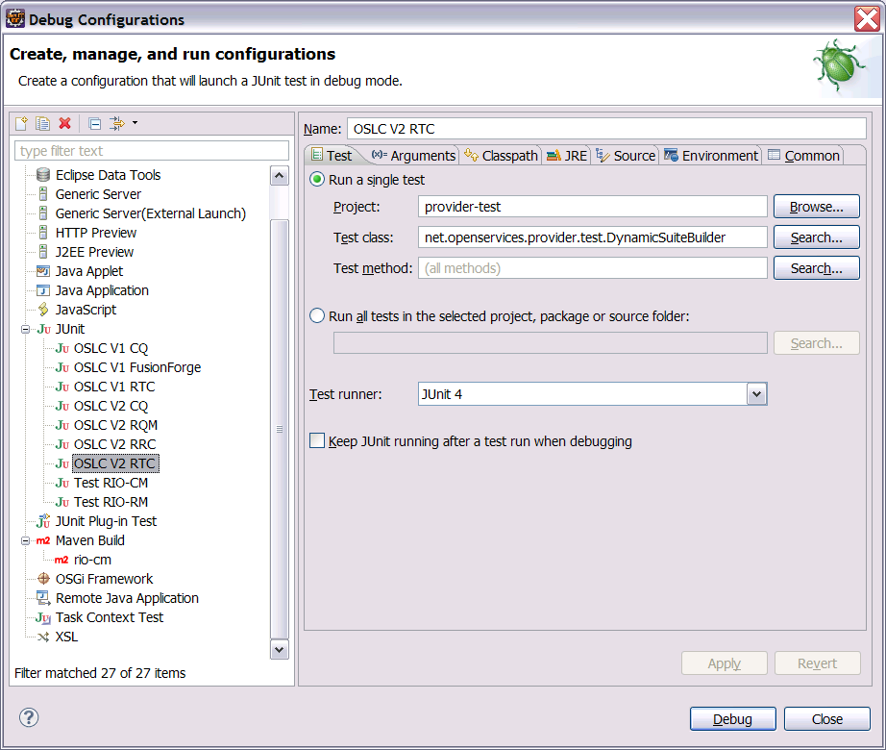

Examine the Test Results
You should see the test results like shown below.
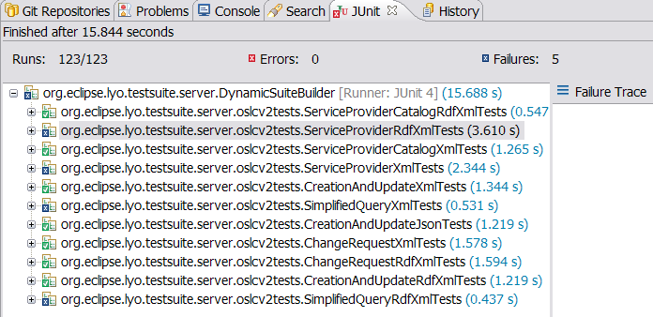

If your result is very different (with more errors or failures) from what is shown above, you need to go back and check your RTC related config files and template files.

Run provider test against ClearQuest (a CM Provider)
This section provides instructions on how to run the provider tests against a ClearQuest Server.

Start a ClearQuest Web Server
First you need to identify a ClearQuest server. You can use your own, or you can use the CQWeb server hosted on machine “quagmire.rtp.raleigh.ibm.com” if you are an IBM internal user.

Verify that it is running by logining to this URL with user/password of “admin/” to dbset “7.0.0”.
https://quagmire.rtp.raleigh.ibm.com/cqweb
or
http://unagi.rtp.raleigh.ibm.com/cqweb/

It is running milestone versions of ClearQuest.

CQ as v1 provider vs. as v2 provider
If you want to test out ClearQuest as an OSLC v1 spec provider,
locate config/cq/OSLC V1 CQ.launch file and run it.

If you want to test out ClearQuset as an OSLC v2 spec provider,
locate config/cq/OSLC V2 CQ.launch file and run it.

CQ Configurations Files
All the CQ configuration files are located off directory config/cq

Config files when running CQ as an OSLC v2 provider.
Config file | Description
cq-setupv2.properties | Main configuration file for v2 testing
cq-template2.xml | Template used by CreateAndUpdateRdfXmlTests.java  and CreateAndUpdateXmlTests.java  (in package org.eclipse.lyo.testsuite.oslcv2)  to create a new change request
cq-json-template2.json | Template used by CreateAndUpdateJsonTests.java  (in package org.eclipse.lyo.testsuite.oslcv2)  to update a newly created change request
cq-update2.xml | Template used by CreateAndUpdateJsonTests.java  (in package org.eclipse.lyo.testsuite.oslcv2)  to create a new change request
cq-json-update2.json | Template used by CreateAndUpdateJsonTests.java  (in package org.eclipse.lyo.testsuite.oslcv2)  to update a newly created change request

Config files when running CQ as an OSLC v1 provider.
Config file | Description
cq-setupv1.properties | Main configuration file for v1 testing
cq-template1.xml  cq-json-template1.json | Template used by CreateAndUpdateTests.java  (in package org.eclipse.lyo.testsuite.server.oslcv1tests)  to create a new change request
cq-update1.xml  cq-json-update1.json | Template used by CreateAndUpdateTests.java  (in package org.eclipse.lyo.testsuite.server.oslcv1tests)  to update a newly created change request

Run provider test against RQM (a QM Provider)
This section provides instructions on how to run the provider tests against RQM.

The default configuration files for RQM runs against a RQM4.0 instance hosted on quagmire
https://quagmire.rtp.raleigh.ibm.com:14443/qm

You need to change the following configuration files and contents if you run against your own RQM server.

RQM configuration files: config/rqm/rqm-setupv2.properties
config/rqm/rqm-templates2.xml
config/rqm/rqm-update2.xml

4.6.1 rqm-setupv2.properties

This is the main configuration file that specifies base URI of the RQM server and other information needed by the tests. Please follow the comments embedded inside the file to understand parameters and their values.

4.6.2 rqm-templates2.xml

This configuration file is used by CreateAndUpdate*Tests.java
The default file is a template for creating a Test Script RQM resource.

4.6.3 rqm-update2.xml

This configuration file is used by CreateAndUpdate*Tests.java
The default file is a template for updating a Test Script RQM resource.

Run provider test against RAM (a AM Provider)

Run provider test against RRC (a RM Provider)
To be added.
- Run Tests and Generate OSLC Assessment Report
This section provides information about running the provider tests with a goal to generate an OSLC assessment report for a particular OSLC provider.

The assessment toolkit is now available in the Lyo TestSuite project. You should be seeing the assessment directory like this:

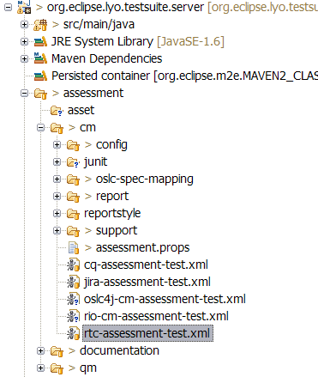
Right now, the assessment toolkit has support for OSLC CM providers (off and OSLC QM providers. Support for other OSLC domains will be added.

Here is a quick walk-through of the assessment toolkit folder structure.

assessment/cm
The “cm” folder contains mappings, report templates and properties files for OSLC CM providers.

assessment/qm
The “qm” folder contains mappings, report templates and properties files for OSLC CM providers.

assessment/documentation
The “documentation” folder contains instructions on how to run the Lyo TestSuite and generate assessment report.

Set up assessment report working environment
Locate the assessment.props file from /assessment/cm
Edit it to provide the location of your eclipse_home directory and the location of your home directory (top). For examples,

eclipse_home=C:/Eclipse36/eclipse
This is your eclipse home directory.
top=C:/Documents and Settings/yyin
This is the directory that contains the .m2 folder.
The assessment tool references jars off the .m2 folder.
provider=RTC3.0.1.1
Use this parameter to specify the name and version of the OSLC provider you test against. It is for reporting and categorizing purpose. In this example, a folder called “RTC3.0.1.1” will be created to gather the Junit test results and report.

Run the Provider Test using the corresponding xml file
Prerequisite: check to make sure that the OSLC service provider server is running.

These are several assessment test xml files off the /assessment/cm directory.
For instances,
rio_cm-assessment-tests.xml
This is for testing against the RIO CM server.
rtc-assessment-test.xml
This is for testing against a RTC server.

Choose one that corresponds to your test interest.

Let’s use the rtc-assessment-test.xml as an example here.

Find the rtc-assessment-test.xml, right click it, from Run As … |Ant Build … to bring up the “Edit configuration and launch” dialog

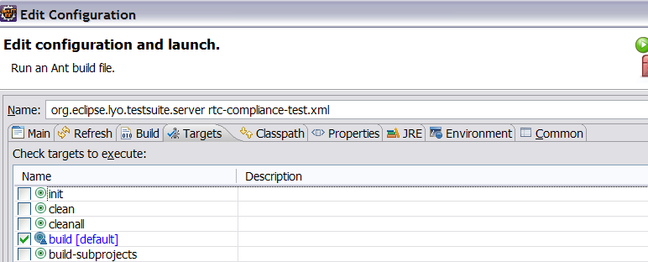

Click the “Classpath” tab, add “ant-contrib-1.0b3.jar” via the “Add External JARs…” button.
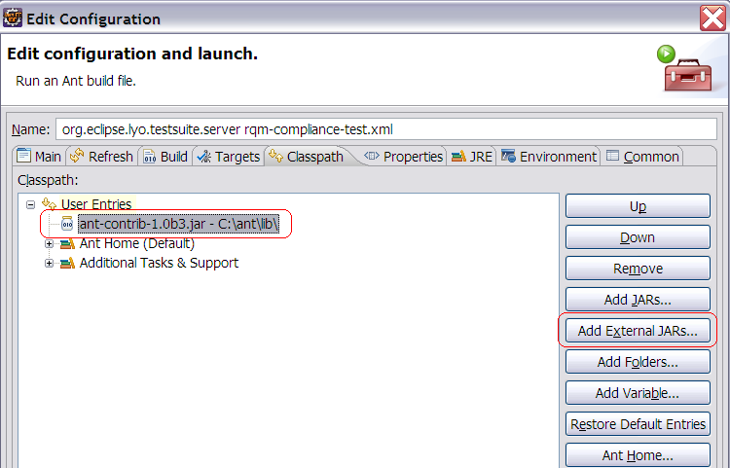

Click the “JRE” tag, in the JVM argument, enter “-Dprops=../../config/rtc/rtc-setupv2.properties” if this is not there.
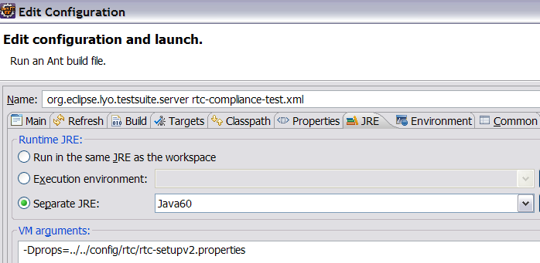

Go to the Target tab, choose the build target of “Build” and click “Run”.

This build should be successful. If not, check the “Trouble Shooting” chapter.

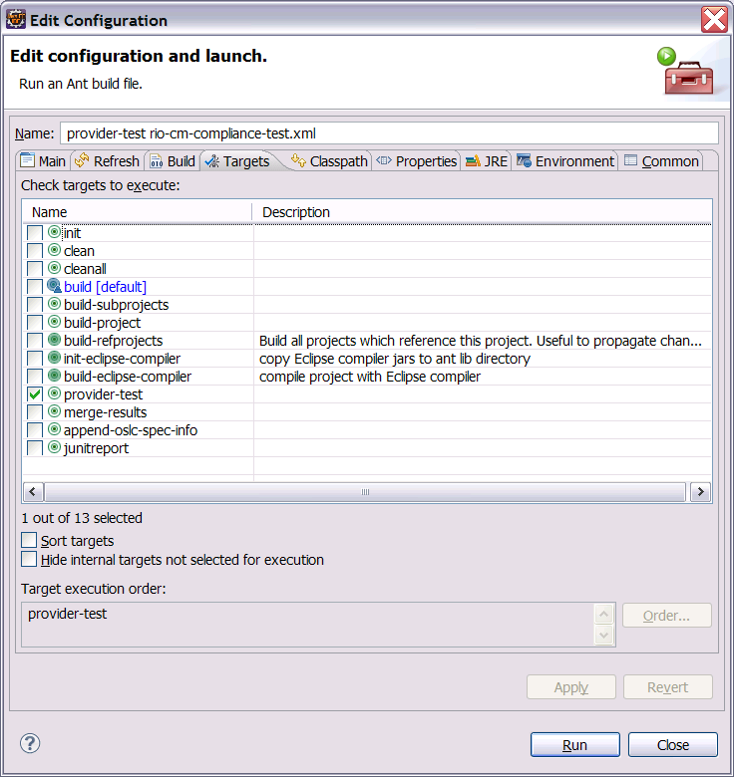
The Junit test will start.

Generate the OSLC Assessment Report

Run the build target “junitreport” (which in turn runs “merge-results” and “append-oslc-spec-info” to generate an OSLC assessment report based on the provider test you run in previous chapter.

Now you can view the generated OSLC assessment report OSLCAssessmentReport.html file from the proper report tree hierarchy. For instance,
assessment/cm/report/rtc/ has the report for RTC
assessment/cm/report/rio-cm/ has the report for RIO-CM

Here is a screenshot of the assessment report when running against a RTC 3.0.1.1 server.
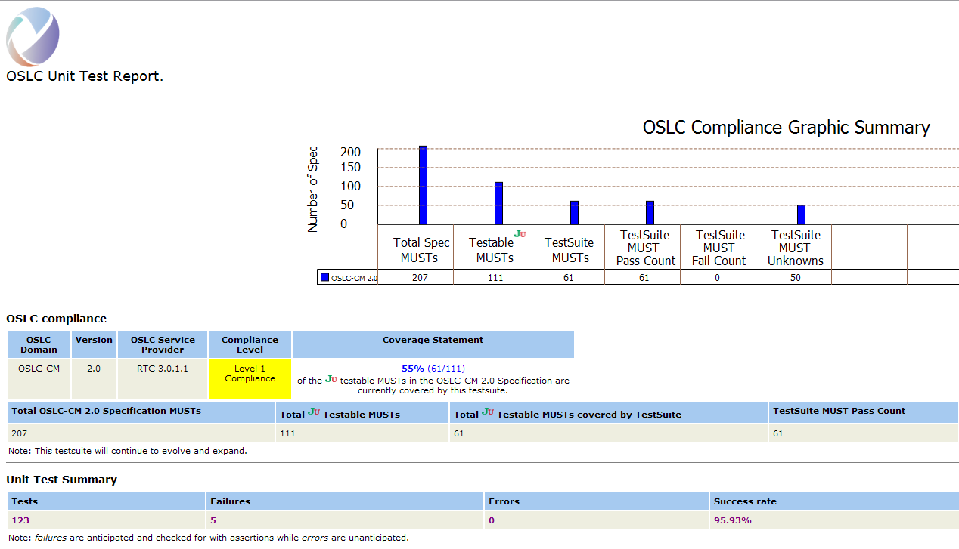

Interpret the OSLC Assessment Report

The assessment report HTML page currently contains the following useful information:
- Total number of the MUST requirements in the an OSLC specification
- Total number of the JUnit Testable MUST requirements in an OSLC specification
- Total number of JUnit Testable MUST requirements covered by the OSLC test suite
- Statement about the test coverage calculated using above numbers.
- Total passed tests for MUST requirements
- Total failed tests for MUST requirements
- Details information about what tests passed or failed

- Trouble Shooting
This section serves a trouble shooting guidance to resolve compilation or run-time errors.

Compilation errors in the RIO
Here are some common errors for the RIO projects.

Error: Import xxx cannot be resolved
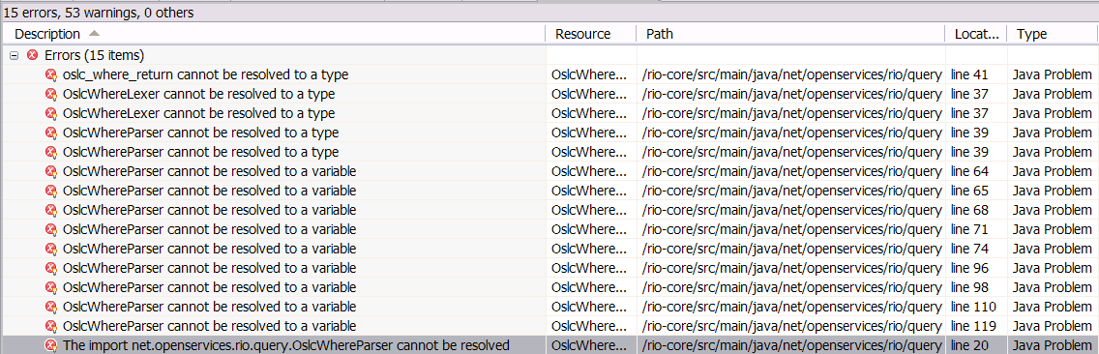

Solution: You can resolve these errors by adding a generated code folder to the project classpath.

For instance, bring up the “Java Build Path” properties page for the project in question.
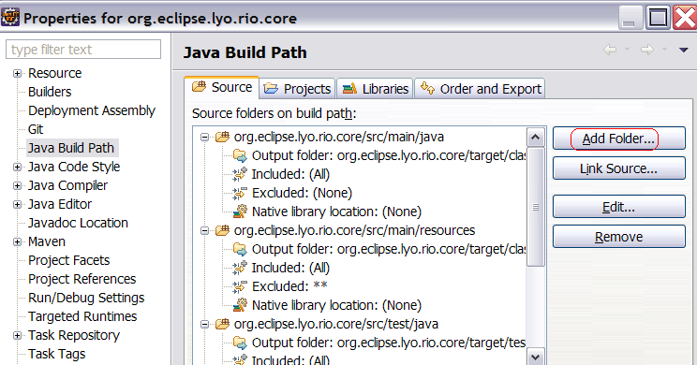

Click the “Add Folder …” button and select the target | generated-sources | antlr3
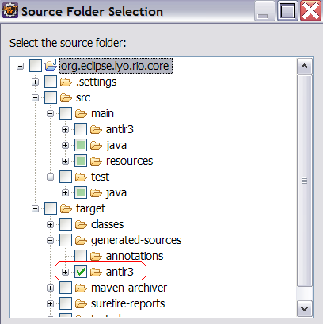

Click “Ok” and rebuild this project.

Compilation errors in the Test Suite
Here are some compilation errors and solutions for the OSLC Test Suite.

6.2.1 Error: xxx
To be added.

Run-time errors in the OSLC Test Suite
Here are some run-time errors and solutions for the OSLC Test Suite.

Error: net/sf/antcontrib/antcontrib.properties.
Error: “[taskdef] Could not load definitions from resource net/sf/antcontrib/antcontrib.properties. It could not be found. It could not be found.”

You can fix this by adding “ant-contrib-1.0b3.jar” via the “Add External JARs…”.

Error: NullPointerException
This type of errors is normally caused by inconsistent contents in your workspace, or by incorrect entries in test config files or the template files, or other issues.

Solution: Start by refreshing to the Test Suite project, running a Maven Clean, and then a Maven Install.

If the NPE still exists, go back read carefully about guidance in previous chapters on how to supply the entries in the config files and the template files.

Error: initializationError
This type of errors is normally caused by incorrect entries in test config files or the template files.

Solution: Go back read carefully about guidance in previous chapters on how to supply the entries in the config files and the template files.

If you still have issues, follow instructions in the next chapter to submit requests on extending the trouble shooting guidance.

Error: The first argument to the non-static Java function 'replace' is not a valid object reference.
Error:

[xslt] Loading stylesheet /Users/sam/git/org.eclipse.lyo.testsuite/org.eclipse.lyo.testsuite.server/assessment/cm/reportstyle/junit-noframes.xsl
[xslt] : Error! The first argument to the non-static Java function 'replace' is not a valid object reference.
[xslt] : Error! Could not compile stylesheet
[xslt] : Fatal Error! Could not compile stylesheet Cause: Cannot convert data-type 'void' to 'reference'.
[xslt] Failed to process

This is a bug introduced in Java 6 build 32. It is worked around in ant-1.9.1, planned for Eclipse 4.4. In the meantime, you might need to run the final junitreport goal from the command-line. Here is an example. (Commands on Windows will be different.)

One time setup:

$ mkdir -p ~/.ant/lib
$ cp /path/to/ant-contrib-1.0b3.jar ~/.ant/lib

Then run:

$ cd org.eclipse.lyo.testsuite.server/assessment/cm/
$ ant -f rtc-assessment-test.xml -Dprops=../../config/rtc/rtc-setupv2.properties junitreport

See discussion at

http://stackoverflow.com/questions/10536095/ant-junit-build-error-inside-eclipse
- How to Search or Report a Test Suite Bug?
OSLC test suite related issues and enhancement requests are tracked in Eclipse Bugzilla system. Here is the home page.

https://bugs.eclipse.org/bugs/

To search for a bug,
Click the orange “Search” icon and go the “Advanced Search” tab and query on unresolved records for Product= Technologies | Lyo and Component=TestSuite.

To report a bug,
You need to create an account if you don’t have one yet.
To do this, click the blue “Open a New Account” icon and follow the instructions.

Login using your account, click the green “File a Bug” icon, select Eclipse Lyo project (Other projects |more) as affected by this problem. In step 2 of the process, set component = TestSuite.

We encourage you to report bugs found during the use of the OSLC Test Suite.

- How to Contribute to the OSLC Test Suite?
Please follow the Lyo test suite wiki page to understand the process.
http://wiki.eclipse.org/Lyo/LyoTestSuite

8.1 Process of adding a new test

8.2 Process of adding a provider

