EMF FeatureMaps

June 24, 2004 (draft)

This document describes the FeatureMap class in EMF and shows how it can be used to automatically implement derived features in a model and how it is also used to manage repeating model groups in XML Schema based models.

Multiple features and cross-feature order

Sometimes when we design a model, we’re faced with a conflict between maintaining data in a single feature versus dividing it among multiple features. Consider the following simple example of a model that manages purchase orders for some store or supplier:

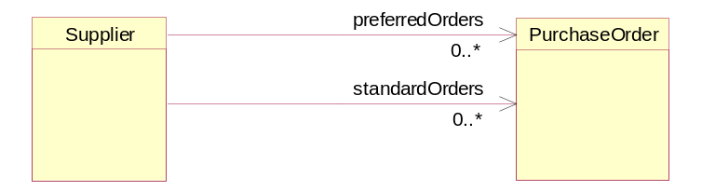

In this model we use two references, preferredOrders and standardOrders, to maintain the purchase orders according to their customer’s status: standard or preferred. If, however, it was important to maintain the purchase orders in, for example, the order in which they arrived, we would instead want to model this using a single reference like this:

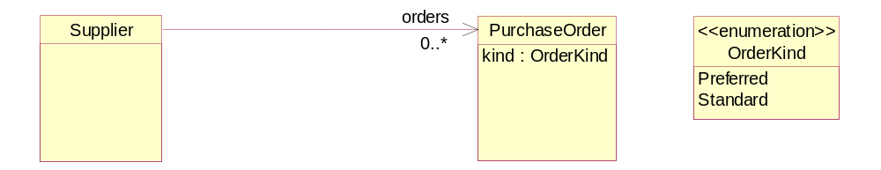

In this case, we maintain all the purchase orders in a single orders list, but we need to add the kind attribute to class PurchaseOrder to keep track of the preferred or standard status of each purchase order. Alternatively, we could define all three references and store each purchase order in two lists (orders and either preferredOrders or standardOrders, depending on its kind):

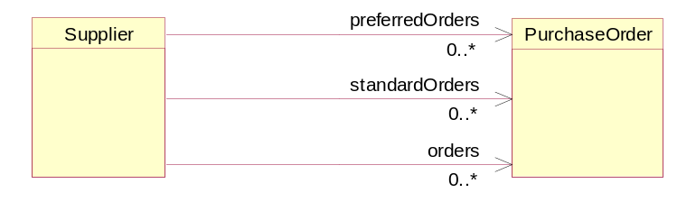

To avoid the redundant storage and having to keep multiple lists in sync, this kind of arrangement is most commonly implemented by making some of the references derive (that is, be computed) from others. For example, we could use the kind attribute, from the previous diagram, to make the preferredOrders and standardOrders references derive from the orders reference, based on the kind value:

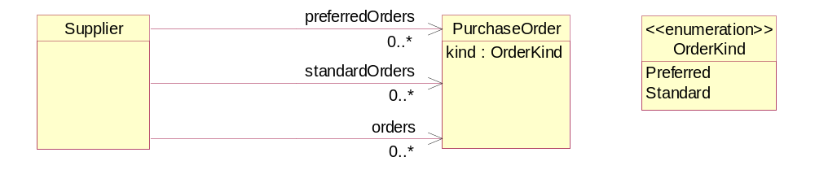

In this model, the preferredOrders and standardOrders references would be volatile, transient, and non changeable, and then implemented by iterating over and filtering the orders reference. For example, the getPreferredOrders() method would look like this:
public EList getPreferredOrders() {
ArrayList preferredOrders = new ArrayList();
for (Iterator iter = getOrders().iterator(); iter.hasNext(); ) {
PurchaseOrder order = (PurchaseOrder)iter.next();
if (order.getKind() == OrderKind.PREFERRED_LITERAL)
preferredOrders.add(order);
}
return new EcoreEList.UnmodifiableEList(this,
POPackage.eINSTANCE.getSupplier_PreferredOrders(),
preferredOrders.size(), preferredOrders.toArray());
}
With this design, a purchase order in the orders list will also appear in one of the preferredOrders or standardOrders references, depending on the value of its kind attribute. A purchase order can only be added to or removed from the standardOrders or preferredOrders reference by adding it to or removing it from the orders reference, or by changing its kind attribute. The two derived lists are themselves not directly modifiable.

An instance of this model might look something like this:

S1
PO1
PO2
PO3
PO4
orders
standardOrders
preferredOrders
kind=Standard
kind=Preferred
kind=Standard
kind=Preferred

A better, but significantly more complicated, solution to this problem would not declare the preferredOrders and standardOrders references as non changeable, but instead would implement them using specialized lists that provide the entire EList API (including add and remove) by delegating to the orders list. For example, an add() operation on the preferredOrders list would delegate through to add() on the orders list, and would also set the kind of the purchase order to Preferred. Because of the complexity, however, the read only approach is generally preferred.

The ExtendedPO2 model in Chapter 12 of [Ref Eclipse Modeling Framework] used this pattern to solve a similar problem. There, two references, pendingOrders and shippedOrders, were derived form the orders reference, based on a status attribute in class PurchaseOrder. This approach worked well in that example, but is less desirable here. The difference in this example is that, unlike the status attribute in the ExtendedPO2 model, the kind attribute is unchanging over time; a purchase order’s kind is intended to be set only once (for example, immediately after the object is created). Changing the kind of a purchase order that is in the orders list would have the undesirable side effect of removing it from one of the derived lists and adding it to the other list.

Ideally, we would like to implement this without the kind attribute or any extra state information in a purchase order at all. To do that, however, we would need to somehow “tag” the entries in the orders list themselves with the equivalent type information:
Fortunately, EMF provides a special kind of list for doing this, FeatureMap, where each entry is tagged with the feature of a derived list, like preferredOrders or standardOrders, to which it belongs. Better yet, the EMF code generator understands this pattern, so the implementation can be completely generated.
S1
PO1
PO2
PO3
PO4
orders
standardOrders
preferredOrders
S
S
P
P

FeatureMap-derived features

A FeatureMap is simply an EList subclass whose elements are feature-value pairs, defined by the interface FeatureMap.Entry:
public interface FeatureMap extends EList
{
public interface Entry
{
EStructuralFeature getEStructuralFeature();
Object getValue();
}

...
}
In the case of a derived multiplicity-1 feature, only one entry for that feature, at most, should ever appear in the list. For a multiplicity-many feature, the backing FeatureMap will contain one entry for each individual value of the derived feature, as opposed to a single entry whose value is the feature’s value-list itself. The FeatureMap interface provides a number of convenience methods, one of which can be used to retrieve the list-view for such a feature:

EList list(EStructuralFeature feature);

Other convenience methods provide direct access to the feature or value at a specific index in the list:

EStructuralFeature getEStructuralFeature(int index);
Object getValue(int index);
Object setValue(int index, Object value);

Methods are also provided to get or set the value of a specific single-valued feature in the list, or to add a value to a multi-valued one:

Object get(EStructuralFeature feature, boolean resolve);
void set(EStructuralFeature feature, Object object);
boolean add(EStructuralFeature feature, Object value);

These methods, and others in the FeatureMap interface, provide a Map-like API for accessing entry values, keyed by a feature – that’s why it is named FeatureMap instead of just EntryList, or something like that.

Given this powerful convenience class, you may be wondering how to use it to implement derived features, such as the preferredOrders and standardOrders references described above. Looking at the interface, you probably have some idea how you might go about programming our purchase order example, but the answer is actually simpler than you might expect. By defining a multiplicity-many EAttribute of type FeatureMap.Entry and adding a couple of EAnnotations to your model, you can make the EMF code generator generate the complete implementation for you. Here’s how you do it in UML:

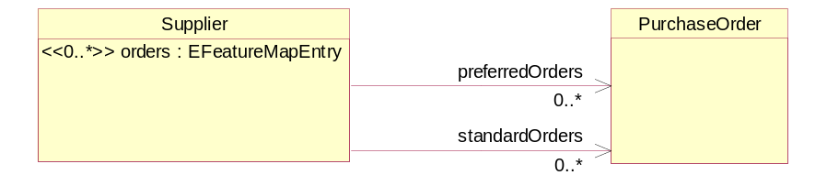

(Note: I think that we should change the importer to alternatively allow the orders feature to be defined in UML as a third reference to PurchaseOrder as in the previous diagram. I think that providing the kind=group annotation would be sufficient information to indicate that it maps to a FeatureMap implementation)

The orders attribute must be a data type with instance class FeatureMap.Entry. The built-in Ecore data type, EFeatureMapEntry, is such a data type:

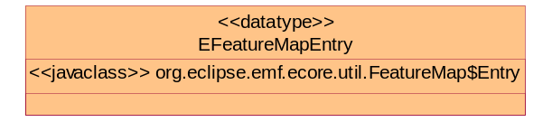

When defining these features, we need to indicate that the preferredOrders and standardOrders implementations are to be derived from the orders feature. To do this, we mark the two references as transient and volatile, in the usual way, but rather than hand coding the implementation methods, we annotate the Ecore model so that the derived implementations will be generated for us. EAnnotations with source URI set to
http:///org/eclipse/emf/ecore/util/ExtendedMetaData, are used for this purpose.

To indicate that the orders attribute will be used to combine (a “group” of) other features, we add to it an ExtendedMetaData-type EAnnotation with a single details entry with key=”kind” and value=”group”. For the two derived references, preferredOrders and standardOrders, we also add such an EAnnotation, but this time with a details entry with key=”group” and value=”#orders”, to indicate that they are derived from the orders (group) attribute.

In Rational Rose, we can use the Ecore page of the Association Specification dialog to set these annotations. For example, we would set the annotation property of the preferredOrders reference like this:

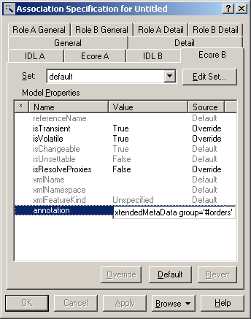

The syntax of the annotation property in Rose is a source URI followed by one or more details key=value pairs, so for our example we would set it to the value: http:///org/eclipse/emf/ecore/util/ExtendedMetaData group='#orders'.

If, instead of using UML, we wanted to define this same model using XML Schema, it would be even easier:
<xsd:complexType name="Supplier">
<xsd:sequence>
<xsd:choice maxOccurs="unbounded" ecore:name="orders">
<xsd:element name="preferredOrders" type="PurchaseOrder"/>
<xsd:element name="standardOrders" type="PurchaseOrder"/>
</xsd:choice>
...
</xsd:sequence>
</xsd:complexType>
In XML Schema, a repeating choice (that is, with maxOccurs > 1) maps to exactly this pattern (that is, the importer would automatically add the EAnnotations to the model). The choice represents a heterogeneous list of the elements defined within it; it represents the orders list in our example. The choice, itself, is not named in an XML Schema, so EMF supports the extended attribute ecore:name to name it. As you can see, we set the name to the value “orders”, highlighted in bold in the schema. If we had not, the FeatureMap feature (orders) would have instead been given a default name of group (possibly followed by a number in the case of conflict, for example group1).

Using either of the model definitions (UML or XML Schema), we can import the model and generate the implementation classes. As expected, the generated Supplier interface looks like this:
public interface Supplier extends EObject
{
FeatureMap getOrders();
EList getPreferredOrders();
EList getStandardOrders();
}
The generated getOrders() method in class SupplierImpl simply creates a default generic FeatureMap implementation class, BasicFeatureMap, like this:
public FeatureMap getOrders() {
if (orders == null) {
orders = new BasicFeatureMap(this, POPackage.SUPPLIER__ORDERS);
}
return orders;
}
The preferredOrders and standardOrders references implementations delegate to the list() method of the orders FeatureMap. For example, the getPreferredOrders() method is implemented as follows:
public EList getPreferredOrders() {
return
(FeatureMap)getOrders()).list(POPackage.eINSTANCE.getSupplier_PreferredOrders());
}
Using these implementations, we can now add, remove or move purchase orders in any of the three lists, and the others will automatically be synchronized.

