Enabling Logical Model Integration in the Eclipse Platform
Abstract
The purpose of this document is to capture the requirements related to the integration of logical models into the Eclipse Platform. It does so by first presenting the set of model characteristics that are exhibited by different logical models. Following this, various scenarios involving logical models are presented is such a way as to describe the way things are and the way things could be. This is not to be taken as a statement that things will be made to work this way. Only that it would be desirable if it could be done.
The goal of this document is to capture the scenarios involving logical models so that the parties involved (i.e. logical model tooling teams and the Eclipse Platform team) are confident that the scope of the problem is understood. Once this document is completed and accepted by these parties, work can begin on identifying possible solutions.
Table of Contents
1 Introduction 2
2 Model Types Found in Eclipse Based Tools 2
2.1 Model Element Maps to a Single File (One-to-One) 2
2.2 Multiple Model Elements in a Single File (Many-to-One) 3
2.3 Model Spans Files (One-to-Many) 3
2.3.1 Fixed Set of Files 3
2.3.2 Variable Set of Files 4
2.4 Model Contains Strong References 4
2.5 Multi-File Model is Atomic 4
2.6 Layered Models 4
2.6.1 Mesh of Models 5
2.6.2 Overlapping Models 6
2.7 Model Not Contained In Files 7
3 Scenarios for Maintaining Model Consistency 8
3.1 Problem Reporting 8
3.1.1 Parse Errors 9
3.1.2 Stale References 10
3.1.3 Problems in Logical Models that Don't Map to Files 10
3.1.4 Filtering Problems by Selection 10
3.1.5 Problem Navigation 11
3.1.6 Model Layering 11
3.1.7 Error Reporting During Repository Operation 11
3.2 Operation Participation 12
3.2.1 File Rename and Deletion 12
3.2.2 Cut and Paste 13
3.2.3 Folder Rename or Deletion 13
3.2.4 Content Modification 13
3.2.5 The Effects of Model Layering 14
3.2.6 Working with Editors 15
3.3 Working with Repositories 16
3.3.1 Model Participation in Repository Operations 17
3.3.2 Model Participation in Merging 17
3.3.3 Decorations 19
3.3.4 Bootstrapping 20
3.3.5 Model Objects and View Content Providers 21
4 Other Areas Related to Logical Models 21
4.1 Generic Navigator 21
4.2 User Roles and Perspectives 21
4.3 Search 22
5 Summary 22

Introduction
The goal of this document is to capture the issues related to integrating logical models into the Eclipse Platform. It is aimed at the owners or implementers of model tooling built on top of the Eclipse Platform. The focus is on those issues that involve maintaining model consistency both locally and remotely in a repository. To move forward, we first need to identify those places in the Platform that degrade the user experience when working with logical models. We also need to understand what the desired user experience would be for these scenarios.
To this end, we will first describe various aspects or characteristics of various logical models that appear in Eclipse based tools. Then we will describe several scenarios and how they relate to these model characteristics. Both the current reality and the desired workflows are described. However, it should be noted that the scenarios contain descriptions of what the ideal workflows could be without considering the viability of making these a reality.

Model Types Found in Eclipse Based Tools
This section describes several different characteristics that can be found in models integrated into Eclipse based products. This list is general and it is most likely that real models will have a combination of these characteristics.

Model Element Maps to a Single File (One-to-One)
The most straightforward relationship between model elements and file system resources is a one-to-one mapping. That is, a model element maps directly to a file system resource.

Multiple Model Elements in a Single File (Many-to-One)
It is often the case that a single file will contain multiple model elements. A simple example of this is a Java file that contains multiple compilation units or classes. Usually, a file contains a single class but multiple classes in the same file are supported. In this case, classes that appear in Java views will still correspond to a single file but performing operations that are resource based, such as repository operations, on the class will include all classes contained in the file in the operation.
Another example of this is a multi-rooted EMF model, where each root is considered a separate EMF resource and is processed separately by the GUI. If a file based operation is performed on one of the model elements contained in the file, any other model elements in the file will also be affected. This is more of an issue than in the Java case because, although both examples have multiple elements in a single file, the users may never see the file representation for the EMF case and so will not understand why the additional model elements changed unless this relationship is made clear to them.

Model Spans Files (One-to-Many)
In some cases, a model may be persisted in more than one file. We will subdivide these cases into models with fixed files and models with variable files.

Fixed Set of Files
In some models, a model element may consist of a fixed set of files. We will use an example from the Eclipse plug-in structure. When developing plug-ins,
- A plugin.xml file is used to determine certain characteristics of the plug-in.
- A plugin.properties file is used to contain human readable strings that appear in the plugin.xml. This is done to support internationalization. Keys in the plugin.xml file reference entries in the plugin.properties file.
These two files are tied together in the sense that they are really one entity that is stored in two files (in reality, there are other files that are part of the plug-in manifest but we'll only use two files to keep it simple). It is possible that the plugin.properties file does not exist (i.e. if the plug-in is not internationalized). However, the file is still considered part of the model in case it gets created in the future.
A similar example is the augmentation of standards based files with a related file that contains additional information such as UI layout. For example, a product may make use of *.BPEL files. When editing such files, the product creates a *.BPEL.EX file that contains additional information used to layout the contents of the BPEL file in the editor. Operations such as move, rename, copy and delete on the *. BPEL file should also include the corresponding *. BPEL.EX file. Also, repository operations on either of the files should include both.

Variable Set of Files
In some tools, several files are related to a single model object through a map file or interfile references. An example of this behavior is a visualization diagram. It has references to every logical artifact (e.g. class) that appears on its contained diagram(s). Each of those references names a physical artifact as part of the URI, so the full model artifact set is implicit (but can be easily calculated) and changeable by simply dragging a class onto the diagram from another artifact. No stability in the set can ever be assumed and the map is built into the root artifact.

Model Contains Strong References
In some cases, it is possible to have a model that doesn't necessarily contain certain files but cannot be reasonably rendered without them. An example of this is a custom profile. A custom profile is a meta-model extension that defines new stereotypes to be applied to an element in the model. The stereotype can also add attributes and can therefore really add a new dimension to the model. But the catch is that the model cannot be properly opened and processed without the custom profile. Now imagine that you create a custom profile in an Eclipse project and apply it to a model in the same project. EMF behaves this way by default and it works perfectly so long as the two artifacts always appear together in the same project.
The reference to a custom profile is relative, which will get you into trouble with team development. The related artifact must be loaded before the model itself can be loaded. It is currently recommend that custom profiles be changed on a different life cycle and that they be deployed to a central location so that they are available to everyone at once in case of merges. If relative references are allowed (the EMF default by the way), we must be able to force the loading of the custom profile at the same time.

Multi-File Model is Atomic
In some cases, a model may be persisted in several file system resources where each file is meaningless on its own. An example would be a large diagram that is divided into files but cannot be rendered if one of the files is missing. This is similar to the fixed or variable relationship cases but has the added characteristic that operations should never be performed on the file-system resources individually.

Layered Models
It is often the case that there are many model layers involved in a product. A simple example would be a J2EE product which includes the following layers (at a minimum):
- Platform resource model
- Java model
- J2EE
Each of these models is built on top of the lower layer (i.e. layer 2 is built on top of layer 1, etc.).
Here is a view of layered models that shows the relationships between the models and the underlying files:
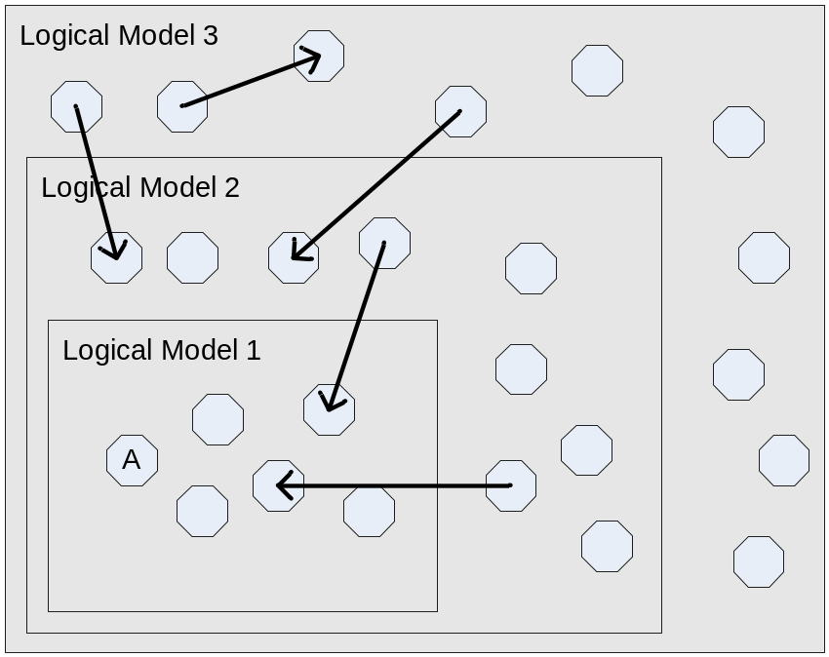
In this diagram, multiple logical models are made up of multiple physical files (the octagons). There are cross-model references as represented by the arrows. In this configuration, we have an increasing set of physical resources that make up each model and we should always be able to say that model 2 contains model 1 and model 3 contains model 2.

Mesh of Models
An alternate view of the containment issue is the mesh of models configuration. This is, in fact, exactly how the RSx product family is currently implemented. This looks something like:
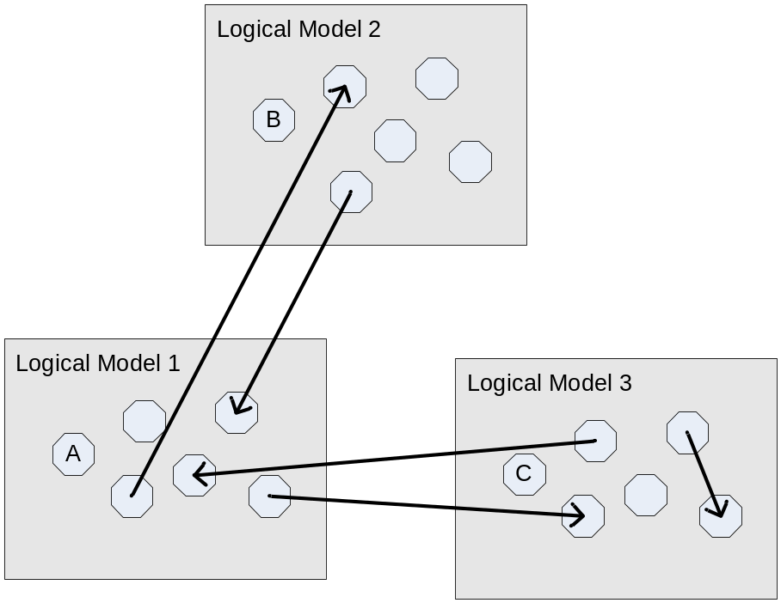
Each logical model here can be opened, edited and merged separately. We still have the choice for each one as to whether we should offer to edit individual artifacts as part of the model or not. This is again a behavior that the model and application designer must choose and be able to configure such that Eclipse and compare support handle things correctly from resource views etc.

Overlapping Models
What happens when an artifact belongs to two models that overlap? That is, neither logical model contains the other, nor may have a relationship to the other except through the common containment of one or more physical artifacts. This happens in the RSx family of products when java artifact is referenced by two diagram visualization files (weak references) or when two models import the same custom profile using EMF relative references (strong references.) The weak references can be modeled as a mesh, but the strong references probably look something like:
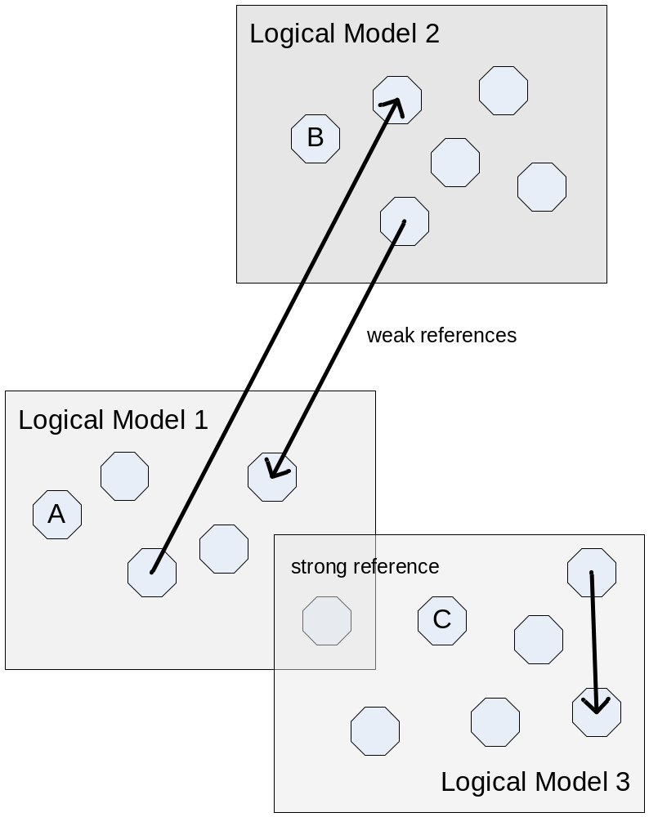
In this case, the shared artifact can be separately edited, but models 1 and 3 cannot be opened separately – they required the shared artifact. This must be somehow configured. In cases where the shared artifact must be opened in the context of one of the models, the same sort of “open as” options will have to be available.
Another example of this is a *.WSDL file, which is parsed by J2EE tooling (such as RAD) and Web Services tooling (such as WID). Each of these toolsets may interpret the contents of the files differently. For WID, the WSDL file contains higher level abstractions such as interfaces and in-lined Business Objects. These abstractions are persisted as entries in the file. Other entries in the file may be used by other tooling, such as J2EE. Ideally, each tooling set should not be interested in the same portions of the file. That is to say that the file contains many different artifacts, some of which are of interest to the J2EE space and some of which are of interest to the Web Services space.

Model Not Contained In Files
It is worth mentioning the case where a model is not persisted in local files but is instead persisted in some other location (e.g. a database). Some of the scenarios that will be mentioned below are still relevant to this case (e.g. problem reporting).

Scenarios for Maintaining Model Consistency
This section covers various scenarios, workflows or use cases that can potentially have an effect on the consistency of a model. There are basically two methods of maintaining model consistency:
- Ensure that operations performed on model elements do so in a manner that preserves model consistency. This applies to both local operations (file content modification, delete, rename, etc.) and remote operations (check-out, check-in, update, tag as version, etc.).
- Report any model inconsistencies to the user. Ideally, this should be done in such a way as to point towards a solution. This could be done by linking problems to editors or even providing QuickFixes for fixing the problem.
Ensuring that all the operations performed on a model will maintain model consistency is straight forward when operations are launched from the tooling associated with the model in question. However, it is often the case that operations are performed on the elements of lower level models directly. For instance, a user who edits the plugin.properties file directly may remove an entry that is still referenced by the plugin.xml file. Or, in the layered model case, a user may delete a Java file that is contained in a model element of a higher-level model. These types of changes lead to a greater chance of models becoming inconsistent.
The workflows in the section are related back to the model characteristics described previously with descriptions of what currently occurs as well as what would be the desirable behavior. The statement of the desirable behavior is by no means a statement of the viability of such a solution. It is only something to shoot for.

Problem Reporting
Currently in Eclipse, dealing with model inconsistencies is mainly done using problem reporting. However, the mechanisms provided by Eclipse (build, markers, Problems view) are highly file system centric. This makes the reporting of problems difficult, as they are always associated with file system resources. This has several shortcomings:
- The relationship between a model and the underlying file system representation may not be obvious to the user.
- It is often the case that multiple problem markers are associated with a single problem. In the current Problems view, there is no mechanism for displaying this type of relationship to the user or to filter problems according to the model of interest to the user.
Ideally, the Problems view should display problems that are associated with any model element, whether it be a file-system resource or an element of a higher-level model. Furthermore, the ability to group related problems together using a tree view or some other type of grouping mechanism would be helpful when the user is presented with a lot of problems that are really all symptoms of one larger problem.
The following sub-sections present specific problem reporting scenarios.

Parse Errors
Consider the case where a model element is persisted in at least one file, which is XML. If that file cannot be parsed, the XML parser will create a problem marker that contains a description of the parse error. Here are some scenarios related to this type of problem:
- In the many-to-one case (2.2), the file may contain several logical model elements, none of which can be recognized by the model tooling due to the parse error. In this case, there may be no logical model element to associate the error with. However, the model tooling may still wish to either annotate the problem representing the parse error with a more understandable description or associate another problem with the file and have it wrap or in some other way override the lower level problem. That's not to say that the lower level problem would be entirely hidden from the user but instead that it would be somehow grouped with the higher-level problem description. This problem could also occur in the one-to-one or one-to-many cases if the parse error prevented the model element from being recognized by the model tooling.
- The model overlap case (2.6.2) is similar to the previous point except that there is no relationship between the two models generating the errors. When parsing the WSDL file, the J2EE tooling will generate errors in a language suitable for that model whereas the WID tooling will generate errors using a different language (i.e. the language of the Web Services model). Users of the WID tool will want to see the WID errors but not the J2EE errors (since they wouldn’t understand them anyway). However, unlike the previous point, there is no way for the WID tooling to even know about the errors from the J2EE tooling so it can’t associate J2EE errors with the corresponding WID errors. One possible solution is to allow the user to filter by model type (determined by user role or activity?) but this always runs the risk of hiding errors that may still be of interest to the user.
- In the one-to-many cases (2.3, 2.4, 2.5, 2.6), it is possible that the contents of the unparsable file only constitute part of a model element. In this case, the model tooling may wish to associate a problem with this logical model element. The following should be considered:
  - The logical model element may or may not map to a file system resource. In either case, it should be possible to have a problem appear in the Problems view that is associated with the model element and contain a description that makes sense in the model space.
  - The problem associated with the logical element should take precedence over the lower level problem. Again, it could either override or parent the lower level problem.

Stale References
Another case to consider is when model elements contain references to other model elements (2.4, 2.5). Changes to a model element may cause references to become stale. That is, a referenced element could be removed or modified in such a way as to make any references to the element no longer valid. With the current Problems view, a problem can be associated with the location in the file where the reference appears. There are a couple of shortcomings with this:
- If the stale reference appears multiple times, then multiple markers could be created. However, providing a link to the position in the file where the link appears may not be enough to help the user to decide how to fix the problem and, even if it does, the user would need to fix the problem in each location it appeared.
- It may not be possible or reasonable for the tooling that is generating the error to map it back to a file location. If tooling does not provide source level editing, there is no benefit to mapping an error to a specific line number. Instead, problems should be mapped to logical objects for which graphical editors are provided.
Ideally, a single problem item should identify the existence of the stale reference. This would allow the user to see the single cause of the multiple stale references. It may still be desirable to associate problems with each of the elements that contain stale references and also with each particular occurrence of a stale reference but the user should only need to see the specific locations if they decided to deal with each occurrence individually.

Problems in Logical Models that Don't Map to Files
Models that are not persisted in files (2.8) may still have model consistencies problem that should appear in the problems view. Currently, problems cannot be associated with logical model elements that do not have a corresponding resource unless the model tooling has its own problems view. Having multiple views that serve the same purpose is confusing for users.

Filtering Problems by Selection
The Problems view currently has the ability to filter by selection. This only works when the items in the selection have a one-to-one mapping to file system resources. Ideally, the following would be supported:
- Support one-to-many mappings (all problems associated with any resource in the mapping should be shown).
- Support many-to-one mappings (i.e. only those problem associated with a portion of the file would be shown).
- Support logical element containment filter (i.e. if a logical model element is selected, show any problems that reference that model element).
- Support logical-to-logical mappings (i.e. if a logical model element at a higher level is selected, display problems for lower levels model elements contained by the higher level element).
With this support, the user could select any element in the UI and see what problems existed for that element.

Problem Navigation
Currently, problem navigation depends on editors to reveal problem locations. There are two problems with this:
- Problem locations are implemented as line numbers, which is useful only for text files.
- Users can override the default editor by used to open a file but problem navigation should be able to always target the "correct" editor regardless of what the user has set as the default.

Model Layering
Many of the scenarios presented previously involve layered models. However, it is worthwhile to mention specific instances of how model layering affects problem reporting. The user will often work at a particular model level and will therefore like to see problems stated in such a way that is consistent with that layer. Thus is would be desirable to be able to:
- Filter problems by model layer or type: i.e. hide errors of other models unless the model the user is working with explicitly includes problems from the other model.
- Arrange problems by model layer if possible: i.e. group problems associated with lower level problems as children of a problem entry associated with the model layer at which the user is working. Ideally, the error from the higher level model will be enough for the user to know how to solve the problem but in the exceptional cases, the lower level errors may be all the user has to go on.

Error Reporting During Repository Operation
It should be the responsibility of the repository provider to highlight any errors that exist on the resources that are being checked-in. For CVS, we do currently show error markers in the Synchronize view but it wouldn't be difficult to show these errors in the check-in prompt as well. I think what we would need to do here is have a set of guidelines or policies for all repository providers to follow with respect to how to handle errors on resources that are being checked in.
Also of interest is what to do with errors that exist on logical objects but are not associated with an underlying file. This currently isn't a problem since the problems view only shows errors that are associated with files. However, if we added the ability to associate problems with logical elements, these errors would need to be accessible by the repository provider when these elements were checked in.

Operation Participation
In this section we look at various operations and their effect on model consistency. Before we do, it is interesting to note that Eclipse already has a refactoring participant mechanism that is used by Java and covers the basic operations (create, delete, rename, move, and copy). This mechanism has the potential to solve some of the problems below when applied more generally.

File Rename and Deletion
First, let’s look at what happens when a file that is part of a model element is renamed. The following conditions will result in model inconsistencies that need to be corrected.
- The file may be referenced by a model element. This can happen in cases 2.4 and 2.5
- Other files may have a name that is linked to the name of the file as described in 2.4
- The file is part of a fixed relationship as in 2.3 or is part of a model whose files should not be modified individually as in 2.6.
The currently supported solution for all these cases is for a builder to recognize the inconsistency and place a problem marker on an appropriate file. For simple cases, a builder could reconcile the other files to make the make the model consistent again. However, for more complex cases, this may not be practical so the best the model tooling could do would be to associate a QuickFix with the problem that would allow the user to correct the problem in a single operation (as opposed to renaming all the necessary files one-by-one). This can be especially problematic for higher level models that have done a good job of hiding the underlying file representation of the model from their users. If this is the case, showing the users markers that are associated with the files will not be of much use.
Ideally, the model tooling would want some or all of these abilities:
- The ability to augment the current operation with additional modifications. For instance, any references could be updated and linked files renamed in the same operation as the original file rename.
- The ability to show a preview of what will take place to the user as part of the UI of the original operation. The user will want to know of any additional modifications that will take place, as well as any conditions that will result in model inconsistency (i.e. the model tooling may not be able to determine the proper augmentation that will preserve model integrity). This preview may need to be viewable with respect to any of the models involved. In other words, it would not be enough just to show the modifications at the file system level. The user would want to see what the changes mean in the model space.
- The ability to prevent the rename in the case where the model will be compromised in such a way that recovery is not possible. This is a critical requirement for structured data – e.g. the typical EMF artifact.
File deletion is similar to the rename case with some additional considerations:
- Deleting a file may have a larger impact on containing model elements. For example, for a diagram, removing a class may also invalidate several relationships in the diagram. It may be desirable to make the user aware of the repercussions before performing the delete. The repercussions should be stated in the language of the model that will suffer them.
- Deleting a file that is an important part of a model element, as in 2.6, could offer to delete the containing model element.

Cut and Paste
Cut and Paste has similar characteristics to file delete and move and would need similar mechanisms for preserving model consistency.

Folder Rename or Deletion
The effects on model consistency are harder to determine on folder (or project) deletion, simply because there are potentially many files being renamed or deleted. It is possible that many file references may become stale upon folder deletion but it is just as likely that all the files contained in or referenced by the model were all contained in the same folder so deleting that folder may introduce no inconsistencies.

Content Modification
There are two cases of interest when looking at file content modification.
- A model may be made up of multiple files that should never be modified directly (as in case 2.6). In this case, any external modifications should be prevented (or, at least, strongly discouraged).
- File contents can be modified directly but may contain references embedded by higher-level model tooling. An example of this could be Java annotations that are used by a diagram. Removing an annotation may have an adverse affect on the diagram. The user should be made aware of what may occur.
The second point is actually rather complicated. First, consider that the contents could be modified by an editor or an operation. In the case of editors, it would be possible for higher level tooling to provide their own Java editor which knew how to maintain the annotation consistency. However, this breaks down if two separate higher level models are embedding annotations in the same Java file. It also doesn’t cover the refactoring cases. Treating content modification as an operation that requires participation is another possible avenue to address this issue.

The Effects of Model Layering
There is a set of standard operations: rename, delete, cut, copy, paste. Currently, each model layer defines what the semantics of these operations are with respect to their models. However, operations performed by lower level model tooling may have a corrupting affect on higher level models. Thus, higher level models may require the ability to participate in the operations of lower level models.
One solution to this would be to have a standard set of operations that all models use. For example, there would be a single rename operation that was executed whenever the user wanted to rename a file. Any models that cared about a particular file could participate in the rename. The complications with this solution includes determining what models care about particular files and explaining what will happen to the user
Another solution is for each model layer to provide their own rename operation with the expectation that higher level models would participate in the operations of lower level models that could potentially corrupt the higher level model. The advantage of this is that the rename operation can be more semantically matched to the model from which it was launched. The disadvantage is that higher level models must make sure they participate in all the lower level operations that affect their model consistency. This is especially complicated if there are models at the same level that can corrupt each others models (which can happen in the 2.6.2 model overlap case).
Another factor to consider is that operations on higher level models may be a combination of two or more of the previously mentioned standard operations. For instance, an operation may result in the deletion of some files and the renaming of others. Models that participate in deletions and renames would expect to be included in the compound operation. However, the entire context of the operation may impact what there participants do (i.e. a higher level model may behave differently in the rename portion of the higher level operation if it knew about other resources that were being modified or deleted).
One solution to this would be to suggest that the model tooling also participate at in the higher level operation so it has access to the complete context of the operation. If this were the case, a mechanism to disable participation at lower levels when higher-level participation takes place would be needed. One complication here is that you could end up in a situation where some models are participating at the highest level while others are participating at lower levels. This may not be a problem semantically but it may be hard to explain to the user what is going on.
Of course, it would be possible for poorly behaved plug-ins to bypass the standard operations altogether, thus meaning that higher level models would not be involved in the operations. In this case, the model tooling would still need to be able to handle any model consistency issues that were introduced either by reconciling the model or creating appropriate problems in the problems view.
Some things to consider here are:
- One crucial aspect of any such participation mechanism is that it does not have a significant performance impact. This is especially important if participation at the lowest levels is supported, as most, if not all, tools built on top of Eclipse will hit this path.
  - Another aspect of performance is plug-in loading. Operations on lower level models may be performed before the plug-ins of the higher-level models are even loaded. Declarative filtering may be needed to efficiently prune the list of interested participants.
- There are a set of standard operations (create, delete, move and rename) that apply across models. Operation participation would be simplified if these standard operations were defined by the platform in some form.
It is also interesting to note that Java refactorings support certain types of participation (create, delete, move and rename).

Working with Editors
Although not technically a model consistency issue, opening an editor is similar to performing other operations. Here are a few cases involving logical models that impact the opening of editors.
- For the layered model case (2.6), when the user opens an artifact from model 1, the GUI must be designed such that it either knows what to do, or offers the user the choice of how to edit. For instance, opening a java file will open the Java editor by default. However, if this file is part of a higher-level model (model 2 or model 3), it may be more appropriate for the default editor for that Java file to be the editor of the model used to generate the file. The options for dealing with such a case are:
  - Open a java editor and let the higher level models react to the changes (auto-reconciliation.)
  - Open the artifact as either model 2 or model 3 and then launch the field editor that represents the java artifact “A”.
  - Offer all options with menu items like: “Edit as java…”, “Edit as Model 2”, and “Edit as Model 3”.
- For the one-to-many cases, when a file contained in the model is edited, it may be possible to edit the file individually but it is just as likely (or more likely) that the file should never be edited on its own. The following may be of interest for this case:
  - Edit leafs allowed (possibly configurable by content-type for each leaf.)
  - Load related logical models (e.g. for mesh and overlapping models.)
  - Edit as <one or more containing models> may be required.
  - Retarget the load to the root artifact (when there is one) of a containing model. This is one mechanism by which a policy of “edit in model only” could be enforced.
- Eclipse strives to have only one editor open on a particular resource, be it a file system resource or a logical model element. Hence, opening an editor on an element searches through the open editors to find a match before opening a new one.
  - For model elements that contain one or more resources, this means that opening up an editor on a file contained in the model element should match an open editor on that model element.
  - In the case where a file may contain multiple editable model elements, the user would not necessarily want the file to match with open editors on the file sub-elements.
- Problems are linked to a location (i.e. line number) is a file. Eclipse provides the capability of opening and editor on the problem and showing the location of the problem. This is straightforward if the mapping from model element to resource is one-to-one but has some complications in other cases:
  - If the editor that is opened is on a model element that contains multiple files, some means of translating the file location to the appropriate area of the editor is needed. As an example, consider the plug-in model in M.3. A problem marker on a key in the plugin.properties file should not only open the plug-in manifest editor but also show the page that deals with the NLS keys and highlight the offending key.
  - If the file contains multiple editable model elements, a means of opening an editor on the appropriate model element is needed. This is less of an issue if problems can be associated directly with model elements.

Working with Repositories
When working with logical models, the user would like to be able to select logical model elements that appear in Eclipse and perform repository operations on them. However, repository tooling tends to be file based so a conversion from the model space to the file system resource space is required. We have introduced API in 3.1 M5 that supports the mapping of logical elements to their underlying file system resources. As of 3.1 M5, the following is supported:
- Model elements with one-to-one mappings to resources have always been supported.
- Model elements with one-to-many mappings can now be the input to repository operations.
  - Fixed relationships are the easiest as the remote state of the model is not required
  - For variable relationships, additional API is specified to allow the model to query the remote state in order to determine if there are additional resources in the remote copy of the model.
- Model elements with many model elements in a single file can still be input to a repository operation. However, the set of model elements being affected may be greater than the set the operation was performed on. For instance, if a *.java files contains multiple classes, performing a repository operation on any of the contained classes will perform the operation on all the contained classes.
The following sections highlight issues that still exist.

Model Participation in Repository Operations
There are some cases where a model may want to participate in repository operations for the purpose of augmenting the list of model elements or file system resources that are being operated on. Examples of when this may be necessary are:
- If a repository operation is performed on a single model element that is contained in the same file with other model elements (case M.2), the user will need to be made aware of the additional model elements that will be included in the operation.
- If the file being operated on is part of a model that should be treated as an atomic unit (case M.6), then any operations on the file itself should instead be performed on the entire model.
- If multiple model layers are involved, repository operations on elements in lower layers may have a corrupting affect if the higher layers are not involved. For instance, consider a merge operation on the WSDL model described in case 2.6.2. If the merge on the WSDL file is performed from the J2EE tooling, the Business Objects of the WID tooling may be inadvertently affected unless the WID tooling can participate in the merge. Another example from case 2.3.1, if an operation is performed on the plugin.xml file, the plug-in tooling may want to include the plugin.properties file in that operation. Some means of making the user aware of this and potentially including additional resources in the operation may be helpful. In the end, this case isn’t all that different from the atomic case, except that it is not unreasonable to expect that there may be multiple higher level models interested in a single artifact in some cases.
The repository tooling may also need to obtain additional input from the user. Although the operation is being performed on file system resources, the relationship between the resources and the originating model should be made obvious to the user.

Model Participation in Merging
One of the more complicated scenarios involving repository operations is that of merging remote changes with local changes. Eclipse has API which supports model based merging for the one-to-one case (M.1). This API could also be used to handle the many-to-one case (M.2), although this may not be adequate for complex models. However, there is currently no mechanism for performing an atomic merge on a model element that contains multiple files. What would be required in this case is API between the model tooling and repository provider in order to reconcile the logical model to the physical model when performing repository operations such as merging.
One potential complication is that a merge operation may involve model elements form different model layers or from different model tooling. Either there would need to be a single merge mechanism that was capable of performing merges on multiple models simultaneously or the merges would need to be sequenced. The former case is more desirable than the later from a usability standpoint.

Multiple Merges in an Atomic Logical Model
When multiple physical artifacts have been changed, the CVS synchronize and ClearCase rebase/deliver commands will discover that there is some number of required merges. If these merges are all members of the same logical model, and if that logical model requires that the entire logical model be merged as a unit, then the tooling must be logical model aware and mark all as merged when one is marked as merged. That is, atomic means atomic in all GUI interfaces.
This looks something like:
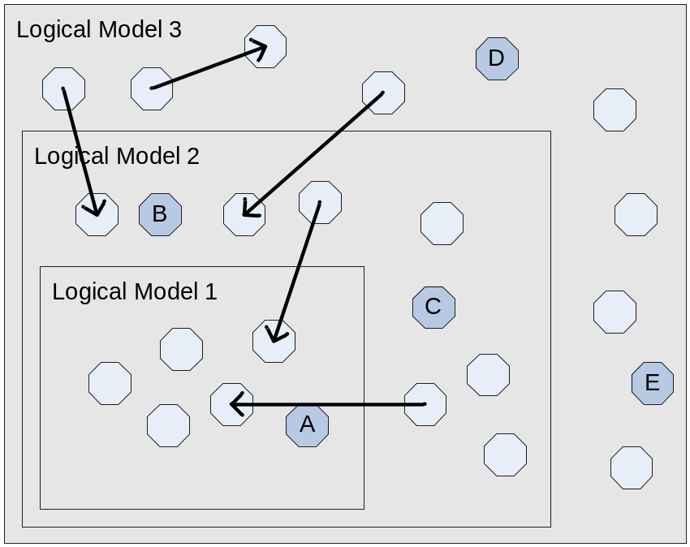
Assume for a moment that artifacts A through E all require merges. Assume also that Logical Model 3 is atomic. This means that all contained artifacts are now atomic for all operations (edit, compare, merge, etc.) Regardless of which artifact appears in the interface first, the entire logical model must be extracted for the remote and ancestor versions of the models, and all three must be loaded for the appropriate difference engine. Once the merge has been completed and the artifacts have been saved in the merged version (local in CVS, merged model in ClearCase), the synchronization, rebase, or deliver view should mark all merged artifacts as merged immediately. In CVS, this is under user control, in ClearCase this is under system control.

Multiple Merges in a Non-Atomic Model
Imagine the same diagram, but where the atomicity is not enforced. In this case, there are several options, depending on how much configurability is allowed:
- Merge each artifact separately. This works ok for Java, and can work tolerably well for EMF structured data, but at the loss of a great deal of context.
- Merge each artifact in the presence of the whole model. We would extract the highest level model for which “merge in the presence of the whole model” was turned on. This allows for more context, but still allows merging to happen in individual artifacts. What it really does is enable referenced data to be at the right version level during the merge. This is also useful to solve the mesh of models problem.

Decorations
Decorating elements that appear in the UI with their state relative to the repository provides valuable feedback to the user in some cases. One such case is a dirty decorator that, when present, indicates that the element has changed locally since the time it was loaded from the repository. There are several issues that need to be solved for this to work:
- As of 3.1, label decorations only support adaptability to resources. This support was release in 3.2 M1 (see bug 86159).
- For the one-to-one and one-to-many case, showing the dirty decoration is straightforward in the sense that the element is dirty if any of its contained files are dirty. However, updating may be difficult as there is no mechanism in place to inform a model object that its state may have changed with respect to the repository.
- For the many-to-one, if the file is dirty, it is impossible to determine which particular element is dirty without the ability to compare the new file contents with the contents in the repository. Fetching the contents from the repository is not something that should be done when calculating decorations.
Handling the update of model object decoration is tricky as the decorator may need to update all model objects that map to a given resource and any model objects that act as parents of the object in any view. The easiest way to do this would be to give the decorator a mapping from model object to view content provider. The decorator would then be able to fire label changed events as necessary.
The problem of dirty markers on many-to-one cases needs to be addressed somehow. If the dirty indicator for the file is shown for each element in the file, the result would be that the user gets dirty markers against all the logical elements which would be confusing. If the dirty indicator isn’t shown at all, the user forgets to check in his changes, which could be disastrous. I can think of a few things we might consider:
- We could have a different dirty overlay for this case. It would indicate that we think the logical element might be dirty.
- Either separate, or in conjunction with that, we could, in a background process, do the work of processing the remote file for the purpose of performing logical element level comparison and then updating the dirty markers. This would work best in conjunction with the above point since the user would see the state go from "maybe dirty" to something definitive.

Bootstrapping
A related issue is that of bootstrapping. In other words, how does a user load model elements that were created by other users? To do this, a root access point is required. In Eclipse, the project acts as this root. Therefore, the user must first load a project and can then access the model elements it contains. In the cases where models span projects, Team projects sets can be used to bootstrap a workspace.
There are a couple of issues involving the use of project sets in this way:
- Project set creation is separate from repository operations. This means that the user that shares a model must also remember to create a project set. If the model spans projects, they must understand which projects are to be included Tooling can automate this to reduce the likelihood of mistakes. But it would be useful if Eclipse (or maybe CVS and ClearCase) could load projects that are referenced in the logical model’s manifest or map. I.e. perhaps this area needs to become logical model aware as well, so that the psf files contain either physical or logical resources and the right things happen anyway.
- Projects sets are just files. If projects are added to or removed from a project set, the project set file must be regenerated and redistributed.
- A project set just contains a set of projects. There is no statement of relationships between other project sets.
One simple means of addressing this may be to support the grouping projects together in a way that ensured that if one got loaded from a repository, they all got loaded.
It is also worthwhile to describe some cases that involve the loading of new artifacts into existing projects.
- Say user A creates a new BPEL and accompanying .BPEL.EX, how does user B know to load both of these pieces? I guess he could reload the whole project but what if he wants to get that specific new BPEL? Similarly, when loading different revisions from history you need to know to get all the bits.
- A cross project case we have is Relationships and Roles, where the roles are by design stored in different projects. Again, user A releases a new Relationship and Roles. How does user B know to pick all these up? A reload of a particular project won't do, he'd need to reload all projects just in case. In any case, I think the problems need to be identified because they hint at the need for repository level awareness of logical relationships (which is unlikely to happen, but needs to be included). Ultimately, ideally, the user could navigate the repository based on logical elements, not just files.

Model Objects and View Content Providers
One subtle problem is that users associate the target of a Team operation as what is selected in a view. For tree views, this includes what is directly selected or what is a child of the selection in a view. For instance, in the Packages explorer, expanding a package shows the Java classes in that package so the user would expect a Team operation like commit to be performed on just those classes. However, the Package Explorer can be configured to display packages as a hierarchy where sub-packages appear under the parent package. In this case, the user would probably expect the commit to be performed on the package and all its sub-packages.
This is a potential problem as the content of a view is really determined by the content provider associated with that view. In most cases, what is visible matches the structure of the model but in some cases, it differs. In these cases, the content provider should take part in deciding how model elements map to resources.
One way of doing this would be for the content provider to be included as part of the selection that is created by the view. Then, the process of converting the model object to a resource mapping can involve the content provider.

Other Areas Related to Logical Models
There are several other areas that involve logical models. There are mentioned here for completeness but will be addressed separately.

Generic Navigator
There is a Generic Navigator in the WTP project. The aim is to work with the WTP team in 3.2 to push the generic navigator back down to Platform level (as a separate set of plug-ins). This will be addressed as a separate issue from those described above in this document.

For more context and history, see https://bugs.eclipse.org/bugs/show_bug.cgi?id=36961.

User Roles and Perspectives
The concept of User Role has come up several times in the Eclipse Platform. The idea is that the role the user is currently performing has an impact on what views are displayed and how the contents of the views are arranged. For instance, if the user is a Web Service designer, perhaps the problems view should only show problems that are relevant to the Web Services model. Similarly, the Generic Navigator could be filtered to only show Web Services related models. It seems reasonable that this type of filtering could be triggered by Perspective.

Search
The Search mechanism in the Eclipse platform already supports pluggable search types. In the Eclipse SDK, there is File, Java and Plug-in searches. Any other tooling can provide there own search type. The Java Search also supports pluggability in the sense that tools that are build on top of Java can augment the Java search to include references to Java code that appear in other model files (e.g. PDE could include the extensions in a plugin.xml in a Java search).
As for a generic Model Search, it may be possible that there is commonality across models that would make a generic search feasible. However, given that search already has generic support of some form, this enhanced support is not as high priority as the model consistency issues being addressed by this document and can be addressed separately if there is enough interest.

Summary
The required support for the scenarios presented in this document can be broken down into three separate features:
- Generic views
  - The main view of interest for model consistency issues is the Problems view
- Repository operations available on logical models
  - Repository provider operations available on model elements that appear in the UI
  - While performing an operation, repository provider should show information in a form consistent with the originating model
- Operation Participation
  - The ability for model tooling to participate in the operations of lower level models (e.g. Java or the Platform resource model) in order to ensure model consistency
- Logical Model Policies
  - Such capabilities as logical model atomicity have a big effect on editors and compare support.
  - A lot of variations can exist in model relationships. The creator of the model should be able to bind in a clear descriptor (perhaps simply extending the existing content type description binding).
  - Strong and weak references invite optional behavior (such as try to load complete model, and never load model) in order to tune performance and improve context during compare and merge support. It is necessary for editors and Compare support to be aware of such policies.
Although there is some overlap between these features, they can each be addressed as separate issues.

