This directory contains the comprehensive template structure for creating a new KIT (Keep It Together) in the Eclipse Tractus-X ecosystem.

Table of Contents
Right-click here and select "Update Field" to generate the Table of Contents.
Tip: In Word, press Ctrl+A then F9 to update all fields including this TOC.

Adoption View

Adoption View
Welcome to the [KIT_NAME] KIT Adoption View. This view provides business value, strategic benefits, and use cases for business stakeholders and decision-makers.
info: Target Audience
Business Managers, Product Owners, Solution Architects, Industry Experts, and Decision Makers.

Business Value

Value Proposition #1: [Title]
Benefit: [Primary benefit description]
Target Stakeholders: [OEMs | SMEs | Solution Providers | etc.]
Measurable Outcomes: [Key metrics]

Value Proposition #2: [Title]
Benefit: [Second benefit description]
Target Stakeholders: [Target audience]
Measurable Outcomes: [Key metrics]

Value Proposition #3: [Title]
Benefit: [Third benefit description]
Target Stakeholders: [Target audience]
Measurable Outcomes: [Key metrics]

Use Case Context

Industry Challenge
[Describe current industry problems and pain points]
Current Challenges:
- Challenge 1: [Problem description and impact]
- Challenge 2: [Problem description and impact]
- Challenge 3: [Problem description and impact]

The Solution
[Explain how this KIT addresses the challenges]
Solution Components:
- [Component 1]: [Description]
- [Component 2]: [Description]
- [Component 3]: [Description]

Business Processes
tip: For industry-specific business processes, see the Industry Extensions documentation.

Core Business Process: [Process Name]
Purpose: [Business goal]
Stakeholders: [List key stakeholders]
Process Steps:
📊 Diagram
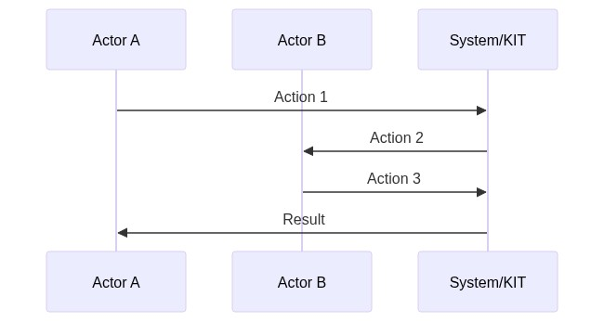
Source Code:
sequenceDiagram
participant A as Actor A
participant B as Actor B
participant C as System/KIT
A->>C: Action 1
C->>B: Action 2
B->>C: Action 3
C->>A: Result
Process Description: [Brief description of key steps]

Access & Usage Policies
warning: Industry-Specific Policies
For industry-specific policy requirements, refer to the Industry Extensions section.

Example Access Policy
{
"policy": {
"permission": {
"action": "use",
"constraint": {
"leftOperand": "UsagePurpose",
"operator": "isAnyOf",
"rightOperand": [
"mx.core.digitalTwinRegistry:1"
]
}
}
}
}
[Brief policy explanation]

Standards
warning: Industry-Specific Standards
For industry-specific standards, refer to the Industry Extensions section.

Supported Standards
Standard | Version | Description | Compliance Level | Link
[Standard 1] | X.Y | [Description] | Mandatory/Optional | [Link]
[Standard 2] | X.Y | [Description] | Mandatory/Optional | [Link]
________________________________________________________________________________

Tutorials & Resources

Getting Started Tutorial
[Link to tutorial or brief description]

Video Resources
Title | Duration | Link
[Video 1] | [X min] | [Link]

Whitepaper
[Link to whitepaper if available]

NOTICE
This work is licensed under the CC-BY-4.0.
- SPDX-License-Identifier: CC-BY-4.0
- SPDX-FileCopyrightText: [YYYY] [YOUR_COMPANY]
- SPDX-FileCopyrightText: [YYYY] Contributors to the Eclipse Foundation
- Source URL: https://github.com/eclipse-tractusx/eclipse-tractusx.github.io

Architecture Overview

Architecture View

Architecture Overview

System Architecture
[High-level architecture diagram and explanation]
📊 Diagram
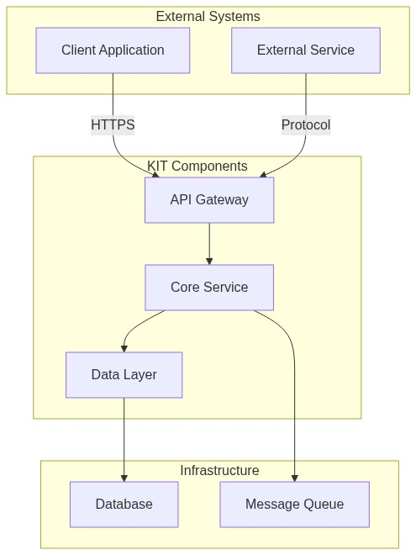
Source Code:
graph TB
subgraph External Systems
A[Client Application]
B[External Service]
end
subgraph KIT Components
C[API Gateway]
D[Core Service]
E[Data Layer]
end
subgraph Infrastructure
F[Database]
G[Message Queue]
end
A -->|HTTPS| C
B -->|Protocol| C
C --> D
D --> E
E --> F
D --> G

Architecture Principles
- Modularity: Loosely coupled components
- Scalability: Horizontal scaling support
- Security: End-to-end encryption
- Interoperability: Standards-based APIs
- Observability: Built-in monitoring and logging

NOTICE
This work is licensed under the CC-BY-4.0.
- SPDX-License-Identifier: CC-BY-4.0
- SPDX-FileCopyrightText: [YYYY] [YOUR_COMPANY]
- SPDX-FileCopyrightText: [YYYY] Contributors to the Eclipse Foundation
- Source URL: https://github.com/eclipse-tractusx/eclipse-tractusx.github.io

Development View

Development View
Technical documentation for developers, architects, and implementers.
info: Target Audience
Software Developers, Solution Architects, Technical Leads, API Developers, Integration Engineers.

Sequence Diagrams

Authentication Flow
📊 Diagram
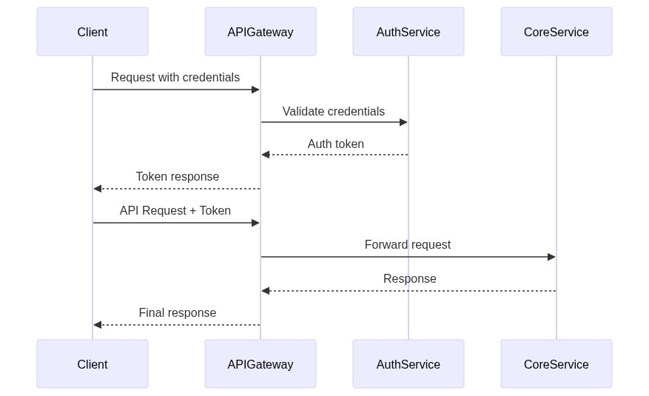
Source Code:
sequenceDiagram
participant Client
participant APIGateway
participant AuthService
participant CoreService
Client->>APIGateway: Request with credentials
APIGateway->>AuthService: Validate credentials
AuthService-->>APIGateway: Auth token
APIGateway-->>Client: Token response
Client->>APIGateway: API Request + Token
APIGateway->>CoreService: Forward request
CoreService-->>APIGateway: Response
APIGateway-->>Client: Final response
[Brief flow description]

Data Exchange Flow
📊 Diagram
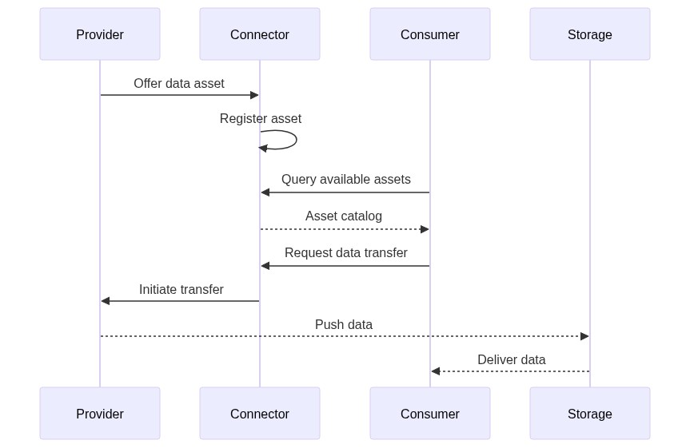
Source Code:
sequenceDiagram
participant Provider
participant Connector
participant Consumer
participant Storage
Provider->>Connector: Offer data asset
Connector->>Connector: Register asset
Consumer->>Connector: Query available assets
Connector-->>Consumer: Asset catalog
Consumer->>Connector: Request data transfer
Connector->>Provider: Initiate transfer
Provider-->>Storage: Push data
Storage-->>Consumer: Deliver data
[Brief flow description]

Standards Compliance
Standard | Version | Compliance | Description
[Standard 1] | X.Y | Mandatory | [Description]
[Standard 2] | X.Y | Optional | [Description]

Standard Details

[Standard Name]
Compliance Level: [Mandatory | Optional | Recommended]
Implementation: [Brief description]
Reference: [Link]

Semantic Models

Model: [Model Name]
Version: X.Y.Z
Namespace: urn:samm:org.eclipse.tractusx.[domain]:[version]#
Description: [Model description]
Key Properties:
Property | Type | Required | Description
property1 | string | Yes | [Description]
property2 | integer | No | [Description]
Example:
{
"@context": {
"@vocab": "urn:samm:org.eclipse.tractusx.[domain]:[version]#"
},
"property1": "value1",
"property2": 42
}
Reference: [Link to SAMM specification]

Sample Data

Sample Dataset: [Dataset Name]
Purpose: [Sample purpose]
Format: JSON
Download: [Link]
Example:
{
"sampleData": [
{
"id": "sample-001",
"field1": "value1"
}
]
}

Integration Examples

Integration with [System Name]
Java Example:
public class KitIntegration {
private final KitClient client;
public KitIntegration(String apiUrl, String apiKey) {
this.client = new KitClient(apiUrl, apiKey);
}
public Resource getResource(String resourceId) {
return client.resources().get(resourceId);
}
}
Python Example:
from kit_sdk import KitClient
client = KitClient(api_url="https://api.example.com", api_key="your-key")
resource = client.resources.get("resource-id")

NOTICE
This work is licensed under the CC-BY-4.0.
- SPDX-License-Identifier: CC-BY-4.0
- SPDX-FileCopyrightText: [YYYY] [YOUR_COMPANY]
- SPDX-FileCopyrightText: [YYYY] Contributors to the Eclipse Foundation
- Source URL: https://github.com/eclipse-tractusx/eclipse-tractusx.github.io

Sample Data

Sample data
{
...
}

NOTICE
This work is licensed under the CC-BY-4.0.
- SPDX-License-Identifier: CC-BY-4.0
- SPDX-FileCopyrightText: [YYYY] [YOUR_COMPANY]
- SPDX-FileCopyrightText: [YYYY] Contributors to the Eclipse Foundation
- Source URL: https://github.com/eclipse-tractusx/eclipse-tractusx.github.io

Automotive Industry Extension

Automotive Industry Extension
This extension adapts the [KIT_NAME] KIT for the automotive industry with Catena-X standards compliance.
info: Extension Purpose
Adds: Catena-X standards, automotive semantic models, business processes, and policies.

Semantic Models

Serial Part (CX-0002)
Version: 3.0.0
Aspect Model: urn:samm:io.catenax.serial_part:3.0.0#SerialPart
Key Attributes: catenaXId, localIdentifiers, manufacturingInformation, partTypeInformation
Example:
{
"catenaXId": "urn:uuid:ed2ace5b-b25d-4e64-9b54-c2fb13c35a5c",
"localIdentifiers": [
{
"key": "manufacturerPartId",
"value": "95657362-83"
}
],
"manufacturingInformation": {
"date": "2023-02-04T14:48:54",
"country": "DEU"
},
"partTypeInformation": {
"manufacturerPartId": "95657362-83",
"nameAtManufacturer": "High Voltage Battery"
}
}
Semantic Hub

Access & Usage Policies

Catena-X Framework Policy
{
"@context": {"odrl": "http://www.w3.org/ns/odrl/2/"},
"@type": "PolicyDefinitionRequestDto",
"@id": "cx-policy",
"policy": {
"@type": "Policy",
"odrl:permission": [{
"odrl:action": "USE",
"odrl:constraint": {
"odrl:leftOperand": "BusinessPartnerNumber",
"odrl:operator": {"@id": "odrl:eq"},
"odrl:rightOperand": "BPNL00000003CRHK"
}
}]
}
}

Compliance
Regulation | Region | Relevance
GDPR | EU | Data protection
Battery Regulation | EU | Battery passport
Supply Chain Due Diligence | DE | ESG reporting
Certifications: ISO/TS 16949, VDA 6.3, TISAX

Resources
- Catena-X Standard Library
- Tractus-X Open Source

NOTICE
This work is licensed under the CC-BY-4.0.
- SPDX-License-Identifier: CC-BY-4.0
- SPDX-FileCopyrightText: [YYYY] [YOUR_COMPANY]
- SPDX-FileCopyrightText: [YYYY] Contributors to the Eclipse Foundation
- Source URL: https://github.com/eclipse-tractusx/eclipse-tractusx.github.io

Manufacturing Industry Extension

Manufacturing Industry Extension

Overview
This extension adapts the [KIT_NAME] KIT for shop-floor operations and manufacturing environments.
info: Extension Purpose
Adds: Manufacturing-X standards, shop-floor semantic models, MES processes, and real-time data exchange.

Semantic Models

Production Order
Version: 1.0.0
Aspect Model: urn:samm:io.manufacturingx.production_order:1.0.0#ProductionOrder
Key Attributes: orderId, orderType, productIdentifier, quantity, scheduledTime, status, assignedResources
Example:
{
"orderId": "PO-2025-11-21-001234",
"orderType": "STANDARD",
"productIdentifier": {
"productId": "PART-A-12345",
"productName": "Gear Housing Assembly"
},
"quantity": {
"planned": 500,
"produced": 342,
"unit": "pieces"
},
"status": "IN_PROGRESS",
"assignedResources": [
{"resourceType": "MACHINE", "resourceId": "CNC-MILL-03"}
]
}

Machine State
Version: 1.0.0
Aspect Model: urn:samm:io.manufacturingx.machine_state:1.0.0#MachineState
Key Attributes: machineId, machineType, operationalStatus, performance, alarms, maintenance, timestamp
Example:
{
"machineId": "CNC-MILL-03",
"machineType": "5-Axis CNC Milling Center",
"operationalStatus": "PRODUCING",
"performance": {
"oee": 78.5,
"availability": 92.3,
"quality": 95.5
},
"alarms": [
{"severity": "WARNING", "type": "TOOL_WEAR", "message": "Tool #5 approaching wear limit"}
],
"timestamp": "2025-11-21T12:00:00Z"
}

Access & Usage Policies

Manufacturing-X Framework Policy
{
"@context": {"odrl": "http://www.w3.org/ns/odrl/2/"},
"@type": "PolicyDefinitionRequestDto",
"@id": "mx-policy",
"policy": {
"@type": "Policy",
"odrl:permission": [{
"odrl:action": "USE",
"odrl:constraint": {
"odrl:leftOperand": "DataspaceParticipant",
"odrl:operator": {"@id": "odrl:eq"},
"odrl:rightOperand": "did:web:example.com"
}
}]
}
}

Compliance
Regulation | Region | Relevance
GDPR | EU | Data protection
ISO 9001 | Global | Quality management
Certifications: ISO/TS 16949, VDA 6.3

Resources
- Manufacturing-X
- Tractus-X Open Source

NOTICE
This work is licensed under the CC-BY-4.0.
- SPDX-License-Identifier: CC-BY-4.0
- SPDX-FileCopyrightText: [YYYY] [YOUR_COMPANY]
- SPDX-FileCopyrightText: [YYYY] Contributors to the Eclipse Foundation
- Source URL: https://github.com/eclipse-tractusx/eclipse-tractusx.github.io

Operations View

Operations View
Guidance for deploying, operating, and maintaining this KIT in production environments.
info: Target Audience
DevOps Engineers, System Administrators, Site Reliability Engineers, Cloud Architects, Infrastructure Teams.

Deployment

Docker Compose
git clone https://github.com/eclipse-tractusx/[repository-name].git
cd [repository-name]
docker-compose up -d
docker-compose.yml:
version: '3.8'
services:
app:
image: [registry]/[kit-name]:latest
ports:
- "8080:8080"
environment:
- DB_HOST=postgres
- DB_NAME=[kit_db]
- DB_USER=[kit_user]
- DB_PASSWORD=[CHANGE_ME]
depends_on:
- postgres
postgres:
image: postgres:14-alpine
environment:
- POSTGRES_DB=[kit_db]
- POSTGRES_USER=[kit_user]
- POSTGRES_PASSWORD=[CHANGE_ME]
volumes:
- postgres-data:/var/lib/postgresql/data
volumes:
postgres-data:

Kubernetes
helm repo add tractusx https://eclipse-tractusx.github.io/charts
helm install [kit-name] tractusx/[kit-name] --namespace [kit-name]
deployment.yaml:
apiVersion: apps/v1
kind: Deployment
metadata:
name: [kit-name]
spec:
replicas: 2
selector:
matchLabels:
app: [kit-name]
template:
metadata:
labels:
app: [kit-name]
spec:
containers:
- name: [kit-name]
image: [registry]/[kit-name]:1.0.0
ports:
- containerPort: 8080
resources:
limits:
cpu: 1000m
memory: 1Gi

Monitoring

Health Checks
Endpoint | Purpose
/health | Overall health status
/health/liveness | Liveness probe
/health/readiness | Readiness probe

Metrics
Prometheus metrics: /actuator/prometheus

Troubleshooting

Common Issues
Application Won't Start
- Check database connectivity
- Verify environment variables
- Check logs: docker-compose logs or kubectl logs
High Memory Usage
- Monitor: kubectl top pods
- Increase memory limits in deployment config
- Tune JVM settings

Diagnostic Commands
# Docker
docker-compose logs [service-name]
# Kubernetes
kubectl logs -n [kit-name] [pod-name]
kubectl describe pod -n [kit-name] [pod-name]

Scaling
# Manual scaling
kubectl scale deployment [kit-name] --replicas=5
# Auto-scaling
kubectl autoscale deployment [kit-name] --cpu-percent=70 --min=2 --max=10
________________________________________________________________________________

NOTICE
This work is licensed under the CC-BY-4.0.
- SPDX-License-Identifier: CC-BY-4.0
- SPDX-FileCopyrightText: [YYYY] [YOUR_COMPANY]
- SPDX-FileCopyrightText: [YYYY] Contributors to the Eclipse Foundation
- Source URL: https://github.com/eclipse-tractusx/eclipse-tractusx.github.io

Your Application Name

[Your Application Name] - Success Story
Organization: [Company/Organization Name]
Industry: [Industry Sector]
Implementation Type: COTS / Open Source / Custom
Go-Live Date: [Month Year]
KIT Version: [e.g., 1.2.0]
Link to Repo: [if exists]

The Challenge

Business Problem
[Describe the business problem or opportunity that led to implementing this KIT]
Key Pain Points:
- [Pain point 1]
- [Pain point 2]
- [Pain point 3]

Technical Requirements
- [Technical requirement 1]
- [Technical requirement 2]
- [Technical requirement 3]

Demos
[Include here demo videos]

Results & Impact

Business Outcomes
Metric | Before | After | Improvement
[Metric 1] | [Value] | [Value] | [X%]
[Metric 2] | [Value] | [Value] | [X%]
[Metric 3] | [Value] | [Value] | [X%]

Quantified Benefits
- Cost Savings: [e.g., "Reduced operational costs by 25%"]
- Time Savings: [e.g., "Decreased processing time from 2 hours to 15 minutes"]
- Quality Improvement: [e.g., "Reduced error rate by 40%"]
- Revenue Impact: [e.g., "Enabled new revenue stream worth €X million"]

Qualitative Benefits
- [Benefit 1 - e.g., "Improved customer satisfaction"]
- [Benefit 2 - e.g., "Enhanced data transparency"]
- [Benefit 3 - e.g., "Better compliance management"]

Testimonial
"[Quote from project sponsor or key stakeholder about the implementation and its impact]"
— [Name], [Title], [Company]

Future Plans
- [ ] [Planned enhancement 1]
- [ ] [Planned enhancement 2]
- [ ] [Planned expansion to other business units/regions]

Related Resources
- [Link to implementation guide]
- [Link to technical documentation]
- [Link to presentation or webinar]

NOTICE
This work is licensed under the CC-BY-4.0.
- SPDX-License-Identifier: CC-BY-4.0
- SPDX-FileCopyrightText: [YYYY] [YOUR_COMPANY]
- SPDX-FileCopyrightText: [YYYY] Contributors to the Eclipse Foundation
- Source URL: https://github.com/eclipse-tractusx/eclipse-tractusx.github.io

Changelog

Changelog
All notable changes to this KIT will be documented in this file.
The format is based on Keep a Changelog,
and this project adheres to Semantic Versioning.

[Unreleased]

Added

Changed

Deprecated

Removed

Fixed

Security
________________________________________________________________________________

Version History

[0.0.1] - YYYY-MM-DD - R26.03

Added
- Initial release of [KIT_NAME] KIT
- Complete adoption view documentation including:
- Vision and mission statement
- Business value propositions
- Use case documentation
- Business process descriptions
- Semantic models
- Standards compliance documentation
- Complete development view documentation including:
- Architecture overview and diagrams
- API specifications (OpenAPI/Swagger)
- Component and sequence diagrams
- Logic and schema definitions
- Sample data and test cases
- Developer tutorials
- Complete operations view documentation including:
- Deployment guides and scripts
- Configuration management
- Monitoring and logging guidelines
- Security best practices
- Troubleshooting guides
- Industry extensions for [INDUSTRY_NAME]
- Reference implementation documentation
- Success stories and case studies

Changed

Deprecated

Removed

Fixed

Security

