This template is the starting point for a new Sandbox or MVP-level KIT.
Requirements can be found here: https://eclipse-tractusx.github.io/documentation/kit-lifecycle#-1-sandbox-level-mvp-kit
⚠ Disclaimer: This Word document is a reference template only and will not be published as part of the KIT. In order to publish a KIT, the content of this document must be manually copied into the KIT template repository and adapted to fit the KIT structure and guidelines.The Table of Contents is not part of the KIT structure and should be removed before publication, it is only relevant for this word document.

Table of Contents
Right-click here and select "Update Field" to generate the Table of Contents.
Tip: In Word, press Ctrl+A then F9 to update all fields including this TOC.

Adoption View

Introduction
✏ TODO
Provide a short description of the KIT's purpose and scope.

Vision and Mission

Vision
✏ TODO
Describe the vision of this KIT. Problem statement

Mission
✏ TODO
Describe the mission of this KIT. Solution statement

Business Context
image-example
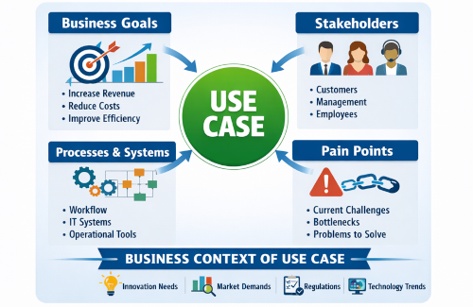
✏ TODO
Describe the relevant business context and stakeholders.
We recommend diagrams in drawio (need to be stored in SVG), or you can use mermaid or plant uml
As described in TRG 1.04: https://eclipse-tractusx.github.io/docs/release/trg-1/trg-1-04
You can also include infografics/ images (which are not diagrams, like above)

Business Value
✏ TODO
Describe the business value of this KIT and why it should be implemented

Standards
✏ TODO
Add the standards or external documetantion
Name | Description | Link to standard
CX-XXXX | This protocol is important when doing the data exchange | example-link
FX-XXXX | This protocol is important when doing a vertical integration with shop floor machinery | example-link
ISO XXXX:XXXX | This protocol is used as | example-link

NOTICE
This work is licensed under the CC-BY-4.0.
- SPDX-License-Identifier: CC-BY-4.0
- SPDX-FileCopyrightText: [YYYY] [YOUR_COMPANY]
- SPDX-FileCopyrightText: [YYYY] [ANOTHER_COMPANY]
- SPDX-FileCopyrightText: [YYYY] Contributors to the Eclipse Foundation
- Source URL: https://github.com/eclipse-tractusx/eclipse-tractusx.github.io

Development View

Architecture Overview
✏ TODO
Describe the technical architecture and key design decisions.
We recommend diagrams in drawio (need to be stored in SVG), or you can use mermaid or plant uml
As described in TRG 1.04: https://eclipse-tractusx.github.io/docs/release/trg-1/trg-1-04.
Explain which components are involved in the KIT data exchange or use case.
Keep the source code so it can be included in the final KIT version in Markdown.
Example:
📊 Diagram
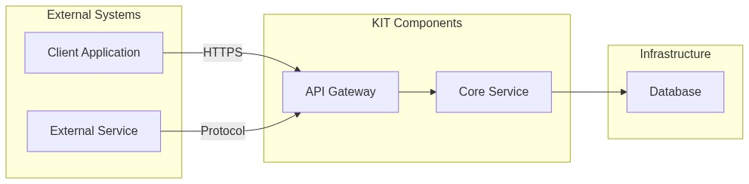
Source Code:
graph LR
subgraph External Systems
A[Client Application]
B[External Service]
end
subgraph KIT Components
C[API Gateway]
D[Core Service]
end
subgraph Infrastructure
F[Database]
end
A -->|HTTPS| C
B -->|Protocol| C
C --> D
D --> F
✏ TODO
Text description of the diagram.

Application Programming Interfaces (API)
✏ TODO
If applicable API specifications.
Detailed APIs can be included as swagger / open api specs
As described in TRG 1.08: https://eclipse-tractusx.github.io/docs/release/trg-1/trg-1-08
Will be hosted in API HUB: https://eclipse-tractusx.github.io/api-hub/

Semantic Models / Data Model
✏ TODO
Link or describe the data model, when using big payloads or json-schemas use expandable sections like below:

Protocols
✏ TODO
Add the protocols which you are using for the data exchange.
Name | Description | Link to Documentation
Protocol Name | This protocol is important when doing the data exchange | example-link

NOTICE
This work is licensed under the CC-BY-4.0.
- SPDX-License-Identifier: CC-BY-4.0
- SPDX-FileCopyrightText: [YYYY] [YOUR_COMPANY]
- SPDX-FileCopyrightText: [YYYY] [ANOTHER_COMPANY]
- SPDX-FileCopyrightText: [YYYY] Contributors to the Eclipse Foundation
- Source URL: https://github.com/eclipse-tractusx/eclipse-tractusx.github.io

Changelog

[0.1.0] - YYYY-MM-DD

Added
- Initial version of the KIT

Changed
- ./.

Removed
- ./.

NOTICE
This work is licensed under the CC-BY-4.0.
- SPDX-License-Identifier: CC-BY-4.0
- SPDX-FileCopyrightText: [YYYY] [YOUR_COMPANY]
- SPDX-FileCopyrightText: [YYYY] [ANOTHER_COMPANY]
- SPDX-FileCopyrightText: [YYYY] Contributors to the Eclipse Foundation
- Source URL: https://github.com/eclipse-tractusx/eclipse-tractusx.github.io

