Accessing the source code of Epsilon from CVS
Dimitrios Kolovos
Dept. of Computer Science, The University of York
dkolovos@cs.york.ac.uk

Introduction
The purpose of this document is to describe the process of setting up a local copy of the source code of Epsilon from the Eclipse CVS server (dev.eclipse.org) using Eclipse 3.2.

Prerequisites
Download and install Eclipse 3.2 and the latest version of EMF.

Accessing the code
1. Switch to the CVS Repository Exploring perspective (from the Window->Open Perspective->Other… menu)

2. Click the Add CVS Repository button () on the CVS Repositories view and enter the following configuration details (no password required for user anonymous):

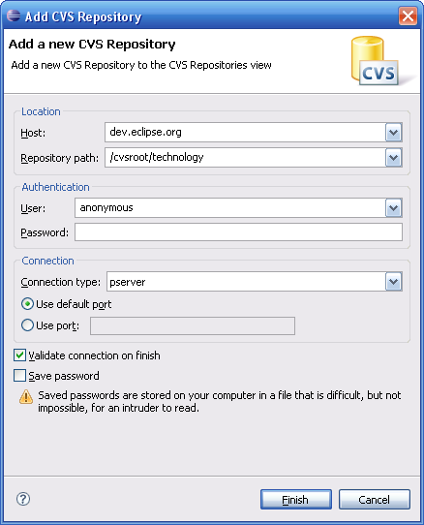

3. Open the HEAD () node and navigate to org.eclipse.gmt/epsilon

4. Select the sub-folders of epsilon that start with the org.epsilon prefix, right-click and check them out as follows:

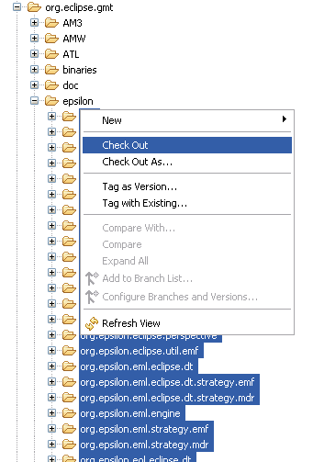

Adding the external libraries
Due to licensing reasons, some libraries required by Epsilon such as ANTLR (http://www.antlr.org) and MDR (http://mdr.netbeans.org) cannot exist in the Eclipse CVS server. Therefore, users have to download and install the following libraries separately. Users can download the files either from their respective websites. However, to make things easier, we have compiled a zip file containing the necessary files available at:

http://www-users.cs.york.ac.uk/~dkolovos/epsilon/EpsilonLibraries.zip

ANTLR

antlr-2.7.5.jar must be placed in the org.epsilon.dependencies directory.

MDR
Files:

jmi.jar

jmiutils.jar
mdrapi.jar
mof.jar
nbmdr.jar
openide-util.jar
must be placed in the org.epsilon.eol.models.mdr.dependencies directory.

Launching Epsilon
Now switch to the Plug-in Development Perspective (from Window->Open Perpective->Other…) and click the Run menu

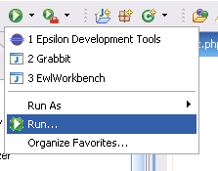

and in the dialog that appears, create a new Eclipse Application launch configuration by selecting the Eclipse Application node and clicking the New Launch Configuration () button.

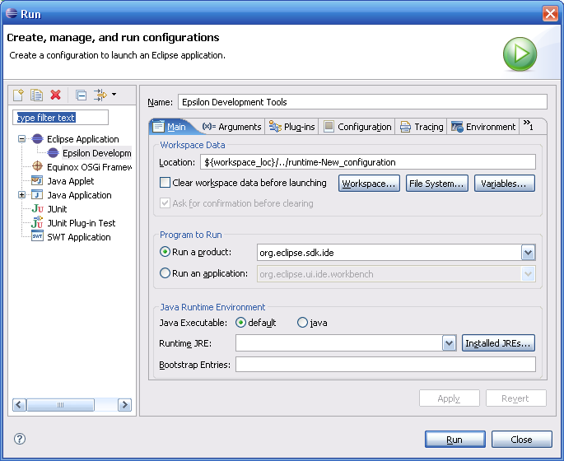

Now click the Run button on the bottom right of the dialog. A new instance of Eclipse should start.

