Accessing the Source Code of Epsilon from SVN
Dimitrios Kolovos
Dept. of Computer Science, The University of York
dkolovos@cs.york.ac.uk

Introduction
The purpose of this document is to describe the process of setting up a local copy of the source code of Epsilon from the Eclipse SVN server (dev.eclipse.org) using Eclipse 3.3+.

Prerequisites
Download and install Java 1.5+, Eclipse 3.3+, the Eclipse SVN client, the latest version of EMF and (optionally) the latest version of GMF.

Accessing the code
1. Switch to the SVN Repository Exploring perspective (from the Window->Open Perspective->Other… menu)

2. Click the New Repository Location on the SVN Repositories view and enter the following details (http://dev.eclipse.org/svnroot/modeling/org.eclipse.gmt.epsilon/):

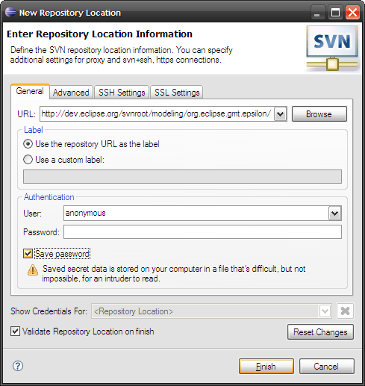

3. Open the trunk node

4. Select the sub-folders of plugins and features, right-click and check them out as follows:

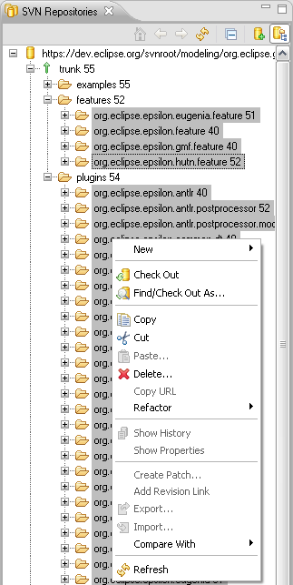

Launching Epsilon
Now switch to the Plug-in Development Perspective (from Window->Open Perpective->Other…) and click the Run menu

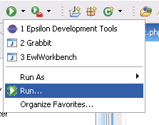

and in the dialog that appears, create a new Eclipse Application launch configuration by selecting the Eclipse Application node and clicking the New Launch Configuration () button.

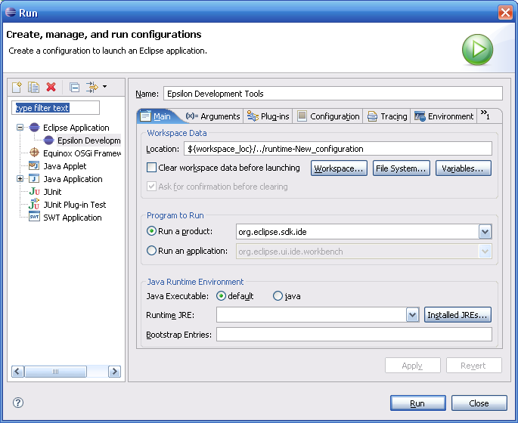

Now click the Run button on the bottom right of the dialog. A new instance of Eclipse should start.

