An Overview of the EglDoc Tool

Louis Rose
lmr109 [at] cs.york.ac.uk
Department of Computer Science,
The University of York

Introduction
This document provides an overview and a usage example of the EglDoc tool, which allows the generation of meta-model documentation that may be viewed in a web browser. EglDoc can be used with any MOF 2.0 (EMF) meta-model.

Generating documentation
To generate documentation, invoke the following command:
> java –jar EglDoc.jar MetaModelPath

Where MetaModelPath is the meta-model file from which documentation will be generated. To generate documentation from within Eclipse, use a launch configuration to invoke the main method of the org.epsilon.egl.doc.EglDoc class. An example launch configuration can be found in the examples directory.

Once the command completes, the current working directory will contain HTML documentation for the specified metamodel:

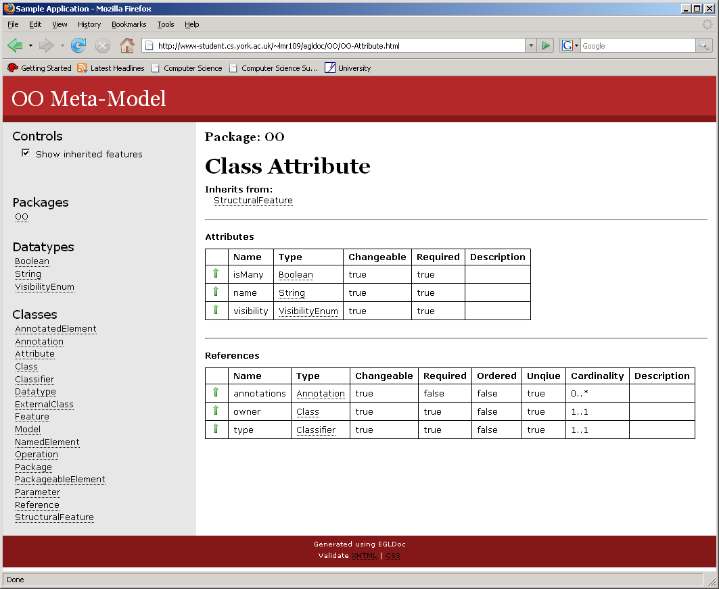

The sidebar to the left allows navigation between elements of the meta-model.

Controlling the Output Destination
The destination switch may be used to specify an alternative directory into which the documentation should be generated. For example, the following command may be used to generate documentation directly to the c:\web directory:
> java –jar EglDoc.jar –destination c:/web/ MetaModelPath

Using GraphViz to Generate a Class Diagram
EglDoc optionally supports the ability to generate a class diagram from input meta-models, which are then embedded into the documentation. In order to utilise this functionality, EglDoc must be able to invoke the dot executable, which is part of the GraphViz tool.

If GraphViz is installed on your system, documentation containing embedded class diagrams may be generated by using a command such as:
> java –jar EglDoc.jar –dot c:/Graphviz/bin/dot.exe MetaModelPath

Annotating Meta-Models for Richer Documentation
EglDoc supports annotation of meta-model elements, via the doc annotation. The details with the following keys can be interpreted by EglDoc:

Key | Applies To | Value | Description
description | EClass  EDataType  EAttribute  EOperation  EReference  EEnumLiteral | Any text. | Provides a textual description of the annotated element.
version | EClass  EDataType | Any text. | Indicates the current version of the annotated element. Equivalent to the Javadoc @version tag.
see | EClass  EDataType | A comma separated list of EClassifier elements. | Denotes those classifiers that have documentation that is related to that of the annotated element. Equivalent to the Javadoc @see tag.

Graphviz may be downloaded from: http://www.graphviz.org/

