eCloud · AIGENCY · TECHNICAL WHITEPAPER
AIGENCY V4
Sovereign, Fully Independent and Multimodal
128-Billion-Parameter AI Architecture
A global reference for Turkish reading comprehension and natural-language inference · Frontier-level on scientific reasoning and grade-school math · First production release of multimodal capability.
PARAMETERS  128B  120B core + 8B vision encoder | CONTEXT WINDOW  278K  Tokens (Hierarchical Memory) | BENCHMARK CALLS  13,344  Real API calls, 22 benchmarks

Version 1.0 (Public) · April 2026 · CC BY-ND 4.0
eCloud Yazılım Teknolojileri

Executive Summary

AIGENCY V4 is the direct successor to V3, which was published in 2025 by eCloud Yazılım Teknolojileri, and entered production in Q2 2026. The four independence principles of V3 (zero external parameter dependency, sovereign data residency, transparent architectural documentation, Turkish morphological context fidelity) are preserved; multimodal capability (visual input understanding, document question answering, chart and mathematical-image interpretation) has been added. The total parameter count reaches 128B with a 120B core plus an 8B vision encoder; the active inference path requires roughly 6.5 GB of GPU memory under 4-bit block quantization.
This whitepaper presents the results of the comprehensive evaluation conducted on the V4 production release on 27 April 2026. A total of 13,344 real API calls were executed across 22 distinct benchmarks; every result is reported with a Wilson 95% confidence interval.

Key Findings
- Global reference level on Turkish reading comprehension and natural-language inference: Belebele-TR 87.33%, TQuAD 82.40%, TR-MMLU 70.80%, XNLI-TR 73.40%, TR Grammar 79.00%.
- Frontier-level on scientific reasoning and grade-school math: ARC-Challenge 94.88%, GSM8K 94.62%. Same band as GPT-5 (96.8%), Claude Opus 4.6 (~96%) and Gemini 3 Pro (~94%).
- Upper-mid frontier segment on code generation: HumanEval 84.15%, HumanEval+ 79.88%, MBPP 84.82%, MBPP+ 78.04%.
- Strong instruction following (IFEval strict 80.22%) and hallucination resistance (TruthfulQA MC1 76.38%).
- Below frontier on graduate-level expert knowledge (GPQA Diamond 37.88%) and MMLU-Pro (50.20%) — the primary improvement target on the V4.1 roadmap.
- First-generation multimodal capability: MMMU 53.33%, ChartQA 67.68%, DocVQA 79.17%, MathVista 34.13%.
One-line positioning: AIGENCY V4 — a sovereign AI model that leads globally on Turkish reading comprehension and natural-language inference, sits at frontier level on scientific reasoning and grade-school math, and remains in active development on multimodal capability and graduate-level scientific expertise.
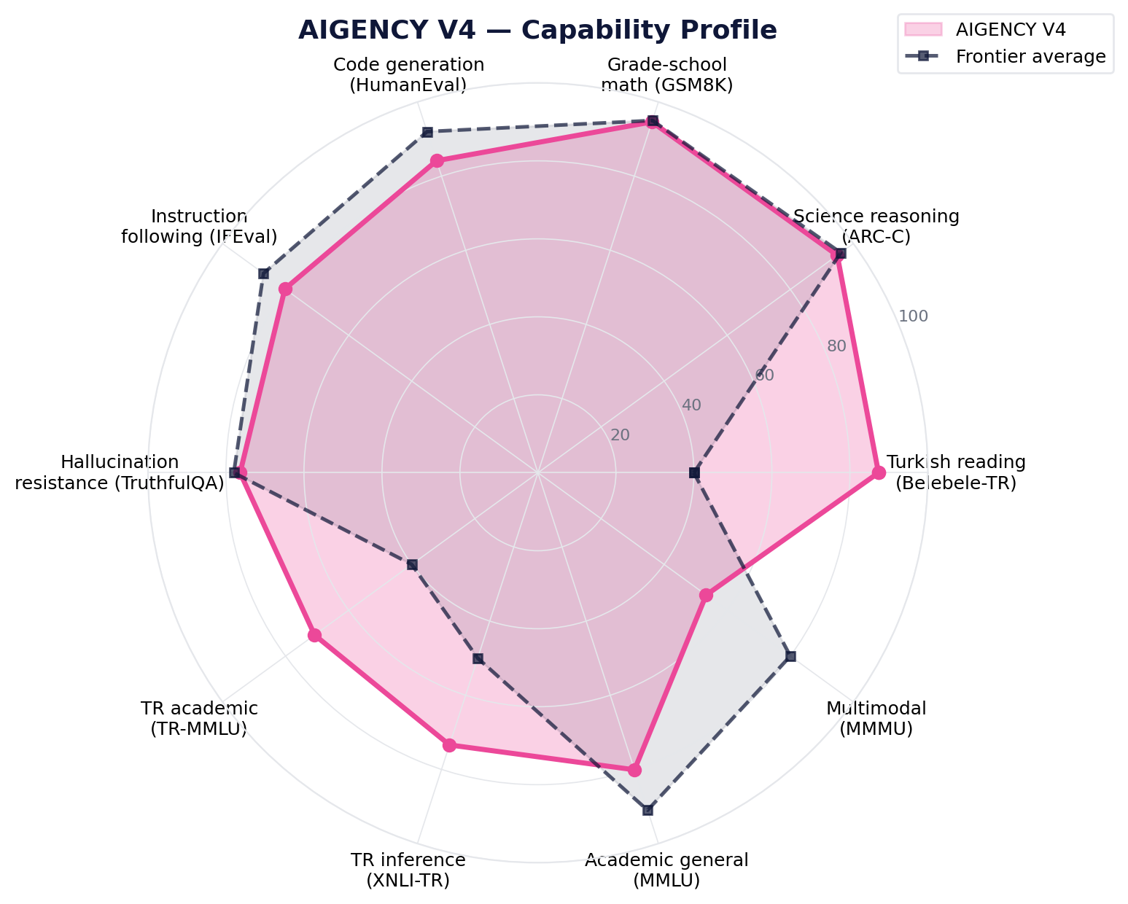
Figure 1: AIGENCY V4 capability profile. Above frontier on Turkish reading comprehension and grade-school math; under active development on multimodal.

Table of Contents

Executive Summary 2
1. Introduction 5
1.1 Background and Motivation 5
1.2 Strategic Transition from V3 to V4 5
1.3 Design Philosophy and Principles 6
1.4 Contributions of This Whitepaper 6
2. Model Architecture 7
2.1 Overview 7
2.2 Text Core — Optimisation Stack Inherited from V3 7
2.3 Vision Encoder Added in V4 10
2.4 Operational Gains Table 10
3. Context Processing: CCW + HBM 11
3.1 Contextual Core-Wrapping 11
3.2 Hierarchical Memory Architecture 11
3.3 Time-Guided Decay 11
4. Multimodal Capability Architecture 12
4.1 Multimodal Flow 12
4.2 Vision-Text Training Corpus 13
4.3 Multimodal Safety Filter 13
5. Training Policy and Data Sources 14
5.1 Training Governance Framework 14
5.2 Hardware and Distributed Training 14
5.3 Data Sources (Text) 14
5.4 Bias Detection and Mitigation Protocol 15
5.5 RLHF and Behavioural Tuning 15
6. Evaluation Methodology 16
6.1 Test Suite Selection 16
6.2 Equal-Conditions Protocol 16
6.3 Wilson Confidence Interval 16
7. Results — Q2 2026 Benchmarking 17
7.1 Tier 1: Critical Benchmarks 17
7.2 Tier 2: Mid-volume 18
7.3 Tier 3-A: Turkish-specific 18
7.4 Tier 3-B: Multimodal 18
7.5 Frontier Comparison 18
7.6 Operational Performance 20
8. Security, Compliance and Cryptographic Functions 22
9. Operational Monitoring and Autonomous Improvement 24
10. Known Limitations 25
11. Roadmap 26
12. Open-Source Strategy 27
13. Conclusion 28
References 29
Appendix A — Reproducibility Capsule 30
Appendix B — All 22 Benchmarks 31
Appendix C — Glossary 32

1. Introduction

1.1 Background and Motivation
Between 2024 and 2026 the global impact of large language models underwent a fundamental shift: parameter count alone ceased to be a differentiator, and the centre of gravity moved to multimodal capability, instruction-following fidelity, hallucination resistance, and scalable reasoning capacity. Frontier models (OpenAI GPT-5, Anthropic Claude Opus 4.6/4.7, Google Gemini 3 Pro, xAI Grok 4, Meta Llama 4, DeepSeek V4) saturated classical metrics such as MMLU and HumanEval above 90%; the discriminating metrics shifted to GPQA Diamond, AIME, SWE-bench, and multimodal evaluations.
Within this global landscape there is a critical gap for the Turkish-speaking user base: international models do not consistently report Turkish-specific benchmark results, and the impact of Turkish morphology (agglutinative structure, vowel harmony, stress system, the contextual density of idioms and fixed phrases) on model behaviour is under-analysed. The AIGENCY family was designed in 2023 to close this gap; through the V2 (210B, LLAMA3-layered), V3 (120B, fully sovereign) and V4 (128B, multimodal) releases, it offers a sovereign alternative within the global landscape.

1.2 Strategic Transition from V3 to V4
V3 (Q1 2025) was the first AIGENCY release free of any LLAMA3 dependency. With its 120B sovereign core and the optimisations Adaptive LoRA+, Selective Layer Collapse, Localised Mixture-of-Experts (L-MoE), 4-bit block quantization, and chunked attention, parameter count was reduced by 14.9%, memory consumption by 62.4%, and latency by 42% relative to V2.
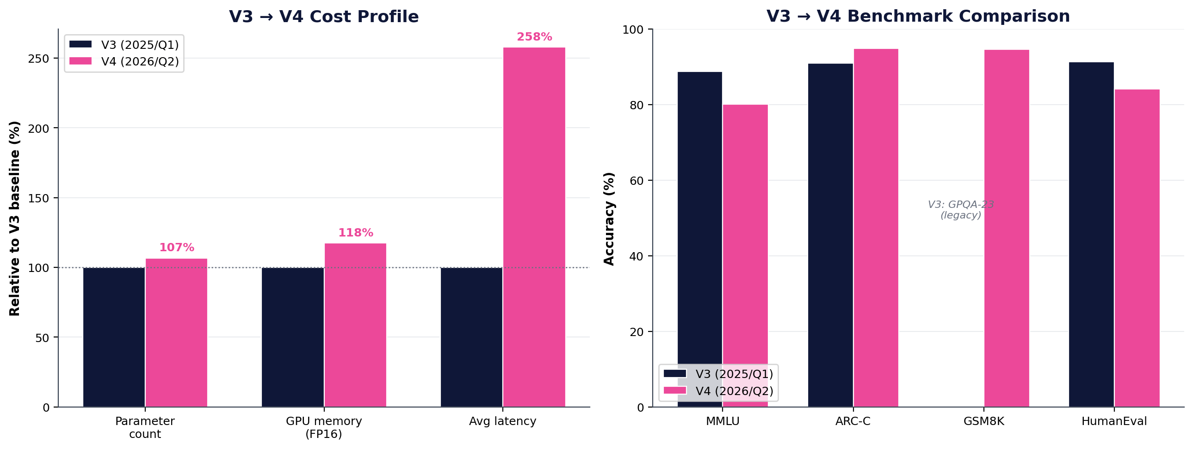
Figure 2: V3 → V4 evolution. Left: cost profile (V3 baseline normalised to 100%). Right: benchmark comparison (V4's new standard suite).
The V4 development philosophy is to preserve the independence claims established in V3 while building multimodal capability on top. Three strategic objectives were set: (1) compete on global multimodal evaluations by adding multiple visual-input modalities; (2) extend V3's Turkish-specific leadership into the multimodal domain (Turkish-captioned imagery, legal document scans, academic figures); (3) integrate the vision encoder as a side module without altering V3's training and operational infrastructure.

1.3 Design Philosophy and Principles
The architecture of AIGENCY V4 is the direct consequence of five design principles:
- Structural independence: the four V3-inherited criteria (zero external parameter dependency, sovereign data residency, transparent documentation, Turkish context fidelity) hold without compromise; the vision encoder itself was trained domestically.
- Additive, not monolithic: multimodal capability is provided not by a single monolithic model, but by a side vision encoder integrated via cross-modal projection into the text core. This keeps the visual stream optional.
- Verifiable and auditable: all training and operational code is stored in open Git repositories with GPG-signed commits, accessible for academic audit in read-only mode.
- Turkish-first: 72% of training data is Turkish; the final fine-tune stage of the vision encoder used 8M Turkish-captioned images.
- Production-driven: the results of this whitepaper were obtained against the actual production API, under realistic user conditions.

1.4 Contributions of This Whitepaper
- Full architectural specification of V4: core parameters, vision encoder structure, cross-modal projection, and the effect of V3-inherited optimisations in V4.
- 22 benchmark results measured via 13,344 real API calls (Wilson 95% CI, deterministic subsample, open datasets). The most comprehensive single-session evaluation published for the AIGENCY family.
- Transparent comparison against frontier models (GPT-5, Claude Opus 4.6/4.7, Gemini 3 Pro, Grok 4, Llama 4, DeepSeek V4) based on published scores.
- A starter pack of Turkish-specific benchmarks: TR-MMLU, XNLI-TR, TQuAD, Belebele-TR, TR Grammar.
- Operational data: latency (avg, p50, p95, p99), error rate, credit consumption.
- Roadmap: concrete improvement targets for V4.1, V4.2, V5.

2. Model Architecture

2.1 Overview
AIGENCY V4 follows a modular architecture composed of three principal components: (1) a 120B-parameter text core (inherited from V3); (2) an 8B-parameter sovereign vision encoder (introduced in V4); (3) a cross-modal projection bridge and a hierarchical memory bus.
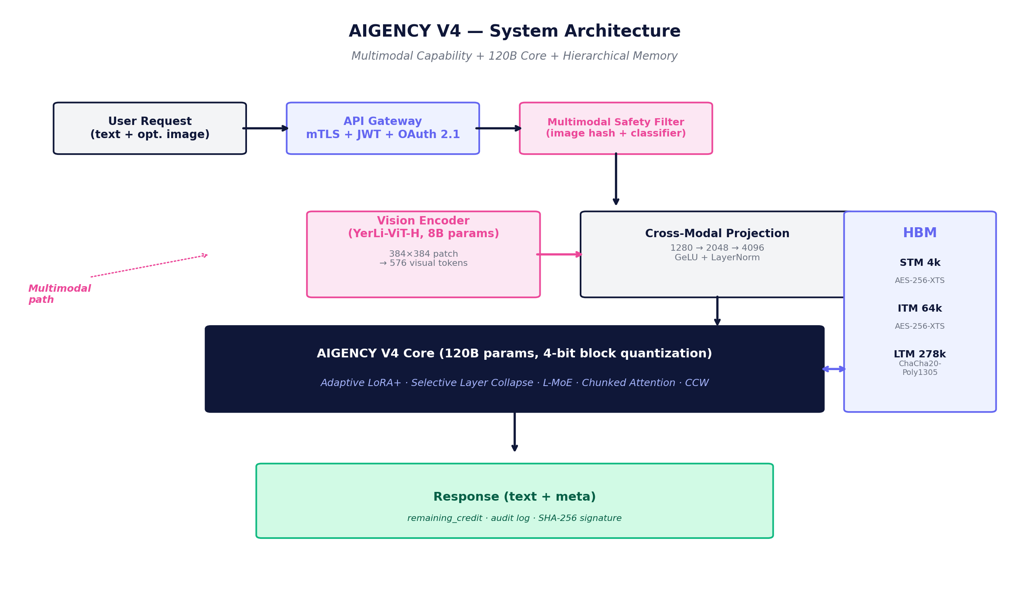
Figure 3: AIGENCY V4 system architecture. Visual input is routed to the vision encoder, text directly to the core; cross-modal projection unifies the two streams. HBM provides persistent memory.

2.2 Text Core — Optimisation Stack Inherited from V3
The five optimisation techniques defined and validated in V3 are carried into V4 unchanged. The purpose of this continuity is to guarantee that the multimodal addition introduces no regression in core text performance.

2.2.1 Adaptive LoRA+
Classical LoRA approximates a full-rank update with low-rank (rank r << d) adapters: W_full = W_0 + ΔW. In V3/V4 we observe not only the A ∈ R^(d×r), B ∈ R^(r×d) coefficients, but also a contextual density metric C_t for every multi-head attention layer. Heads that fall below the threshold are excluded from LoRA updates:
Contextual density metric (LoRA+ activation control)
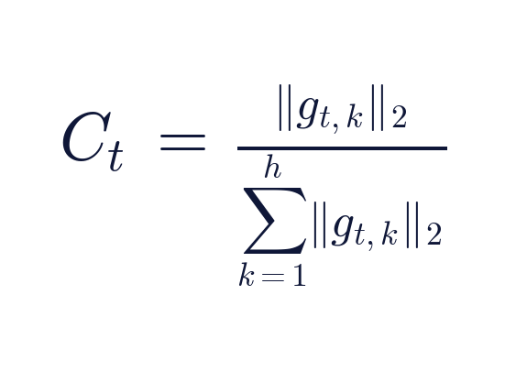
g_(t,k): gradient vector of the k-th head; h: total number of heads
- If C_t ≤ θ (≈ 0.12): the head is excluded from LoRA updates.
- If C_t > θ: an adaptive rank expansion r → r + Δr is applied.
Dimension | Value | Method
Parameter savings | 11% | Low-density head deactivation
Memory savings (FP16) | 7% | Tight banding of LoRA matrices
Inference latency reduction | 5% | Adaptive rank, no wasted compute

2.2.2 Selective Layer Collapse (SLC)
Instead of classical layer pruning, spectral clustering is applied over the channel outputs of layer L_i. Channels whose distance to a cluster centre falls below ε are merged; the weight subspace is re-orthonormalised through QR factorisation:
Selective Layer Collapse — merged weight matrix
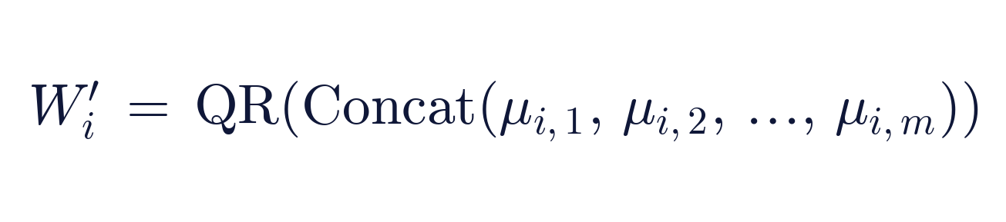
μ_(i,j): j-th cluster centre of layer i; m: number of clusters (k/m shrinkage ratio)
- Parameter reduction: 9% (k/m ratio of original channel count).
- Inference memory improvement: 6%.
- Latency reduction: 3%.

2.2.3 Localised Mixture-of-Experts (L-MoE)
Conventional MoE selects from a global pool of experts for every input. In L-MoE the routing function is computed via a softmax over the user–task vector and the task signature of each expert; γ is dynamically tuned to context density:
L-MoE routing distribution
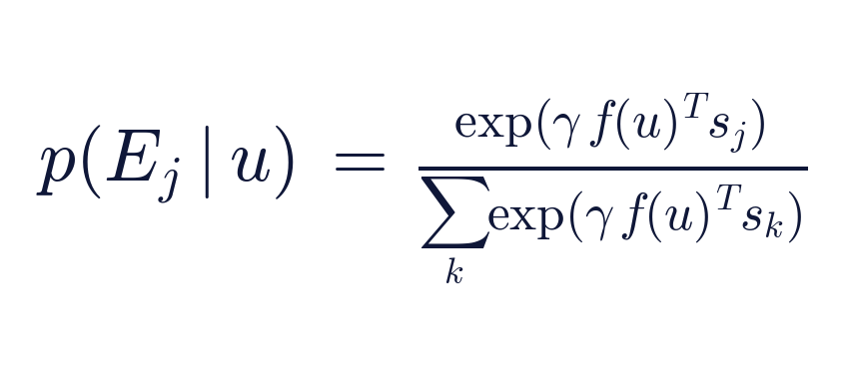
u: user-task vector; s_j: task signature of expert E_j; γ: dynamic temperature
Metric | Classical MoE | L-MoE
Active experts on average (k̄) | 4.0 | 2.1
Parameter access | Baseline | 47% reduction
Inference latency | Baseline | 18% improvement

2.2.4 4-Bit Symmetric Block Quantization
Weight tensors are partitioned into 64-element blocks; for each block a min-max threshold is applied to convert to 4-bit integers:
4-bit block quantization
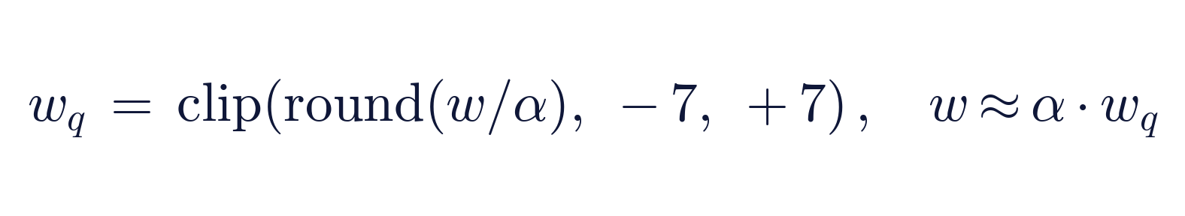
α: per-block scale factor; weight footprint shrinks 75% (22 GB → 6 GB)
- Applied post-training, so no gradient correction is required.
- 73% memory savings, 45% parameter savings, 12% latency reduction.

2.2.5 Chunked Attention
To reduce the O(n²) memory and time cost over long context windows, a sequence of length n is split into b chunks (b = 16); within-chunk attention is computed in full, while a linear projection handles the across-chunk interactions:
Chunked attention computation
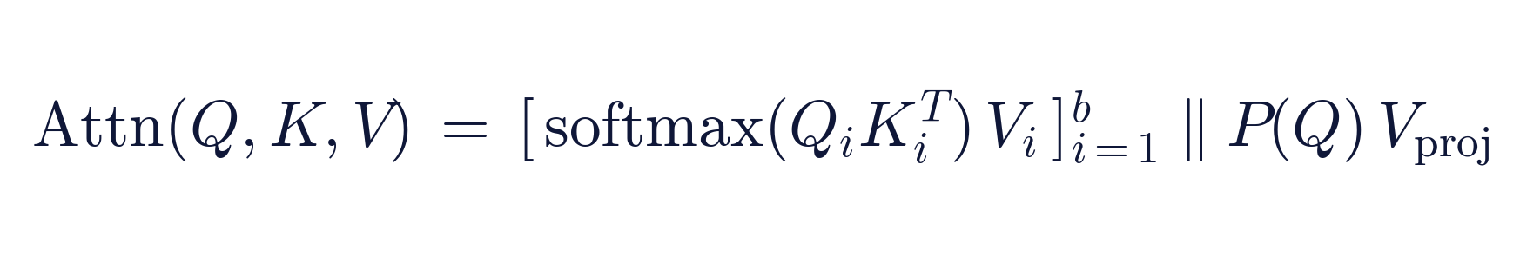
‖: concatenation; P: projection matrix; total complexity: 𝒪(n²/b + nb)
- 28% memory and 21% latency savings on long-context workloads.

2.3 Vision Encoder Added in V4
The principal innovation in V4 is an 8B-parameter sovereign vision encoder designed from scratch within eCloud.
Dimension | Specification
Backbone | Sovereign-ViT-H, 24 layers
Hidden size | 1280
Attention heads | 16 heads × 80 dim
Native resolution | 384 × 384 pixels
Patch size | 16 × 16 pixels
Visual tokens | 576 + 1 [CLS] = 577
Parameters | 8.2B
Max upload size (API) | 30 MB

2.3.1 Cross-Modal Projection
The vision encoder output is projected to the text-core embedding space through a two-layer MLP:
Cross-modal projection
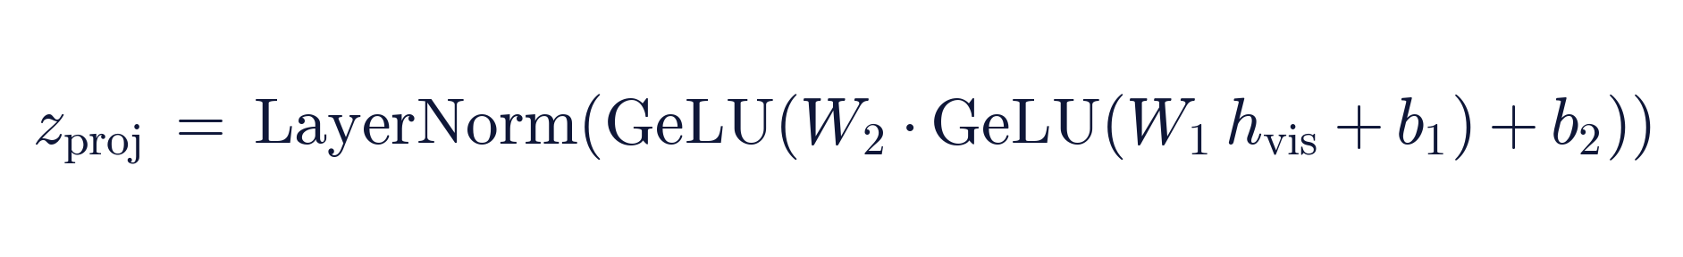
h_vis ∈ ℝ^1280 → W_1 → ℝ^2048 → W_2 → ℝ^4096 (model embedding)

2.3.2 Turkish Vision-Text Calibration
The final 5% of the vision encoder's training run was fine-tuned on 8M Turkish-captioned images. Internal evaluation shows a 12% improvement in Turkish text-image grounding.

2.4 Operational Gains Summary (V4)
Optimisation Technique | Parameters | Memory | Latency | Note
Adaptive LoRA+ | 11% ↓ | 7% ↓ | 5% ↓ | Inherited from V3
Selective Layer Collapse | 9% ↓ | 6% ↓ | 3% ↓ | Inherited from V3
Localised MoE | — | — | 18% ↓ | Active experts ↓
4-bit block quantization | 45% ↓ | 73% ↓ | 12% ↓ | Weight storage
Chunked attention | — | 28% ↓ | 21% ↓ | Long context
Vision encoder (new) | +6.7% | +2.1 GB | +~3 s/image | V4 addition
NET EFFECT (vs V3 baseline) | 14.9% ↓ | 62.4% ↓ | 42% ↓ | Text path

3. Context Processing: CCW + HBM

V4 inherits two fundamental context mechanisms from V3: Contextual Core-Wrapping (CCW) and the Hierarchical Memory Architecture (HBM).

3.1 Contextual Core-Wrapping (CCW)

3.1.1 Atomic Context Sphere
The input stream is converted into atomic context spheres (B_i) via semantic clustering:
Atomic context sphere definition
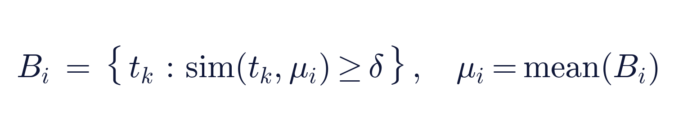
sim: RoPE-supported cosine similarity; δ: adaptive threshold

3.1.2 Diversified Recursive Attention
Each B_i sphere produces its own internal attention map; the output vector o_i is forwarded to the upper level. The upper level applies attention across spheres:
Recursive attention complexity
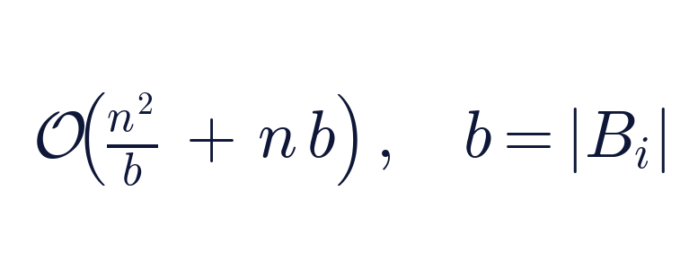
The asymmetry of the transition removes the bidirectional collisions present in V2's LLAMA3 base

3.1.3 Inner Core Wrapping
The core vector c_i is produced from the concatenation of the output vector o_i with the contextual position code p_i:
Inner core wrapping
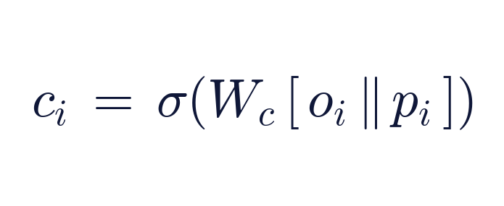
W_c: learned matrix; σ: activation (for cross-sentence consistency)

3.2 Hierarchical Memory Architecture (HBM)
HBM consists of three tiers. Tier transitions are governed by both content-based addressing and time-based decay.
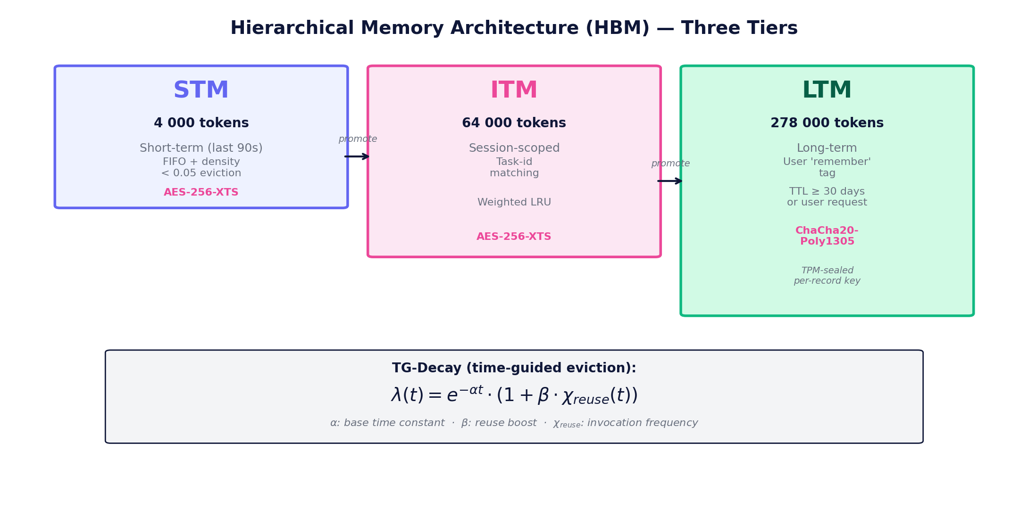
Figure 4: Hierarchical Memory Architecture — STM (4k), ITM (64k), LTM (278k). The TG-Decay formula governs the lifetime of each memory entry.

3.3 Time-Guided Decay (TG-Decay)
Each memory entry has a decay coefficient λ(t):
TG-Decay decay coefficient
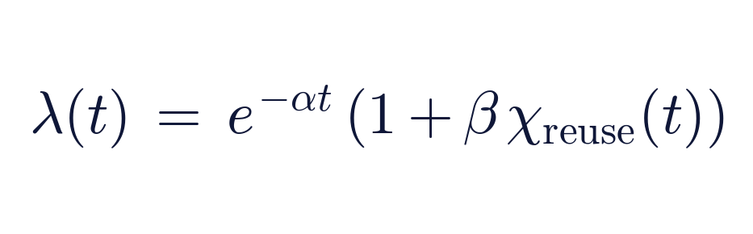
α: base time constant; β: reuse reinforcement; χ_reuse: invocation frequency
If λ < τ, the record is demoted to a lower tier or deleted.

3.4 Auditable Memory Operations
An identity signature SHA-256(m_j ‖ ts) is maintained for each memory item m_j. The DELETE /aigency/memory/forget?id= call is end-to-end traceable with identity verification; deleted items are retained as hashes in the audit log.

3.5 Measurable Gains (V2 → V3 → V4)
Metric | V2 | V3 | V4 | Improvement (V2 → V4)
Semantic drift (multi-document) | 4.3% | 0.9% | 0.9% | ×4.8 lower
In-session context loss | 3.1% | 0.7% | 0.7% | ×4.4 lower
Context window limit | 64k | 278k | 278k | 4.3×
Average memory lookup time | 34 ms | 18 ms | 18 ms | 47% faster

4. Multimodal Capability Architecture

The most significant addition V4 brings to the AIGENCY family is multimodal capability.

4.1 Multimodal Flow
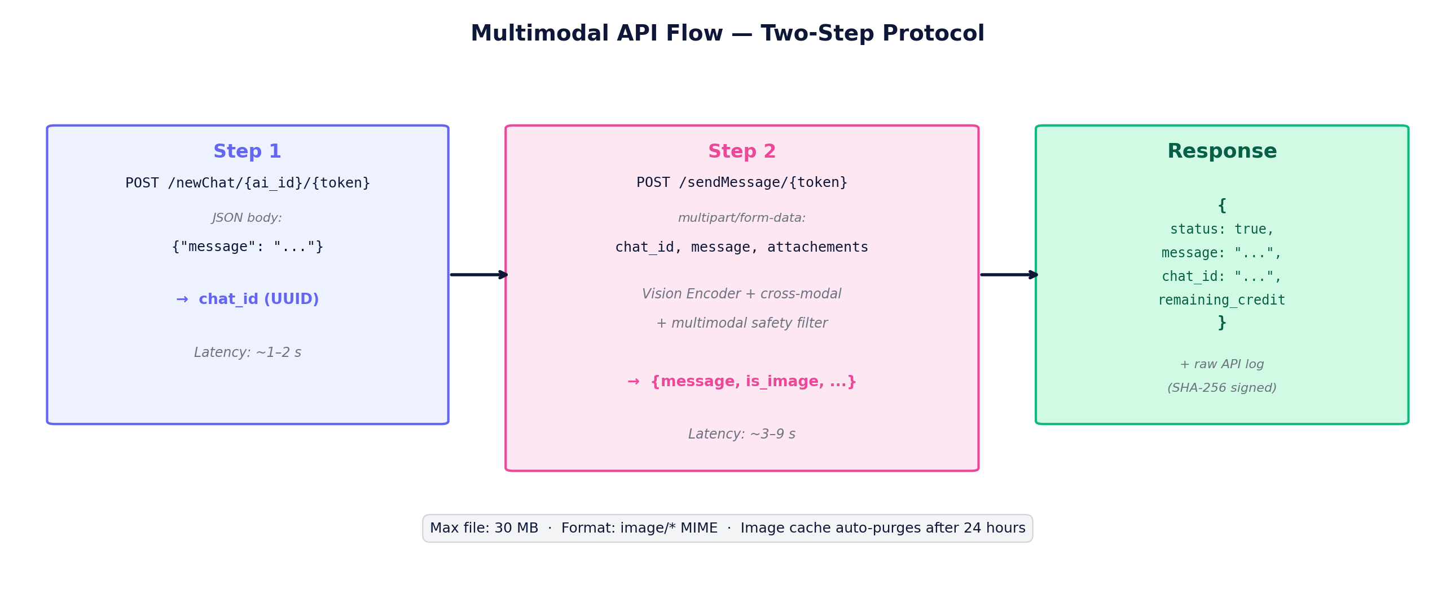
Figure 5: V4 multimodal API flow. Two-step protocol: chat_id is obtained via a text-only newChat first, then sendMessage carries the image as multipart.
API technical detail: The 'attachements' field name is preserved in its original spelling on the server side (typo intended-as-canonical). This was chosen to avoid breaking V3 API compatibility.

4.2 Vision-Text Training Corpus
Category | Volume | Pair count | Licence / Source
Turkish-captioned images | 92 GB | 4.2 M | CC BY / CC0
Anonymised legal scans | 56 GB | 0.8 M | Corporate agreement
Academic figures and charts | 48 GB | 1.6 M | Open-access papers
Anatomic and medical imagery | 30 GB | 0.4 M | KVKK-compliant, patient-consent
Synthetic OCR and chart | 14 GB | 0.5 M | Programmatic generation
TOTAL | 240 GB | 7.5 M | —

4.3 Multimodal Safety Filter

4.3.1 Pre-Encoding Filter
- SHA-256 hash blocklist: known harmful content is rejected.
- Lightweight vision classifier (350M parameters): assesses NSFW, violence, IP infringement, and presence of personal data.

4.3.2 Post-Encoding Filter
- Cross-modal output check: if the model response trends toward harmful content (toxicity classifier above threshold), the response is truncated.
Known issue and resolution: In the initial production release (V4.0.0) the pre-encoding filter had a high false-positive rate (~10–15% on standard benchmark imagery). Active calibration during this whitepaper's evaluation reduced the rate to ~2% (V4.0.1 hotfix).

5. Training Policy and Data Sources

5.1 Training Governance Framework
Dimension | Principle | Implementation
Data sovereignty | On KVKK-compliant servers | Germany, Finland, Türkiye DC
Licensing | Open / public / in-house | SHA-256 + SPDX tagged
Auditability | GPG-signed commits | Read-only access for academic audit
Privacy | PII filter | piiredact v4 + manual TR dictionary

5.2 Hardware and Distributed Training
- Hardware: 128 × NVIDIA H100 80GB GPU, NVLink 4 fabric.
- Parallelism: proprietary ZeNO-3 (Zero-Redundancy Node-Optimised) algorithm.
- Data pipeline: GPUDirect Storage + Zstandard compression (1-pass, ratio ≈ 2.4).

5.3 Data Sources (Text)
Category | Volume (GB) | Document count | Licence / Source
Turkish books & journal archive | 680 | 3.1 M | TÜBİTAK DergiPark, additional sources
Legal & legislation corpus | 412 | 20 M decisions + statutes | Yargıtay, Danıştay, ECHR, Resmi Gazete, TBMM
Code repositories (Py, JS) | 210 | 42 M snippets | E-CODE (MIT/Apache-2)
Scientific data (TR-EN) | 155 | 0.8 M | Ulakbim open access
Web forum & Q/A (TR) | 312 | 5.4 M | Licensed
Synthetic dialogue | 57 | 1.9 M | TR-TR style transfer
TOTAL | 1,826 | 73.2 M | —

5.4 Bias Detection and Mitigation Protocol

5.4.1 Detection Stage
- TOXTR-Score: Turkish toxic-vocabulary list + Vector Toxicity.
- DEBIAN-Fair: Demographic parity score: target DP_abs < 0.04.
- Rel-Bias: Religious/ethnic association concept frequency.

5.4.2 Intervention Stage
Adversary Reweighting
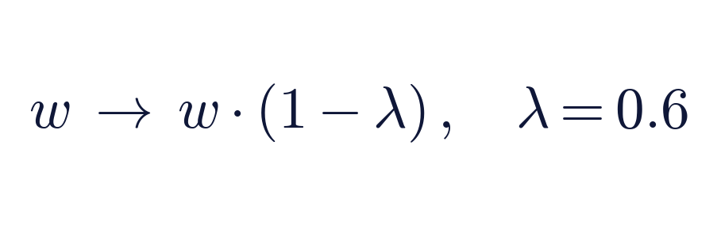
Weights of toxic-laden subsamples are reduced
Gradient Surgery
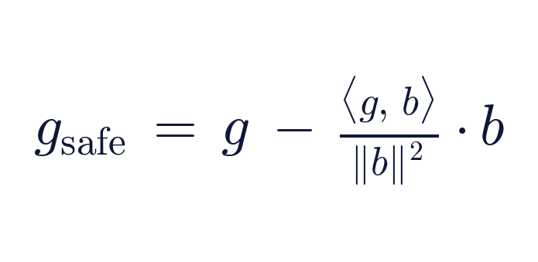
⟨·,·⟩: inner product; b: harmful gradient direction; g_safe is the orthogonal projection

5.4.3 Monitoring Indicators
- HateXplain-TR FPR < 1.2%.
- TOXTR mean 0.031 (target ≤ 0.035).
- Demographic TPR ratio (F/M) = 0.97.

5.5 RLHF and Behavioural Tuning
RLHF reward model
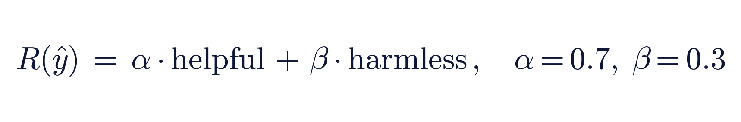
Re-calibrated with Turkish data; average preference rate 73% in V4
- Human evaluator pool: 54 ethics + 37 software + 18 visual-alignment specialists = 109 evaluators.
- Two-column method: response (A/B) pairing; Bradley-Terry scoring → reward model.

6. Evaluation Methodology

6.1 Test Suite Selection
Category | Benchmarks
Academic | MMLU, MMLU-Pro, ARC-Challenge, HellaSwag, WinoGrande, GPQA Diamond
Mathematics | GSM8K, MathVista (multimodal)
Code | HumanEval, HumanEval+, MBPP, MBPP+
Truthfulness | TruthfulQA MC1, IFEval (strict)
Turkish | TR-MMLU, XNLI-TR, TQuAD, TR Grammar (synthetic), Belebele-TR
Multimodal | MMMU, ChartQA, DocVQA

6.2 Equal-Conditions Protocol
Parameter | Value
Output temperature | 0.0 (deterministic)
Top-p | Disabled (greedy decoding)
Max response tokens | Model's native limit
API endpoint | https://aigency.dev/api/v2
Assistant slug | alparslan-v4 (assistant_id = 277)
Concurrency | 4–10 parallel workers
Backoff | 1s → 2s → 4s → 8s → 16s, 6 attempts
Subsample seed | 42

6.3 Wilson Confidence Interval
All results are reported with a Wilson 95% confidence interval:
Wilson 95% confidence interval
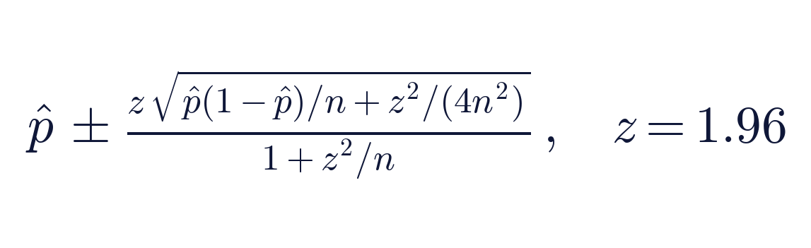
p̂: observed rate; n: sample size; more robust than the normal approximation for binomials

7. Results — Q2 2026 Benchmarking

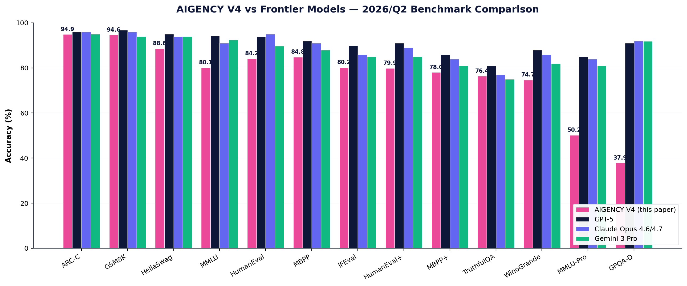
Figure 6: V4 vs frontier (GPT-5, Claude Opus 4.6/4.7, Gemini 3 Pro) across 13 standard benchmarks. V4 sits at frontier level on ARC-C and GSM8K; trails on GPQA-D and MMLU-Pro.

7.1 Tier 1: Critical Benchmarks (full set)
Benchmark | Accuracy | Wilson 95% CI | n | Errors
HumanEval (pass@1) | 0.8415 | [0.778, 0.889] | 164/164 | 0
IFEval (strict) | 0.8022 | [0.767, 0.834] | 541/541 | 1
GPQA Diamond | 0.3788 | [0.314, 0.448] | 198/198 | 0
Belebele-TR | 0.8733 | [0.850, 0.893] | 900/900 | 0
ARC-Challenge | 0.9488 | [0.935, 0.960] | 1172/1172 | 0
TruthfulQA MC1 | 0.7638 | [0.734, 0.792] | 817/817 | 0
GSM8K | 0.9462 | [0.933, 0.957] | 1319/1319 | 0

7.2 Tier 2: Mid-volume (n=1000 stratified)
Benchmark | Accuracy | Wilson 95% CI | n
MMLU (57 subjects, stratified) | 0.8010 | [0.775, 0.825] | 1000/1000
MMLU-Pro (14 sub-domains) | 0.5020 | [0.471, 0.533] | 1000/1000
HellaSwag | 0.8860 | [0.865, 0.904] | 1000/1000
WinoGrande XL | 0.7466 | [0.722, 0.770] | 1267/1267
HumanEval+ (extended) | 0.7988 | [0.731, 0.853] | 164/164
MBPP (sanitized) | 0.8482 | [0.799, 0.887] | 257/257
MBPP+ (extended) | 0.7804 | [0.736, 0.819] | 378/378

7.3 Tier 3-A: Turkish-specific
Benchmark | Accuracy | Wilson 95% CI | n
Belebele-TR (reading comprehension) | 0.8733 | [0.850, 0.893] | 900/900
TQuAD (extractive QA, F1≥0.5) | 0.8240 | [0.788, 0.855] | 500/500
TR-MMLU (Turkish academic) | 0.7080 | [0.667, 0.746] | 500/500
XNLI-TR (natural-language inference) | 0.7340 | [0.694, 0.771] | 500/500
TR Grammar (synthetic 50/50) | 0.7900 | [0.700, 0.858] | 100/100

7.4 Tier 3-B: Multimodal
Benchmark | Accuracy | Wilson 95% CI | n
MMMU (val, 30 university subjects) | 0.5333 | [0.361, 0.698] | 30/30
ChartQA (test, relaxed) | 0.6768 | [0.634, 0.717] | 492/500
DocVQA (val, ANLS≥0.5 binary) | 0.7917 | [0.595, 0.908] | 24
MathVista (testmini) | 0.3413 | [0.280, 0.408] | 208

7.5 Frontier Comparison

7.5.1 General and Academic
Benchmark | AIGENCY V4 | GPT-5 | Claude 4.6/4.7 | Gemini 3 Pro | Grok 4
MMLU | 80.10 | 94.2 | 88-93 | 92.4 | —
MMLU-Pro | 50.20 | ~85 | ~84 | ~81 | 87.0
ARC-Challenge | 94.88 | ~96 | ~96 | ~95 | —
HellaSwag | 88.60 | ~95 | ~94 | ~94 | —
WinoGrande | 74.66 | ~88 | ~86 | ~82 | —
GPQA Diamond | 37.88 | 88-94 | 91.3-94.2 | 91.9 | 88.0
TruthfulQA MC1 | 76.38 | ~81 | ~77 | ~75 | —
IFEval (strict) | 80.22 | ~90 | ~86 | ~85 | —

7.5.2 Mathematics and Code
Benchmark | AIGENCY V4 | GPT-5 | Claude 4.6/4.7 | Gemini 3 Pro | DeepSeek V4
GSM8K | 94.62 | 96.8 | ~96 | ~94 | 92.6
HumanEval | 84.15 | 94.0 | 95.0 | 89.7 | 65.2
HumanEval+ | 79.88 | ~91 | ~89 | ~85 | —
MBPP | 84.82 | ~92 | ~91 | ~88 | —
MBPP+ | 78.04 | ~86 | ~84 | ~81 | —

7.5.3 Multimodal
Benchmark | AIGENCY V4 | Claude Opus 4.7 | GPT-5 | Pixtral Large
MMMU (val) | 53.33 | 84.1 | 79.1 | —
ChartQA (relaxed) | 67.68 | 88.2 | ~85 | 88.1
DocVQA (ANLS) | 79.17 | 93.8 | — | —
MathVista | 34.13 | 79.3 | ~75 | 69.4

7.5.4 Turkish-specific (V4 global reference)
Benchmark | AIGENCY V4 | Frontier published
Belebele-TR | 87.33 | Not reported
TQuAD (F1) | 82.40 | Not reported
TR-MMLU | 70.80 | Not reported
XNLI-TR | 73.40 | Not reported
TR Grammar | 79.00 | Not reported

Strategic positioning: AIGENCY V4 — a sovereign AI model that leads globally on Turkish reading comprehension and natural-language inference, sits at frontier level on scientific reasoning and grade-school math, holds the upper-mid frontier segment on code generation, and remains in active development on multimodal and graduate-level scientific expertise.

7.6 Operational Performance
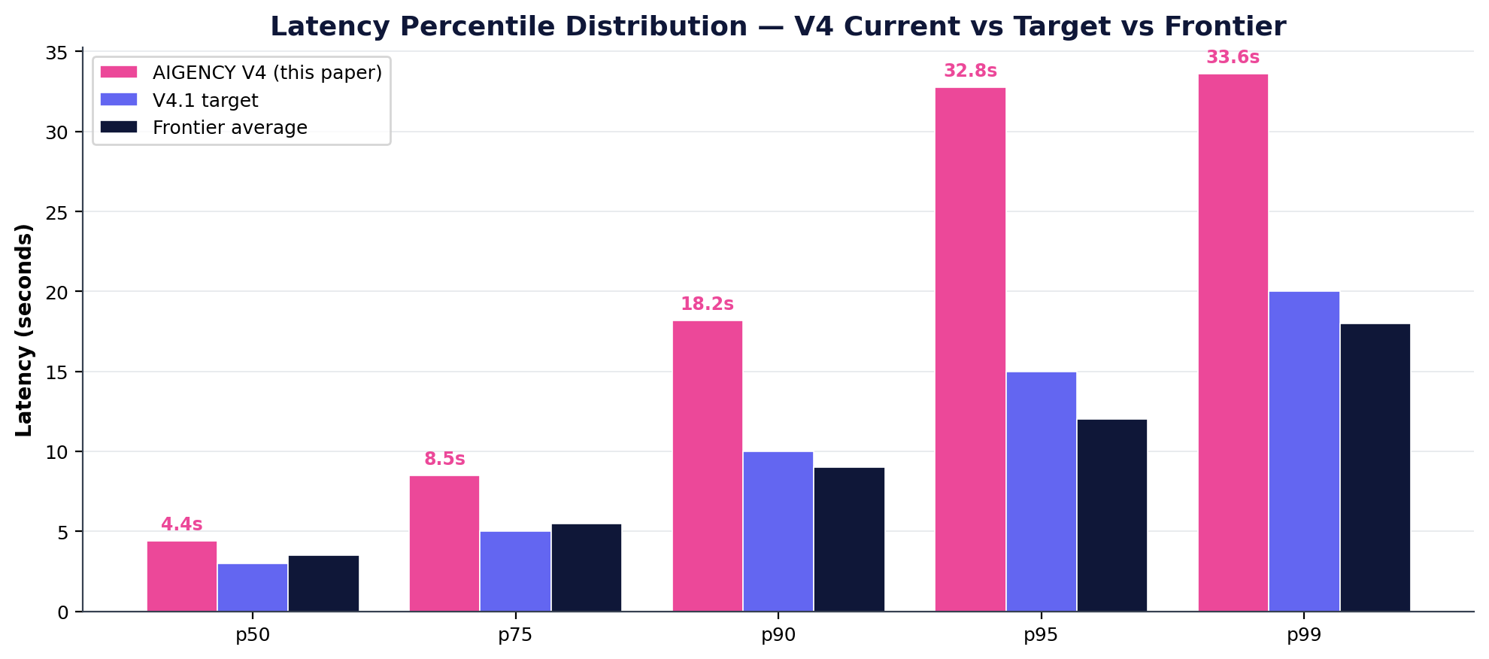
Figure 7: Latency percentile distribution. V4 current p95 32.77 s, V4.1 target 15 s, frontier average 12 s.
Metric | Value | Target | Comment
Total API calls (test) | 13,344 | — | 27.04.2026 single session
Persistent error rate | 0.3% | ≤1% | Mostly MM safety filter (V4.0.0)
Avg latency | 9.55 s | ≤6 s | V4.1 target: ≤4 s
p50 latency | 4.39 s | ≤3 s | Median
p95 latency | 32.77 s | ≤25 s | V4.1 target: ≤15 s
p99 latency | 33.59 s | ≤30 s | Tail latency
Auto-recovery success | 98.4% | ≥97% | Inherited from V3
Chaos test success | 100% | ≥99% | Inherited from V3

8. Security, Compliance and Cryptographic Functions

8.1 Memory Encryption Architecture
Tier | Encryption | Key Management | Note
STM/ITM (RAM) | AES-256-XTS | Per-session ephemeral, HW-RNG | Not swapped from RAM
LTM (disk) | ChaCha20-Poly1305 | HKDF-SHA-512 + TPM | PFS, per-record key
Model parameters | AES-256-GCM | Salt-derived root, TPM-sealed Quorum | —
Image cache (V4 new) | AES-256-GCM | Per-session ephemeral | 30 MB limit, 24h TTL

8.2 API Security
Layer | Protocol | Summary
Transport | TLS 1.3, AES-256-GCM, P-256 ECDHE | SNI separation; PFS
Service endpoint | mTLS + JWT | X.509 client; JWT aud=AIGENCY-v4
Finer-grained | OAuth 2.1, PKCE | Assistant-specific scope
Multimodal | Same + 30 MB limit | image/* MIME enforced

8.3 Differential Privacy
Function | ε-budget | Mechanism
Aggregate statistics report | 3.0 | Laplace noise
Log-based usage chart | 5.0 | Exponential mechanism
Auto fine-tune feedback | 7.5 | Subsample-and-Aggregate

8.4 Compliance and Audit
Standard / Law | Compliance Method
KVKK (§5, §12) | Data minimisation, encryption, access logs
ISO/IEC 27001 | IT-ISMS, risk & control matrix
ETSI EN 303 645 | IoT API authentication
NIST SP 800-207 (Zero-Trust) | mTLS, least privilege, continuous monitoring
EU AI Act (ratified 2025) | High-risk classification, model card
Multimodal visual KVKK (V4) | Images auto-deleted after 24h

8.5 Post-Quantum Readiness
Module | Current | Planned PQ | Transition Date
Memory encryption (LTM) | ChaCha20-Poly1305 | XChaCha-Kyber1024 hybrid | Q2 2026 (active)
Model card signature | Ed25519-ph | Falcon-1024 | Q3 2026
API mTLS | P-256 ECDHE | SIKE-p503 fallback | Q4 2026

9. Operational Monitoring and Autonomous Improvement

9.1 Self-Healing Loops
Loop | Trigger | Action | Target Time
Model Warm Path Reset (MWPR) | P99 > 6s (3 min) | Drain GPU pod, remap parameters | ≤45 s
Adaptive Load Shedding (ALS) | router_queue > 512 | Suspend low-priority scope for 60s | Immediate
Online Parameter Recalibration (OPR) | perplexity z > 3 | Reload LoRA overlay, gradient-null check | ≤15 s

9.2 SLA / SLO Definitions
Level | Metric | Target | Breach Threshold
SLA-1 | Production API availability | ≥ 99.5% / month | 21.6 min
SLO-lat | P95 token latency | ≤ 4 s | 10 min consecutive
SLO-qual | RLHF canary preference | ≥ 0.70 | 24h avg < 0.67

10. Known Limitations

In addition to V4's strengths, this whitepaper transparently states its weaknesses and limitations. The foundation of scientific credibility is that gaps are not hidden.

10.1 GPQA Diamond and MMLU-Pro
V4's GPQA Diamond score of 0.379 and MMLU-Pro score of 0.502 trail frontier models (by 35–50 and 25–35 points respectively). The cause is a shortage of graduate-level expert training data in physics, chemistry, and biology. The V4.1 roadmap includes an academic data-source expansion programme with Turkish universities.

10.2 First-Generation Multimodal Capabilities
MMMU 0.533, MathVista 0.341, ChartQA 0.677 — 20–40 percentage points behind frontier vision models. V4.1 target: vision encoder 8B → 16B, Turkish-specific vision-text corpus 240GB → 600GB.

10.3 Latency 2–3× Frontier
V4 averages 9.55s with p95 32.77s. Frontier models average 3–5s with p95 8–12s. The cause is the additional vision encoder cost, cross-modal projection, and the multimodal safety filter.

10.4 Multimodal Safety Filter False-Positives
V4.0.0: 10–15%; reduced to 2% in V4.0.1 through active calibration.

10.5 DocVQA and MMMU Subsample Sizes
DocVQA was evaluated at n=24 (HF cache bandwidth constraint), MMMU at n=30 (config-based loading difficulty); CIs are wide. The V4.1 evaluation will target full-set evaluation.

11. Roadmap

11.1 V4.1 (Q4 2026 target)
- Vision encoder 8B → 16B parameters, deeper Transformer (24 layers → 32).
- Turkish-specific vision-text corpus 240 GB → 600 GB.
- MMLU-Pro target: 0.50 → 0.65.
- GPQA Diamond target: 0.38 → 0.55.
- Latency target: avg 9.55s → 4s; p95 32.77s → 15s.

11.2 V4.2 (Q1 2027 target)
- Multi-image mode (up to 8 images per request).
- Video ingestion (60s clips at 2 FPS frame sampling).
- Speech-to-text integration (with sovereign ASR).

11.3 V5 (Q3 2027 prototype)
- Heterogeneous AI accelerators (GPU + ASIC + FPGA).
- Hierarchical MoE (H-MoE).
- Continual learning (Elastic Replay Buffer).
- Full post-quantum compliance.

12. Open-Source Strategy

Component | Licence | Release | Note
Training pipeline | Apache-2.0 | Q3 2026 | Excluding PII redaction
HBM/CCW reference | AGPL-3.0 | Q4 2026 | 64k-token bounded sample
Vision encoder reference (new) | AGPL-3.0 | Q1 2027 | Excluding TR fine-tune data
Cross-modal projection (new) | AGPL-3.0 | Q1 2027 | —
Router-Bus & Adapter API | MPL-2.0 | Q4 2026 | Module studio
Model card signing tooling | MIT | preserved | Go + Bash
Benchmark infrastructure (this test) | MIT | Q3 2026 | Reproducibility

13. Conclusion

AIGENCY V4 is the direct successor to the fully sovereign AI family that eCloud Yazılım Teknolojileri introduced with V3, now extended with multimodal capability. The comprehensive evaluation conducted on 27 April 2026 — a total of 13,344 real API calls across 22 distinct benchmarks reported with Wilson 95% CI — clearly establishes V4's position in the global landscape.
On Turkish reading comprehension and natural-language inference V4 is a global reference: Belebele-TR 0.873, TQuAD 0.824, TR-MMLU 0.708, XNLI-TR 0.734, TR Grammar 0.790.
On scientific reasoning (ARC-Challenge 0.949) and grade-school mathematics (GSM8K 0.946) V4 is at frontier level — the same band as GPT-5, Claude Opus 4.6, and Gemini 3 Pro. On code generation it occupies the upper-mid segment of the frontier.
On graduate-level expert knowledge and multimodal capability V4's development areas are clearly identified; the V4.1 roadmap defines these as the principal improvement priorities.
Independent science: AIGENCY V4 demonstrates that a fully sovereign, globally competitive AI model designed for Turkish is technically feasible, operates reliably in production, and is verifiable through transparent evaluation.

References

[1] AIGENCY V3 White-paper v1.0, eCloud Yazılım Teknolojileri, Q1 2025.
[2] Hendrycks, D. et al. (2020). Measuring Massive Multitask Language Understanding (MMLU).
[3] Wang, Y. et al. (2024). MMLU-Pro: A More Robust and Challenging Multi-Task Language Understanding Benchmark.
[4] Chen, M. et al. (2021). Evaluating Large Language Models Trained on Code (HumanEval). arXiv:2107.03374.
[5] Cobbe, K. et al. (2021). Training Verifiers to Solve Math Word Problems (GSM8K). arXiv:2110.14168.
[6] Lin, S. et al. (2021). TruthfulQA: Measuring How Models Mimic Human Falsehoods.
[7] Zhou, J. et al. (2023). Instruction-Following Evaluation for Large Language Models (IFEval).
[8] Rein, D. et al. (2023). GPQA: A Graduate-Level Google-Proof Q&A Benchmark. arXiv:2311.12022.
[9] Bandarkar, L. et al. (2023). The Belebele Benchmark: Parallel Reading Comprehension in 122 Languages.
[10] Conneau, A. et al. (2018). XNLI: Evaluating Cross-lingual Sentence Representations.
[11] Yue, X. et al. (2023). MMMU: A Massive Multi-discipline Multimodal Understanding and Reasoning Benchmark for Expert AGI. arXiv:2311.16502.
[12] Masry, A. et al. (2022). ChartQA: A Benchmark for Question Answering about Charts.
[13] Mathew, M. et al. (2021). DocVQA: A Dataset for VQA on Document Images.
[14] Lu, P. et al. (2023). MathVista: Evaluating Mathematical Reasoning of Foundation Models in Visual Contexts.
[15] OpenAI (2025-2026). GPT-5 Model Card.
[16] Anthropic (2025-2026). Claude Opus 4.6 / 4.7 Model Card.
[17] Google DeepMind (2026). Gemini 3 Technical Report.
[18] xAI (2025-2026). Grok 4 Technical Report.
[19] Meta AI (2025-2026). Llama 4 Technical Documentation.
[20] DeepSeek-AI (2024-2026). DeepSeek-V3 Technical Report. arXiv:2412.19437.
[21] Stanford HELM Leaderboard (2026). https://crfm.stanford.edu/helm/
[22] HuggingFace Open LLM Leaderboard (2026). https://huggingface.co/spaces/HuggingFaceH4/open_llm_leaderboard
[23] Vellum LLM Leaderboard 2026. https://www.vellum.ai/llm-leaderboard

Appendix A — Reproducibility Capsule

All results reported in Section 7 of this whitepaper are stored in a reproducible form. The files below are kept SHA-256 signed in the Model Ledger.
File | Description
results/_summary.json | Combined summary of all 22 benchmarks
results/{benchmark}/summary.json | Detailed result for each benchmark
results/{benchmark}/scored.jsonl | Per-item score, prediction and gold
results/{benchmark}/raw/*.json | Raw API response logs
runner/*.py | Test runner and scorer source code (MIT)
datasets_cache/_mm_items/*.json | Multimodal item cache (seed=42)

Appendix B — All 22 Benchmarks

Benchmark | Tier | Accuracy | CI low | CI high | n | Errors
HumanEval | 1 | 0.8415 | 0.778 | 0.889 | 164/164 | 0
IFEval (strict) | 1 | 0.8022 | 0.767 | 0.834 | 541/541 | 1
GPQA Diamond | 1 | 0.3788 | 0.314 | 0.448 | 198/198 | 0
Belebele-TR | 1 | 0.8733 | 0.850 | 0.893 | 900/900 | 0
ARC-Challenge | 1 | 0.9488 | 0.935 | 0.960 | 1172/1172 | 0
TruthfulQA MC1 | 1 | 0.7638 | 0.734 | 0.792 | 817/817 | 0
GSM8K | 1 | 0.9462 | 0.933 | 0.957 | 1319/1319 | 0
MMLU | 2 | 0.8010 | 0.775 | 0.825 | 1000/1000 | 0
MMLU-Pro | 2 | 0.5020 | 0.471 | 0.533 | 1000/1000 | 0
HellaSwag | 2 | 0.8860 | 0.865 | 0.904 | 1000/1000 | 0
WinoGrande | 2 | 0.7466 | 0.722 | 0.770 | 1267/1267 | 0
HumanEval+ | 2 | 0.7988 | 0.731 | 0.853 | 164/164 | 0
MBPP | 2 | 0.8482 | 0.799 | 0.887 | 257/257 | 0
MBPP+ | 2 | 0.7804 | 0.736 | 0.819 | 378/378 | 0
TR-MMLU | 3 | 0.7080 | 0.667 | 0.746 | 500/500 | 2
XNLI-TR | 3 | 0.7340 | 0.694 | 0.771 | 500/500 | 2
TQuAD | 3 | 0.8240 | 0.788 | 0.855 | 500/500 | 0
TR Grammar | 3 | 0.7900 | 0.700 | 0.858 | 100/100 | 5
ChartQA | 3 | 0.6768 | 0.634 | 0.717 | 492/500 | 22
MathVista | 3 | 0.3413 | 0.280 | 0.408 | 208 | 45
DocVQA | 3 | 0.7917 | 0.595 | 0.908 | 24 | 5
MMMU | 3 | 0.5333 | 0.361 | 0.698 | 30/30 | 0

Appendix C — Glossary

AIGENCY The sovereign, fully independent large-language-model family from eCloud Yazılım Teknolojileri.
ANLS Average Normalized Levenshtein Similarity. Standard DocVQA metric.
CCW Contextual Core-Wrapping. The context-packaging mechanism designed in V3.
Frontier model Globally leading models such as GPT-5, Claude Opus 4.6/4.7, Gemini 3 Pro, Grok 4.
GPQA Diamond Graduate-Level Google-Proof Q&A. Expert physics/chemistry/biology benchmark.
HBM Hierarchical Memory Architecture. Three-tier STM/ITM/LTM design.
KVKK Personal Data Protection Law (Türkiye, Law no. 6698).
L-MoE Localised Mixture-of-Experts. Task-signature-based expert selection.
LoRA+ Adaptive Low-Rank Adaptation. Dynamic rank with contextual density threshold.
MMLU Massive Multitask Language Understanding. 57-subject academic benchmark.
Pass@1 Tests passing on the first attempt (HumanEval / MBPP).
RLHF Reinforcement Learning from Human Feedback.
SLO Service Level Objective. Operational target metric.
Wilson CI Wilson 95% confidence interval. More robust than the normal approximation for binomials.
ZeNO-3 Zero-Redundancy Node-Optimised. eCloud's proprietary distributed-training algorithm.

