Spring 2023 ME459 Final Project Report
University of Wisconsin-Madison

Using the Canvas API to Download Select Student Submissions

Elliott Magnuson

May 7, 2023

Abstract

The purpose of this project came to me when I started as a teaching assistant for a Biology class here at UW Madison. I have to grade papers and assignments that students submit to Canvas. On these papers I like to provide feedback in the form of comments on their paper, so it was preferable for me to download their submission and mark it up. On Canvas, there exists the option to download all of the submissions for one assignment as a zip file. But, I only teach one section a semester, so I only care about 20 of those 100 assignments. What I needed to do before this was download all of the assignments, and then manually pick out the 20 students I care about. I initially used a repository hosted on github by workers at the University of Central Florida (UCF) to help me accomplish this task. However, this repo just wraps Python around the actual Canvas LMS REST API, and provides various APIs to use it. I therefore decided to use the Canvas API myself and rewrote the program using the Python requests package. The current Gitlab repository for my Final Project represents this new rewrite. If you would like to test it, there is a README detailing how to get your Canvas API key. That, along with getting the Python requests package is all of the setup you would need to do. The API URL is already set for UW Madison. Additionally, I have provided the old version of this program using the UCF API in the `old` directory. A lot of the functions have the same name, but I have spent significant effort to try to make it cleaner by separating methods into smaller parts. This program runs in the command line. Its entry point is “main.py”, which also has the methods for accessing the various things I want from Canvas like assignments and students, etc. After running the program, it just accepts user inputs. The full example of the programming running is a gif in my Gitlab repository README

Contents

1. Problem statement 3
2. Solution description 4
3. Overview of results. Demonstration of your project 6
4. Deliverables: 7
5. Conclusions and Future Work 8
References 9

General information

- Biomedical Engineering
- Masters
- I release the ME459 Final Project code as open source and under a BSD3 license for unfettered use of it by any interested party.

Problem statement

I grade papers that students submit to Canvas. For each assignment, there is the ability on Canvas to download a zip file of all of the submissions, but I only have to grade one section of students - about 20 of the 100 students in the class. I used to manually pick out all of the students that are in my section, but that is kind of annoying. Likewise, I like to organize the directories of the students based on their group, as well as copy a grading sheeting into each student directory. It was really tedious doing it by hand.

To give a visual representation of the directory format that I like to have, I have included this below in Figure 1. The highest directory is the assignment, followed by a directory for each group, followed by a directory for each student, and then finally a grading sheet with the actual assignment submitted itself.

.
└── FinalEnzymeGraded
└── Lab 3 Group 1
└── JohnDoe
├── JohnDoe_FinalEnzymeGraded.pdf
└── JohnDoe_FinalPaperFeedback.doc

Figure 1: Tree representation of the directory that I have used to install student files to. For each group director (Lab 3 Group 1 for example), each student has their own directory inside. For each of these student directories, each student has the paper I am grading as well as the grading sheets that I use to grade. Inside of the FinalEnzymeGraded directory is all of the groups. Within each group is each student. Within each student is the assignment I downloaded alongside a feedback sheet.

As you could imagine, this was kind of annoying setting it up like this by hand, so I initially wrote a python program using a Github page online that I found from UCF. This worked well, and I had initially had ideas to continue using this resource but just add additional information to it. However, I was thinking of ways that I could learn additional resources that the Python language has, without taking on a really large challenge that would be too resource intensive. So, I decided to do a rewrite of the program and instead make my own get requests to the API directly with the Python requests package. This has worked out pretty well I think. I’ve had to do a lot of digging through the Canvas LMS REST API to get this to work.

Solution description

My solution implementation is completely procedural, but I use a few classes just as data classes to hold information about students, etc. The program is not a command line program in that it accepts flags, but it is used in the command line interface. On my gitlab repo there is a file called “main.py” that is the file that gets run. The format that I have chosen to use for this program is a procedural design where you tell the program more and more information to get more information back. As a note: this program is chiefly designed to get assignments that students have submitted. It was designed with the mindset of a teacher or TA to get student submissions, nothing else.

I had goals that I wanted to accomplish with this program. It needs to allow me to get a specific course, get all of the students in a specific section of that course, and then finally get all of the groups in that section. Along the way I have tried to make the program itself collect all of the information it needs itself instead of the user providing it to a file for the program to read in. The only thing that needs to be collected is the API URL (school canvas page) and API KEY in the auth.json file. This is detailed in the gitlab README.

The basic URL for any call to the Canvas API is “canvas.edu/api/v1”, so for us it is “https://canvas.wisc.edu/api/v1”. This base URL provides responses in JSON format to all GET requests made to it. For example, a call to “https://canvas.wisc.edu/api/v1/courses” will give you all of the courses that are active for you currently. This URL gets built upon as you want more and more information that you want to call. You can actually go to these links and see the JSON page of the information.

For example, after running main.py, the initial thing that shows to the user is below in Figure 2. With the API, you can send a GET request toget all of the courses. Using the parameters, in my gitlab repo I have a function “get_courses()” that uses this API. It further narrows down to the courses that I care about when I use the params "enrollment_type": "teacher" and "enrollment_state": "active", to get only active courses where I am a teacher.

Inside of this function, I have used an object that I made “CanvasRequester” inside of canvas.py that accepts one optional argument, which is the extension_url. This object has a modified requests.get() method that reads in from auth.json to get the URL and API KEY, pass it to the headers, and accepts optional kwargs params. This object's modified object has an attribute, self_url, where “self.full_url = self.d["API_URL"] + self.extension_url”. This means that it has the base url of whatever API_URL you self in the auth.json (for our example it is “https://canvas.wisc.edu/api/v1”), and then builds on it. So, to get the courses all I need to do is “c = CanvasRequests(“/courses”)” for it to build the full url of “https://canvas.wisc.edu/api/v1/courses”.

This implementation continues on and on as I request more information from the program. For example, I want to get specific section information, which I can do with a call to the sections page API. This get request requires the course id, which I was able to get after I selected a course. After I get the sections, I can get groups, and assignments. I have tried to separate the concerns to the best of my ability, in that one method just does one thing. I have created a “main()” function in “main.py” that follows the format of:

- Prompt get a course (required)
- Prompt get a section (this is not required)
- Prompt get groups in course or section (this is not required)
- Get a specific assignment (required)
- Prompt a specific name to be added to every assignment as it is renamed
- Download that assignment

Every crossover is allowable here. For example, you can get all students in a course and not care about students in a section and their groups. Or you could get all of the students in one section and not get any of their groups. The main function in “main.py” is representative of this nature. I tried to make it very clear with what it is doing.

The ability that I wanted, though, was to get all students in one section of a course, along with their groups. This ended up being a little bit more difficult than I had hoped. It took me some time as well because I think the Canvas API itself is a little strange with the way they name their API access points. For example, step one, get all users in one course. The API has an access point for that, and you can use the parameters to get a list of all of the users in the course. A User is an API resource in itself that includes useful attributes like name, id, etc. This worked great until I needed to get group information. It turns out a User object has no idea about any group information in a course, so I needed to find another way.

It turns out that the API has another way of getting information about people in a course called enrollments. This API endpoint gives the same information about name, id, but there is also an optional parameter called “group_ids” to get the ids of the groups that the students are in. Using this, I was able to get the information that I needed - students in one section, name, id, groups.

Getting student groups is one final thing that requires some logic to get right. I mentioned that getting enrollments gets me group_ids, but that doesn’t tell me much, as the Canvas API has like 5 group objects, and they all have varying levels of information on what they do and don’t know. What I eventually figured out is that there is an object called a “Group Category” that gives all of the highest level groups that exist in the class. For example, in my class the students have had two units - “Enzyme Unit” and “Yeast Unit”. The students were put into groups for both units. But the enrollments group_id doesn’t give me any information about the group category. So in my program I prompt the user what group category they want to get, 2 for my example, and from there I was able to get all of the groups in a group category. Each group in the category has its own id, which matches up with the group_id from enrollments.

As I built up more information from the GET requests, I ended up creating a data class Student object that has a lot of useful attributes that I needed, such as name, id, group_ids, name of the chosen groups I want to get for the student, and finally the submission attachments they made for a specific assignment. This is built inside the function “populate_students(enrollments)”. It takes all of the chosen enrollments and creates the objects from them. I had to take extra effort when renaming the files to keep track of the actual file format of the submission. Every Student object has a field as a list called“submission_attatchments”, which is one singular submission for an assignment. Sometimes there are multiple submissions for an assignment. When I rename the assignment, inside of the “submission_attatchments” field is another field the Canvas API provides called “mime_class”. This represents the students original assignments original extension. For example if I rename an assignment from “FinalPaper.docx” to “StudentName_YeastFinalPaper” I need to then paste the original extension onto the end to make it “StudentName_YeastFinalPaper.docx” to avoid any issues.

Speaking to that point, anytime you download an assignment, the person's name gets appended to the renamed assignment at the beginning, in the manner I just mentioned. So when it prompts you to rename the assignment, and you say “YPP_Graded” it will rename an assignment “FinalPaper.docx” to “StudentName_YPP_Graded.docx”. That way, I always know the name of the person just from the name of the file. This helps a lot, as everyone submits their assignment in that manner and then I have like 20 papers all named something like “FinalPaper” and I had no notion of who is who.

Overview of results. Demonstration of your project

A gif representation of the program is here on the gitlab repo. It works as well as I could have hoped, although it is slow.

There is a README on the gitlab repo that shows you how to set up your Canvas API key. For my implementation I do not have this key hard coded into the program, but read from a JSON file - auth.JSON - in the same directory. Inside of this file, the API URL is set correctly for UW Madison students and teachers.

If you set up the API URL and API KEY correctly, it will first prompt you to select only currently active classes in which you are a TA or teacher that you want to get assignments from. I use the parameters in my repo provided by the Canvas Courses API. A representation of that is below in Figure 2. The program accepts the integer input representing the course you want to pick. It will not accept any value other than the 4 integer values available to you, so the program will not crash if you enter “g”, etc.

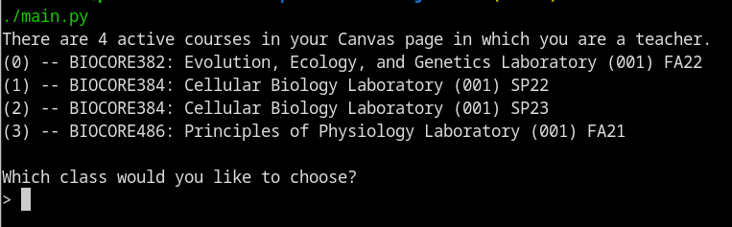
Figure 2: The first prompt from the program. I will only accept the given values of 0, 1, 2, 3. Anything else will just be run through a loop re-prompting the correct input type until you do so. The full prompt is available as a gif here

After this, it will prompt you if you want to get any specific section or not. If you do not, there is a message present that lets you collect all of the students instead. It will then prompt you to ask if you want group information from the class. If there is more than one group category it will prompt you for that as well. For example, there were two projects in the class I teach called “Enzyme Groups” and “Yeast Groups”. It will next prompt you for what assignment you would like to collect. Using the parameters from the API it will only show assignments that are active, visible to students, and have not been graded. You can pick an assignment, and then it will prompt you for the name of the directory that it will get downloaded to, as well as the name that the student file gets populated with. It will then download all of the students' submissions in the same format as Figure 1 above.

Deliverables:

This code should be runnable even outside of Docker. I left a “requirements.txt” file to install the only dependency outside of the standard library - requests. Likewise, the README gives detailed instructions for how to set your API KEY on Canvas. The API KEY and API URL go in the auth.json file. The URL is already set to the correct base URL for UW Madison of “https://canvas.wisc.edu/api/v1”, but it would be easy to switch for any other school so long as you keep the “/api/v1” after your .edu address for Canvas.

After you have read the README and followed the instructions for setting the API KEY in auth.json that you can get from the Canvas settings, the program is 100% ready to run. You can just open up a terminal and do “python3 main.py” or directly make it executable - as it has a shebang - and run “./main.py”. It will prompt you with the dialogue seen in Figure 2 above.

There is a “resources” directory that exists in the main final project repo that you can put any file into. While the program is running it will copy that file into every student's directory in the manner of Figure 1 above.

I’ve tried to be “intelligent” with what it prompts you. It will only ask you to pick a class where you are a teacher or TA that is also currently active. Likewise, when asking to download assignment submissions, it will only give you assignments that are visible to students and do not have grades released.

Use of ME459 knowledge

- Python shebang
- Python if __name__ == __main__() to make sure it is being ran
- Using functions to have a specific behavior that is encapsulated
- Making a class that has attributes and methods that can be created
- Looping through lists and other collections
- Conditional logic to check if values are what I want to them to be

When I made the get request inside of “def section_students(section_id):”, I used ChatGPT [1]. The Canvas API defaults the size of a list to 10. So if you wanted to get all students, it would only get the first 10. You can extend this to a max of 100 “per page”, and anything past that. You can solve this with pagination, but I couldn’t figure it out so I tried ChatGPT and it mostly worked. I had to tweak it a bit. Funny story.. actually when I made a get request to the URL “/api/v1/courses/:course_id/enrollments”, the API doubled every response. For every student in the class, it would get each student two times, doubling the enrollment response, which pushed me past the 100 limit. I thought this was a bug in my code, but the same thing happens when I use the Github Canvas API as well… so I am partially led to believe that it is not my fault.

My answer to this was to just get the list of duplicates from the get request and then remove each duplicate, which is still in the all_students(course_id) function. This is kind of a lame solution for this problem, but there was nothing else I could do. My debugger in Figure 3 below shows that when I make the get request it just duplicates each student, because the return length is 184, twice the amount of students in the class.

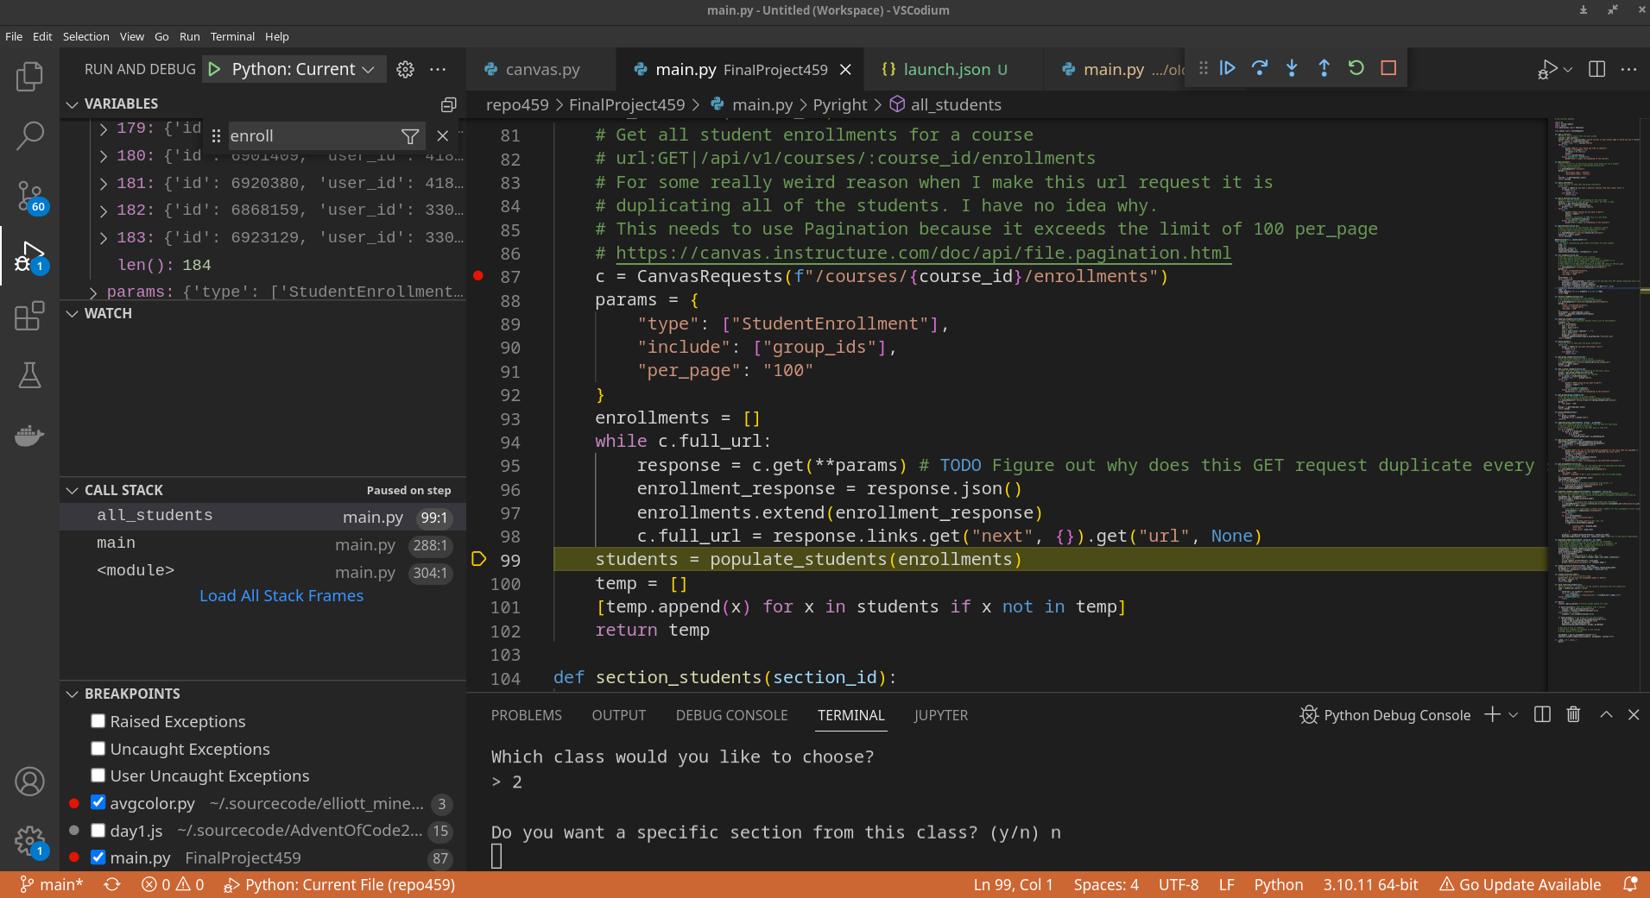
Figure 3: In the debug pane in the upper left corner, the enrollments variable length is 184, exactly twice the amount of students in the class I TA. Very strange.

Conclusions and Future Work

I mentioned before that this ended up being more difficult than I hoped. Since I have to get enrollments, it is not very time performant. In fact, if you have to get all of the students, this takes a really long time. It takes like 5 seconds to fully get all of the students of the class I TA, which is 100 students. Downloading all of those assignments also takes a couple of minutes. I would like to have tried doing some threading to speed it up, but I don’t have the time and am focusing on graduation, thesis, job search, etc.

Overall, I would say that it is very successful. The thing I didn’t get time to actually implement is to notify me when a submission is late. When I download an attachment, the API doesn’t provide that information in the attachment, but in the overall submission. It would be another case where I would need to pull in a ton of information just to see if it is late and that didn’t make sense to me since when I manually upload their graded sheet to Canvas I can just see if it is late. Likewise, at the end when it is printing that it is downloading the assignments, I would like it to be a little prettier, but actually clearing the line seems to be a little bit more difficult that I would imagine. Sometimes it will work on one shell but not the other, so I left it to print new lines.

References

[1] OpenAI. (2023). ChatGPT (Mar 14 version) [Large language model]. https://chat.openai.com/chat

