How to Run Test Cases:

* Initial Set-Up

1. Put all files into a directory (java files and database – make sure you have sqlite-jdbc downloaded in the directory)
2. Open the java file StoreManager.java and change the string value of DB_FILE to the directory that the database is located.
3. Run StoreManager.java. This will pull up the main UI.

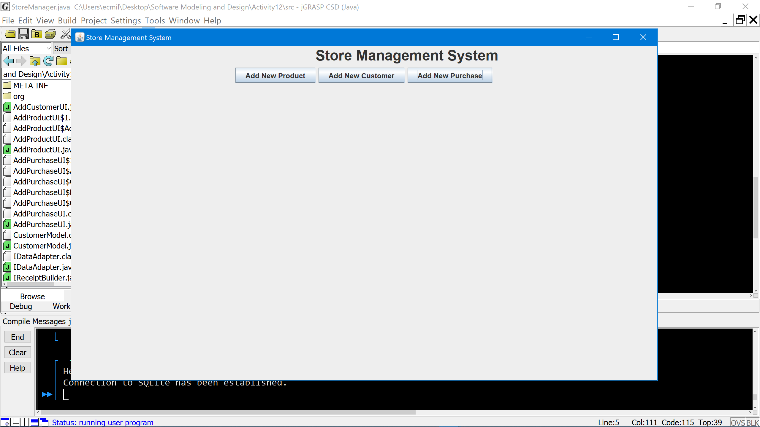

* Successful Product Addition

1. Click “Add New Product” button in main UI. This will pull up the Add Product UI

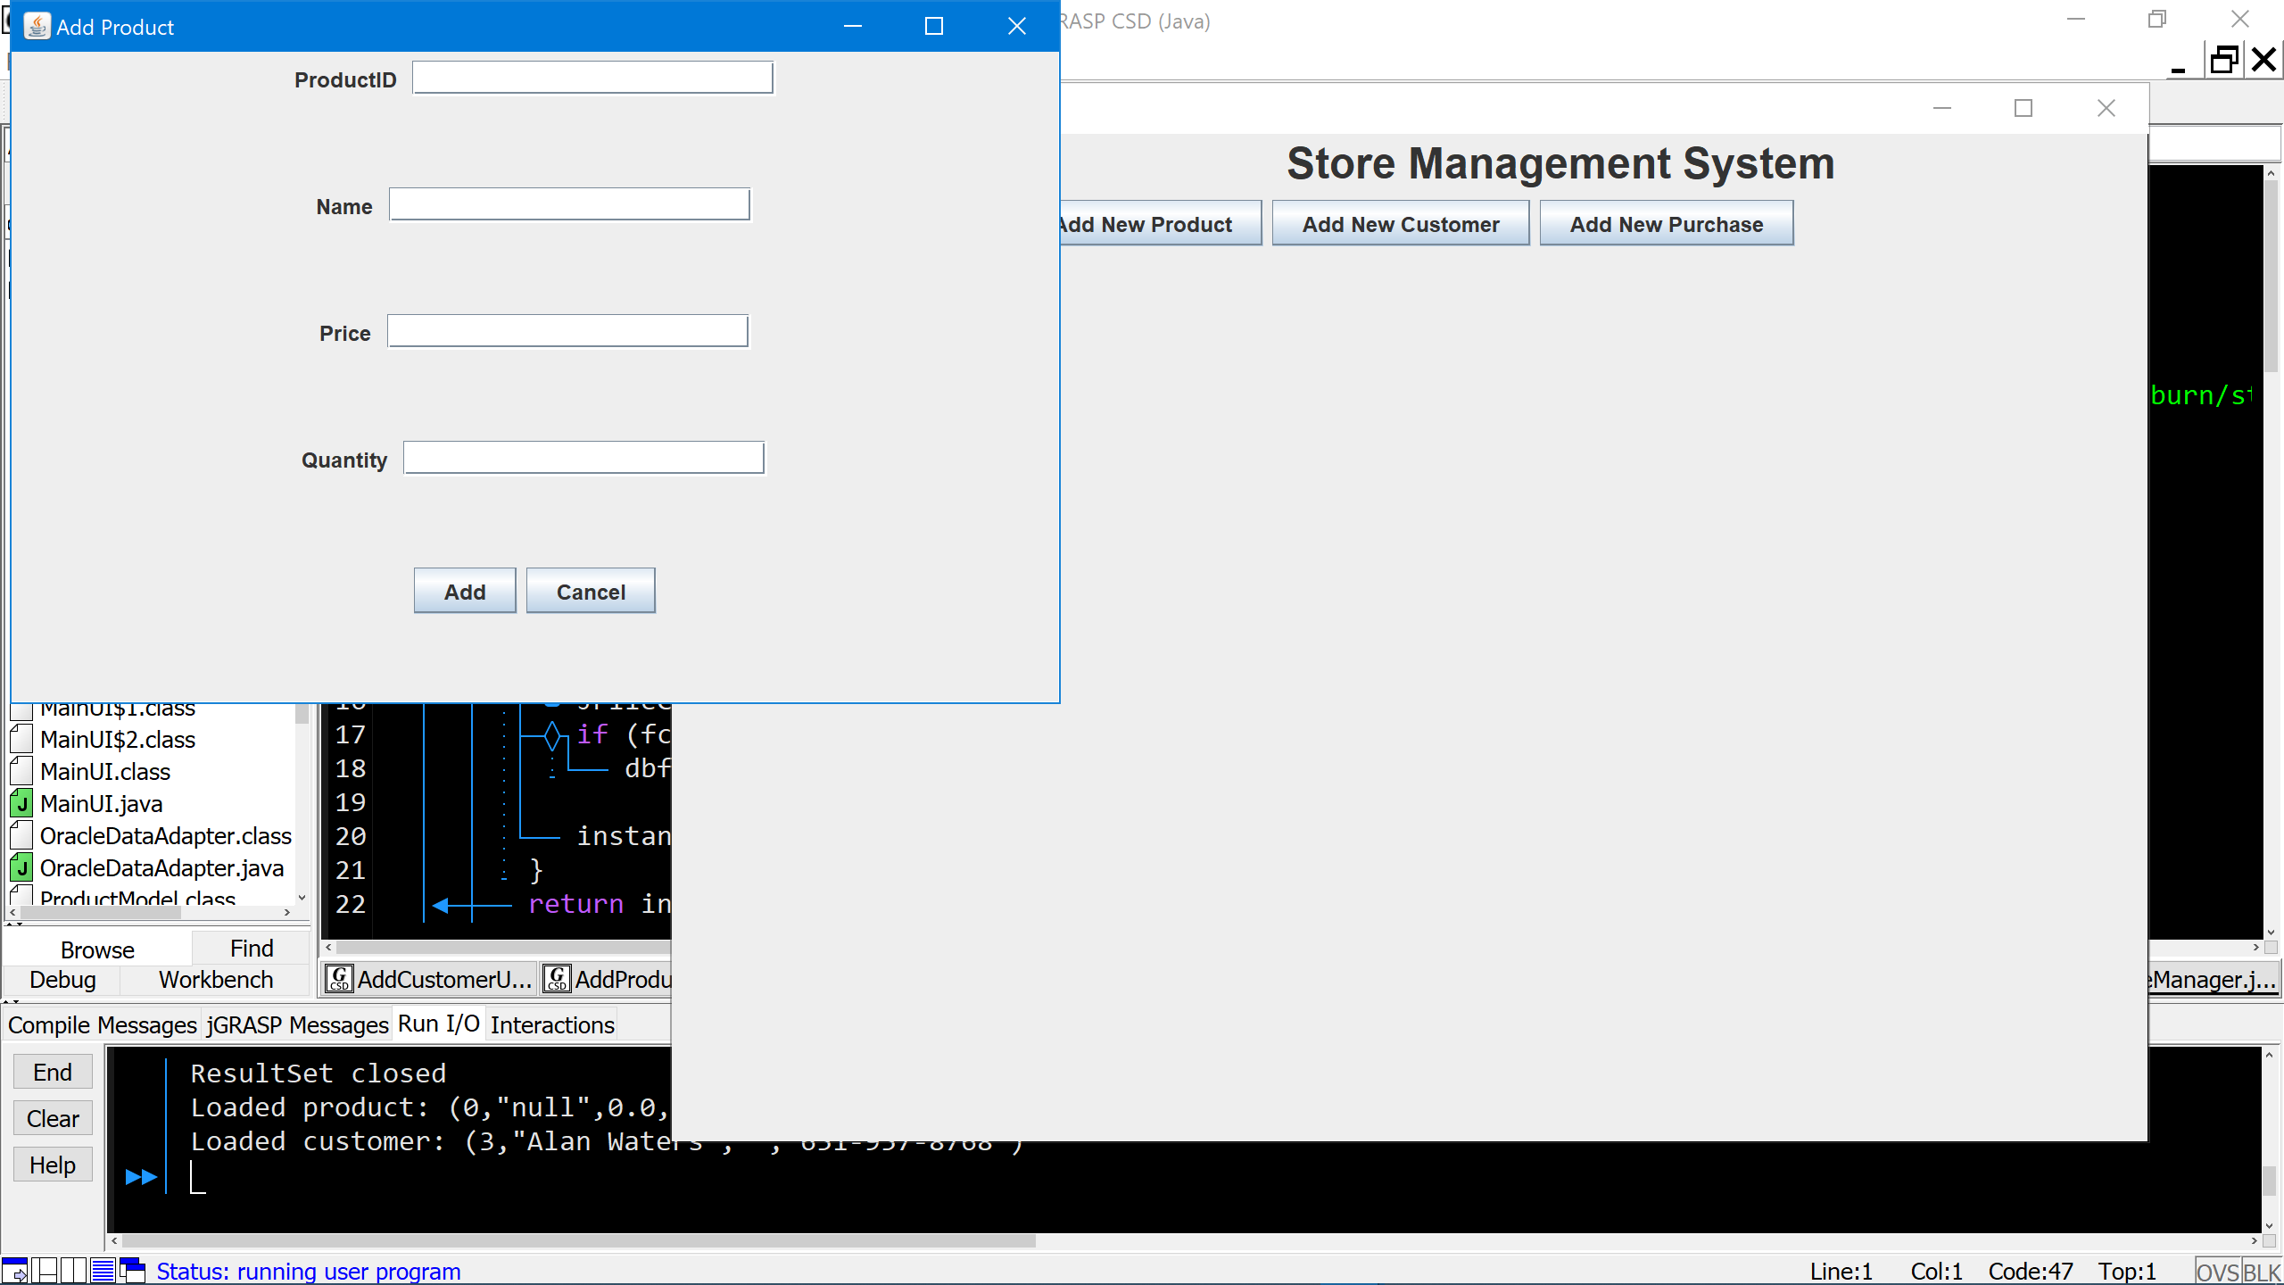

1. Enter in Product information. Click the “OK” button to add information to database.

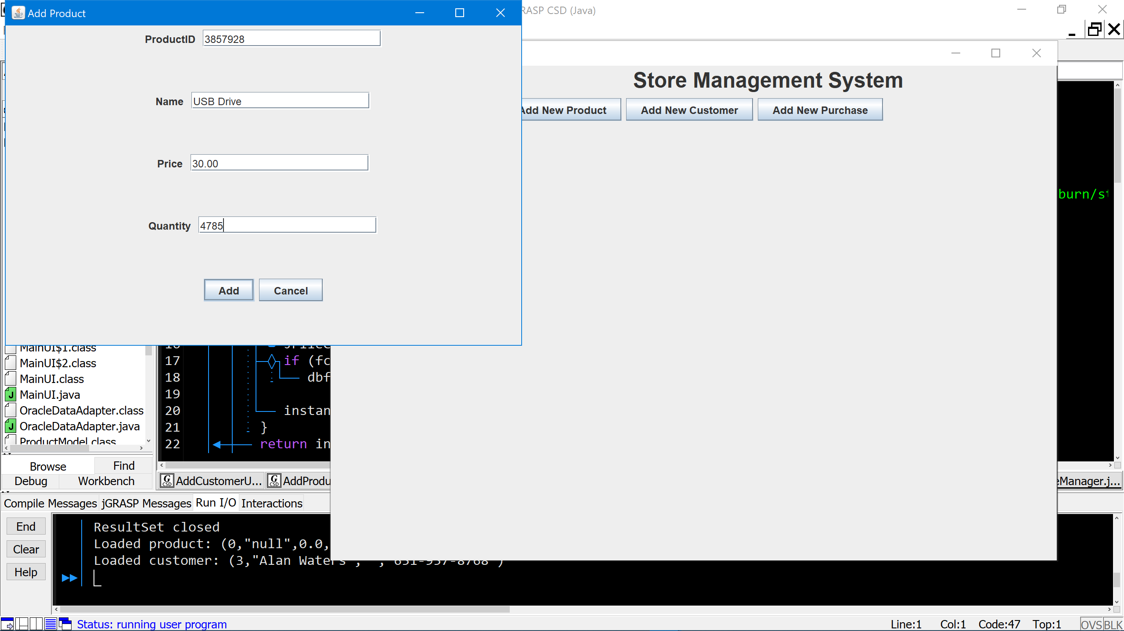

1. Click the “OK” button on pop-up that confirms the data added and it will close.

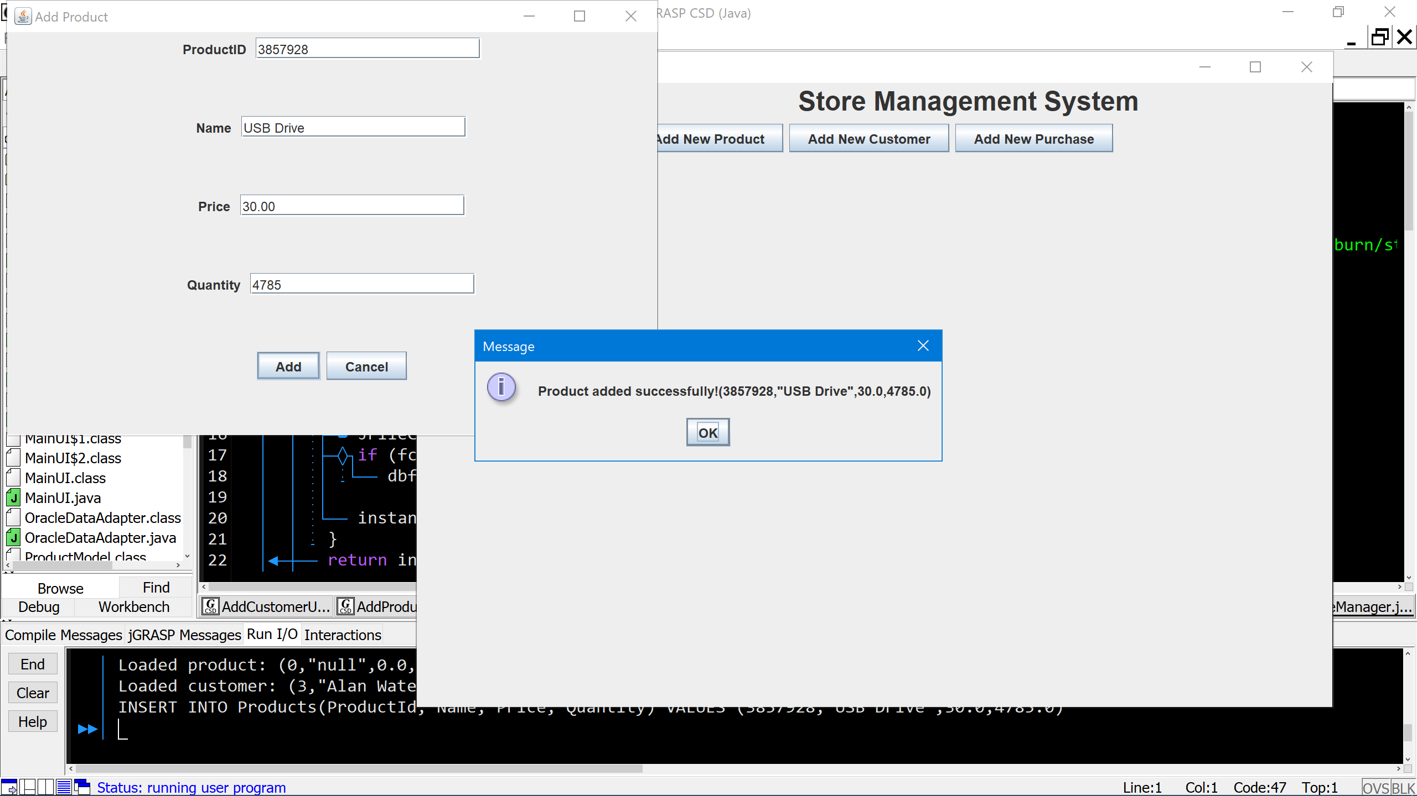

1. Click the “Cancel” button on Add Product UI to return to main UI.

* Failed Product Addition because of Duplicate Product ID
  + The only difference is in step 6. The pop-up will look like this:

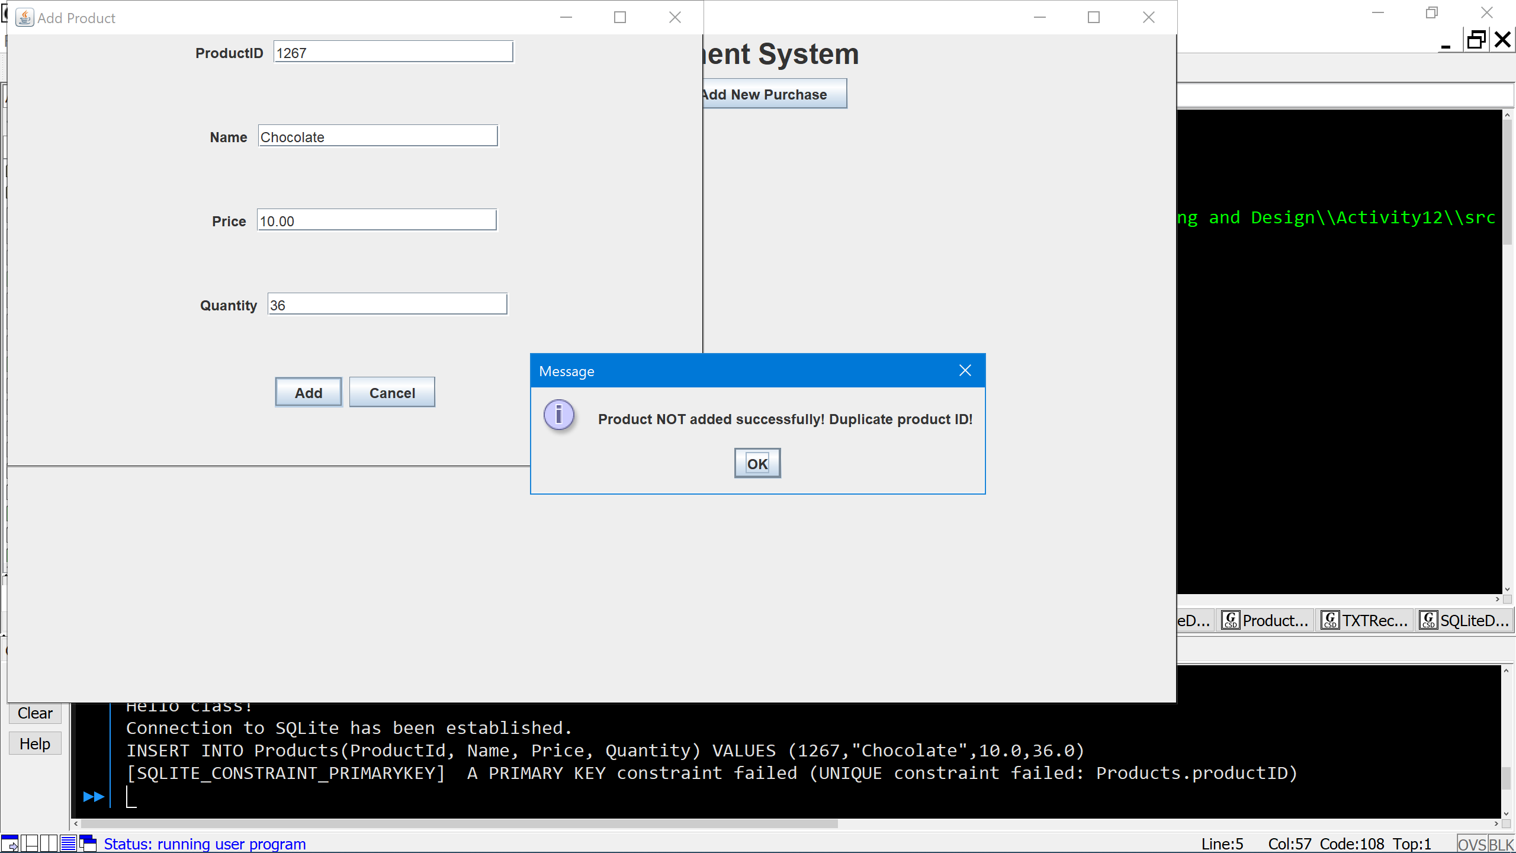

* Successful Customer Addition

1. Click “Add New Customer” button in main UI. This will pull up the Add Customer UI
2. Enter in Customer information. Click the “OK” button to add information to database.

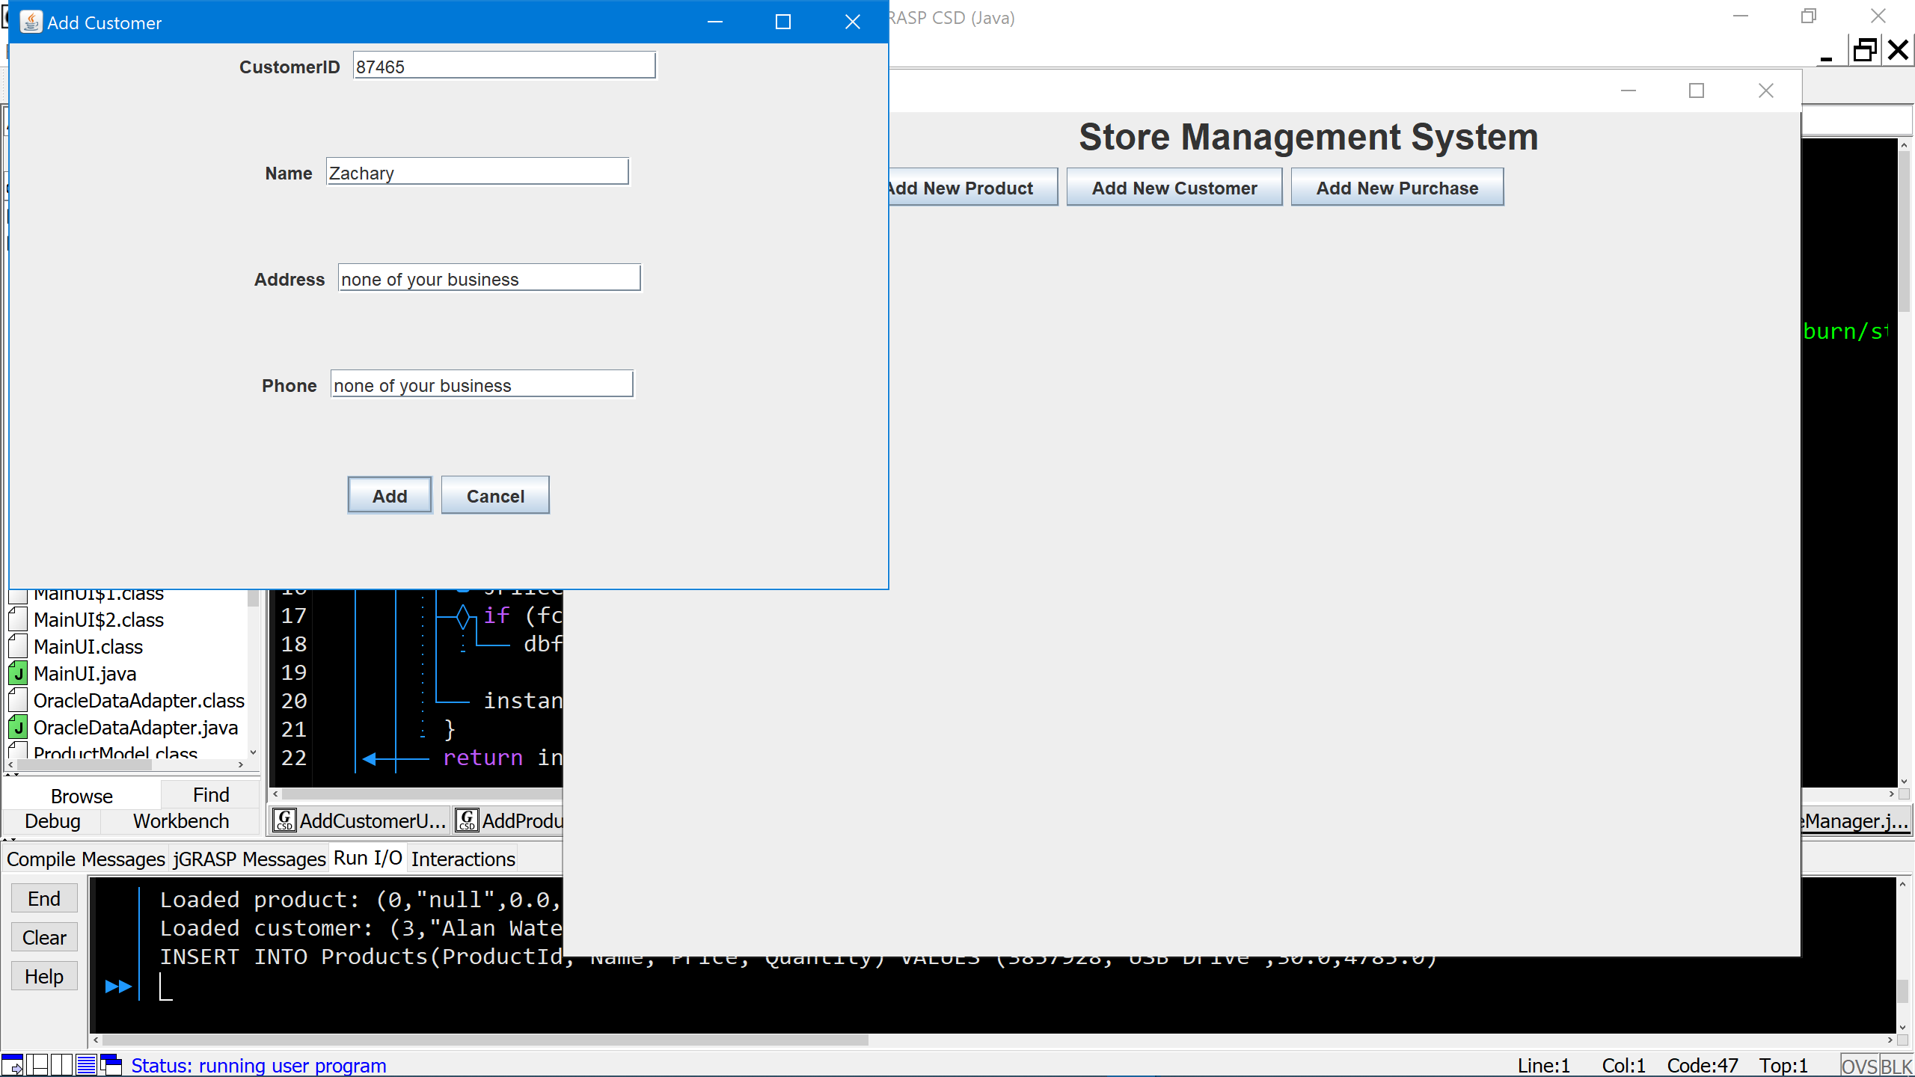

1. Click the “OK” button on pop-up that confirms the data added and it will close.

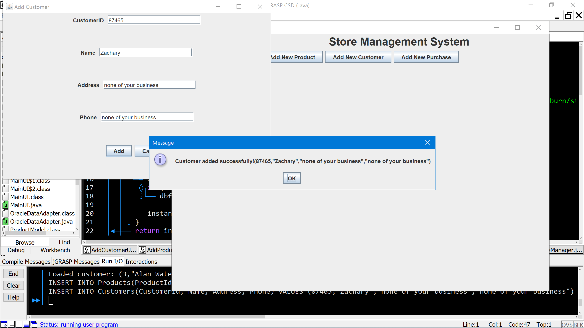

1. Click the “Cancel” button on Add Customer UI to return to main UI.

* Failed Customer Addition because of Duplicate Customer ID
  + The only difference is in step 10. The pop-up will look like this:

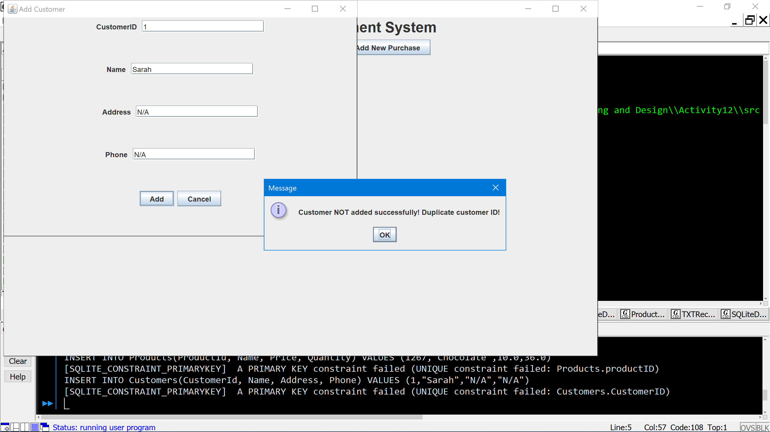

* Successful Purchase Addition

1. Click “Add New Purchase” button in main UI. This will pull up the Add Purchase UI.

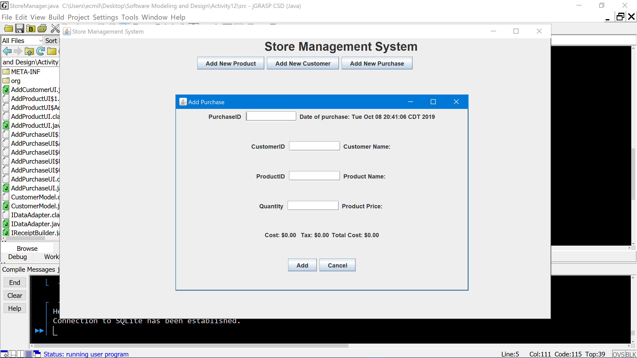

1. Enter in purchase information:
   * Purchase ID - cannot be a duplicate of a Purchase ID that already exists in the database

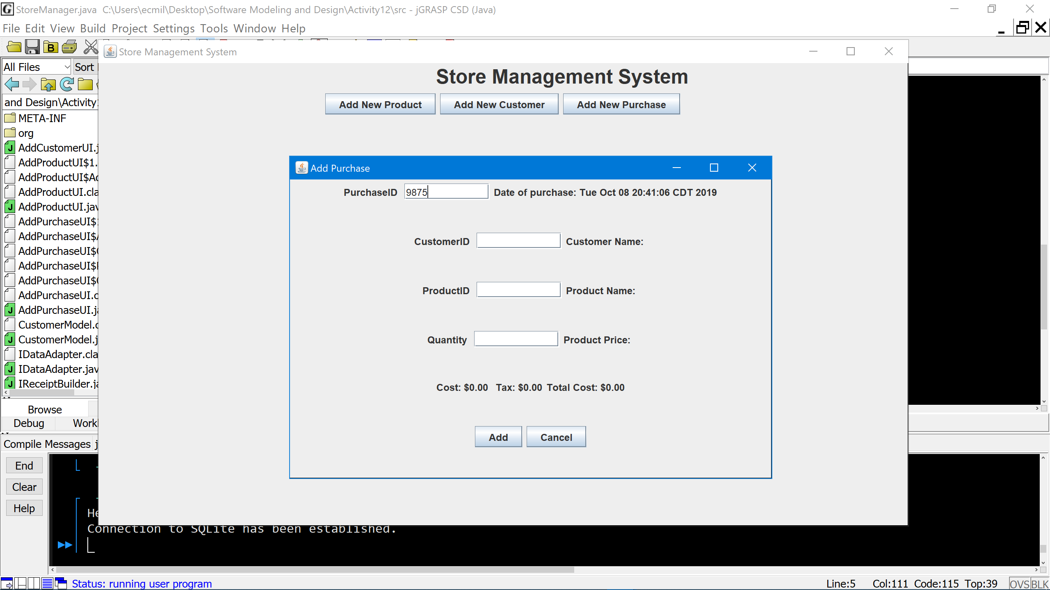

* + Customer ID - The ID MUST be from a customer already in the database. When you move your cursor to next textbox the corresponding data in the database will be shown next to the CustomerID textbox.

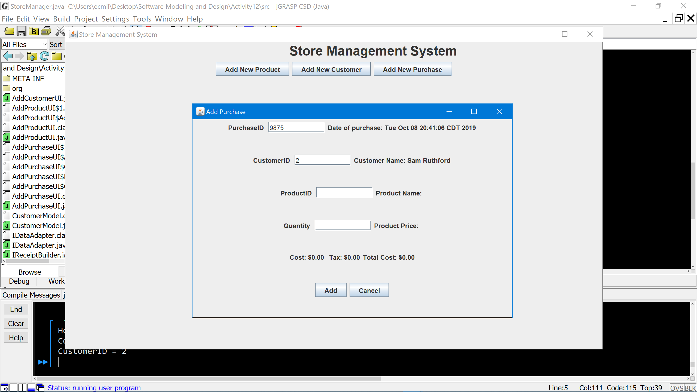

* + Product ID - The ID MUST be from a product already in the database. Move cursor to next text box and corresponding data in database will be shown next to the ProductID textbox.

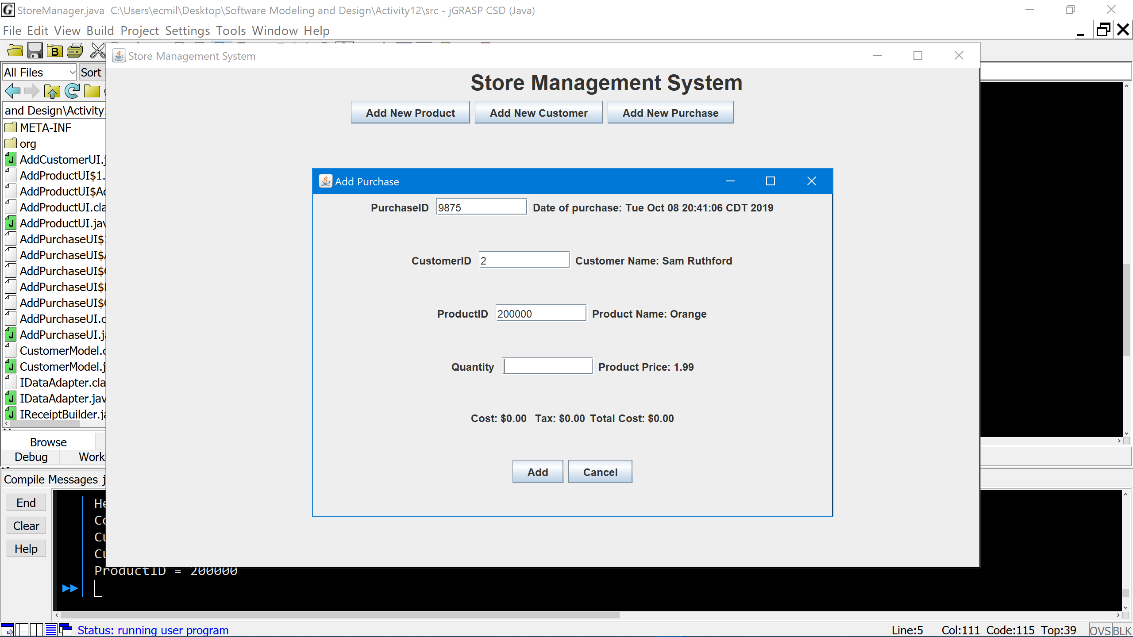

* + Quantity - enter the quantity that the customer bought. Now the cost, tax, and total cost parts of the UI are automatically filled out.

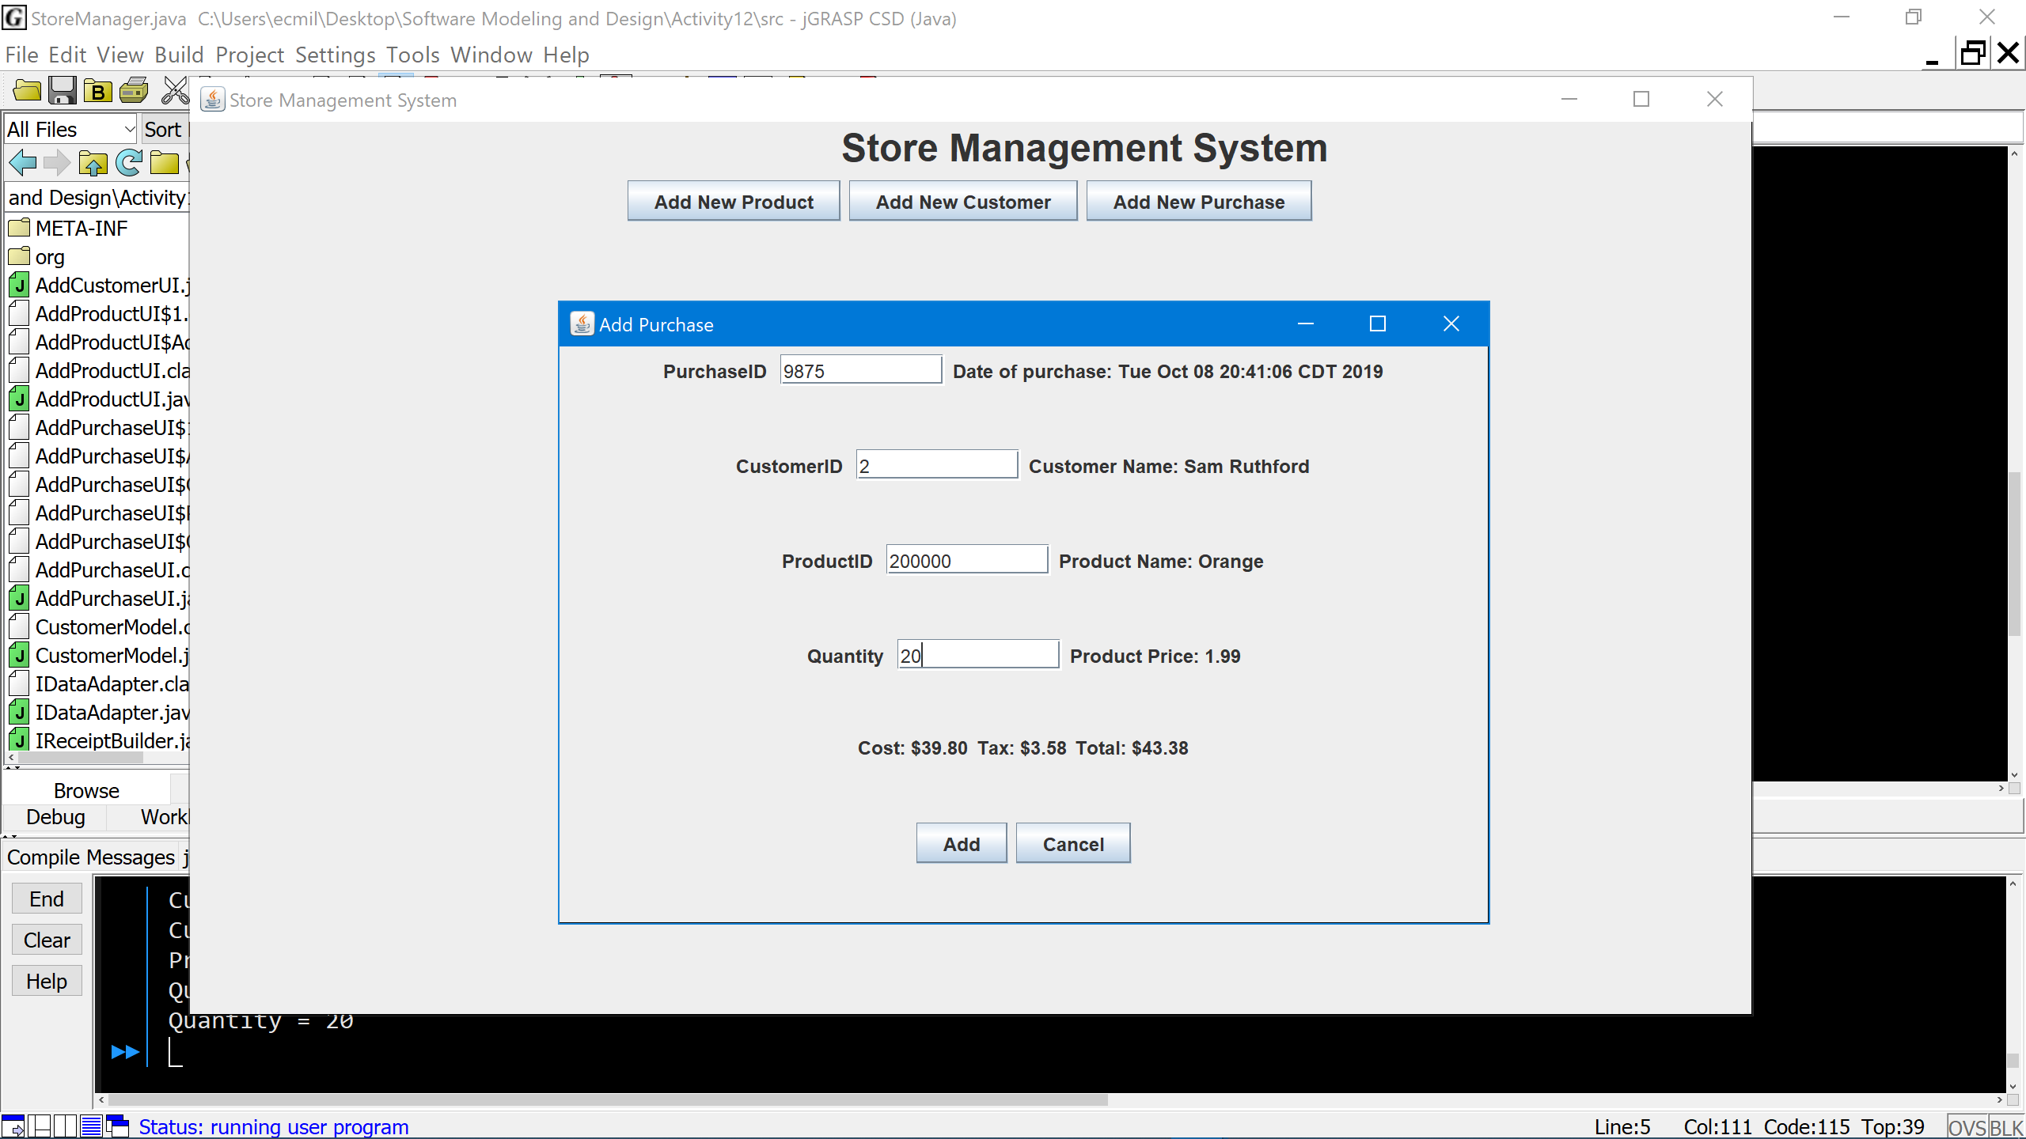

1. Click “Add” button and the Purchase Receipt will appear.

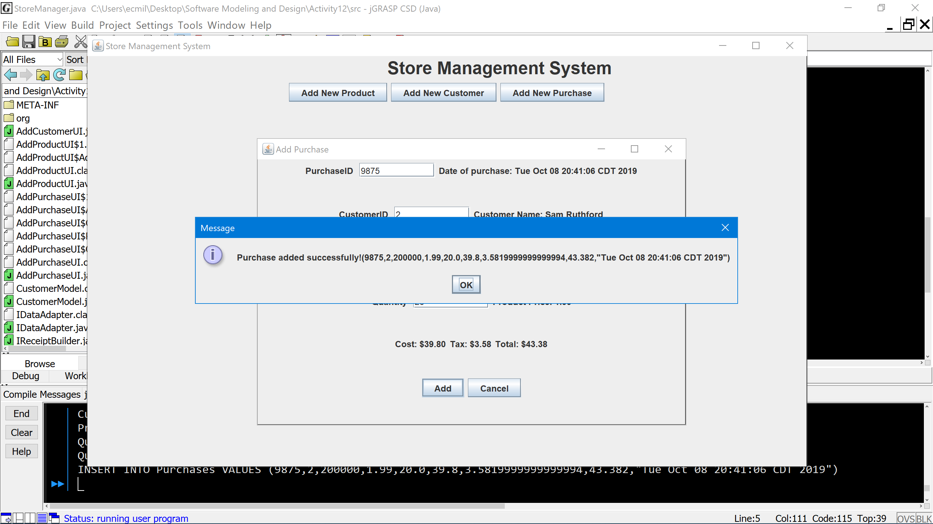

1. Click OK” button on Purchase Receipt pop-up and it will close.



1. Click the “Cancel” button on Add Purchase UI to return to main UI.

* Failed Purchase Addition because CustomerID and ProductID not in store database

