* As a user, I want to add a new product or update a current product in the system.

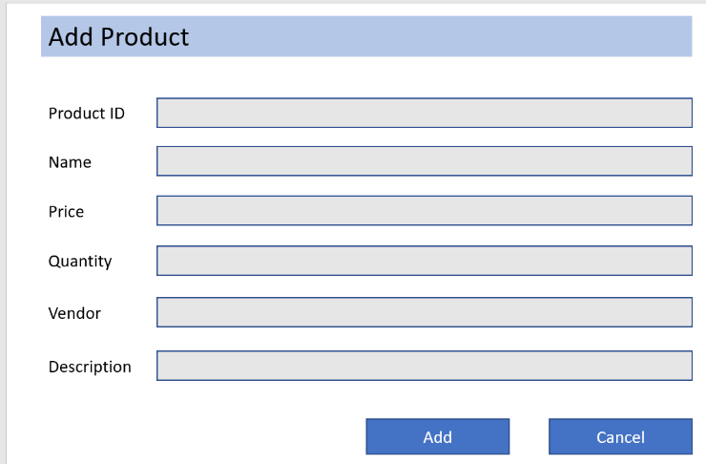

Update

* + Successful/update of product

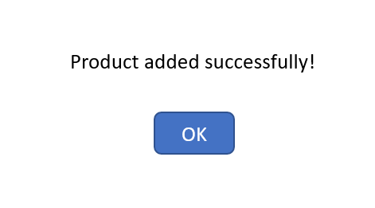

* + Failed addition/update of product



Product is NOT saved successfully!

* As a user, I want to add a new customer or update a current customer in the system.

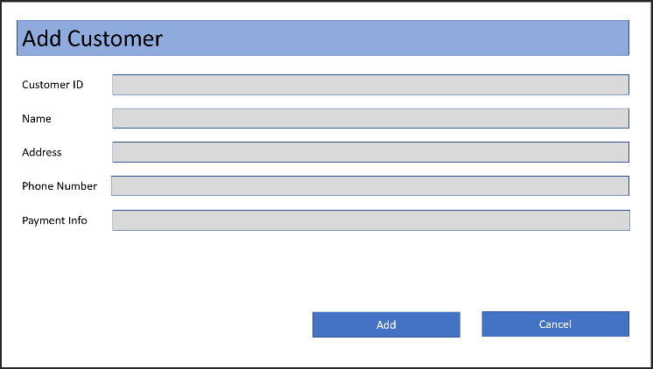

Update

* + Successful add/update of customer

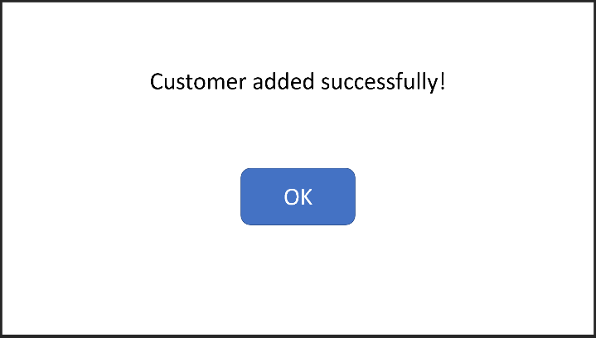

* + Failed addition/update of customer
  + 

Customer is NOT saved successfully!

* As a user, I want to add a new purchase or update a current purchase in the system.

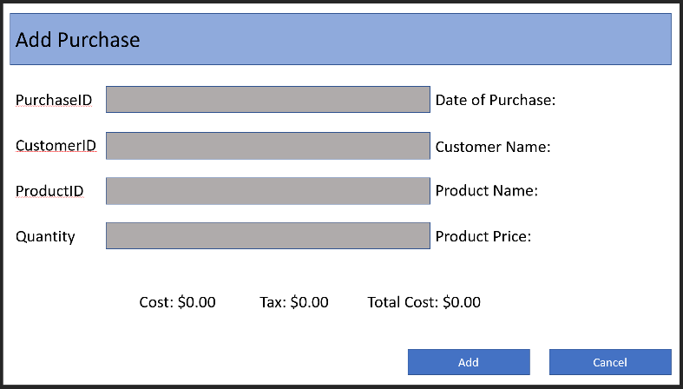

Update

* + Successful addition/update of purchase

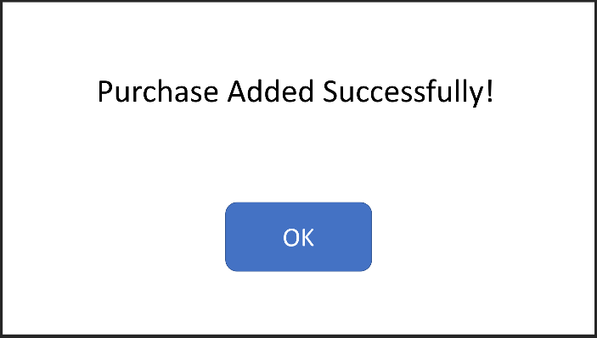

* + Failed addition/update of purchase



Purchase is NOT saved successfully!