1. Start the program by running the store server and then the store manager. (Make sure you have all the libraries configured and all the database locations changed to the directory of your current database).
2. Main Menu

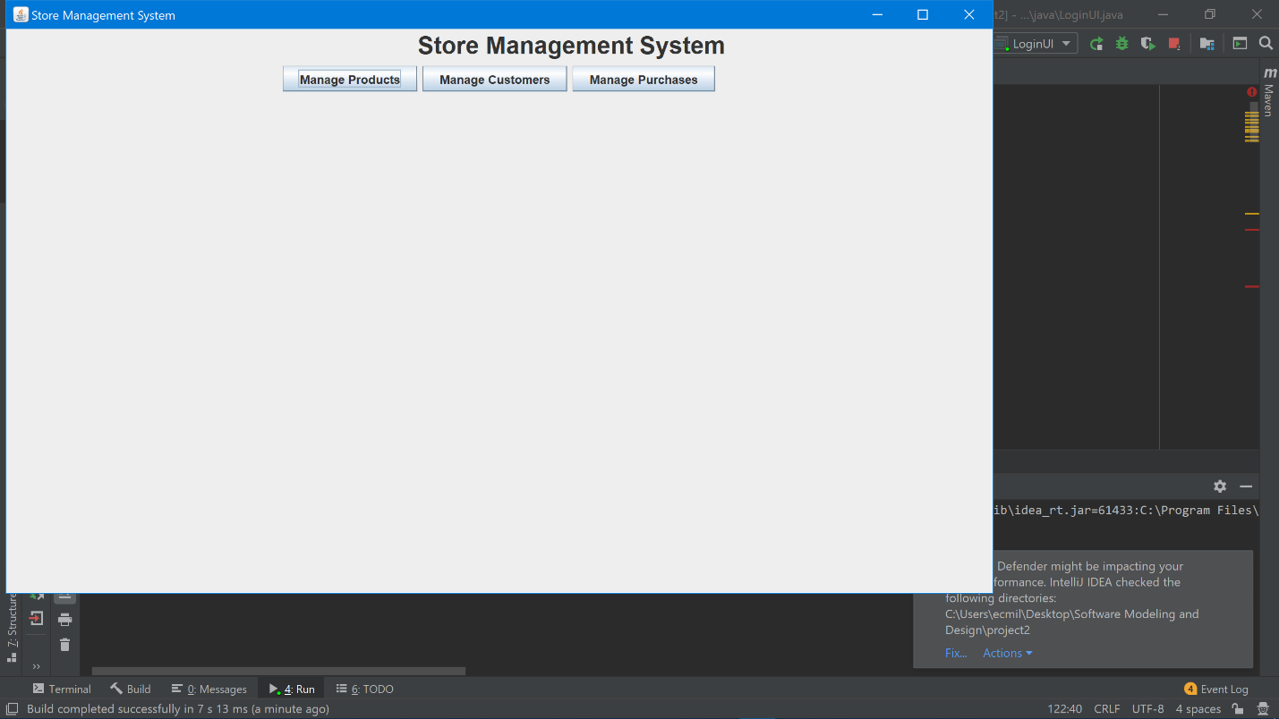

1. Manage Customers UI

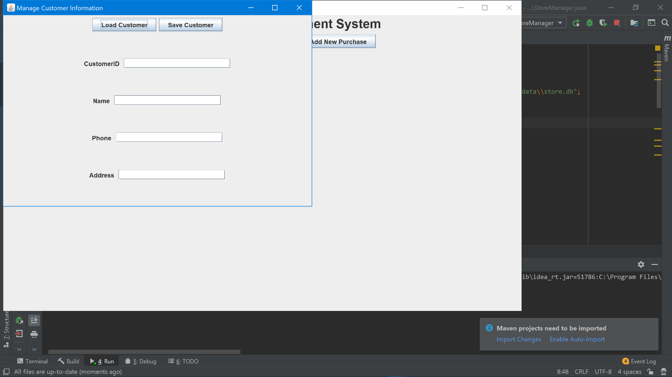

1. The database before the customer alterations.

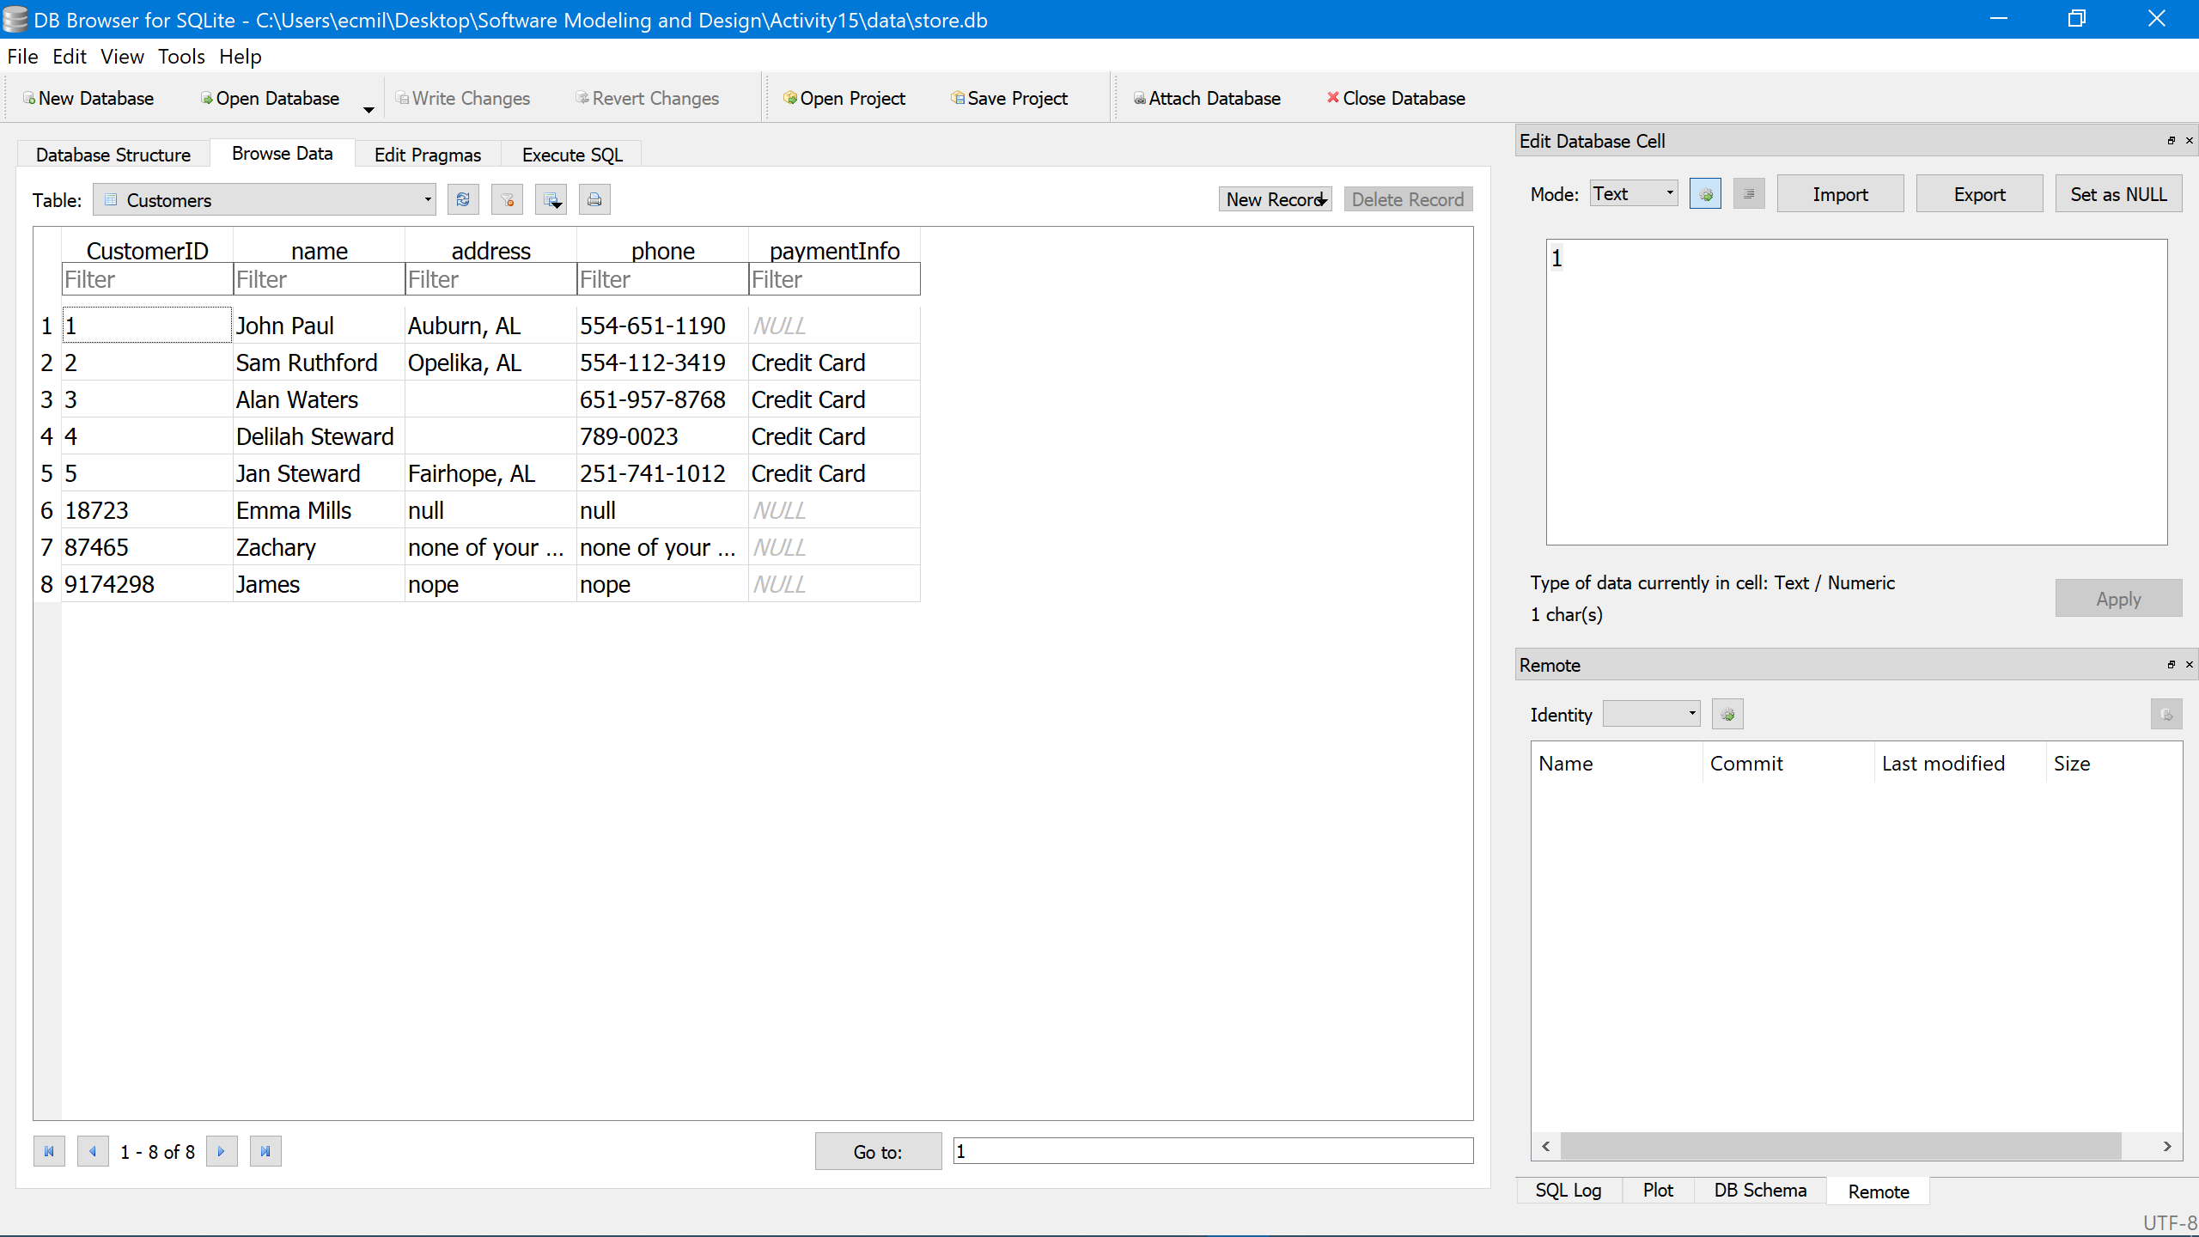

1. Entering the CustomerID and loading the corresponding customer in the database.

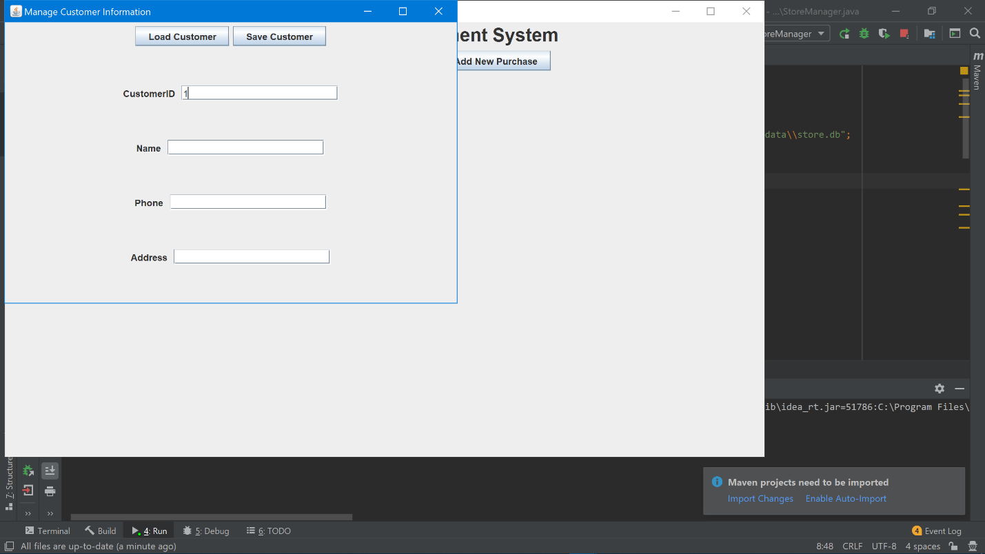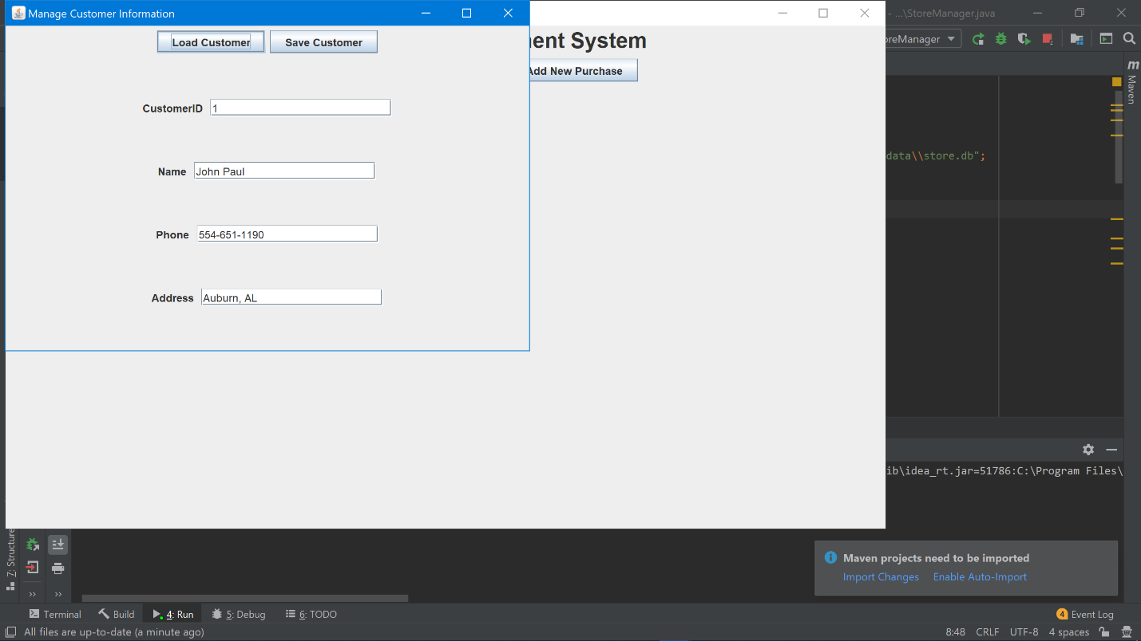

1. Altering and saving the customer information.

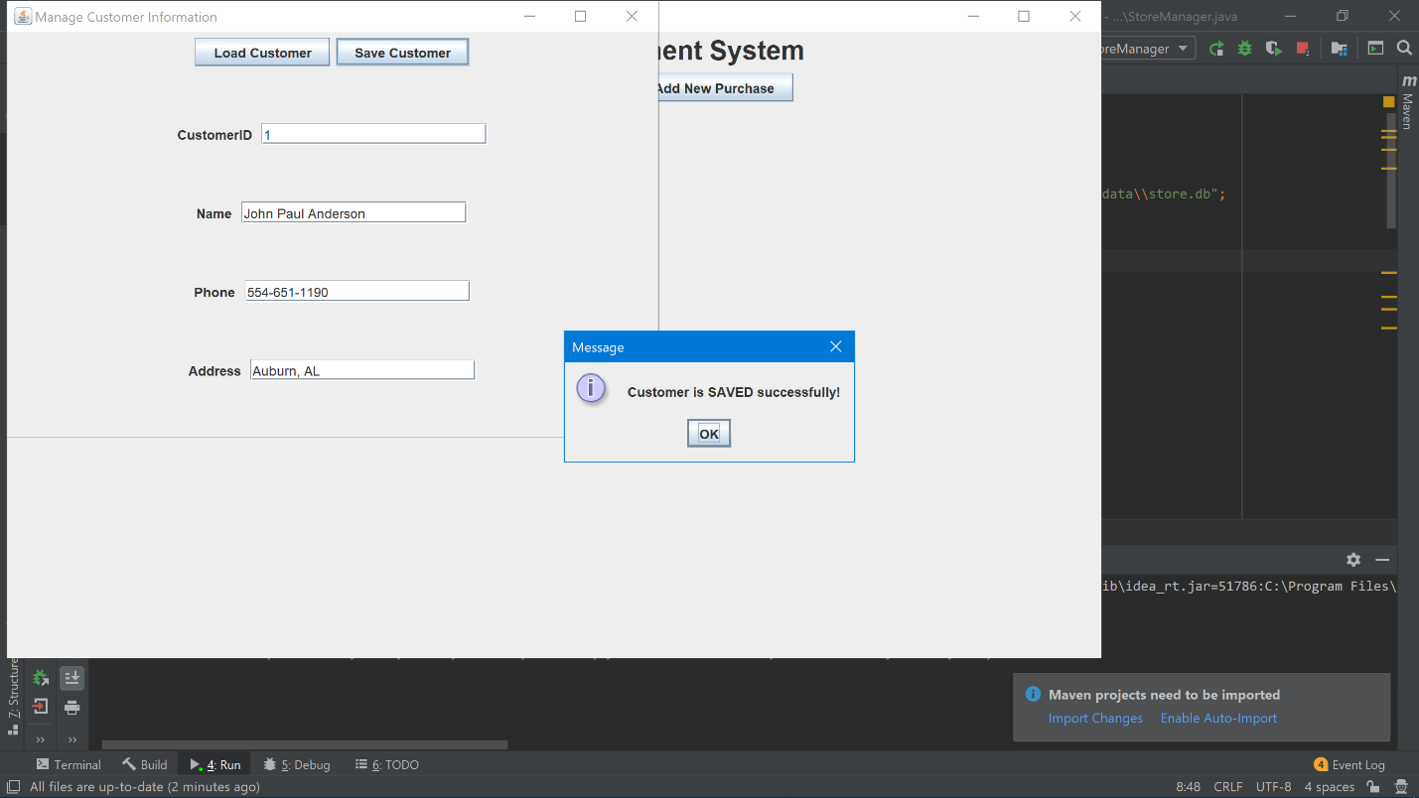

1. The updated database after the alterations.

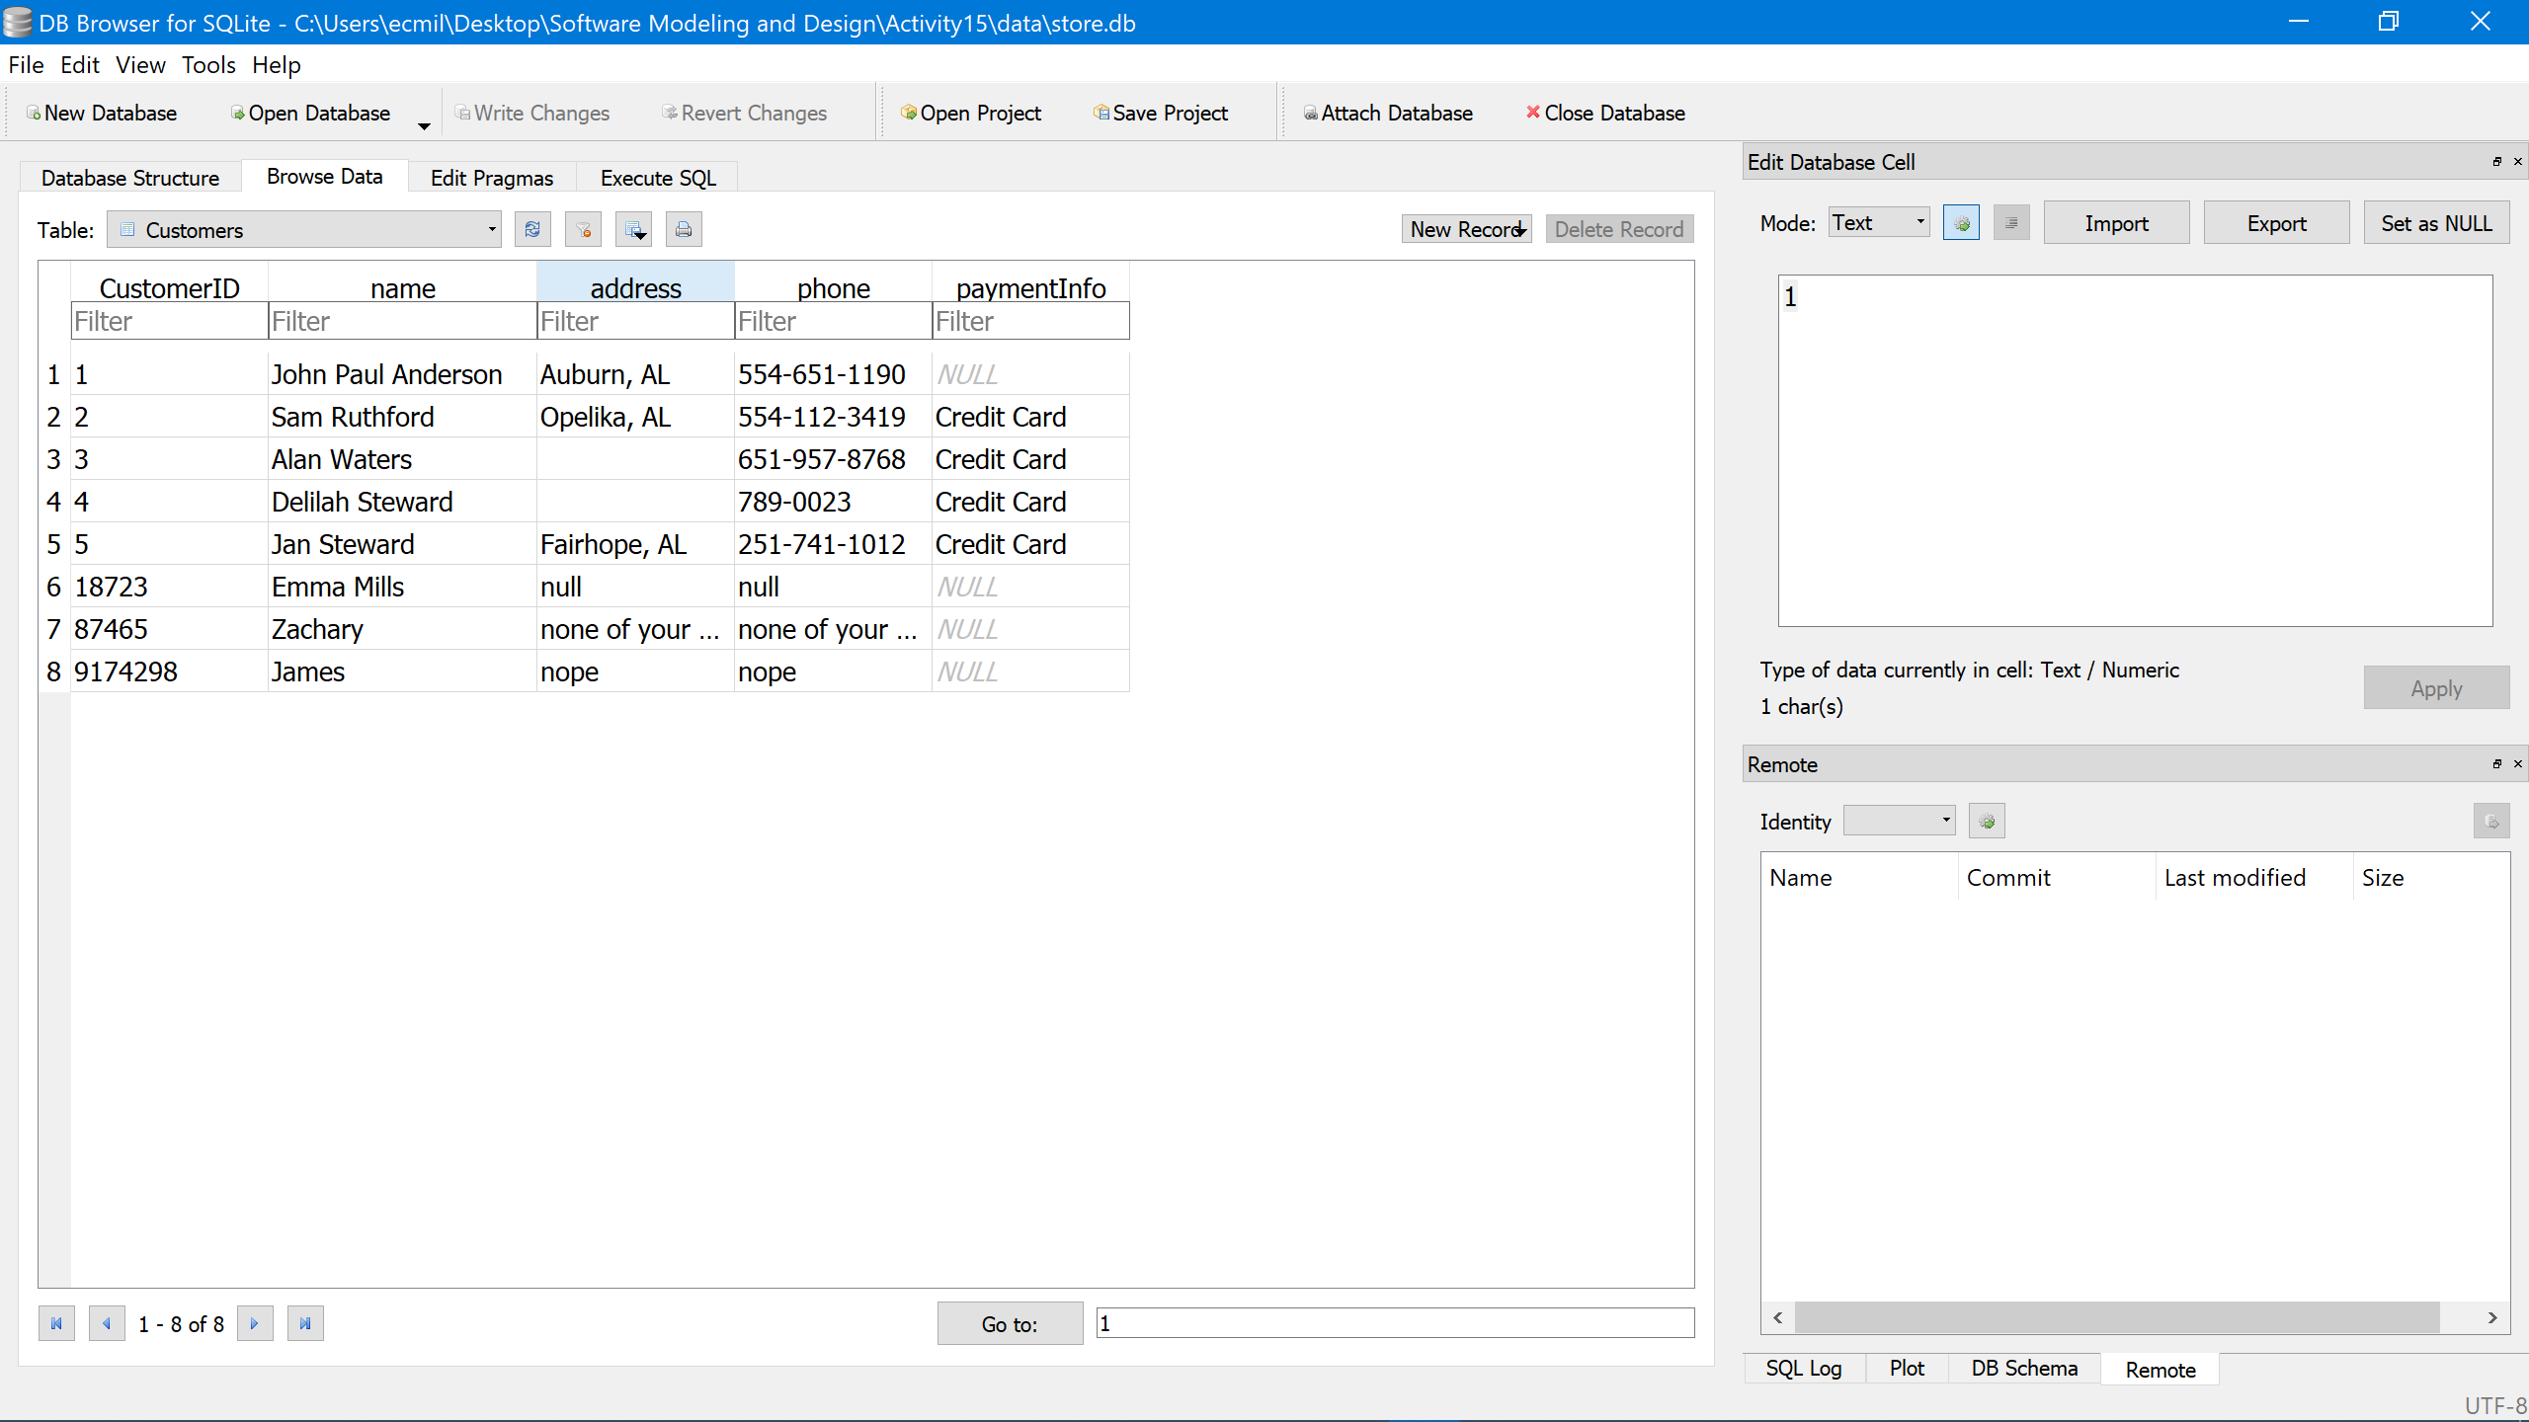

1. Manage Products UI

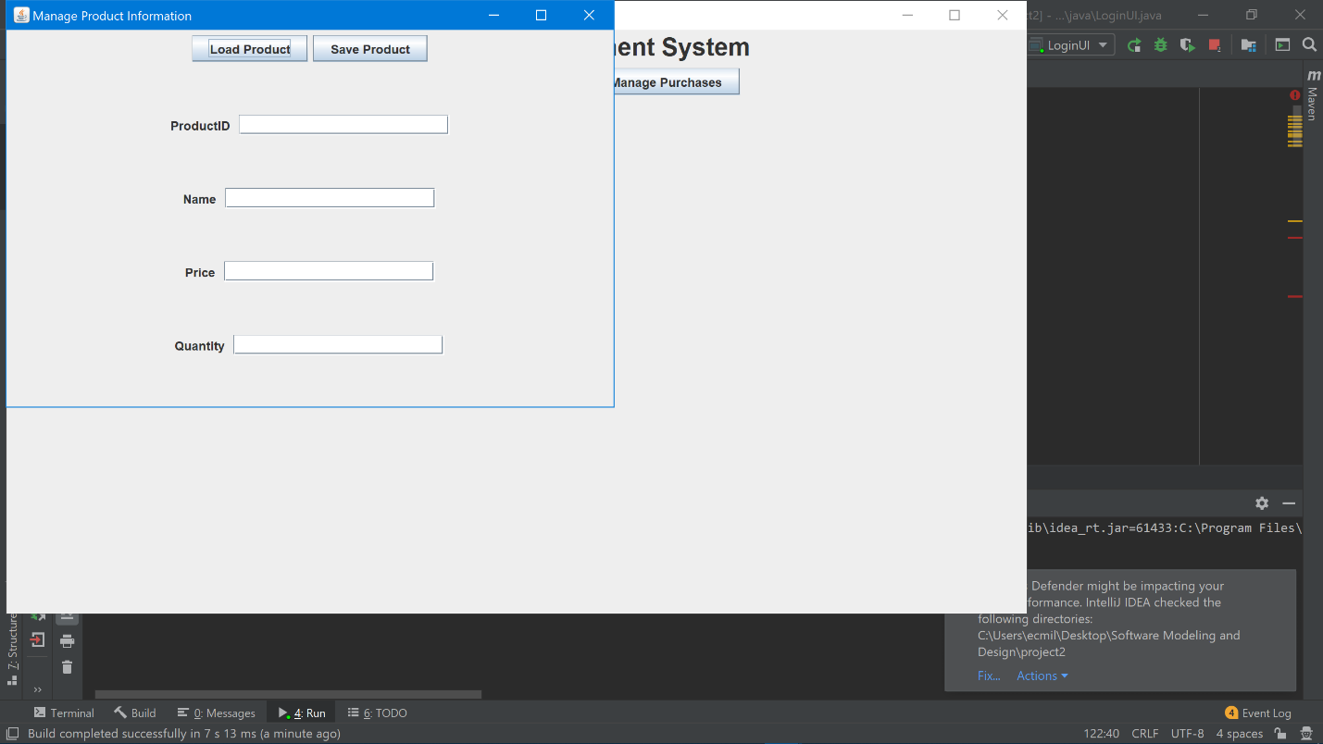

1. The database before the product alterations.

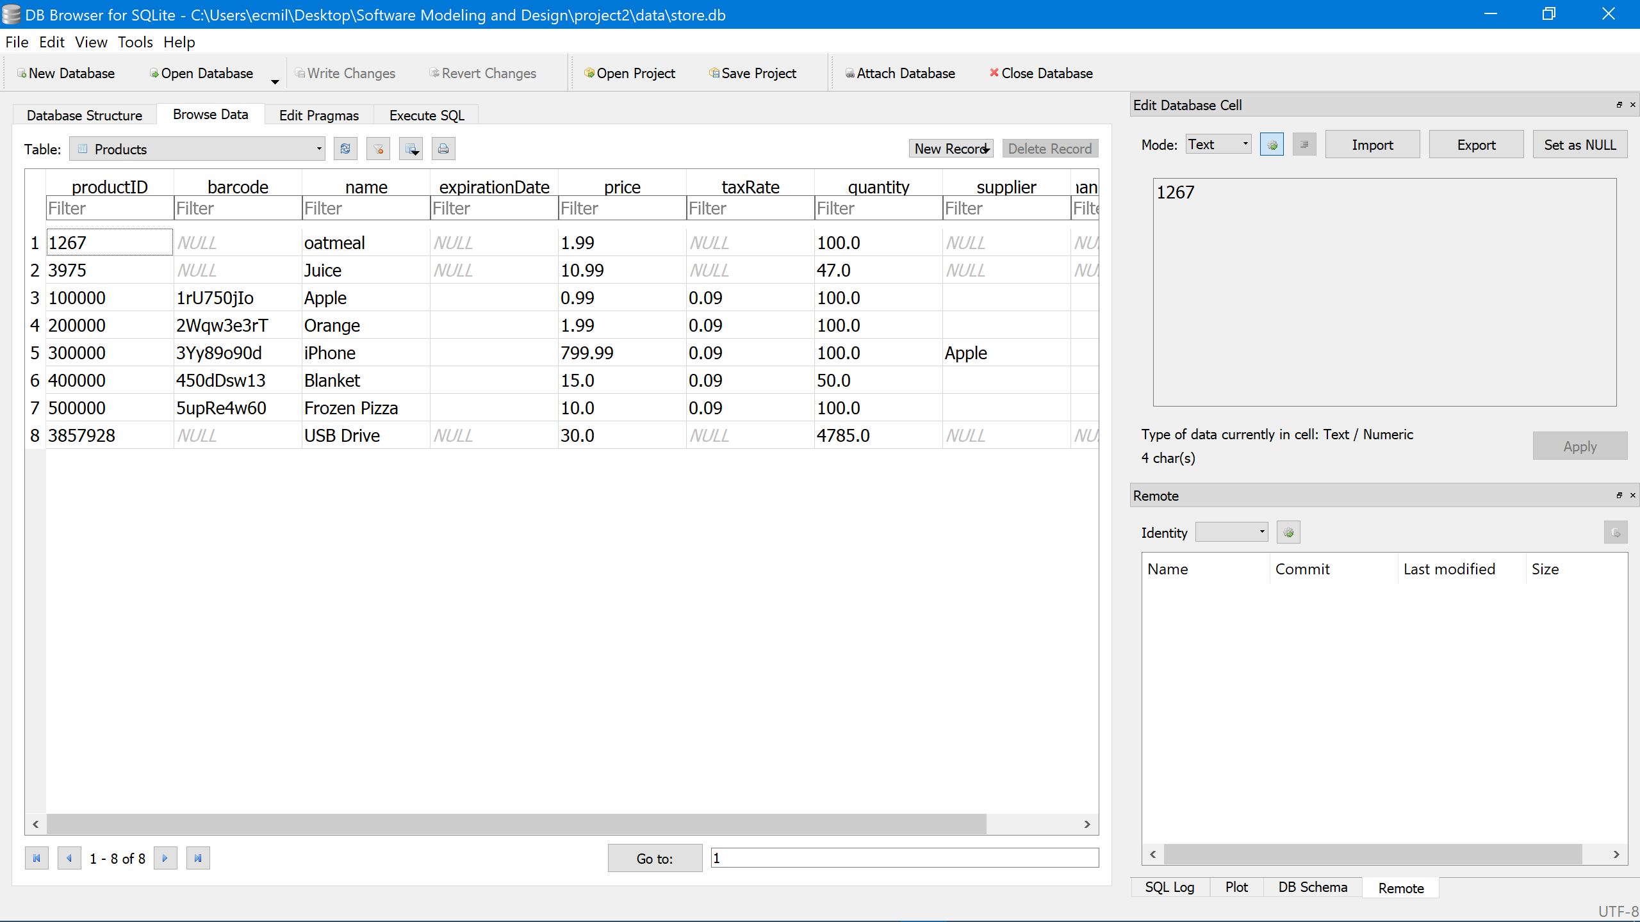

1. Entering the ProductID and loading the corresponding product in the database.

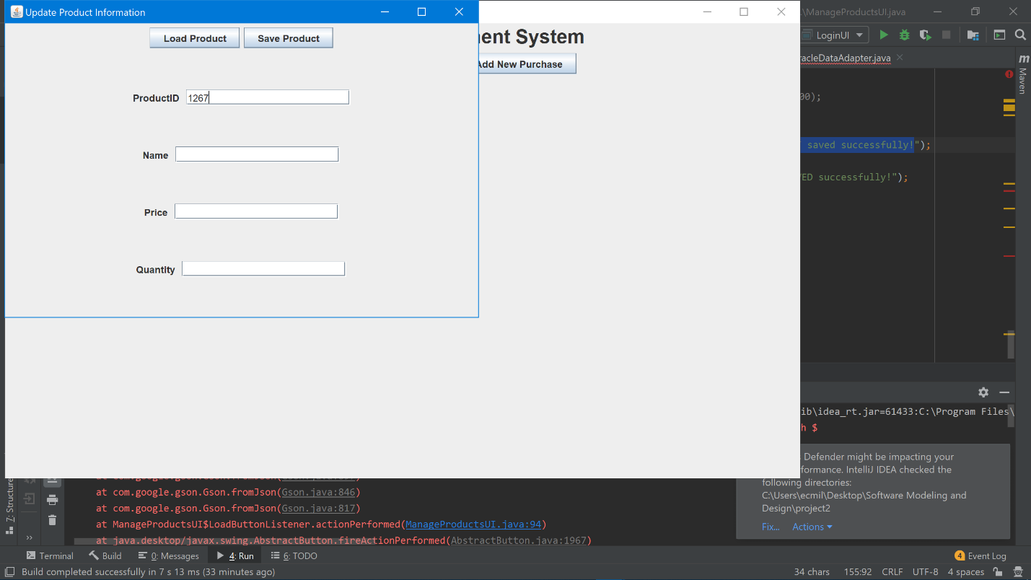

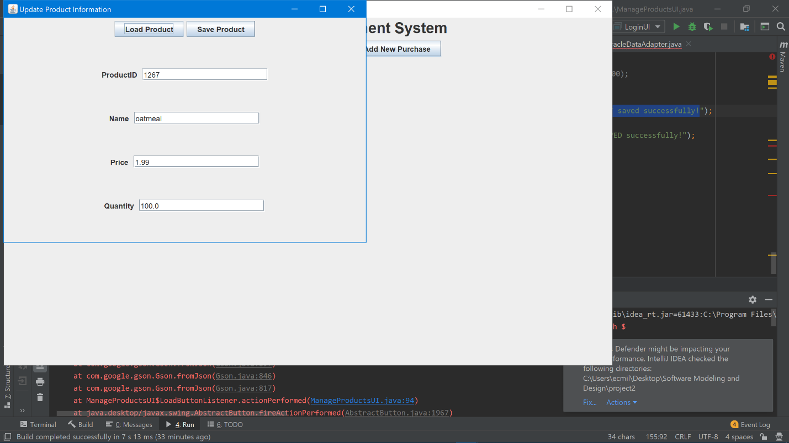

1. Altering and saving the product information.

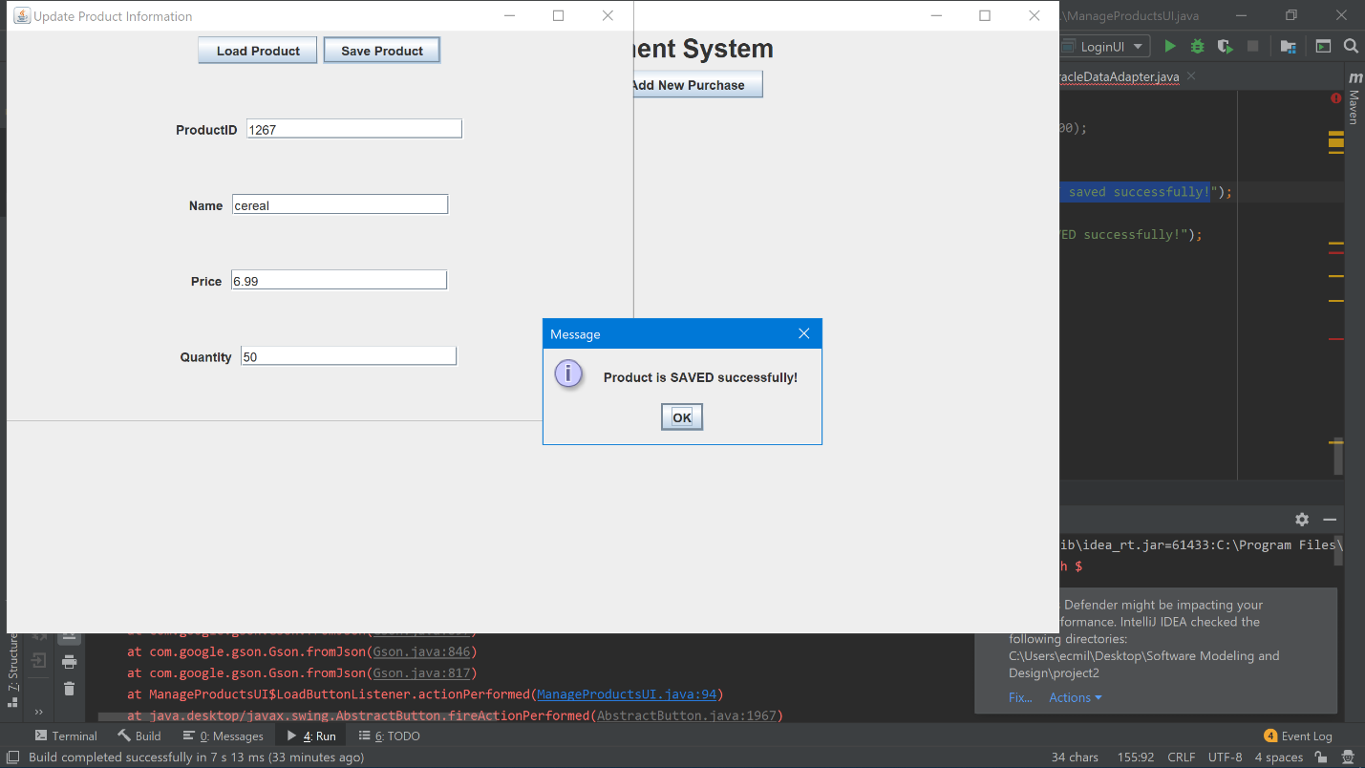

1. The updated database after the alterations.

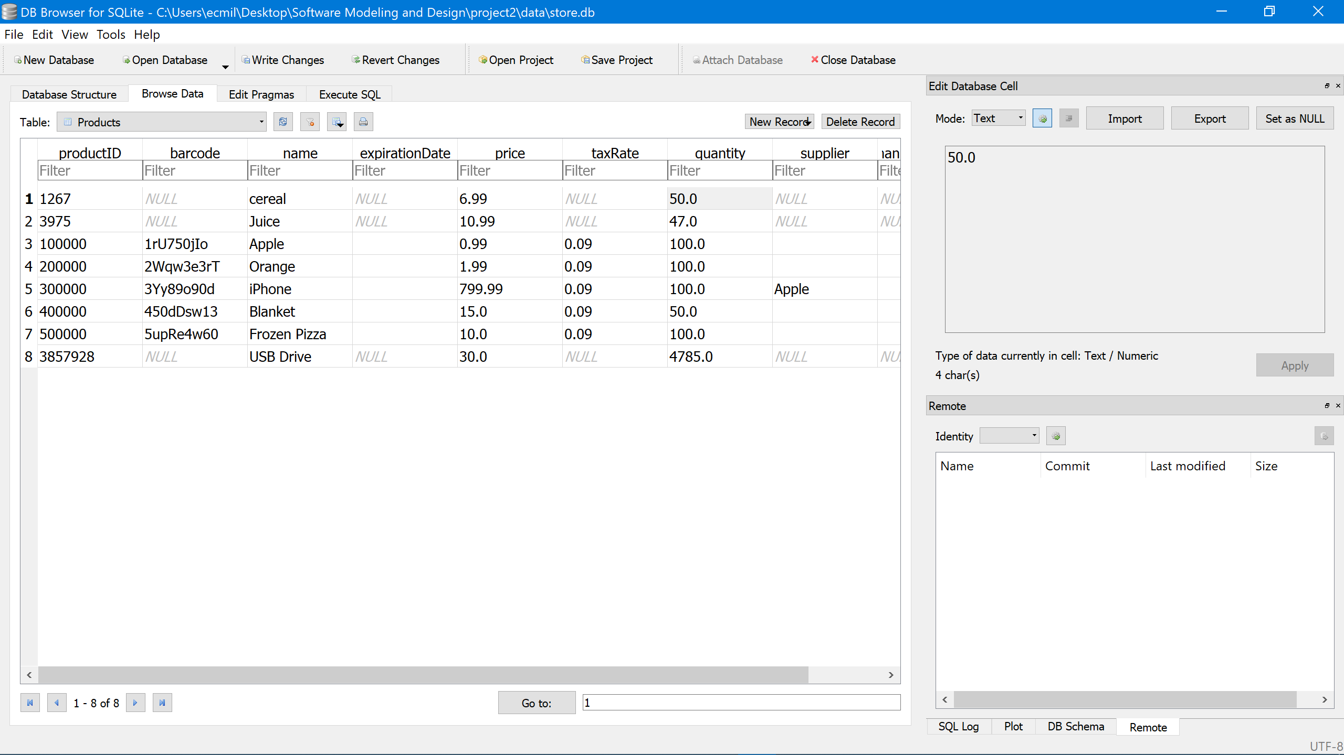

1. Manage Purchases UI

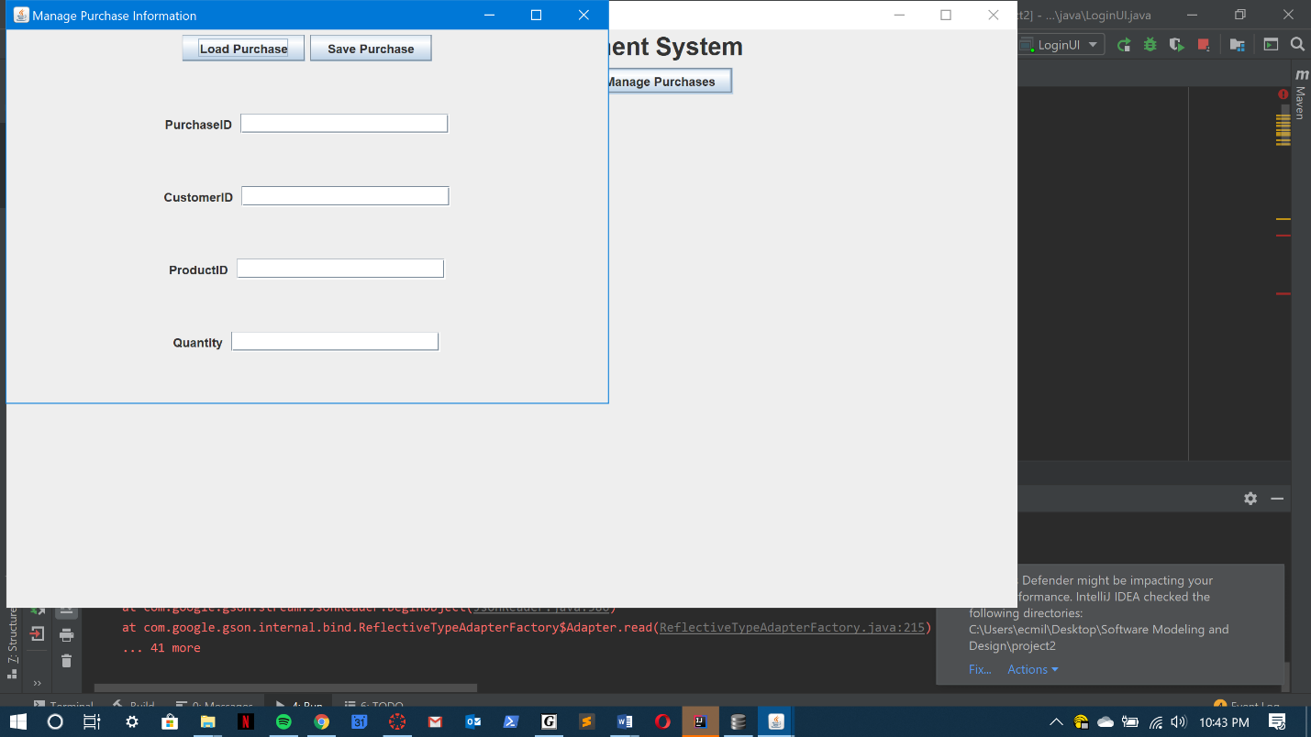

1. The database before the purchase alterations.

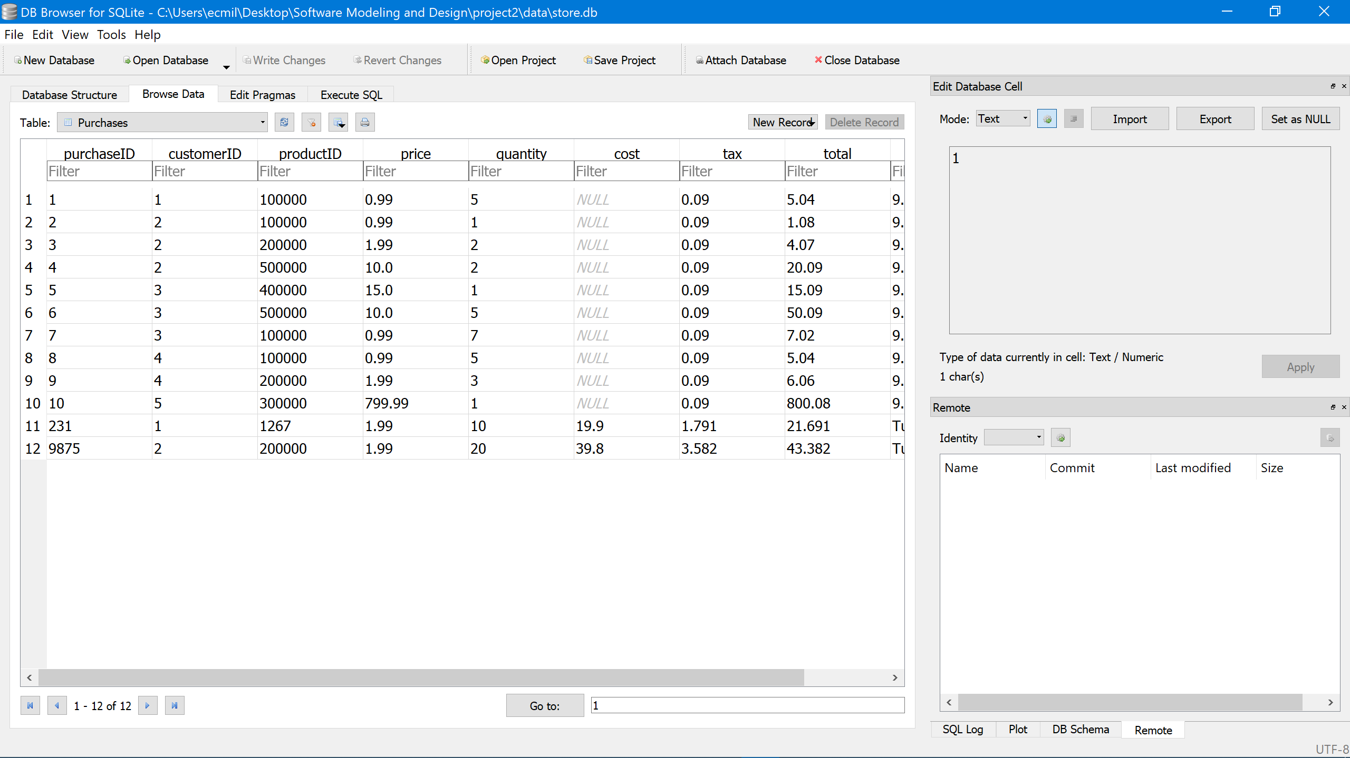

1. Entering the PurchaseID and loading the corresponding purchase in the database.

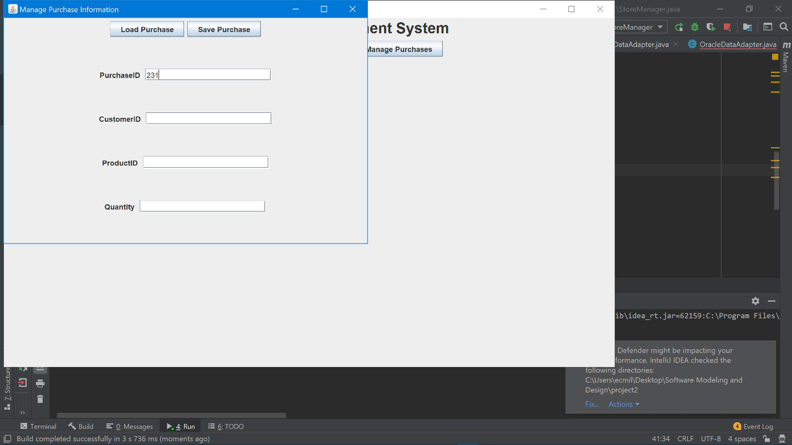

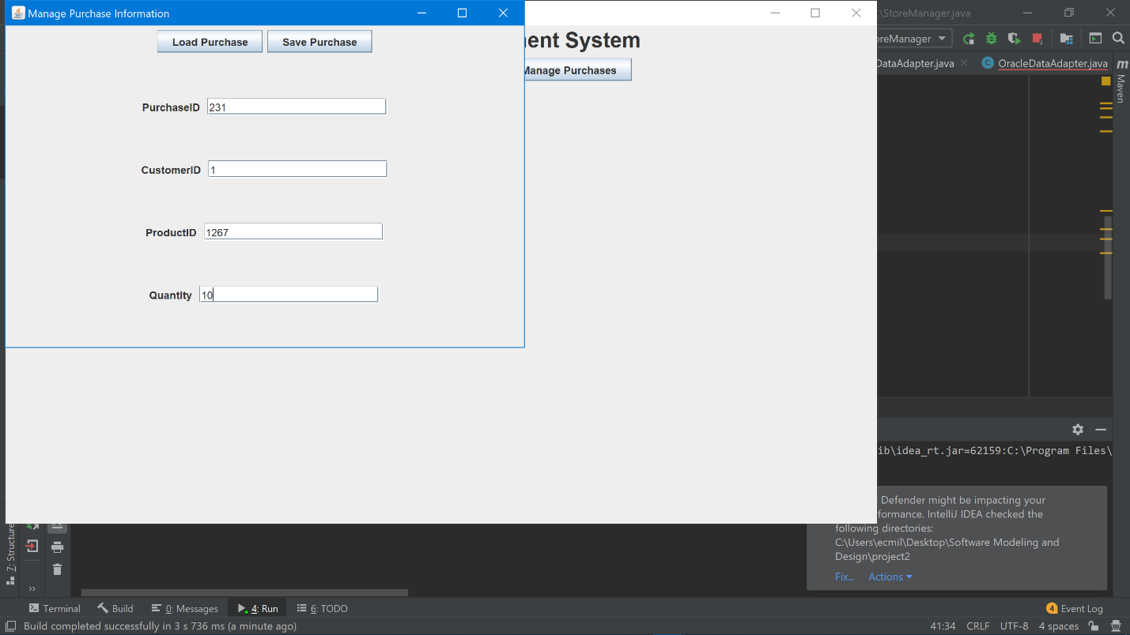

1. Altering and saving the purchase information.

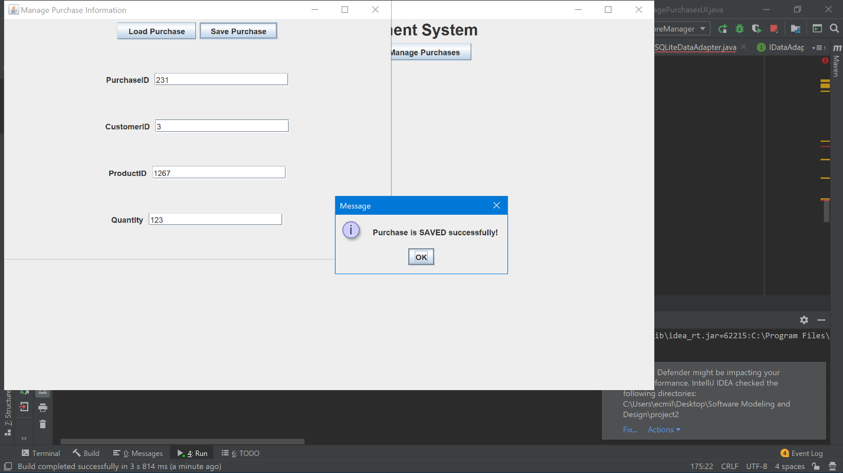

1. The updated database after the alterations.

