**Christian Nelson**

850.463.7535

*ChristianN@creetheduck.com*

**Education**

*Bachelor’s Degree*, University of West Florida

*Associates Degree*, Pensacola State College

9/2019- 12/2019

**Social Media/SEO Compliance Director**

As the Social Media/SEO Compliance Director I oversee our online presence. My responsibilities include correcting our NAP, building and maintaining our social media presence, optimizing our website for best SEO practices, writing analytics reports, keyword research, content creation/editing, as well as creating legal documents such as our privacy and legal policies.

5/2019- 12/2019

**Intern UWF**

As an intern at UWF I have been working with the mechanical engineering department to build a robot that balances a pendulum. I am working as the programmer analyzing photos using Nvidia CUDA to send information between a controller and the robot.

5/2019- 12/2019

**Freelance Web Design**

As a freelance web designer, I met with clients took in requests for sites to finish or create. I then implemented a plan to build the site and built said site. Regularly communicated with customers on views and design to make sure they were satisfied with the site. A full list of the sites I worked on can be found on my GitHub upon request.

11/2018- 9/2019

**Substitute Teacher**

As a Substitute Teacher I managed a class of 25-30 students. Followed and taught lesson plans assigned, by permanent teacher for students' in grades Kindergarten through the 12th grade. Guided students through planned activities and tend to their physical needs. Maintained effective classroom management strategies and applied advanced teaching capabilities in all subject areas. Determined appropriate consequences for inappropriate student behavior and write a report for teacher about the class’s events.

6/2016 – 02/2018

**Retention Specialist | CSR**

As a Retentions Specialist I took incoming calls of escalated customers on the verge of canceling service. I then deescalated the customers, solved any issues they may have using sales tactics and rebuttals, convincing them to maintain service. I provided exceptional service to the customer, and follow them throughout installation, assuring complete satisfaction.

5/2014 – 7/2016

**Shift leader**

As a Shift leader I learned the leadership skills necessary for overseeing and directing a crew. I made sure to always observe and comply with company policy and procedures, and to teach my team the correct procedure. I was always the first person staff came to when they had a question, and with the knowledge I gained I answered in a way that helped the questioner learn.

**Professional Associations & Recognitions:**

* Recognized Top Junior Runner in Cross Country
* Received the Dolphin Award in Cross Country
* Earned the top GPA award in my grade for cross country 3 years in a row
* Top 19 and under runner, in the First Light 2016 Marathon
* Worked soccer camps for handicapped children 2014 – 2017
* Code Fest participant 2019 UWF

**Technical Skills:**

AJAX Batch C C# C++ CUDA CSS HTML Java JavaFX JavaScript Json MySQL PHP PowerShell Raptor SQL TypeScript Unix Shell Visual Basic XML Angular Android Studio AWS Firebase GitBash GitHub Linux MongoDB Node.js POSTMAN React Weebly WordPress Facebook Twitter Instagram On Page SEO Digital Marketing Microsoft Office Microsoft Excel Microsoft PowerPoint Email Management Information Management Data Entry Digital Calendars (Google, Outlook) Instant Messaging Video Conferencing Social Media Management Digital Media Website Analytics(aHrefs, Mozbar) Software Programming Data Analytics Object Oriented Database Management Systems (OODBMS) Relational database management systems (RDBMS) Statistics NoSQL Tech Support Software Troubleshooting Remote Access Software Windows Shell APIs Unity

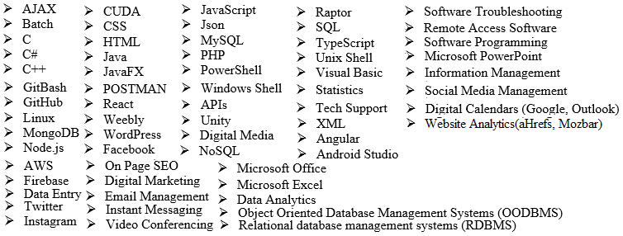

**References – More Available on Request:**

1. Michael Gray | CEO MEG Financial, Inc. | 850.529.0685
2. Dr. Evorell Fridge | Teacher UWF | 850.474.2046 | [efridge@uwf.edu](mailto:efridge@uwf.edu)
3. Amanda Green | Supervisor | 850.686.6631

GitHub: <https://github.com/ecn3/Portfolio>