

SAP Cloud Platform Integration
Technical Specification

Technical Specifications Document

[RFC]
[Change Document Number]

Document Release Note
Document Name: | SF-TimeEvent-POSTING-DATA
Version: | 1.0.0
Description:
Release Date:

Revision History
Revision  Number | Revision  Date | Revision Description | Page Number | Rationale For Change | Change Type (add/ modify/ delete)
1.0 |  | Draft | All | Initial Version | N/A

Document Contact Information
Name: | Khaled Abdellatif Hussein
Role: | Technical Consultant
E-mail: | khaled.abdellatif@eco-ds.com
Senior Manager: | Abdelrahman Hussein

Table of Contents
1. BUSINESS CONTEXT 4
1.1. OVERVIEW 4
1.2. DEVELOPMENT UNIT INFORMATION 4
Employee Master from SuccessFactors to Kronos Effective Delta 4
2. DETAILED DESIGN 4
2.1. CONFIGURATION DETAILS 4
2.2. SAP CPI IFLOW DESIGN 5
2.3. Excluding Sales & Distribution Employees: 5
2.3.1. Integration flow to Package 7
2.3.2. Adapter Configuration (Sender & Receiver) 7
2.3.3. Mapping Document 8
2.4. ERROR HANDLING 8
3. TESTING 9
3.1. TEST CONDITIONS AND EXPECTED RESULTS 9
4. APPENDIX 9

BUSINESS CONTEXT

OVERVIEW

this IFLOW is designed to push Biometric data to the SF time tracking.

1-Get the Biometric filtered data and split it into batches as the sf rest api only accept 1k records each time.

2-Sending emails to Nadec team on what is success and what is fault (fault records are attachaed).

DEVELOPMENT UNIT INFORMATION
Module | SAP Cloud Platform
Sub Module | Hana Cloud Integration
iflow Title | SF-TimeEvent-POSTING-DATA
Processing Type | Background Online
Execution Frequency | Daily Hourly Real-Time  Others

DETAILED DESIGN

CONFIGURATION DETAILS
Package Name: SF-Nadec-Timeevents
iFlow Name:SF-TimeEvent-POSTING-DATA.

Security Material Keys/Certificate Name: NadecIntegAdmin Basic

SAP CPI IFLOW DESIGN
It is a custom design SAP CPI Integration flow an interface to push data from Biometric to SF.

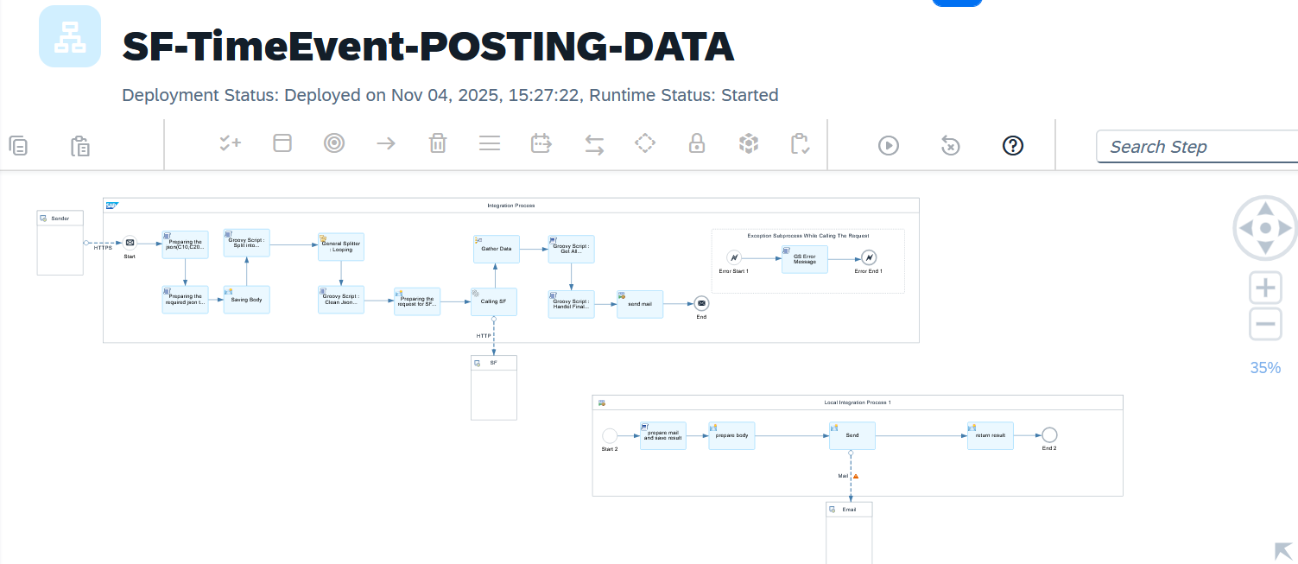

Detailed Requirements:

- Preparing the json(C10,C20 and the DateTime Format) here we change to format of Biometric to SF json format.
- Preparing the required json to be sent to SF call(json accepted by sf rest api)
- Saving Body at content modifier.
- Groovy Script : Split into batches(prepare the json for the splitter).
- General Splitter : Looping(the rest api only accept 1k record each time).
- Groovy Script : Clean Json Format(after the splitter to make msg as json again).
- Content Modifier : Preparing the request for SF call(setting up some headers parameters).
- Calling SF Rest API.
- Gather Data
- Groovy Script : Get All Response(formatting the gather output to a valid json).
- Groovy Script : Handel Final Response (Kronos Response).
- Process Call(send mail).
- Groovy Script : prepare mail and save result.
- Content Modifier: preparation for mail adapter(Attachment Part).
- Sending emails with attachment of failed records if exists and status for overall responses

Excluding Sales & Distribution Employees:
NA

Groovy Script Name | Description
Groovy Script: Prepare For Preparing the json(C10,C20 and the DateTime Format) | Preparing the json(C10,C20 and the DateTime Format
Preparing the required json to be sent to SF call | Formating the json to the accepted format of the rest api
Groovy Script : Split into batches | Prepare the json to be valid xml for the splitter operation
Groovy Script : Clean Json Format | Clean the json format
Groovy Script : Get All Response | Prepare the response after the gathering
Groovy Script : Handel Final Response (Kronos Response) | Prepare for the accepted response to biometric
prepare mail and save result | Formatting the email and the attachment

Integration flow to Package

Adapter Configuration (Sender & Receiver)

Configure HTTP adapters with required parameters (End Point).

Receiver(SF-QAS) : https://api23preview.sapsf.com/rest/timemanagement/timeeventprocessing/v1/TimeEvents
SF-Nadec-TimeEvent (AUTH-Bearer assersion)

Mapping Document

ERROR HANDLING
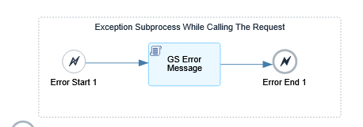

TESTING

TEST CONDITIONS AND EXPECTED RESULTS

Test Condition | Expected Results
CPI get the data pushed from the other iflow(SF-CPI-ENDPOINT) | Data posted to SF TimeEvent

3.2 TEST DATA CONSIDERATIONS

3.3 PERFORMANCE CONSIDERATIONS

APPENDIX

