
SAP Cloud Platform Integration
Technical Specification
Technical Specifications Document

Document Release Note
Document Name: | Get Employee Timesheet List
Version: | 1.0.0
Description: | Retrieves timesheet events (C10 check-in and C20 check-out) from SuccessFactors, groups them by date, and pairs check-ins with check-outs for each employee. This flow processes time events and converts UTC timestamps to local time (Asia/Riyadh timezone).
Release Date: | 2025-11-06
Revision History
Revision | Date | Description | Page | Rationale | Type
1.0 | 2025-11-06 | Initial Draft | All | Initial Version | Add
Document Contact Information
Name: | Abdelrahman Hussein
Role: | Technical Consultant

Table of Contents
1. BUSINESS CONTEXT 4
1.1 Overview 4
1.2 Development Unit Information 4
2. DETAILED DESIGN 5
2.1 Configuration Details 5
2.2 SAP CPI iFlow Design 5
Detailed Requirements: 5
Groovy Scripts 5
2.3 Adapter Configuration (Sender & Receiver) 6
2.4 Error Handling 6
3. TESTING 7
3.1 Test Conditions and Expected Results 7
3.2 Test Data Considerations 7
3.3 Performance Considerations 7

1. BUSINESS CONTEXT

1.1 Overview
Retrieves timesheet events (C10 check-in and C20 check-out) from SuccessFactors, groups them by date, and pairs check-ins with check-outs for each employee. This flow processes time events and converts UTC timestamps to local time (Asia/Riyadh timezone).

1.2 Development Unit Information
Module | SAP Cloud Platform
Sub Module | Hana Cloud Integration
iFlow Title | Get Employee Timesheet List
Processing Type | Background Online
Execution Frequency | On-Demand (Called by orchestrator flows)

2. DETAILED DESIGN

2.1 Configuration Details
Package Name: SF-Nadec-WorkAssignment
iFlow Name: Get Employee Timesheet List
Technical Name: SF_TimeEvent_GetByEmployeeDate
Endpoint: /timeEvent/getListOfEmployeeTimeSheet

2.2 SAP CPI iFlow Design
This is a custom-designed SAP CPI Integration flow for work assignment and timesheet conflict resolution.
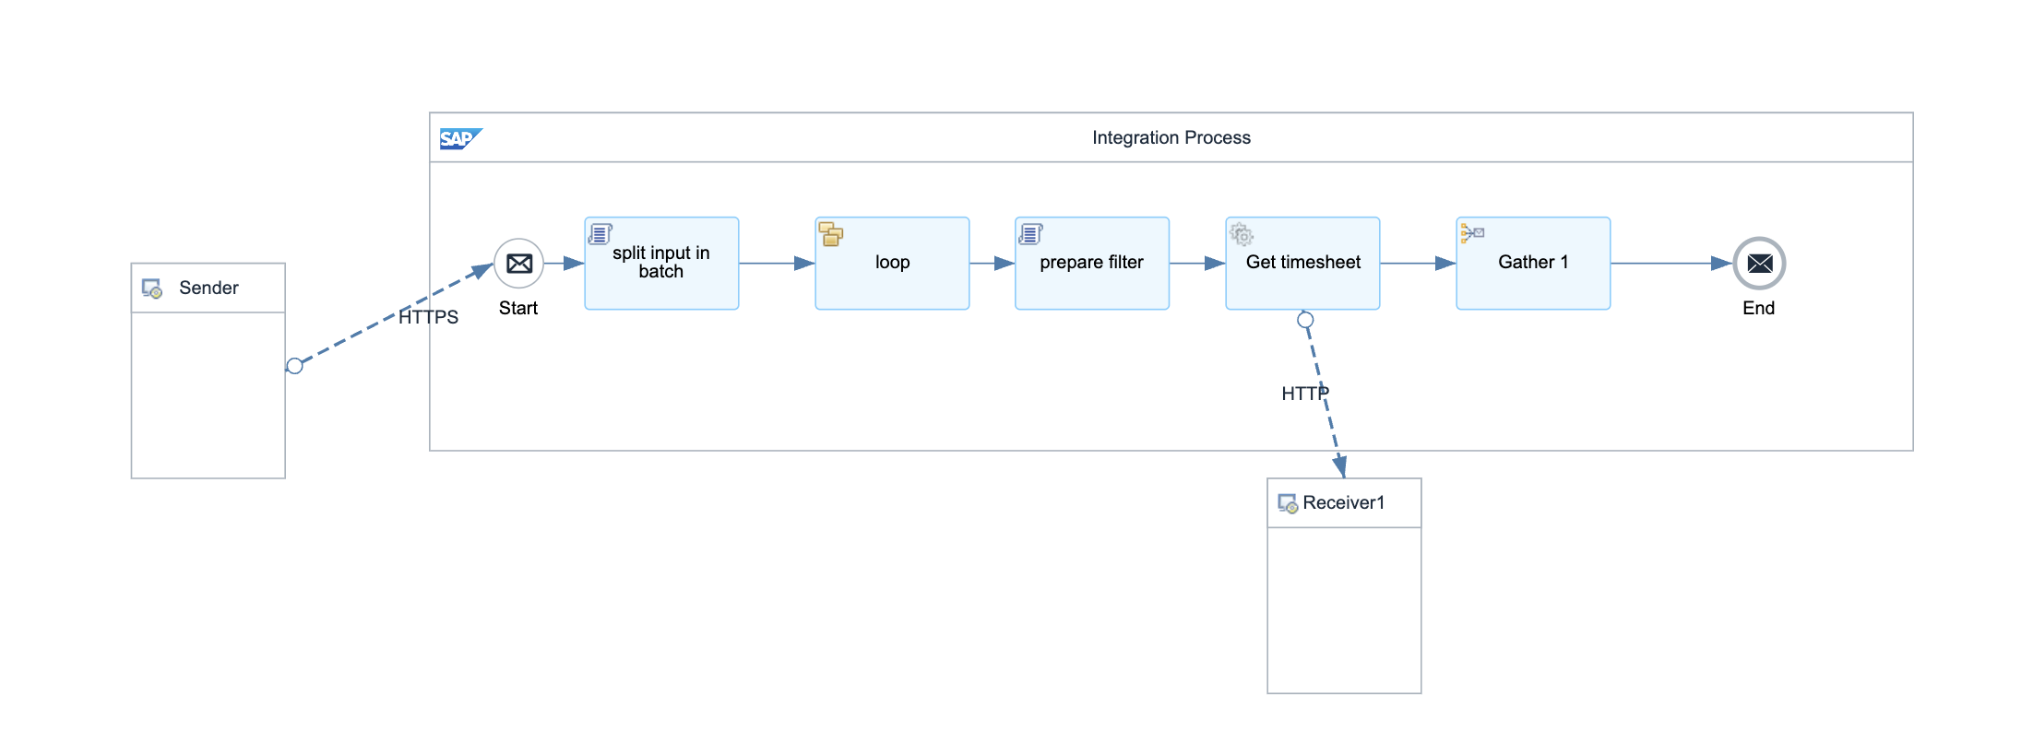

Detailed Requirements:
- Fetch TimeEvent data from SuccessFactors OData API
- Filter events by employee ID and date range
- Group time events by local date (handling timezone offsets)
- Sort events by timestamp within each date
- Pair first C10 (check-in) with last C20 (check-out) per day
- Convert UTC timestamps to local time strings (HH:mm:ss format)
- Return structured JSON with employeeId, date, checkIn/Out IDs and times

Groovy Scripts
Script Name | Description
Fetch Time Events | Calls SF OData API to retrieve TimeEvent records filtered by employee and date
Group by Date | Groups events by local date, handles timezone offsets (Asia/Riyadh)
Pair Check-ins/Outs | Sorts events and pairs first C10 with last C20 per day
Format Response | Converts UTC to local time, structures output JSON with paired events
Handle Edge Cases | Manages incomplete pairs, multiple check-ins/outs, and timezone conversions

2.3 Adapter Configuration (Sender & Receiver)
Receiver (SF): SuccessFactors OData v2 API for TimeEvent entity Authentication: OAuth Bearer Assertion (SF-Nadec-TimeEvent)

2.4 Error Handling
Standard CPI error handling applies. Errors are logged to message processing log. Failed messages are stored in error queue for manual intervention. Retry mechanism is configured for transient failures (3 attempts with 5-second delay).

3. TESTING

3.1 Test Conditions and Expected Results
Test Condition | Expected Result
Employee with normal check-in/check-out pairs | Returns paired events with correct local times
Employee with multiple check-ins on same day | Pairs first check-in with last check-out
Employee with no time events | Returns empty array for timesheet data
Cross-timezone date handling | Events grouped correctly by local date, not UTC date

3.2 Test Data Considerations
Test data should include: (1) Typical scenarios with standard work assignments and timesheets, (2) Edge cases with time zone boundaries, (3) Error scenarios with malformed data, (4) Load testing with bulk data volumes.

3.3 Performance Considerations
Expected processing time: <5 seconds for single record, <60 seconds for batch of 100 records. SF API rate limits: 5000 calls/hour. Memory usage: <500MB for typical batch operations.

