
SAP Cloud Platform Integration
Technical Specification
Technical Specifications Document

Document Release Note
Document Name: | Delete Work Assignment
Version: | 1.0.0
Description: | Deletes work assignments in SuccessFactors by setting their approval status to CANCELLED. This flow is called by the conflict resolution execute actions flow when work assignments need to be removed due to time conflicts with timesheet events.
Release Date: | 2025-11-06
Revision History
Revision | Date | Description | Page | Rationale | Type
1.0 | 2025-11-06 | Initial Draft | All | Initial Version | Add
Document Contact Information
Name: | Abdelrahman Hussein
Role: | Technical Consultant

Table of Contents
1. BUSINESS CONTEXT 4
1.1 Overview 4
1.2 Development Unit Information 4
2. DETAILED DESIGN 5
2.1 Configuration Details 5
2.2 SAP CPI iFlow Design 5
Detailed Requirements: 5
Groovy Scripts 5
2.3 Adapter Configuration (Sender & Receiver) 5
2.4 Error Handling 5
3. TESTING 7
3.1 Test Conditions and Expected Results 7
3.2 Test Data Considerations 7
3.3 Performance Considerations 7

1. BUSINESS CONTEXT

1.1 Overview
Deletes work assignments in SuccessFactors by setting their approval status to CANCELLED. This flow is called by the conflict resolution execute actions flow when work assignments need to be removed due to time conflicts with timesheet events.

1.2 Development Unit Information
Module | SAP Cloud Platform
Sub Module | Hana Cloud Integration
iFlow Title | Delete Work Assignment
Processing Type | Background Online
Execution Frequency | On-Demand (Called by conflict resolution)

2. DETAILED DESIGN

2.1 Configuration Details
Package Name: SF-Nadec-WorkAssignment
iFlow Name: Delete Work Assignment
Technical Name: SF_WorkAssignment_Delete
Endpoint: /deleteWAList

2.2 SAP CPI iFlow Design
This is a custom-designed SAP CPI Integration flow for work assignment and timesheet conflict resolution.
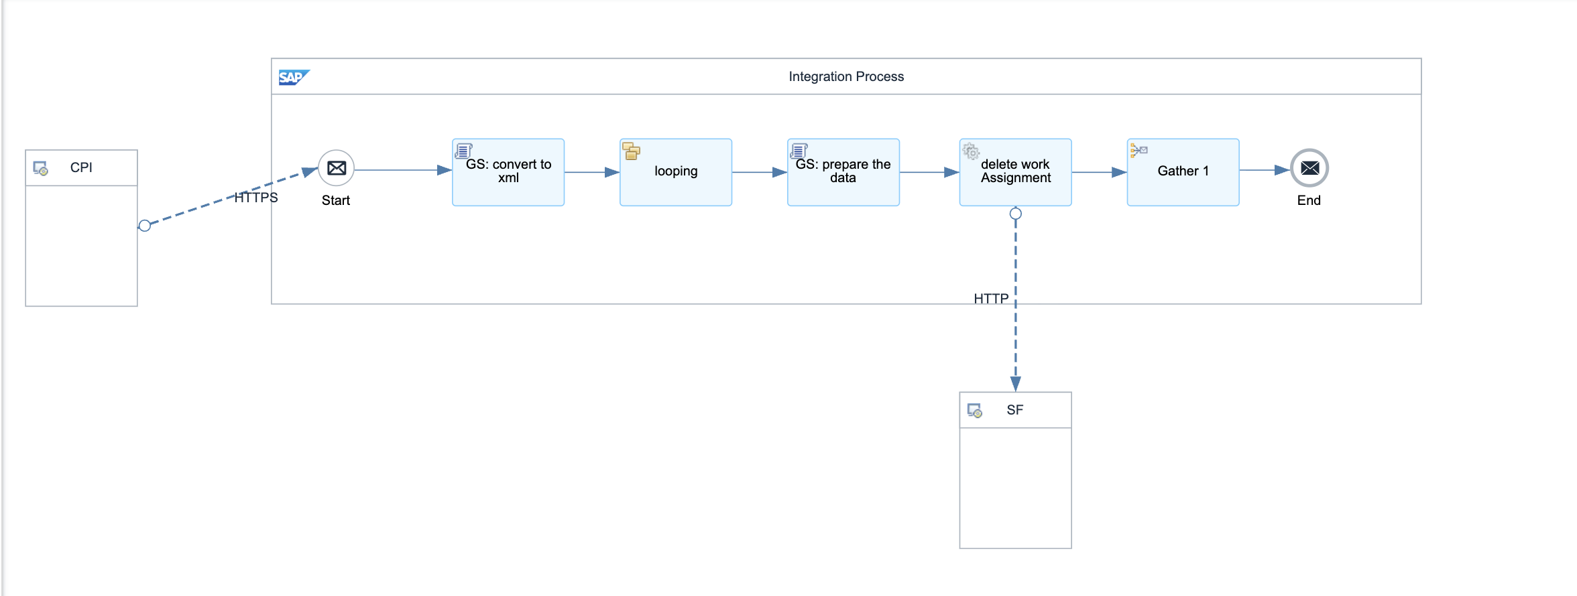

Detailed Requirements:
- Receives XML payload with work assignment IDs marked as deleted=true
- Filters and extracts only deleted work assignments
- Transforms XML to JSON format for SF OData API
- Sets approvalStatus to CANCELLED for each work assignment
- Executes upsert operation via SuccessFactors OData API

Groovy Scripts
Script Name | Description
Parse Delete List | Reads XML <Item> nodes and filters items where deleted=true
Transform to SF Format | Creates SF OData upsert payload with approvalStatus: CANCELLED
Prepare API Request | Sets required headers and authentication for SF API call

2.3 Adapter Configuration (Sender & Receiver)
Receiver (SF): SuccessFactors OData v2 API for Work Assignment entity Authentication: Basic (NadecIntegAdmin)

2.4 Error Handling
Standard CPI error handling applies. Errors are logged to message processing log. Failed messages are stored in error queue for manual intervention. Retry mechanism is configured for transient failures (3 attempts with 5-second delay).

3. TESTING

3.1 Test Conditions and Expected Results
Test Condition | Expected Result
Work assignment IDs provided in XML with deleted=true | Work assignments marked as CANCELLED in SuccessFactors
Empty or malformed XML payload | Error handling triggered, appropriate error message returned
SF API authentication failure | Error captured and logged, retry mechanism activated

3.2 Test Data Considerations
Test data should include: (1) Typical scenarios with standard work assignments and timesheets, (2) Edge cases with time zone boundaries, (3) Error scenarios with malformed data, (4) Load testing with bulk data volumes.

3.3 Performance Considerations
Expected processing time: <5 seconds for single record, <60 seconds for batch of 100 records. SF API rate limits: 5000 calls/hour. Memory usage: <500MB for typical batch operations.

