
SAP Cloud Platform Integration
Technical Specification
Technical Specifications Document

Document Release Note
Document Name: | Get Work Assignment List
Version: | 1.0.0
Description: | Fetches work assignments from SuccessFactors within a dynamic date range. The date range is automatically calculated as: first day of 2 months ago to last day of current month. For example, if executed on 2025-11-06, it retrieves work assignments from 2025-09-01 to 2025-11-30.
Release Date: | 2025-11-06
Revision History
Revision | Date | Description | Page | Rationale | Type
1.0 | 2025-11-06 | Initial Draft | All | Initial Version | Add
Document Contact Information
Name: | Abdelrahman Hussein
Role: | Technical Consultant

Table of Contents
1. BUSINESS CONTEXT 4
1.1 Overview 4
1.2 Development Unit Information 4
2. DETAILED DESIGN 5
2.1 Configuration Details 5
2.2 SAP CPI iFlow Design 5
Detailed Requirements: 5
Groovy Scripts 5
2.3 Adapter Configuration (Sender & Receiver) 5
2.4 Error Handling 6
3. TESTING 7
3.1 Test Conditions and Expected Results 7
3.2 Test Data Considerations 7
3.3 Performance Considerations 7

1. BUSINESS CONTEXT

1.1 Overview
Fetches work assignments from SuccessFactors within a dynamic date range. The date range is automatically calculated as: first day of 2 months ago to last day of current month. For example, if executed on 2025-11-06, it retrieves work assignments from 2025-09-01 to 2025-11-30.

1.2 Development Unit Information
Module | SAP Cloud Platform
Sub Module | Hana Cloud Integration
iFlow Title | Get Work Assignment List
Processing Type | Background Online
Execution Frequency | Scheduled Daily / On-Demand

2. DETAILED DESIGN

2.1 Configuration Details
Package Name: SF-Nadec-WorkAssignment
iFlow Name: Get Work Assignment List
Technical Name: SF_WorkAssignment_GetByDateRange
Endpoint: /workAssignment

2.2 SAP CPI iFlow Design
This is a custom-designed SAP CPI Integration flow for work assignment and timesheet conflict resolution.
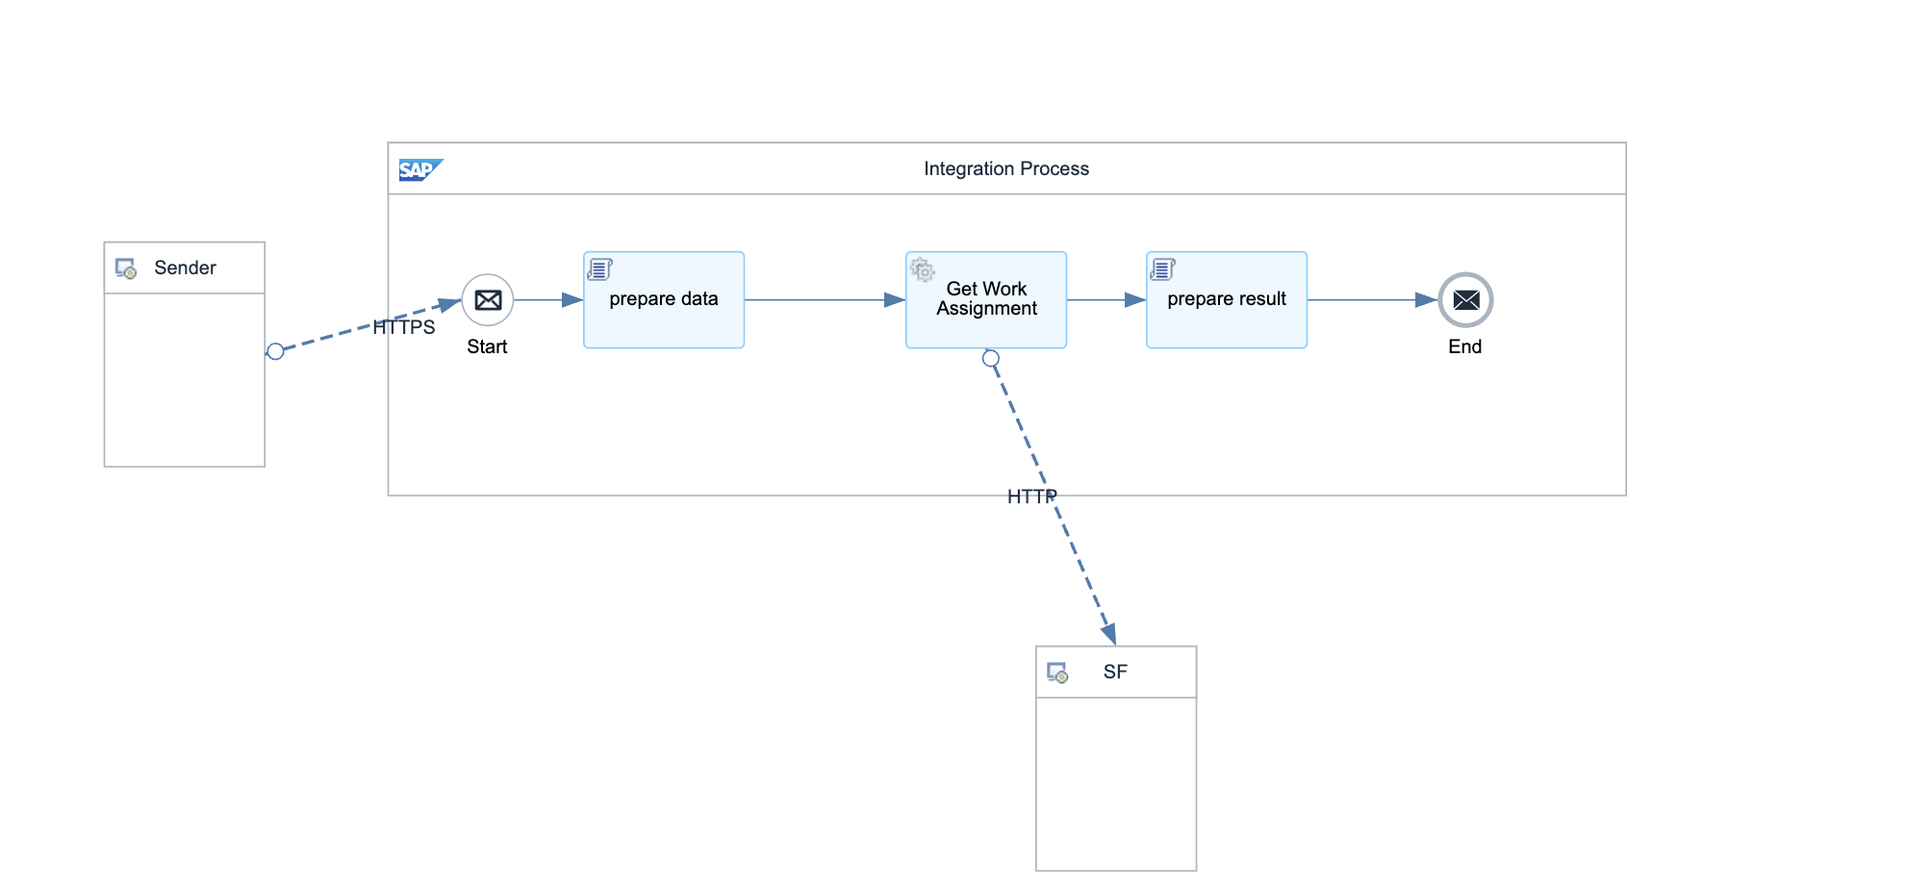

Detailed Requirements:
- Calculate dynamic date range: first day of (current month - 2) to last day of current month
- Build OData filter query with calculated date range
- Fetch work assignment records from SuccessFactors
- Use UTC timezone for date calculations
- Return work assignment data with employee IDs, dates, and time ranges

Groovy Scripts
Script Name | Description
Calculate Date Range | Computes first day of 2 months ago and last day of current month using UTC
Build OData Filter | Constructs filter: startDate ge datetime'...' and startDate le datetime'...'
Format Response | Structures work assignment data for downstream processing

2.3 Adapter Configuration (Sender & Receiver)
Receiver (SF): SuccessFactors OData v2 API for Work Assignment entity Authentication: Basic (NadecIntegAdmin)

2.4 Error Handling
Standard CPI error handling applies. Errors are logged to message processing log. Failed messages are stored in error queue for manual intervention. Retry mechanism is configured for transient failures (3 attempts with 5-second delay).

3. TESTING

3.1 Test Conditions and Expected Results
Test Condition | Expected Result
Scheduled execution on any date | Returns work assignments for calculated 3-month range
Work assignments exist in date range | All matching records retrieved successfully
No work assignments in date range | Returns empty result set without error
SF API rate limit exceeded | Retry mechanism handles rate limiting gracefully

3.2 Test Data Considerations
Test data should include: (1) Typical scenarios with standard work assignments and timesheets, (2) Edge cases with time zone boundaries, (3) Error scenarios with malformed data, (4) Load testing with bulk data volumes.

3.3 Performance Considerations
Expected processing time: <5 seconds for single record, <60 seconds for batch of 100 records. SF API rate limits: 5000 calls/hour. Memory usage: <500MB for typical batch operations.

