
SAP Cloud Platform Integration
Technical Specification
Technical Specifications Document

Document Release Note
Document Name: | WA and TS Data Bulk Retrieval
Version: | 1.0.0
Description: | Batch processing flow that retrieves and combines multiple work assignments with their corresponding timesheets. Optimized for bulk operations, this flow handles large volumes of records efficiently by processing them in batches and implementing appropriate delays for SF API rate limiting.
Release Date: | 2025-11-06
Revision History
Revision | Date | Description | Page | Rationale | Type
1.0 | 2025-11-06 | Initial Draft | All | Initial Version | Add
Document Contact Information
Name: | Abdelrahman Hussein
Role: | Technical Consultant

Table of Contents
1. BUSINESS CONTEXT 4
1.1 Overview 4
1.2 Development Unit Information 4
2. DETAILED DESIGN 5
2.1 Configuration Details 5
2.2 SAP CPI iFlow Design 5
Detailed Requirements: 5
Groovy Scripts 5
2.3 Adapter Configuration (Sender & Receiver) 6
2.4 Error Handling 6
3. TESTING 7
3.1 Test Conditions and Expected Results 7
3.2 Test Data Considerations 7
3.3 Performance Considerations 7

1. BUSINESS CONTEXT

1.1 Overview
Batch processing flow that retrieves and combines multiple work assignments with their corresponding timesheets. Optimized for bulk operations, this flow handles large volumes of records efficiently by processing them in batches and implementing appropriate delays for SF API rate limiting.

1.2 Development Unit Information
Module | SAP Cloud Platform
Sub Module | Hana Cloud Integration
iFlow Title | WA and TS Data Bulk Retrieval
Processing Type | Background Online
Execution Frequency | On-Demand (Batch Processing)

2. DETAILED DESIGN

2.1 Configuration Details
Package Name: SF-Nadec-WorkAssignment
iFlow Name: WA and TS Data Bulk Retrieval
Technical Name: WA_TS_Combine_Bulk
Endpoint: /getWAAndTimesheetBulk

2.2 SAP CPI iFlow Design
This is a custom-designed SAP CPI Integration flow for work assignment and timesheet conflict resolution.
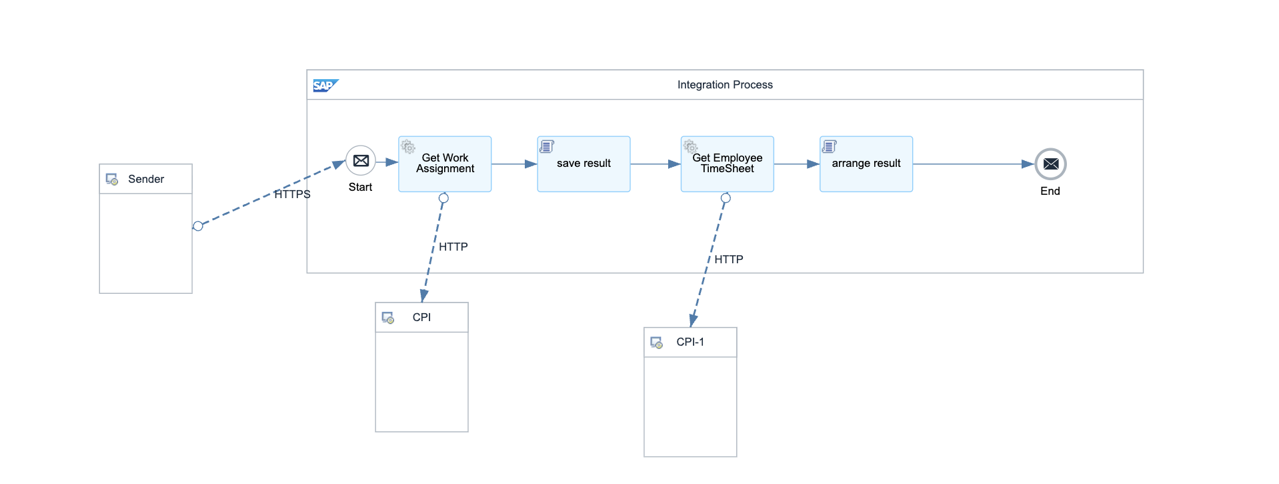

Detailed Requirements:
- Accept multiple work assignment records as JSON array input
- Convert JSON array to XML <Records> structure for processing
- Extract and save work assignment data to message property
- Fetch corresponding timesheet data for each work assignment
- Combine work assignment XML with timesheet JSON
- Apply 5-second delay for SF API rate limiting compliance
- Return combined XML with all work assignments and timesheets

Groovy Scripts
Script Name | Description
JSON to XML Conversion | Converts input JSON array to XML <Records> structure
Extract WA Data | Extracts work assignment data and saves to message property 'workAssignmentData'
Combine Data | Merges work assignment XML with fetched timesheet JSON
Aggregate Results | Combines multiple WA-TS pairs into single payload
Format Output | Structures final XML output with <WorkAssignment> and <Timesheet> sections
Rate Limit Handler | Implements 5-second delay (Thread.sleep) between batch operations

2.3 Adapter Configuration (Sender & Receiver)
Receiver (SF): Multiple API calls - Work Assignment OData API - TimeEvent OData API Authentication: Basic + OAuth Bearer

2.4 Error Handling
Standard CPI error handling applies. Errors are logged to message processing log. Failed messages are stored in error queue for manual intervention. Retry mechanism is configured for transient failures (3 attempts with 5-second delay).

3. TESTING

3.1 Test Conditions and Expected Results
Test Condition | Expected Result
Bulk input with 100 work assignments | All records processed, combined with timesheets successfully
Work assignments with no matching timesheets | Returns WA data with empty timesheet sections
SF API rate limiting triggered | 5-second delay prevents rate limit errors
Large payload > 10MB | Chunking mechanism handles large data volumes

3.2 Test Data Considerations
Test data should include: (1) Typical scenarios with standard work assignments and timesheets, (2) Edge cases with time zone boundaries, (3) Error scenarios with malformed data, (4) Load testing with bulk data volumes.

3.3 Performance Considerations
Expected processing time: <5 seconds for single record, <60 seconds for batch of 100 records. SF API rate limits: 5000 calls/hour. Memory usage: <500MB for typical batch operations.

