
SAP Cloud Platform Integration
Technical Specification
Technical Specifications Document

Document Release Note
Document Name: | WA Conflict Resolution - Core Orchestrator
Version: | 1.0.0
Description: | CORE ORCHESTRATOR: Coordinates the conflict resolution process. Expects combined work assignment and timesheet data as input, orchestrates conflict analysis by calling the Analyze Logic flow, then executes the resolved actions by calling the Execute Actions flow. This is a pure orchestrator with no business logic in scripts.
Release Date: | 2025-11-06
Revision History
Revision | Date | Description | Page | Rationale | Type
1.0 | 2025-11-06 | Initial Draft | All | Initial Version | Add
Document Contact Information
Name: | Abdelrahman Hussein
Role: | Technical Consultant

Table of Contents
1. BUSINESS CONTEXT 4
1.1 Overview 4
1.2 Development Unit Information 4
2. DETAILED DESIGN 5
2.1 Configuration Details 5
2.2 SAP CPI iFlow Design 5
Detailed Requirements: 5
Groovy Scripts 5
2.3 Adapter Configuration (Sender & Receiver) 6
2.4 Error Handling 6
3. TESTING 7
3.1 Test Conditions and Expected Results 7
3.2 Test Data Considerations 7
3.3 Performance Considerations 7

1. BUSINESS CONTEXT

1.1 Overview
CORE ORCHESTRATOR: Coordinates the conflict resolution process. Expects combined work assignment and timesheet data as input, orchestrates conflict analysis by calling the Analyze Logic flow, then executes the resolved actions by calling the Execute Actions flow. This is a pure orchestrator with no business logic in scripts.

1.2 Development Unit Information
Module
Sub Module | Hana Cloud Integration
iFlow Title | WA Conflict Resolution - Core Orchestrator
Processing Type | Background Online
Execution Frequency | On-Demand (Orchestration)

2. DETAILED DESIGN

2.1 Configuration Details
Package Name: SF-Nadec-WorkAssignment
iFlow Name: WA Conflict Resolution - Core Orchestrator
Technical Name: WA_TS_Conflict_CoreOrchestrator
Endpoint: /resolveWAConflictMain

2.2 SAP CPI iFlow Design
This is a custom-designed SAP CPI Integration flow for work assignment and timesheet conflict resolution.
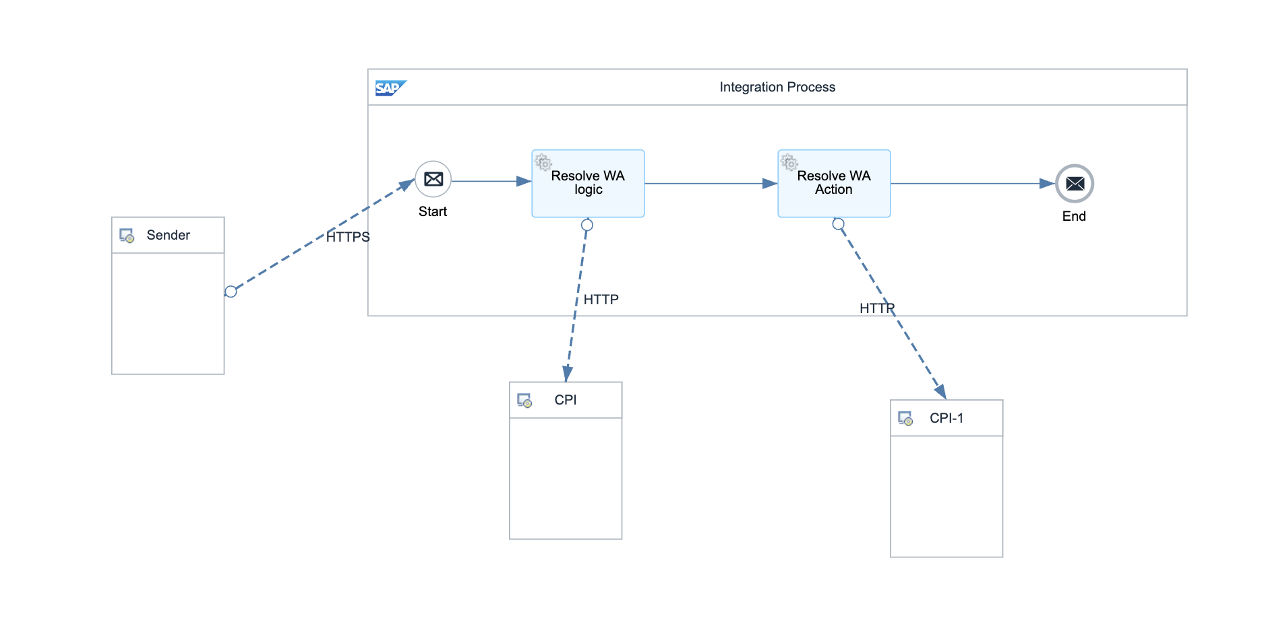

Detailed Requirements:
- Receive combined WA+TS data (XML or JSON)
- Call Analyze Logic flow to detect and resolve conflicts
- Receive resolution output (delete lists, trim events)
- Call Execute Actions flow to apply changes in SuccessFactors
- Return final execution status and results

Groovy Scripts
Script Name | Description
Validate Input | Checks input data structure and completeness
Prepare Analysis Call | Formats payload for Analyze Logic endpoint
Prepare Action Call | Formats resolution output for Execute Actions endpoint
Aggregate Results | Combines analysis and execution results for final response

2.3 Adapter Configuration (Sender & Receiver)
Internal orchestration: - Calls: WA Conflict Resolution - Analyze Logic - Calls: WA Conflict Resolution - Execute Actions

2.4 Error Handling
Standard CPI error handling applies. Errors are logged to message processing log. Failed messages are stored in error queue for manual intervention. Retry mechanism is configured for transient failures (3 attempts with 5-second delay).

3. TESTING

3.1 Test Conditions and Expected Results
Test Condition | Expected Result
Combined WA+TS data with conflicts | Analyzes and executes resolution successfully
Analyze Logic flow returns empty actions | Execute Actions not called, process completes
Execute Actions flow fails | Error handling captures failure, rolls back if needed
Large dataset with 1000+ pairs | Processes all pairs efficiently, handles timeouts

3.2 Test Data Considerations
Test data should include: (1) Typical scenarios with standard work assignments and timesheets, (2) Edge cases with time zone boundaries, (3) Error scenarios with malformed data, (4) Load testing with bulk data volumes.

3.3 Performance Considerations
Expected processing time: <5 seconds for single record, <60 seconds for batch of 100 records. SF API rate limits: 5000 calls/hour. Memory usage: <500MB for typical batch operations.

