
SAP Cloud Platform Integration
Technical Specification
Technical Specifications Document

Document Release Note
Document Name: | WA Conflict Resolution - End to End
Version: | 1.0.0
Description: | END-TO-END ORCHESTRATOR: Complete conflict resolution process from data retrieval to action execution. Fetches work assignments and timesheets from SuccessFactors, combines them, analyzes conflicts, and executes resolutions. This is the main entry point for automated conflict resolution jobs.
Release Date: | 2025-11-06
Revision History
Revision | Date | Description | Page | Rationale | Type
1.0 | 2025-11-06 | Initial Draft | All | Initial Version | Add
Document Contact Information
Name: | Abdelrahman Hussein
Role: | Technical Consultant

Table of Contents
1. BUSINESS CONTEXT 4
1.1 Overview 4
1.2 Development Unit Information 4
2. DETAILED DESIGN 5
2.1 Configuration Details 5
2.2 SAP CPI iFlow Design 5
Detailed Requirements: 5
Groovy Scripts 5
2.3 Adapter Configuration (Sender & Receiver) 6
2.4 Error Handling 6
3. TESTING 7
3.1 Test Conditions and Expected Results 7
3.2 Test Data Considerations 7
3.3 Performance Considerations 7

1. BUSINESS CONTEXT

1.1 Overview
END-TO-END ORCHESTRATOR: Complete conflict resolution process from data retrieval to action execution. Fetches work assignments and timesheets from SuccessFactors, combines them, analyzes conflicts, and executes resolutions. This is the main entry point for automated conflict resolution jobs.

1.2 Development Unit Information
Module | SAP Cloud Platform
Sub Module | Hana Cloud Integration
iFlow Title | WA Conflict Resolution - End to End
Processing Type | Background Online
Execution Frequency | Scheduled Daily / On-Demand

2. DETAILED DESIGN

2.1 Configuration Details
Package Name: SF-Nadec-WorkAssignment
iFlow Name: WA Conflict Resolution - End to End
Technical Name: WA_TS_Conflict_EndToEnd
Endpoint: /resolveWAMain

2.2 SAP CPI iFlow Design
This is a custom-designed SAP CPI Integration flow for work assignment and timesheet conflict resolution.
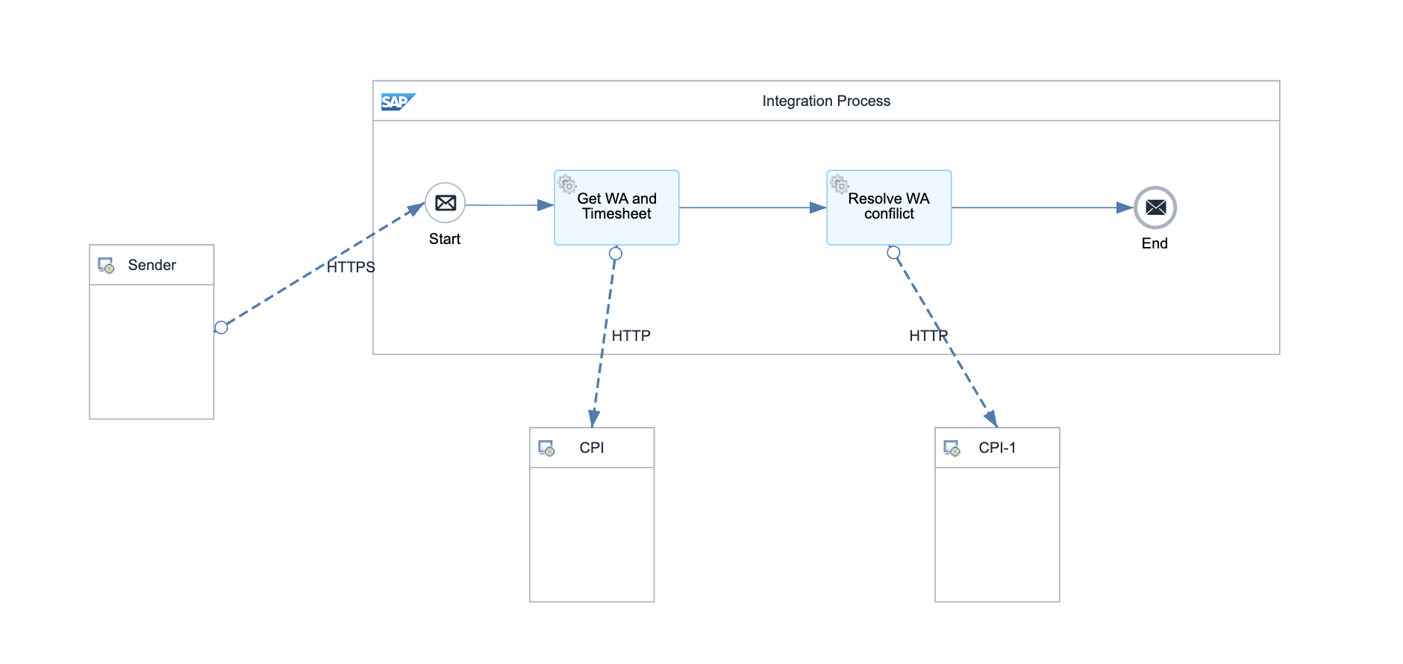

Detailed Requirements:
- Fetch work assignments for date range (calls Get Work Assignment List)
- Fetch corresponding timesheets (calls Get Employee Timesheet List)
- Combine WA and TS data (calls WA and TS Data Bulk Retrieval)
- Analyze conflicts (calls WA Conflict Resolution - Analyze Logic)
- Execute resolutions (calls WA Conflict Resolution - Execute Actions)
- Return comprehensive results with statistics

Groovy Scripts
Script Name | Description
Initiate Process | Sets up date range and initializes counters
Fetch WA Data | Calls external iFlow: WA and TS Data Bulk Retrieval
Orchestrate Resolution | Calls: WA Conflict Resolution - Core Orchestrator
Aggregate Statistics | Counts resolved items, deletions, trims, and errors

2.3 Adapter Configuration (Sender & Receiver)
Orchestrates multiple flows: - Get Work Assignment List - WA and TS Data Bulk Retrieval - WA Conflict Resolution - Core Orchestrator

2.4 Error Handling
Standard CPI error handling applies. Errors are logged to message processing log. Failed messages are stored in error queue for manual intervention. Retry mechanism is configured for transient failures (3 attempts with 5-second delay).

3. TESTING

3.1 Test Conditions and Expected Results
Test Condition | Expected Result
Scheduled daily execution | Processes all WA-TS pairs for configured date range
100 conflicts detected and resolved | All conflicts analyzed and actions executed successfully
SF API temporarily unavailable | Retry mechanism handles transient failures
Process exceeds 10-minute timeout | Chunks processing into smaller batches

3.2 Test Data Considerations
Test data should include: (1) Typical scenarios with standard work assignments and timesheets, (2) Edge cases with time zone boundaries, (3) Error scenarios with malformed data, (4) Load testing with bulk data volumes.

3.3 Performance Considerations
Expected processing time: <5 seconds for single record, <60 seconds for batch of 100 records. SF API rate limits: 5000 calls/hour. Memory usage: <500MB for typical batch operations.

