
SAP Cloud Platform Integration
Technical Specification
Technical Specifications Document

Document Release Note
Document Name: | WA Conflict Resolution - Execute Actions
Version: | 1.0.0
Description: | ACTION EXECUTOR: Executes conflict resolution actions in SuccessFactors based on analysis output. Performs three types of operations: (1) Delete work assignments by setting status to CANCELLED, (2) Delete timesheet events (C10/C20), (3) Insert new timesheet events for trimmed times.
Release Date: | 2025-11-06
Revision History
Revision | Date | Description | Page | Rationale | Type
1.0 | 2025-11-06 | Initial Draft | All | Initial Version | Add
Document Contact Information
Name: | Abdelrahman Hussein
Role: | Technical Consultant

Table of Contents
1. BUSINESS CONTEXT 4
1.1 Overview 4
1.2 Development Unit Information 4
2. DETAILED DESIGN 5
2.1 Configuration Details 5
2.2 SAP CPI iFlow Design 5
Detailed Requirements: 5
Groovy Scripts 5
2.3 Adapter Configuration (Sender & Receiver) 6
2.4 Error Handling 6
3. TESTING 7
3.1 Test Conditions and Expected Results 7
3.2 Test Data Considerations 7
3.3 Performance Considerations 7

1. BUSINESS CONTEXT

1.1 Overview
ACTION EXECUTOR: Executes conflict resolution actions in SuccessFactors based on analysis output. Performs three types of operations: (1) Delete work assignments by setting status to CANCELLED, (2) Delete timesheet events (C10/C20), (3) Insert new timesheet events for trimmed times.

1.2 Development Unit Information
Module | SAP Cloud Platform
Sub Module | Hana Cloud Integration
iFlow Title | WA Conflict Resolution - Execute Actions
Processing Type | Background Online
Execution Frequency | On-Demand (Called by orchestrator)

2. DETAILED DESIGN

2.1 Configuration Details
Package Name: SF-Nadec-WorkAssignment
iFlow Name: WA Conflict Resolution - Execute Actions
Technical Name: WA_TS_Conflict_Execute
Endpoint: /resolveWAConflictAction

2.2 SAP CPI iFlow Design
This is a custom-designed SAP CPI Integration flow for work assignment and timesheet conflict resolution.

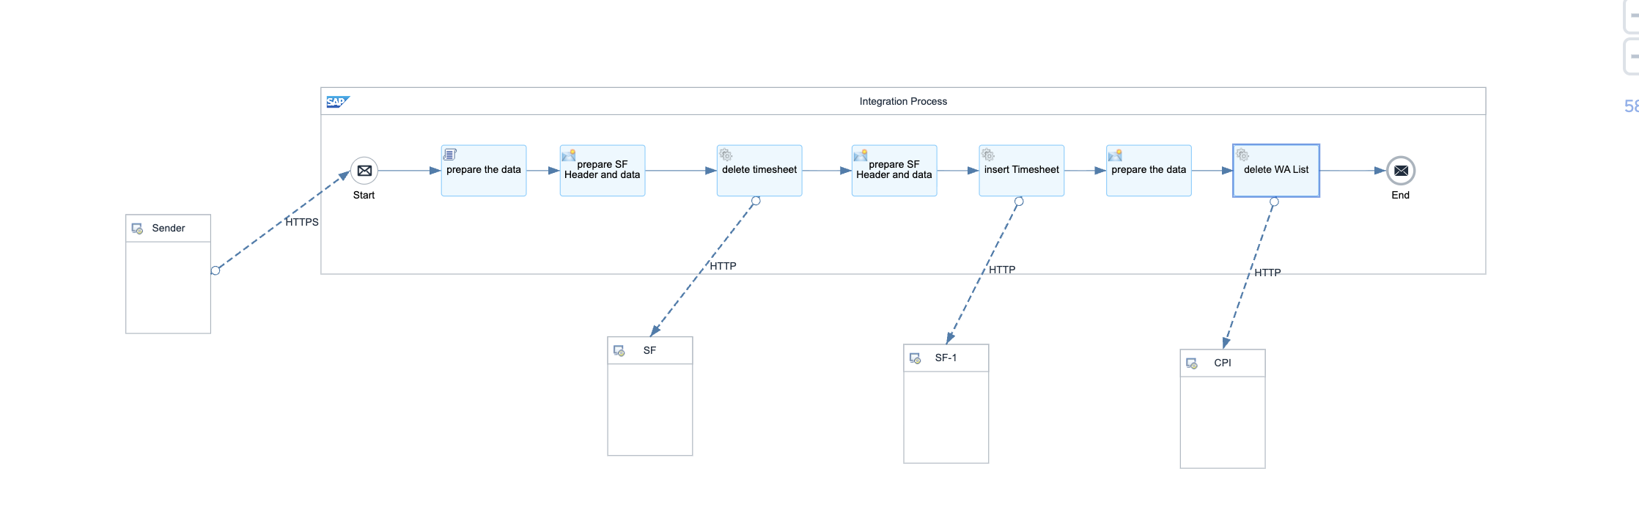

Detailed Requirements:
- Receive resolution output from Analyze Logic flow
- Extract delete lists: timesheetDelete, workAssignmentDelete
- Extract insert list: timeEventInsert (for trimmed times)
- Execute work assignment deletions (calls Delete Work Assignment flow)
- Execute timesheet deletions via SF TimeEvent OData API
- Create new timesheet events for trimmed times via SF TimeEvent API
- Handle batch operations for multiple records
- Return execution results with success/failure counts

Groovy Scripts
Script Name | Description
Parse Resolution Data | Extracts delete and insert arrays from input JSON
Execute WA Deletions | Transforms WA IDs to XML, calls Delete Work Assignment flow
Execute TS Deletions | Formats C10/C20 IDs for SF OData delete API, executes batch delete
Create Trimmed Events | Generates new TimeEvent records with adjusted times (±1 min), posts to SF
Aggregate Results | Counts successful/failed operations, structures response

2.3 Adapter Configuration (Sender & Receiver)
Receiver (SF): Multiple operations - Delete WA: Calls SF_WorkAssignment_Delete flow - Delete TS: SF TimeEvent OData API (DELETE) - Insert TS: SF TimeEvent API (POST) Authentication: Basic + OAuth Bearer

2.4 Error Handling
Standard CPI error handling applies. Errors are logged to message processing log. Failed messages are stored in error queue for manual intervention. Retry mechanism is configured for transient failures (3 attempts with 5-second delay).

3. TESTING

3.1 Test Conditions and Expected Results
Test Condition | Expected Result
10 WA deletions, 5 TS deletions, 3 TS inserts | All operations executed successfully
SF API rejects TS insert (validation error) | Error captured, other operations continue
Duplicate TS event in insert list | SF handles duplicate, returns appropriate error
Network timeout during execution | Retry mechanism handles timeout, resumes from last successful operation

3.2 Test Data Considerations
Test data should include: (1) Typical scenarios with standard work assignments and timesheets, (2) Edge cases with time zone boundaries, (3) Error scenarios with malformed data, (4) Load testing with bulk data volumes.

3.3 Performance Considerations
Expected processing time: <5 seconds for single record, <60 seconds for batch of 100 records. SF API rate limits: 5000 calls/hour. Memory usage: <500MB for typical batch operations.

