O2 use and|or configure ROVER client interface...

Because Esp32 flash memory is limited to 4 MB, the pilot interface can be installed directly on the smartphone (to be confortable with heavy javascript libraries).

USER INSTALL:
┌┐└┘═╔╗╚╝║◓╭
╭──────╮
│ test │
╰──────╯

=============

On your smartphone
Install Termux which is a chroot linux operating system to run node server of wifi pilot interface.

- Google Play Store
- Install Termux
- Launch Termux (You can see this screen):

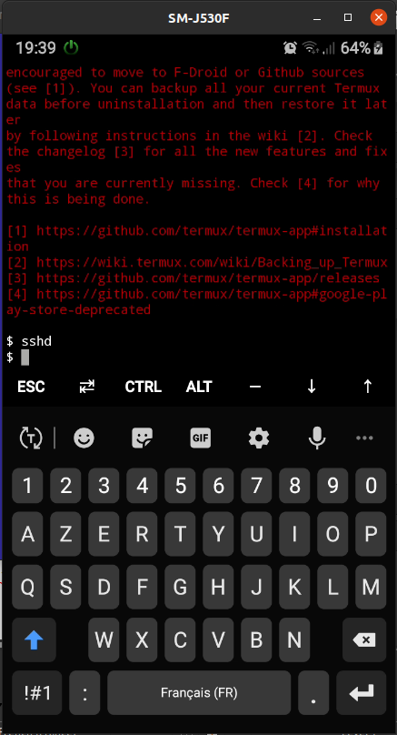

Update Termux install utilities & node for web server
- $ apt update && apt upgrade
- $ apt install coreutils
- $ apt install nodejs
- $ npm init
- $ apt update && apt upgrade # because of !!!! cannot link executable node

Connect the smartphone USB cable to your host PC & accept data access

On you PC

- Copy node folder on your external SDcard for example /storage/4419-5442/Android/data/com.termux/files

USER PILOT :
- Assume the wifi is ok
- Power on your rover
- Launch Termux & type the command ./rover.sh
- From chrome browser goto localhost:3001/pil.html url.

DEVELOPPER:

Tools environment

Control your smartphone from host PC
https://smart-tech.mg/comment-controler-et-mettre-en-miroir-un-telephone-android-dans-ubuntu/
- From host :
  - sudo snap install scrcpy
  - connect usb smartphone
  - scrcpy

Use ssh sessions

- From Termux :
  - install the openssh server
  - From Termux, type the command sshd to launch the ssh server
- Identify your user name & define a passsword
- From host :
  - open an ssh session

ANNEX

Warning with termux-setup-storage !!!

User boot
Just launch rover.sh sccript
$ cat rover.sh
cd ./storage/external-1/ROVER
pwd
#ls -als
while (true); do
node server.js
done
$

CLONE THREE.JS

https://www.google.com/search?channel=fs&client=ubuntu&q=skypack+OrbitControls
https://www.skypack.dev/view/threejs-orbit-controls

https://www.skypack.dev/view/three

Cloning this repository
Cloning the repo with all its history results in a ~2 GB download. If you don't need the whole history you can use the depth parameter to significantly reduce download size.
git clone --depth=1 https://github.com/mrdoob/three.js.git

At boot :

Launch rover.sh script
$ pwd
Check rover.sh script
$ pwd
/data/data/com.termux/files/home
$ whoami
u0_a738

$ nano ./rover.sh
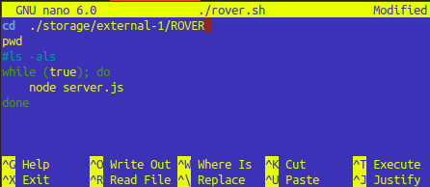
$
$ tree -pufhDtr
.
├── [-rwxrwxrwx u0_a738 85 Jan 10 09:35] ./rover.sh
├── [-rw------- u0_a738 57 Jan 4 17:03] ./server.js
├── [-rw------- u0_a738 49 Dec 27 17:44] ./package.json
├── [-rw------- u0_a738 768 Dec 27 17:44] ./package-lock.json
├── [drwx------ u0_a738 4.0K Dec 27 17:44] ./node_modules
│ └── [drwx------ u0_a738 4.0K Dec 27 17:44] ./node_modules/mime
│ ├── [-rw------- u0_a738 1.1K Dec 27 17:44] ./node_modules/mime/package.json
│ ├── [-rw------- u0_a738 5.0K Dec 27 17:44] ./node_modules/mime/README.md
│ ├── [-rw------- u0_a738 13K Dec 27 17:44] ./node_modules/mime/CHANGELOG.md
│ ├── [drwx------ u0_a738 4.0K Dec 27 17:44] ./node_modules/mime/types
│ │ ├── [-rw------- u0_a738 9.3K Dec 27 17:44] ./node_modules/mime/types/standard.js
│ │ └── [-rw------- u0_a738 25K Dec 27 17:44] ./node_modules/mime/types/other.js
│ ├── [-rw------- u0_a738 2.8K Dec 27 17:44] ./node_modules/mime/Mime.js
│ ├── [-rw------- u0_a738 101 Dec 27 17:44] ./node_modules/mime/lite.js
│ ├── [-rw------- u0_a738 127 Dec 27 17:44] ./node_modules/mime/index.js
│ ├── [-rwx------ u0_a738 1.2K Dec 27 17:44] ./node_modules/mime/cli.js
│ └── [-rw------- u0_a738 1.1K Dec 27 17:44] ./node_modules/mime/LICENSE
├── [drwx------ u0_a738 4.0K Dec 8 14:35] ./storage
│ ├── [drwx------ u0_a738 4.0K Dec 8 14:39] ./storage/ROVER
│ │ └── [-rw------- u0_a738 0 Dec 8 14:39] ./storage/ROVER/Toro
│ ├── [lrwxrwxrwx u0_a738 19 Dec 8 14:31] ./storage/shared -> /storage/emulated/0
│ ├── [lrwxrwxrwx u0_a738 28 Dec 8 14:31] ./storage/pictures -> /storage/emulated/0/Pictures
│ ├── [lrwxrwxrwx u0_a738 25 Dec 8 14:31] ./storage/music -> /storage/emulated/0/Music
│ ├── [lrwxrwxrwx u0_a738 26 Dec 8 14:31] ./storage/movies -> /storage/emulated/0/Movies
│ ├── [lrwxrwxrwx u0_a738 48 Dec 8 14:31] ./storage/external-1 -> /storage/4419-5442/Android/data/com.termux/files
│ ├── [lrwxrwxrwx u0_a738 28 Dec 8 14:31] ./storage/downloads -> /storage/emulated/0/Download
│ └── [lrwxrwxrwx u0_a738 24 Dec 8 14:31] ./storage/dcim -> /storage/emulated/0/DCIM
└── [drwx------ u0_a738 4.0K Dec 8 12:56] ./test-node
└── [-rw------- u0_a738 30 Dec 8 12:59] ./test-node/server.js

13 directories, 16 files
$

$ cd ./storage/external-1
$ pwd
/data/data/com.termux/files/home/storage/external-1
$
$ tree -pufhDt
.
└── [drwxr-x--- u0_a738 128K Jan 10 09:23] ./ROVER
├── [-rwxr-x--- u0_a738 14K Jan 7 18:58] ./ROVER/CENTER.jpg
├── [-rwxr-x--- u0_a738 1.0K Jan 7 18:58] ./ROVER/EMERGENCY.gif
├── [-rwxr-x--- u0_a738 1.1K Jan 7 18:58] ./ROVER/favicon.ico
├── [-rwxr-x--- u0_a738 4.0K Jan 7 18:58] ./ROVER/index.html
├── [-rwxr-x--- u0_a738 8.6K Jan 7 18:58] ./ROVER/pil.css
├── [-rwxr-x--- u0_a738 12K Jan 7 18:58] ./ROVER/pil.html
├── [-rwxr-x--- u0_a738 102K Jan 7 18:58] ./ROVER/pil.js
├── [-rwxr-x--- u0_a738 13 Jan 7 18:58] ./ROVER/rover.sh
├── [-rwxr-x--- u0_a738 3.2K Jan 7 18:58] ./ROVER/server_999.js
├── [-rwxr-x--- u0_a738 188 Jan 7 18:58] ./ROVER/testNodeServer.sh
└── [-rwxr-x--- u0_a738 3.2K Jan 10 09:23] ./ROVER/server.js

1 directory, 12 filesSmartphone
Wifi bdoor
Launch Termux
Termux sshd # Launch ssh server
Connect USB cable
Accept data access
Host desktop
Nautilus via USB to upload|download to|from host to mtp://SAMSUNG_SAMSUNG_Android_520041e0ececc493/Card/Android/data/com.termux/files/ROVER

Host console tab 1
Run scrcpy
Host console tab 2 Host console
ssh u0_a738@192.168.13.12 -p8022 # 3655
df # to see
ls # to see
tree -puh

$ cd ~
$ pwd
/data/data/com.termux/files/home
$ ls -als
total 64
4 drwx------ 9 u0_a738 u0_a738 4096 Jan 7 17:23 .
4 drwxrwx--x 4 u0_a738 u0_a738 4096 Dec 8 12:33 ..
4 -rw------- 1 u0_a738 u0_a738 3613 Jan 4 17:17 .bash_history
4 drwx------ 4 u0_a738 u0_a738 4096 Dec 27 17:44 .npm
4 -rw------- 1 u0_a738 u0_a738 24 Jan 7 17:23 .npmrc
4 drwx------ 2 u0_a738 u0_a738 4096 Dec 24 13:39 .ssh
4 drwx------ 3 u0_a738 u0_a738 4096 Dec 27 15:57 .suroot
4 drwx------ 2 u0_a738 u0_a738 4096 Dec 15 01:09 .termux
4 -rw------- 1 u0_a738 u0_a738 ./rover.sh20 Dec 24 13:52 .termux_authinfo
4 drwx------ 4 u0_a738 u0_a738 4096 Dec 27 17:44 node_modules
4 -rw------- 1 u0_a738 u0_a738 768 Dec 27 17:44 package-lock.json
4 -rw------- 1 u0_a738 u0_a738 49 Dec 27 17:44 package.json
4 -rwxrwxrwx 1 u0_a738 u0_a738 85 Jan 4 16:54 rover.sh
4 -rw------- 1 u0_a738 u0_a738 57 Jan 4 17:03 server.js
4 drwx------ 3 u0_a738 u0_a738 4096 Dec 8 14:35 storage
4 drwx------ 2 u0_a738 u0_a738 4096 Dec 8 12:56 test-node
$

# cd ~/storage/4419-5442/NODE.JS

cd ~/storage/external-1
tree -puh

./rover.sh # launch server.sh with while true (if server crash...)
Smartphone
Chrome localhost:3001/pil.html # no 192.168.13.12/...

echo "edit to understand"
NON: FileZilla 192.168.13.12 # goto /storage/4419-5442/NODE.JS

read car
exit
ls /storage/4419-5442

- $ node server.js
- $ mkdir test-node && cd test-node
- $ apt install nano #basic text editor (if need)
- $ touch server.js
- $ nano server.js # console.log('This is Node.js running on Android.')

$ cd ~/storage/external-1

$ ls -als
total 384
128 drwxr-x--- 3 u0_a738 everybody 131072 Jan 7 19:00 .
128 drwxr-x--- 3 u0_a738 everybody 131072 Dec 8 14:31 ..
128 drwxr-x--- 2 u0_a738 everybody 131072 Jan 7 19:28 ROVER
$ ls -als ROVER
total 1664
128 drwxr-x--- 2 u0_a738 everybody 131072 Jan 7 19:28 .
128 drwxr-x--- 3 u0_a738 everybody 131072 Jan 7 19:00 ..
128 -rwxr-x--- 1 u0_a738 everybody 14233 Jan 7 18:58 CENTER.jpg
128 -rwxr-x--- 1 u0_a738 everybody 1074 Jan 7 18:58 EMERGENCY.gif
128 -rwxr-x--- 1 u0_a738 everybody 1150 Jan 7 18:58 favicon.ico
128 -rwxr-x--- 1 u0_a738 everybody 4145 Jan 7 18:58 index.html
128 -rwxr-x--- 1 u0_a738 everybody 8850 Jan 7 18:58 pil.css
128 -rwxr-x--- 1 u0_a738 everybody 12682 Jan 7 18:58 pil.html
128 -rwxr-x--- 1 u0_a738 everybody 104785 Jan 7 18:58 pil.js
128 -rwxr-x--- 1 u0_a738 everybody 13 Jan 7 18:58 rover.sh
128 -rwxr-x--- 1 u0_a738 everybody 106 Jan 7 18:58 roverTestNodeServer_000.sh
128 -rwxr-x--- 1 u0_a738 everybody 3267 Jan 7 18:58 server.js
128 -rwxr-x--- 1 u0_a738 everybody 188 Jan 7 18:58 testNodeServer.sh
$

Wifi bdoor
Launch Termux
./rover.sh # Termux launch server.sh with while true (if server crash...)
Chrome localhost:3001/pil.html # not 192.168.13.12/...

