The availability of vegetative mesohabitats determines bird behavior in desert habitats

Abstract

Positive interactions, such as mutualism, are key interactions many species employ in order to survive harsh environments like deserts. In animals, mutualistic interactions with plants are usually exhibited in observable interactions (e.g. pollination and seed dispersal). Because plants provide resources like food and shelter to birds, these plants are often the site of these mutualistic behaviors, thereby promoting their own fitness as well as the interacting birds’. However, birds and plants both experience phenological shifts that require interactions from both parties. We investigated the behavioral mesohabitat association shifts that birds make in between the migration/flowering season (spring) and the breeding/fruiting season (summer). We recorded the mesohabitat and behavior of all birds seen during line transect walks in both seasons. We found that bird community structure was significantly more diverse in spring (p-value<0.0001), that site-wide behaviors are influenced by the birds found in a system, and that behaviors were influenced by mesohabitat. These findings suggest that availability of foundational and keystone plants species is important for the expression of bird behavior. The expression of behaviors is, in turn, important for the proliferation of mesohabitats many desert taxa rely on.

1. Introduction

Desert ecosystems are generally stressful; ultraviolet radiation, heat, water scarcity, wind, and other abiotic and biotic ecological factors contribute to this harshness (CITE). Because of this, positive interactions in these ecosystems arise and fluctuate within the system as stress abounds and changes (CITE stress gradient hypothesis). Most usually, plant-plant interactions are most reported as a response to stress gradients due to the relative ease of interaction measurement (CITE). However, plant-animal interactions (and further, more complex indirect interactions) also follow this hypothesis (CITE).

Mutualism is a category of positive interaction wherein the participating parties (usually interspecifics) both benefit from said interaction, usually in the form of resource acquisition that thereby increases the survival or fitness of the parties (CITE). We know that positive interactions influence ecosystem infrastructure (CITE), thereby determining habitat for any species in the ecosystem, not just the interacting parties. Pollination and seed dispersal are two common forms of mutualism that directly create and maintain habitat in most ecosystems, both of which are performed by birds found in desert ecosystems. The overall habitat structure may, therefore, be dependent on interactions between birds and foundational plant species may.

One major influence on the potential of bird-plant mutualism is physical proximity; that is to say, birds and plants must be in the same area in order to interact (CITE). As plant phenological cycles (e.g. flowering and fruiting seasons) are determined by either daylength or temperature (CITE), phenologically-dependent mutualistic interactions (i.e. pollination and seed dispersal) are also temporally limited (CITE). The two constraints of time and space come into play when considering that bird communities migrate yearly (CITE). In the Mojave Desert, birds fall into similar categories as other bird-supporting ecosystems: migratory spring and fall visitors, or summer, winter, and yearlong residents. Because spring and summer contain the intersections of bird migrating/plant flowering and bird breeding/plant fruiting, respectively, they are two seasons where our mutualistic interactions of interest may occur. However, because pollination and seed dispersal may be performed by many different biotic (bees, bats, squirrels, etc.) or abiotic (wind, water, etc.) actors, we must first determine the potentiality for these interactions to even occur.

In this study, we investigated the hypothesis that bird-plant mutualistic interactions are dependent on small-scale geographic and temporal limitations. Our research questions are: 1) How does desert bird community taxonomic diversity change between migratory/flowering seasons (hereafter referred to as spring) and breeding/fruiting seasons (hereafter referred to as summer)? 2) How do birds associate with mesohabitats and exhibit behaviors in different seasons? And 3) are mesohabitats fostering certain behaviors among birds? We predict that 1) bird community diversity will be different in the spring season than in the summer season, 2) observed mesohabitats and behaviors will be defined by the birds’ functional and taxonomic diversity, and 4) behavior exhibited by birds is dependent on mesohabitat association.

2. Methods

2.1 Study Site

The Mojave Desert is located on the South Eastern border of California, with most of the land being designated as the Mojave National Preserve under the United States National Park System. Directly adjacent to the public lands of the preserve is the Sweeney Granite Mountains Desert Research Center (34°48′20″N 115°39′50″W), which is land owned by the University of California as a part of the UC Reserve System. This land is only available to researchers and classes, thereby preventing interference from public visitors. Located in the Granite Mountains of the Eastern Mojave Desert, the 3,600 hectares of the research center’s elevation ranges from 1,128 to 2,071 m. Like many other arid ecosystems, rainfall varies significantly throughout the year, though the yearly average being 22 cm per year. The July average minimum and maximum is 20°C and 33°C respectively, while the December average minimum and maximum is -1°C and 8°C. Geologically, the site is unique with alluvial fans and bajadas to granitic pinnacles. Springs, seeps, and washes are common topographical features throughout the land.

2.2 Study system

This study site within the reserve system is dominated by perennial woody and succulent shrubs such as *Cylindropuntia acanthocarpa, Yucca mohavensis, Larrea tridentata, Ambrosia salsola, Pinus monophylla,* and numerous other shrub species. A hub of desert diversity, 156 birds, 42 mammals, 2 amphibians, and 504 species of vascular plants have been documented throughout the reserve. The field work for this study was conducted from May to August of 2019, a spring and summer following an unusually strong rainy season. Higher winter rain levels typically result in stronger blooms in this area, with this year being no exception (***rainfall levels in 2019 winter). However, an unusually cool early spring led to a delay for many thermally induced blooms such as several *Cylindropuntia* ssp*.*

The avian community of the Mojave Desert includes typical species of the American Southwest, but also is home to desert obligate species which rely on plant species only found in wild desert areas (e.g. the Cactus Wren, *Campylorhynchus* *brunneicapillus*). A complete list of all known avian species to the field site is available via the site’s website (CITE).

2.3 Field observations

To sample the bird community makeup, we repeated walked a 500-meter line transects over a two-hour period at cooler day times, which was associated with peak bird activity from 7-10am or 5-8pm (N=41). We sampled two individual line transects, which were spaced 80 meters a part due to physical blocks of craggy mountains. The starting coordinates for transect 1 and 2 were 34.78299, -115.662 and 34.78303, -115.663, respectively. A single observer familiar with the local bird species recorded all visual (n=755) or audial (n=463) bird queues and identified each observation to species (though some female/juvenile hummingbirds were identified only to family due to the visual similarity between species). However, we only included visual observations of birds in mesohabitat and behavioral analyses, since the data is less fine. Flyovers (defined as birds flying roughly 25 feet above the shrub line that did not land within sight) were not included as an observation. In addition to species, we also recorded behavior (as designated by an ethogram), mesohabitat, geographic coordinates, the time of the sighting/hearing, and an estimate of the distance from the transect (<25 meters, 25-50 meters, or >50 meters). We also took photographs of birds using a Nikon D5300 camera equipped with a Sigma 150-600mm lens which served as identification aids and behavioral/mesohabitat records.

Behavior and mesohabitat functioned as dependent variables for each observation of a bird. Behavioral observations were then categorized into broader behaviors (active movement, cleaning, feeding, inactive, and territorial/mating). Mesohabitat level observations were distilled into 2-level (vegetative or non-vegetative) and 3-level (cactus, shrub, or other). Trophic guild and migratory class were the metrics we used to define functional diversity. We categorized all observed species into trophic guilds using CITE and into migratory classes using CITE. Taxonomic diversity was originally recorded to species level, and then grouped into broader taxonomic designations (family and order).

2.4 Statistical Analyses

Using each line transect walk as a level of replication, we calculated species abundance (A), richness (S), Turnover (T), and evenness (J) using the R Vegan Package (CITE). Additionally, we calculated Simpson’s Diversity Index (D) and Shannon’s Diversity Index (H) to encourage transparency on the influence of evenness or richness, respectively. Using these different metrics for community structure, we created linear regression models to determine differences in community structure in spring and summer, excluding species richness, for which we performed a general loglinear model (due to the non-normal, poisson distribution of species richness through both seasons). We included each walk of a transect in the models as a random effect.

Additionally, to determine the species variance impact on community structure, we performed a Principle Components Analysis for both spring and summer. We then composed two distance-based Moran's eigenvector maps for each season as a visualization for the species’ variance.

To determine the impact of bird taxonomic on the likelihood of mesohabitat use, we compared bird species abundance across different levels of mesohabitat. On that same note, we determined the impact of bird functional diversity on mesohabitat use, we compared bird trophic guild abundance as well as bird migratory class abundance across different levels of mesohabitat. Because we observed birds associating with 11 different types of mesohabitat, we compressed these data into 3-level responses (shrub, cactus, or other) and 2-level responses (vegetation or non-vegetation). We conducted a One-way ANOVA across these three or two mesohabitat levels to determine if there was a difference in mesohabitat type birds most often associated with. We conducted this analysis both within and between seasons.

Similarly to our mesohabitat association tests, we compared bird taxonomic diversity (represented as bird species abundance) across different behavior types both, as well as bird functional diversity (represented as trophic guild abundance and migratory class abundance). Again, because we observed 15 different ethogram-defined behaviors, we binned behaviors into 5 broad behaviors: active movement, inactivity, cleaning, feeding/foraging, and territorial/mating. We conducted a One-way ANOVA across these 5 behavior levels to determine if behavior types exhibited by birds significantly differed. Again, we conducted this analysis both within and between seasons. When an ANOVA model showed significant differences in these response variables, we used a Tukey Honest Significance posthoc test to determine exactly which behaviors were more or less frequently exhibited.

To examine the influence of a bird’s mesohabitat on its behavior, we performed a two Pearson’s Chi-squared test; the first including 3-levels of mesohabitat (shrub, cactus, or other) as the independent variable, the second broadening our perspective with 2-levels of mesohabitat (vegetative or non-vegetative). Again, we compared within and between seasons. However, due to the small cell size of “cleaning” level of bird behavior leading to incorrect Chi-squared approximation, we removed “cleaning” as a level, eliminating 5 observations out of 750 total bird interactions. Any Chi-squared tests yielding significant differences were then analyzed using a Bonferroni posthoc test. All analyses were performed in R version 3.5.1 (CITE).

3. Results

3.1 Community structure between seasons

Spring had significantly higher levels in all metrics of community structure than summer, except in species turnover (Table 1; Fig. 1). Simpson’s Diversity Index accounts more for evenness in it’s metric, whereas Shannon’s Diversity Index accounts more richness.

Seeking an 80% of species variance explained by included principle components, our principle components analysis showed that, for spring, 80.68% of variance in bird species is explained by the first 6 principle components. Summer, however, had 89.24% of species variance explained by principle components 1 and 2 (Fig. 2). Considering that a total 43 species were observed during this study (Table 2), the compression of this community into 6 and 2 principle components shows clarity among represented species.

3.2 Mutualistic interaction possibilities

Comparing the differences in bird species abundance (Table 2) between shrub, cactus, and other mesohabitat types, we found no significant difference both within seasons and between spring or summer. This was also true for our two-level analysis of vegetative or non-vegetative mesohabitats, suggesting no difference in which mesohabitats birds are associating with in spring or summer. There was also no statistical distinction between either of the functional diversity metrics. Trophic guild abundance and migratory classes did not differ within or between seasons, regardless of the number of mesohabitat levels defined (Table 5; Fig.3).

Behaviors exhibited by bird species, however, did differ. When comparing bird species abundance across both seasons, territorial/mating behaviors were higher in spring than cleaning or feeding behaviors in either season and higher than inactivity in summer. For trophic guild abundance across both seasons, we again found that territorial/mating behaviors were higher in spring than cleaning behaviors in spring or summer. However, when representing functional diversity as migratory classes, we found no significant differences in behavior types exhibited (Table 5; Fig. 3).

3.3 Mesohabitats’ influence behavior

Lastly, we compared mesohabitats influence on bird behavior. When comparing the influence of vegetative or non-vegetative mesohabitats on behavior & shrub, cactus, or other mesohabitats on behavior, we found significant differences between both the three-level mesohabitat as predictors (Pearson’s Chi-squared Test, X2=26.47, df=6, p<0.001) and the two-level mesohabitat as predictors (Pearson’s Chi-squared Test, X2=23.66, df=3, p<0.0001). The Bonferroni test showed that mesohabitats other than shrubs or cacti had a positive influence on active movement, and a negative influence on territorial/mating behaviors (Fig. 4). When we broadened our perspective, we found that vegetative mesohabitats had a negative influence on active movement but a positive influence on territorial/mating behaviors, and that non-vegetative mesohabitats had a positive influence on active movement and a negative influence on territorial/mating behaviors (Fig. 4).

4. Discussion

Positive interactions, including mutualism, are responsible for habitat infrastructure across ecosystems where cohabitation can be beneficial for all parties involved (CITE). This is especially true in arid ecosystems where abiotic and biotic stressors are abundant (CITE). In this study, we investigated the relationship between birds and their biotic habitat to determine the capacity and for mutualistic interactions during different phenological stages (for plants) and migratory stages (for birds) that are important for desert habitat creation and maintenance. Specifically, we tested for differences in bird community structure between spring and summer, for the influence of taxonomic and functional diversity on mesohabitat and behavior, and for the influence of mesohabitats birds associate with on bird behavior.

4.1 Does community structure change between spring and summer?

In our bird community structure between seasons, we found support for the prediction that each season had different species makeups. In fact, we found that spring consistently had more species, more individuals, more evenly distributed individuals in all species, and higher diversity (both in terms of Shannon’s Diversity Index and Simpson’s Diversity Index). However, we did not see significant turnover throughout the season, showing that there was a consistent representation of species throughout each season. These findings support the prediction that bird community structure is changing throughout the seasons. Therefore, we suggest that the shifting of community structures through migration has influence one way or the other on the capacity for mutualistic interactions linked to phenological stages such as pollination and seed endozoochoric seed dispersal.

Our Principle Components Analysis showed that the in spring, the abundance of bird species was less easily collapsible than the abundance of summer bird species. This makes sense considering metrics of diversity, abundance, richness, and evenness all were higher in spring. Similarity among species within seasons is higher in summer, suggesting less opportunity for diverse interactions between plants and birds in the summer. Summer months in deserts, being much hotter and dried than the spring months, are known to exhibit lower diversity of many vertebrates during this time as species migrate to cooler/wetter areas, or as they enter torpor to conserve energy during this harsh time (CITE; CITE). While our methods of observation could not account for those species or individuals removing themselves from the desert, our methods do account for active wildlife; any birds that are active during this time of the year and during the day are represented in our study.

As the two communities do appear to differ between spring and summer, this community structural change suggests the opportunity (or compulsion) for plants benefitted by birds to adapt to these birds’ constraints.

4.2 How do birds associate with mesohabitats and exhibit behaviors?

Whether or not these shifting community structures do result in a changed use of habitat for birds/a changed interaction between birds and plants required further investigation. Mesohabitat associations did not differ when we considered taxonomic variation in birds as an explanatory variable; this was true when we compared spring and summer mesohabitat associations against each other, but also when we isolated each season. That is to say, birds associated with shrubs, cacti, and other mesohabitats equally often in spring and summer. This is true even when we broaden our perspectives, as birds associate with vegetation and non-vegetation equally often in spring as they do in summer. However, we did see that behaviors exhibited by birds were not consistent across seasons. Territorial or mating behavior was higher in spring than cleaning or feeding in either season and higher than inactivity in summer.

These findings do not entirely support our original hypothesis; we see that birds will not alter their mesohabitat associations with the seasons, but instead will alter their behaviors. Remembering that summer is a much hotter and drier seasons, his is consistent with previous work showing that many animal species must behaviorally adapt to harsh environments (CITE something about facilitation). Additionally, territoriality or mating behaviors are the most common in spring, which makes sense considering the phenology of birds, as nests and mates are determined in spring for most bird species (CITE). However, the fact that mesohabitat did not differ reflects the importance of consistency and availability of all mesohabitats throughout the seasons in desert ecosystems.

4.3 Are mesohabitats fostering certain behaviors?

Lastly, we saw that depending on where a bird was, it would change what it’s doing. This is to say that mesohabitat association had a clear influence on exhibited bird behavior. This idea is consistent with our previous conclusions that consistency and availability of mesohabitats is deeply important for birds behavioral expression. We see similar stories across many species, in that behaviors of many species are exclusive to certain environments (CITE).

5. Conclusions

Desert habitats, like many other environments, are undergoing severe habitat loss and degradation due to a multitude of anthropogenically-influenced factors such as climate change, invasion of non-native species, and increased human development (CITE). Our results show the importance of management for infrastructural plant species, as the presence or absence of these foundational and keystone plants have strong implications on the expression of bird behavior. We hope that this information helps environmental managers make informed decisions on how to facilitate successful taxonomic diversity, food-web interactions, and migratory safe-havens.

Table 1: Here we report the means and standard deviation, p-values, adjusted R2, and F-statistics & degrees of freedom of the models testing for the differences between seasons using a variety of community metrics.

|  |  |  |  |  |
| --- | --- | --- | --- | --- |
| Community Metric | Mean ± SD | p-value | Adjusted R2 | F-statistic |
| Abundance | 16.06 ±9.18 | >0.0001 | 0.3121 | F(1,45)=21.87 |
| Richness | 6.23 ± 3.56 | >0.0001 | 0.5738 | F(1,45)=62.92 |
| Evenness | 0.74 ± 0.27 | >0.0001 | 0.3271 | F(1,41)=21.41 |
| Turnover | 0.67 ± 0.17 | 0.9473 | -0.02315 | F(1,43)=0.004424 |
| Simpson’s Diversity | 0.61 ± 0.27 | >0.0001 | 0.5709 | F(1,45)=62.21 |
| Shannon’s Diversity | 1.36 ± 0.71 | >0.0001 | 0.6419 | F(1,45)=83.44 |

Table 2: Excluding unidentifiable birds, 39 distinct species were observed in spring and summer 2019 at the Granite Mountains site. In total, 755 individual birds were visually observed, 539 in spring and 216 in summer.

|  |  |  |
| --- | --- | --- |
| Bird Species | Spring Abundance | Summer Abundance |
| Anna’s Hummingbird | 10 | 0 |
| Ash-throated Flycatcher | 23 | 1 |
| Bewick’s Wren | 0 | 3 |
| Black-chinned Hummingbird | 1 | 0 |
| Black-headed Grosbeak | 5 | 0 |
| Black-tailed Gnatcatcher | 18 | 2 |
| Black-throated Sparrow | 144 | 131 |
| Blue-gray Gnatcatcher | 65 | 6 |
| Cactus Wren | 1 | 11 |
| Costa’s Hummingbird | 14 | 0 |
| Crissal Thrasher | 1 | 5 |
| Gambel’s Quail | 9 | 22 |
| Gray Flycatcher | 3 | 0 |
| Greater Roadrunner | 0 | 2 |
| Green-tailed Towhee | 4 | 0 |
| Hammond’s Flycatcher | 1 | 0 |
| Hooded Oriole | 1 | 0 |
| House finch | 9 | 0 |
| Loggerhead Shrike | 0 | 3 |
| MacGillivray’s Warbler | 2 | 0 |
| Mourning Dove | 25 | 0 |
| Nashville Warbler | 1 | 0 |
| Northern Mockingbird | 36 | 0 |
| Nuttall’s Woodpecker | 0 | 1 |
| Nuttall’s/Ladderback Woodpecker Hybrid | 1 | 1 |
| Pacific-slope Flycatcher | 2 | 0 |
| Phainopepla | 33 | 0 |
| Rock Wren | 36 | 0 |
| Say’s Phoebe | 12 | 0 |
| Scott’s Oriole | 0 | 5 |
| Townsend’s Warbler | 3 | 0 |
| Verdin | 18 | 9 |
| Violet-green Swallow | 9 | 0 |
| Warbling Vireo | 1 | 0 |
| Western Kingbird | 0 | 1 |
| Western Wood-pewee | 3 | 0 |
| White-throated Swift | 18 | 0 |
| Wilson’s Warbler | 9 | 1 |
| Unknown Hummingbird | 16 | 0 |
| Unknown Passerine | 1 | 1 |
| Unknown | 7 | 0 |

Table 3: Migratory classes of all visually observed birds were mostly residents in both seasons.

|  |  |  |
| --- | --- | --- |
| Migratory Class | Spring Abundance | Summer Abundance |
| Migrant | 30 | 1 |
| Resident | 358 | 201 |
| Summer resident | 143 | 13 |
| Unknown | 8 | 1 |

Table 4: Granivores and insectivores were the most commonly observed trophic guilds at the Granite Mountains site in spring and summer 2019

|  |  |  |
| --- | --- | --- |
| Trophic Guild | Spring Abundance | Summer Abundance |
| Carnivore | 0 | 3 |
| Frugivore | 44 | 4 |
| Granivore | 169 | 131 |
| Herbivore | 9 | 22 |
| Insectivore | 221 | 34 |
| Nectarivore | 41 | 0 |
| Omnivore | 47 | 21 |
| Unknown | 8 | 1 |

Table 5: Here we present the means ± standard deviances of spring and summer for species abundances, trophic guild abundances, and migratory classes abundances between each mesohabitat type, and behavior type. Frequency of behaviors exhibited by differing bird species and trophic guilds were significantly different between each other.

|  |  |  |  |  |  |
| --- | --- | --- | --- | --- | --- |
|  |  |  | Mean ± SD (spring, summer) | p-value | F |
| Species | 3 mesohabitat | Shrub | 5.88 ± 14.4, 2.00 ± 8.4 | 0.122 | 1.758 |
|  |  | Cactus | 2.30 ± 6.69, 1.77 ± 7.84 |  |  |
|  |  | Other | 4.35 ± 8.03, 1.26 ± 5.02 |  |  |
|  | 2 mesohabitat | Vegetative | 8.40 ± 7.77, 1.23 ± 5.02 | 0.114 | 2.010 |
|  |  | Non-vegetative | 4.14 ± 20.20, 3.79 ± 16.13 |  |  |
|  | Behavior | Active movement | 3.63 ± 6.44, 1.51 ± 6.17 | **<0.001** | 3.304 |
|  |  | Cleaning | 0.09 ± 0.37 |  |  |
|  |  | Feeding | 0.79 ± 1.57, 0.74 ± 3.26 |  |  |
|  |  | Inactivity | 2.02 ± 3.14, 1.00 ± 5.35 |  |  |
|  |  | Territorial/mating | 6.00 ± 15.31, 1.74 ± 8.21 |  |  |
| Trophic | 3 mesohabitat | Shrub | 28.11 ± 42.96, 9.56 ± 18.10 | 0.345 | 1.155 |
|  |  | Cactus | 11.00 ± 13.64, 8.44 ± 16.33 |  |  |
|  |  | Other | 20.78 ± 26.84, 6.00 ± 10.09 |  |  |
|  | 2 mesohabitat | Vegetative | 40.11 ± 53.76, 18.11 ± 34.36 | 0.237 | 1.486 |
|  |  | Non-vegetative | 19.78 ± 26.46, 5.89 ± 10.12 |  |  |
|  | Behavior | Active movement | 17.33 ± 19.94, 7.22 ± 13.46 | **0.038** | 2.11 |
|  |  | Cleaning | 0.44 ± 1.01, 0.11 ± 0.33 |  |  |
|  |  | Feeding | 3.78 ± 5.78, 3.56 ± 6.71 |  |  |
|  |  | Inactivity | 9.67 ± 10.62, 4.78 ± 11.41 |  |  |
|  |  | Territorial/mating | 28.67 ± 45.16, 8.33 ±17.30 |  |  |
| Migratory | 3 mesohabitat | Shrub | 63.25 ± 60.92, 21.50 ± 35.95 | 0.631 | 0.699 |
|  |  | Cactus | 24.75 ± 36.65, 19.00 ± 36.67 |  |  |
|  |  | Other | 46.75 ± 66.79, 13.50 ± 25.68 |  |  |
|  | 2 mesohabitat | Vegetative | 90.25 ± 97.50, 40.75 ± 72.99 | 0.500 | 0.835 |
|  |  | Non-vegetative | 44.50 ± 63.66, 13.25 ± 25.18 |  |  |
|  | Behavior | Active movement | 39.00 ± 45.74, 16.25 ± 28.03 | 0.352 | 1.165 |
|  |  | Cleaning | 1.00 ± 1.15, 0.25 ± 0.50 |  |  |
|  |  | Feeding | 8.50 ±6.61, 8.00 ± 12.78 |  |  |
|  |  | Inactivity | 21.75 ± 23.87, 10.75 ± 21.50 |  |  |
|  |  | Territorial/mating | 64.50 ± 88.19, 18.75 ± 36.17 |  |  |

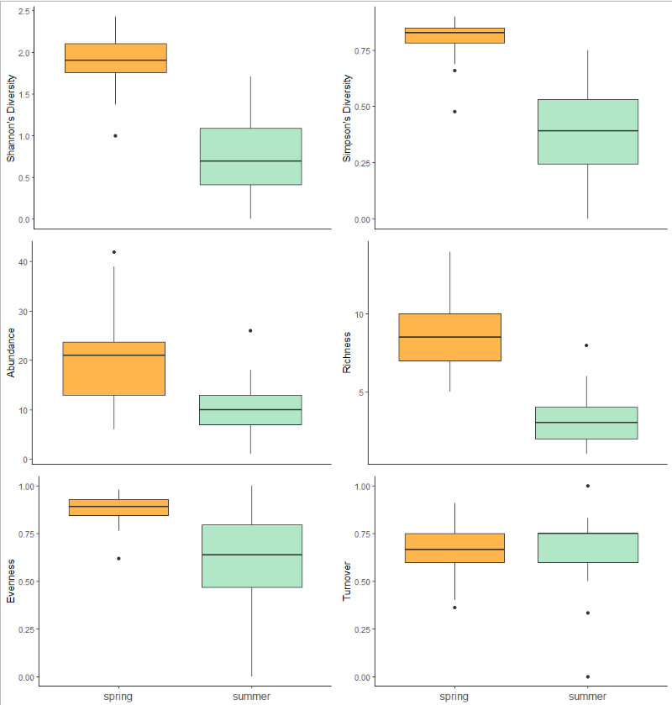

Figure 1: Spring levels of Shannon's Diversity Index, Simpson's Diversity Index, abundance, richness, and evenness. Turnover, however, did not show any difference between the two seasons.

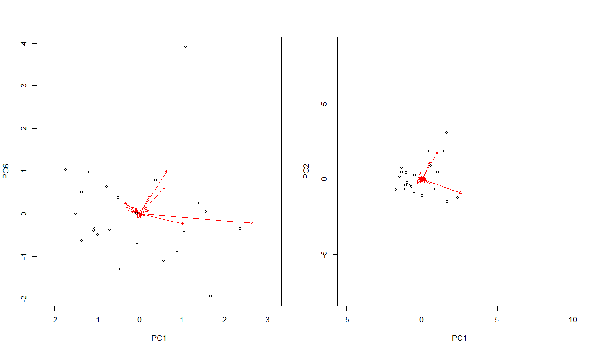

Figure 2: 80% of variance is explained by six principle components in spring, whereas in summer, 80% is explained by only two principle components.

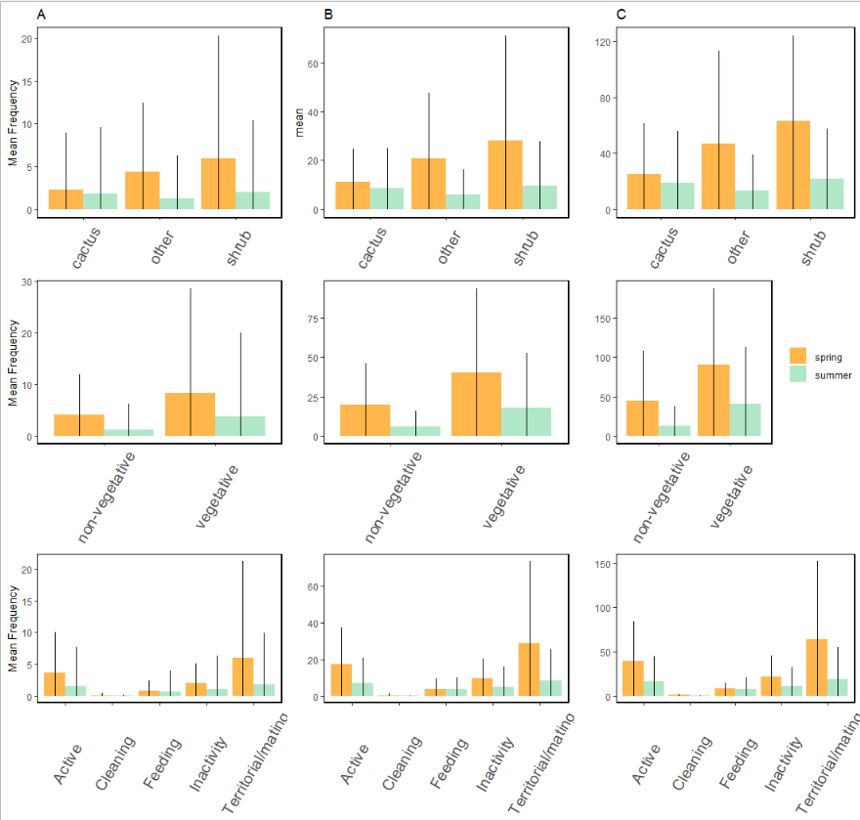

Figure 3: Mesohabitats, regardless of season and number of mesohabitat levels showed no significant differences in bird association. However, analyses on bird behaviors showed territorial/mating behaviors were significantly higher than cleaning behaviors. Between A) species abundance, B) trophic guild abundance, and C) migration class abundance analyses, behavior was consistently the only model that showed significant differences.

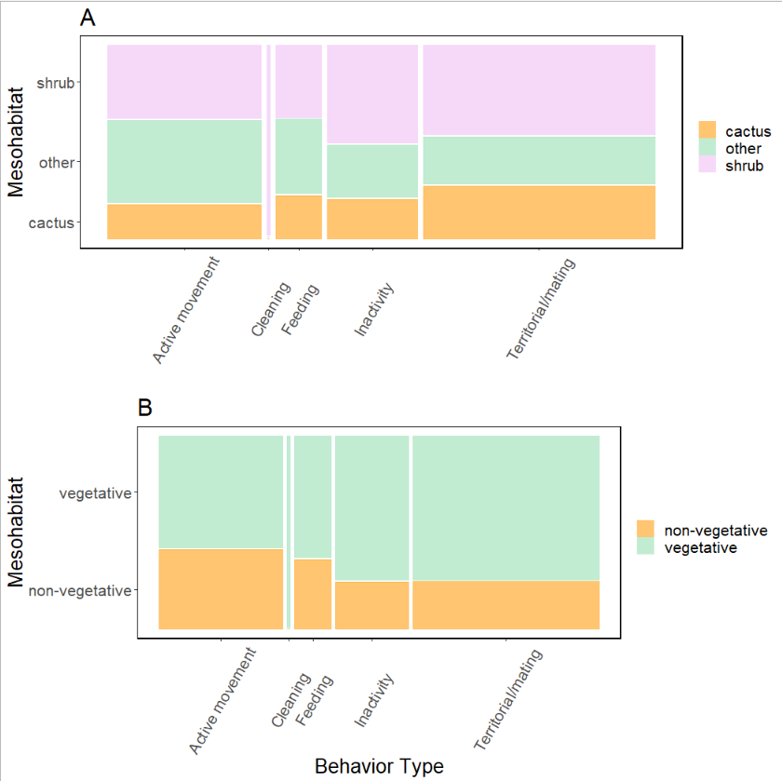

Figure 4: The mesohabitat a bird associated with had significant impact on the behavior that bird was exhibiting. When delineating mesohabitat into A) three levels, we found that mesohabitats that were not shrub or cacti positively influenced active movement but negatively influenced territorial/mating behaviors. This information was recontextualized when mesohabitat was broaden into B) two levels, where we then found vegetative mesohabitats had a negative influence on active movement and a positive influence on territorial/mating behaviors and for non-vegetative mesohabitats, the opposite was true: non-vegetative mesohabitat positively influenced active movement but restricted territorial/mating behaviors.