Scenario Analysis
  - Insights from a EU-RoW SOCIO-ECO-MRIO-SFC Model
Oriol Vallès Codina
2026-03-28
Table of contents

Scenarios
Scenario Registry
shock | domain | sector | transaction | shift | target | primary | secondary | rho
1 | Final Demand | Household | Consumption | Food | beta | 7 | 8 | 0.20
2 | Final Demand | Household | Consumption | Energy | beta | 31 | 32 | 0.20
3 | Final Demand | Household | Consumption | Wood | beta | 11 | 12 | 0.20
4 | Final Demand | Government | Consumption | Plastics | sigma | 17 | 18 | 0.20
5 | Final Demand | Firm | Fixed Investment | Construction | iota | 36 | 37 | 0.05
6 | Final Demand | Firm | Fixed Investment | Metal | iota | 26 | 27 | 0.20
7 | Intermediate Demand | Firm | Production | Wood | a | 11 | 12 | 0.20
8 | Intermediate Demand | Firm | Production | Pulp | a | 13 | 14 | 0.20
9 | Intermediate Demand | Firm | Production | Plastics | a | 17 | 18 | 0.20
10 | Intermediate Demand | Firm | Production | Metal | a | 26 | 27 | 0.20
11 | Intermediate Demand | Firm | Production | Glass | a | 21 | 22 | 0.20
12 | Intermediate Demand | Firm | Production | Cement | a | 24 | 25 | 0.20
13 | Intermediate Demand | Firm | Production | Energy | a | 31 | 32 | 0.20
14 | Intermediate Demand | Firm | Production | Construction | a | 36 | 37 | 0.05

Scenario Comparison

Domestic (EU) Effects
Warning in grid.Call.graphics(C_text, as.graphicsAnnot(x$label), x$x, x$y, :
conversion failure on 'Shock Parameter ρ = 0.2 (0.05 for Construction, Sc5 &
Sc14)' in 'mbcsToSbcs': for ρ (U+03C1)
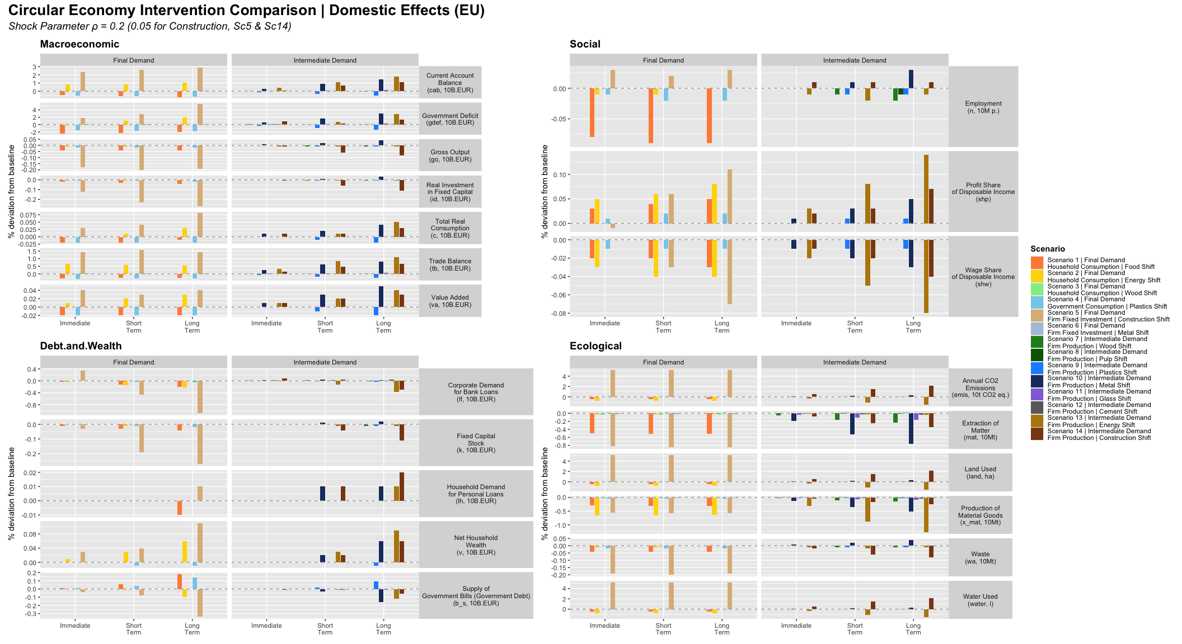
All Scenarios — EU (Domestic) Effects

Cross-Border (RoW) Effects
Warning in grid.Call.graphics(C_text, as.graphicsAnnot(x$label), x$x, x$y, :
conversion failure on 'Shock Parameter ρ = 0.2 (0.05 for Construction, Sc5 &
Sc14)' in 'mbcsToSbcs': for ρ (U+03C1)
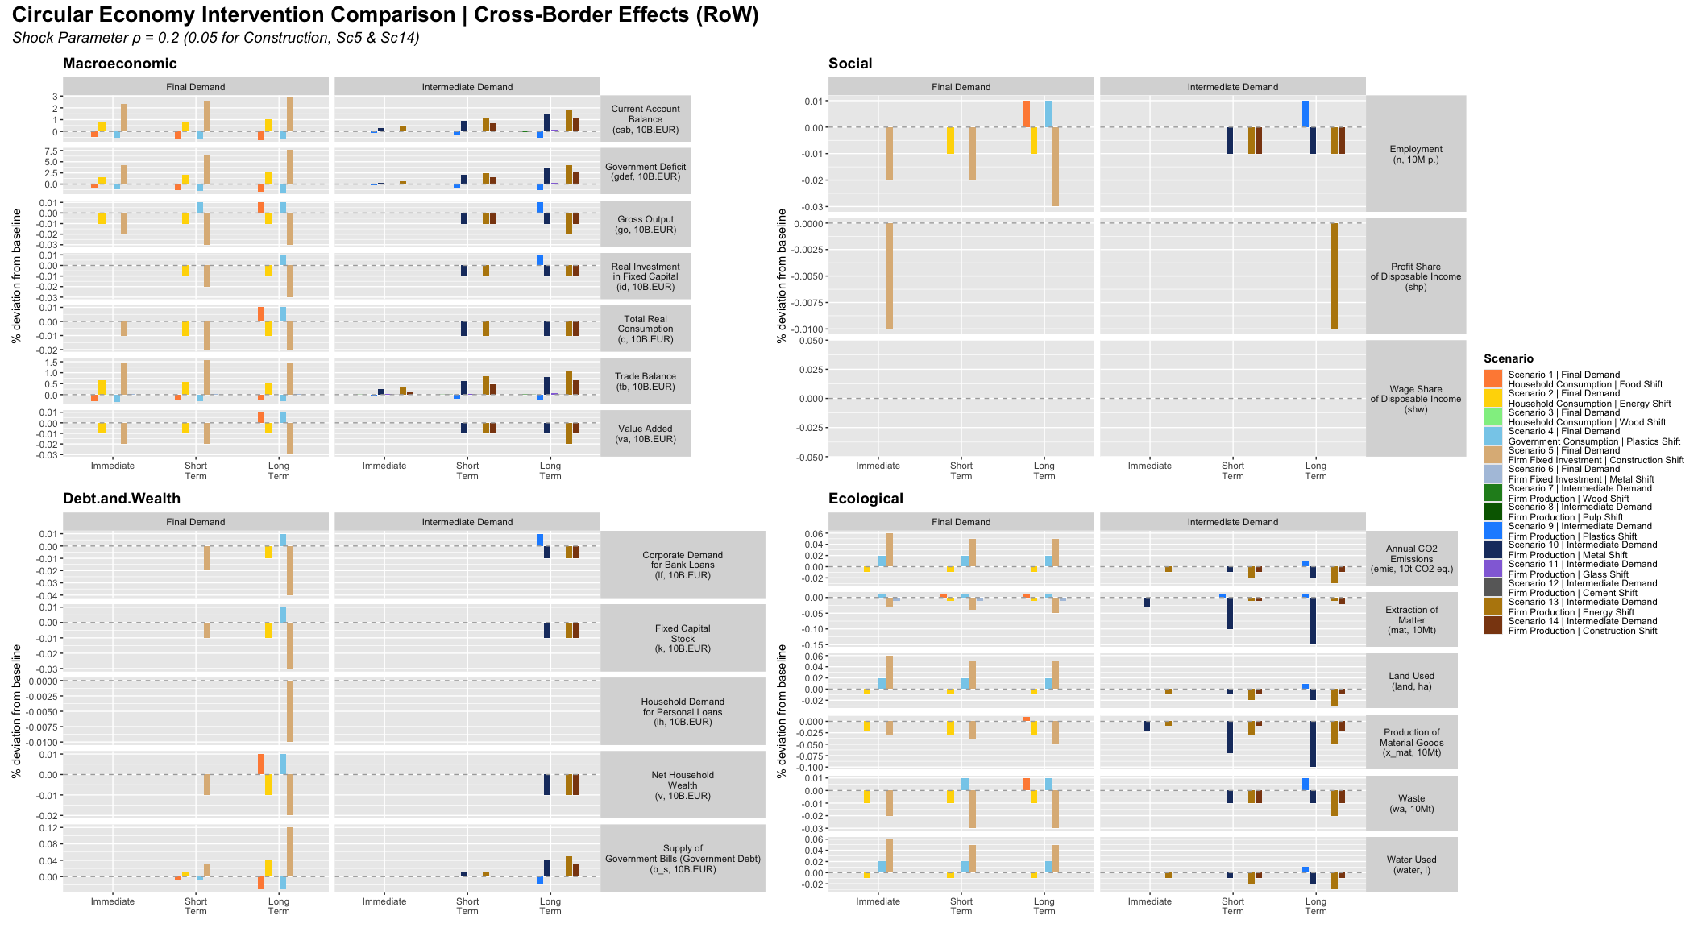
All Scenarios — Cross-Border (RoW) Effects

Circular Economy: Primary vs Secondary Sector Outputs
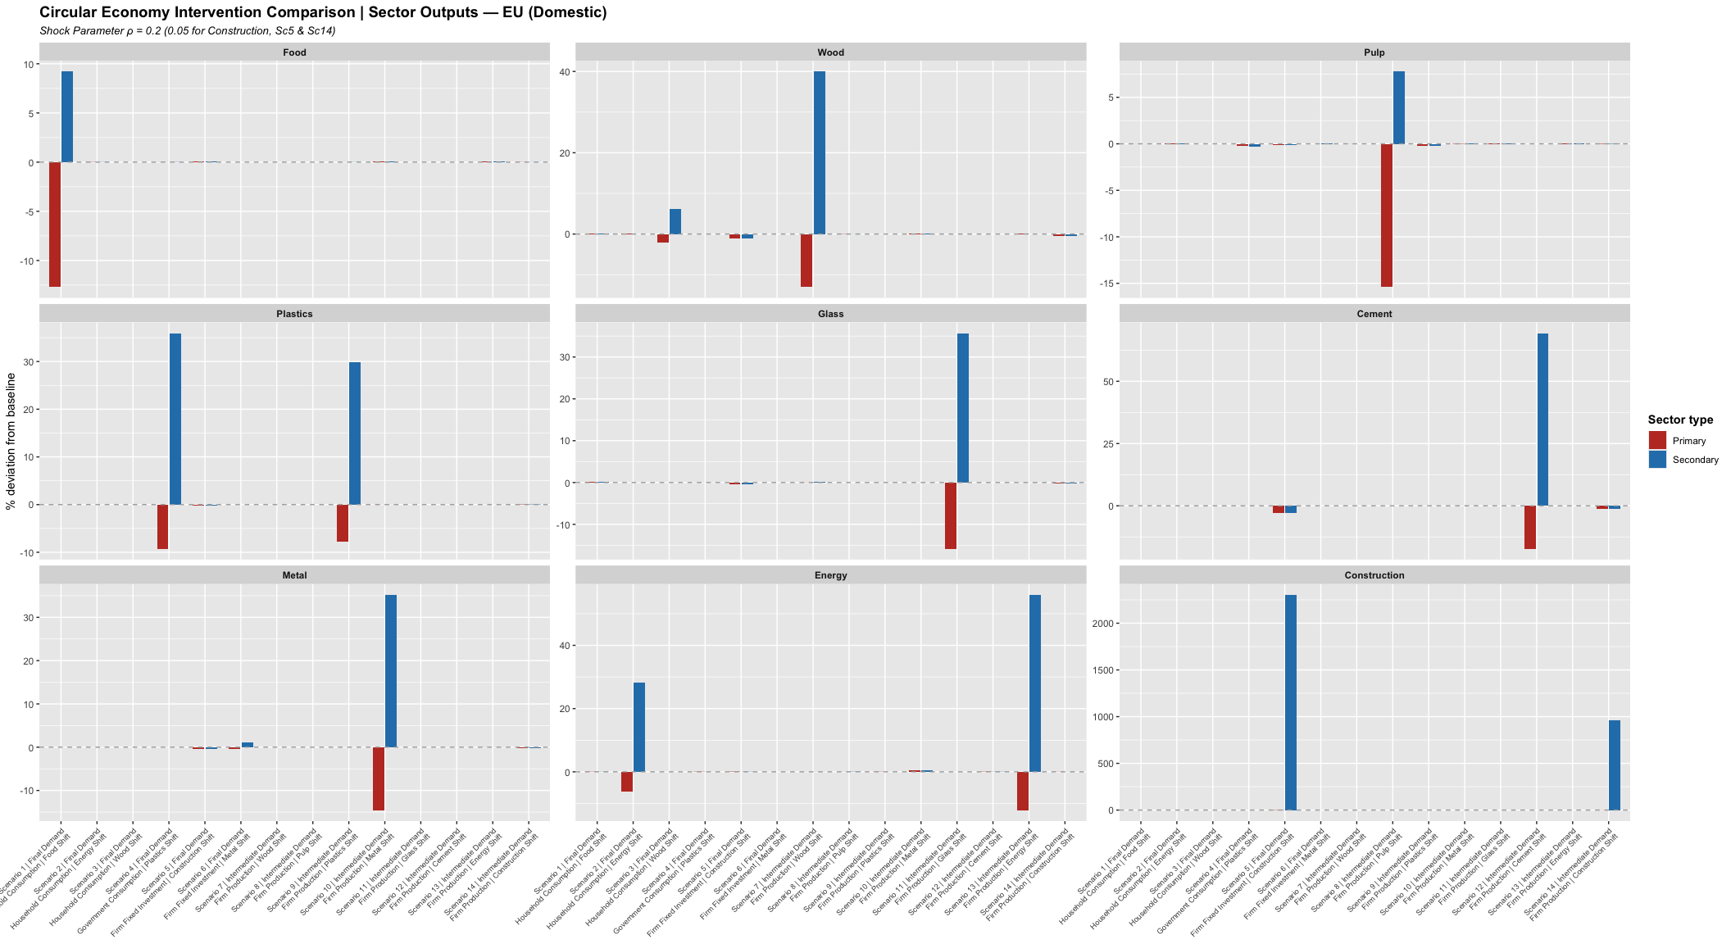
CE Sector Outputs — EU (Domestic): % deviation from baseline at Long Term (t* + 20)
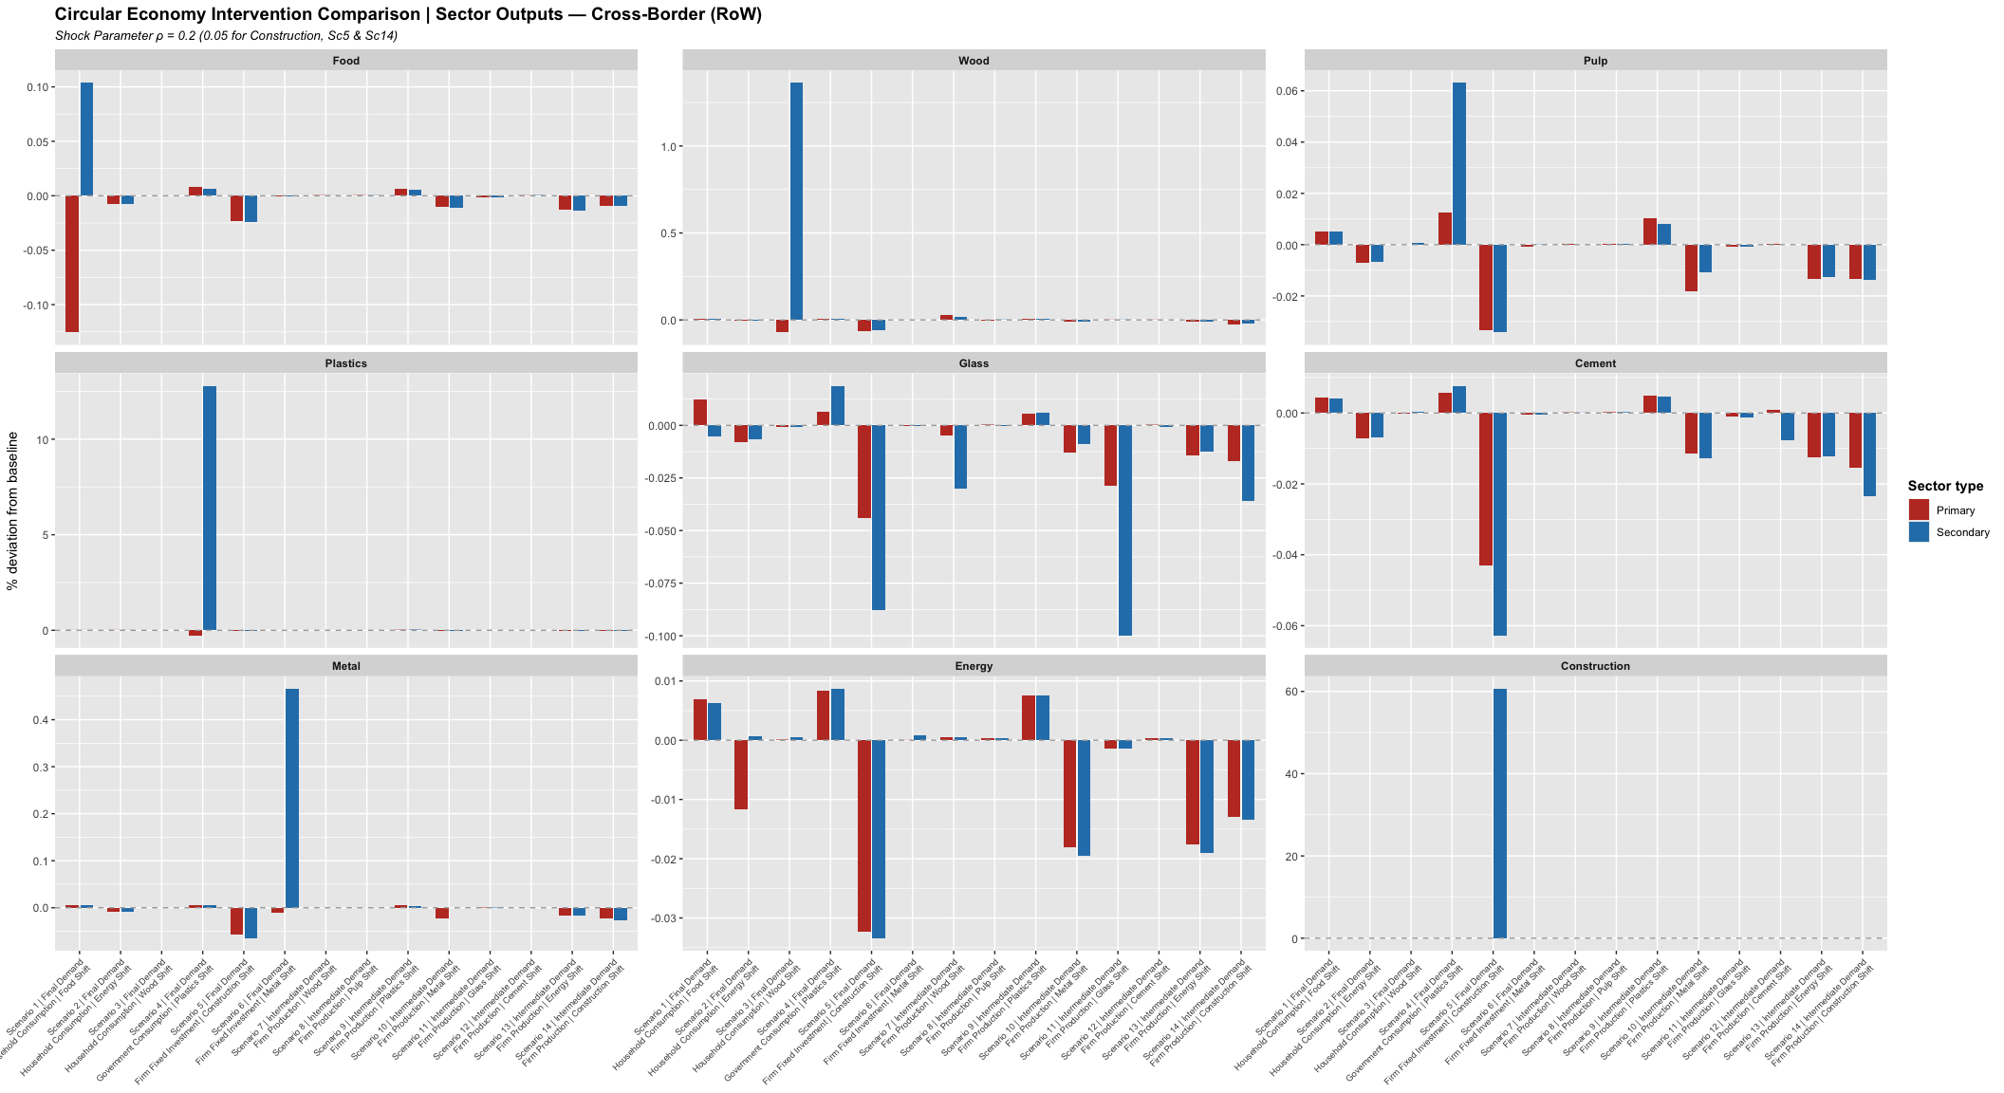
CE Sector Outputs — RoW (Cross-Border): % deviation from baseline at Long Term (t* + 20)

Circular Economy: Sector Outputs — Comparison Style
Warning in grid.Call.graphics(C_text, as.graphicsAnnot(x$label), x$x, x$y, :
conversion failure on 'Shock Parameter ρ = 0.2 (0.05 for Construction, Sc5 &
Sc14)' in 'mbcsToSbcs': for ρ (U+03C1)
Warning in grid.Call.graphics(C_text, as.graphicsAnnot(x$label), x$x, x$y, :
for 'Circular Economy Intervention Comparison | Sector Outputs — EU (Domestic)'
in 'mbcsToSbcs': - substituted for — (U+2014)
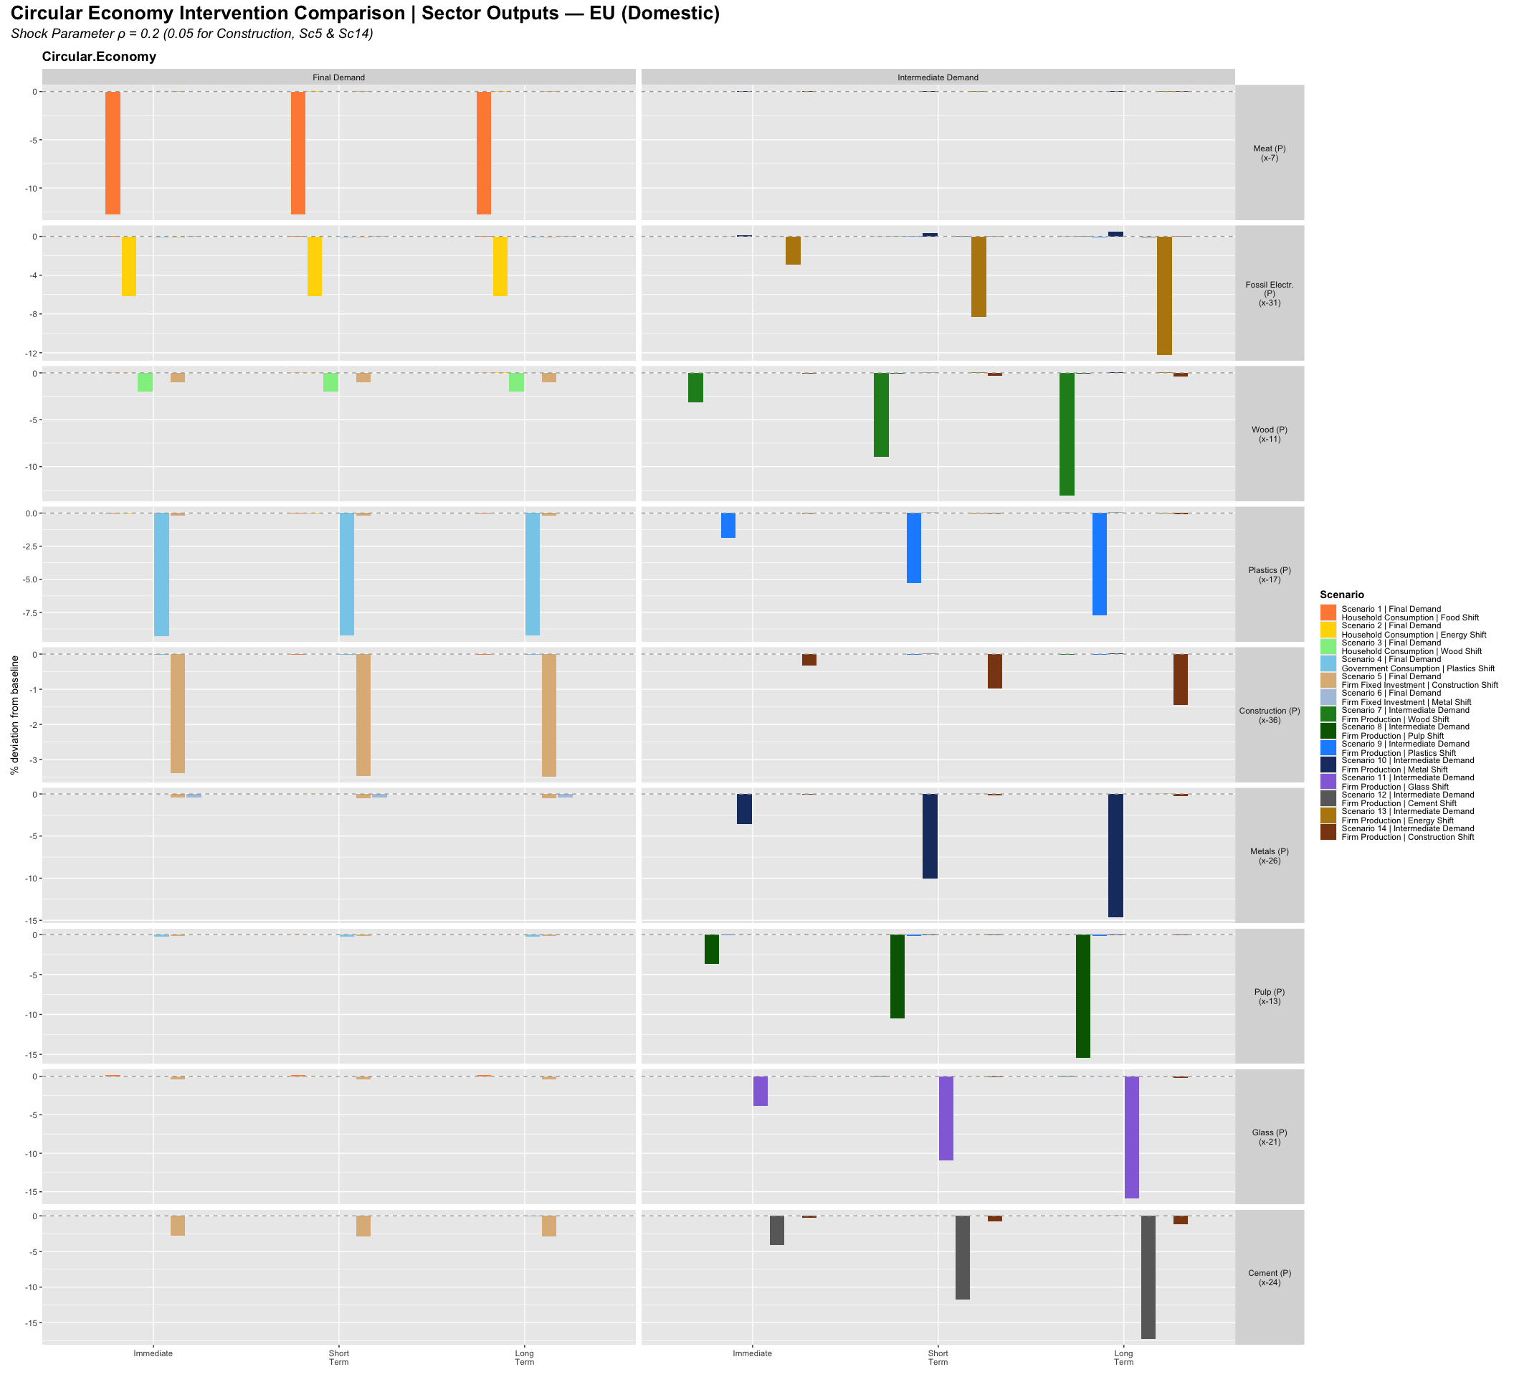
CE Sector Outputs — EU: bar-chart comparison across all scenarios (Immediate / Short / Long Term)
Warning in grid.Call.graphics(C_text, as.graphicsAnnot(x$label), x$x, x$y, :
conversion failure on 'Shock Parameter ρ = 0.2 (0.05 for Construction, Sc5 &
Sc14)' in 'mbcsToSbcs': for ρ (U+03C1)
Warning in grid.Call.graphics(C_text, as.graphicsAnnot(x$label), x$x, x$y, :
for 'Circular Economy Intervention Comparison | Sector Outputs — Cross-Border
(RoW)' in 'mbcsToSbcs': - substituted for — (U+2014)
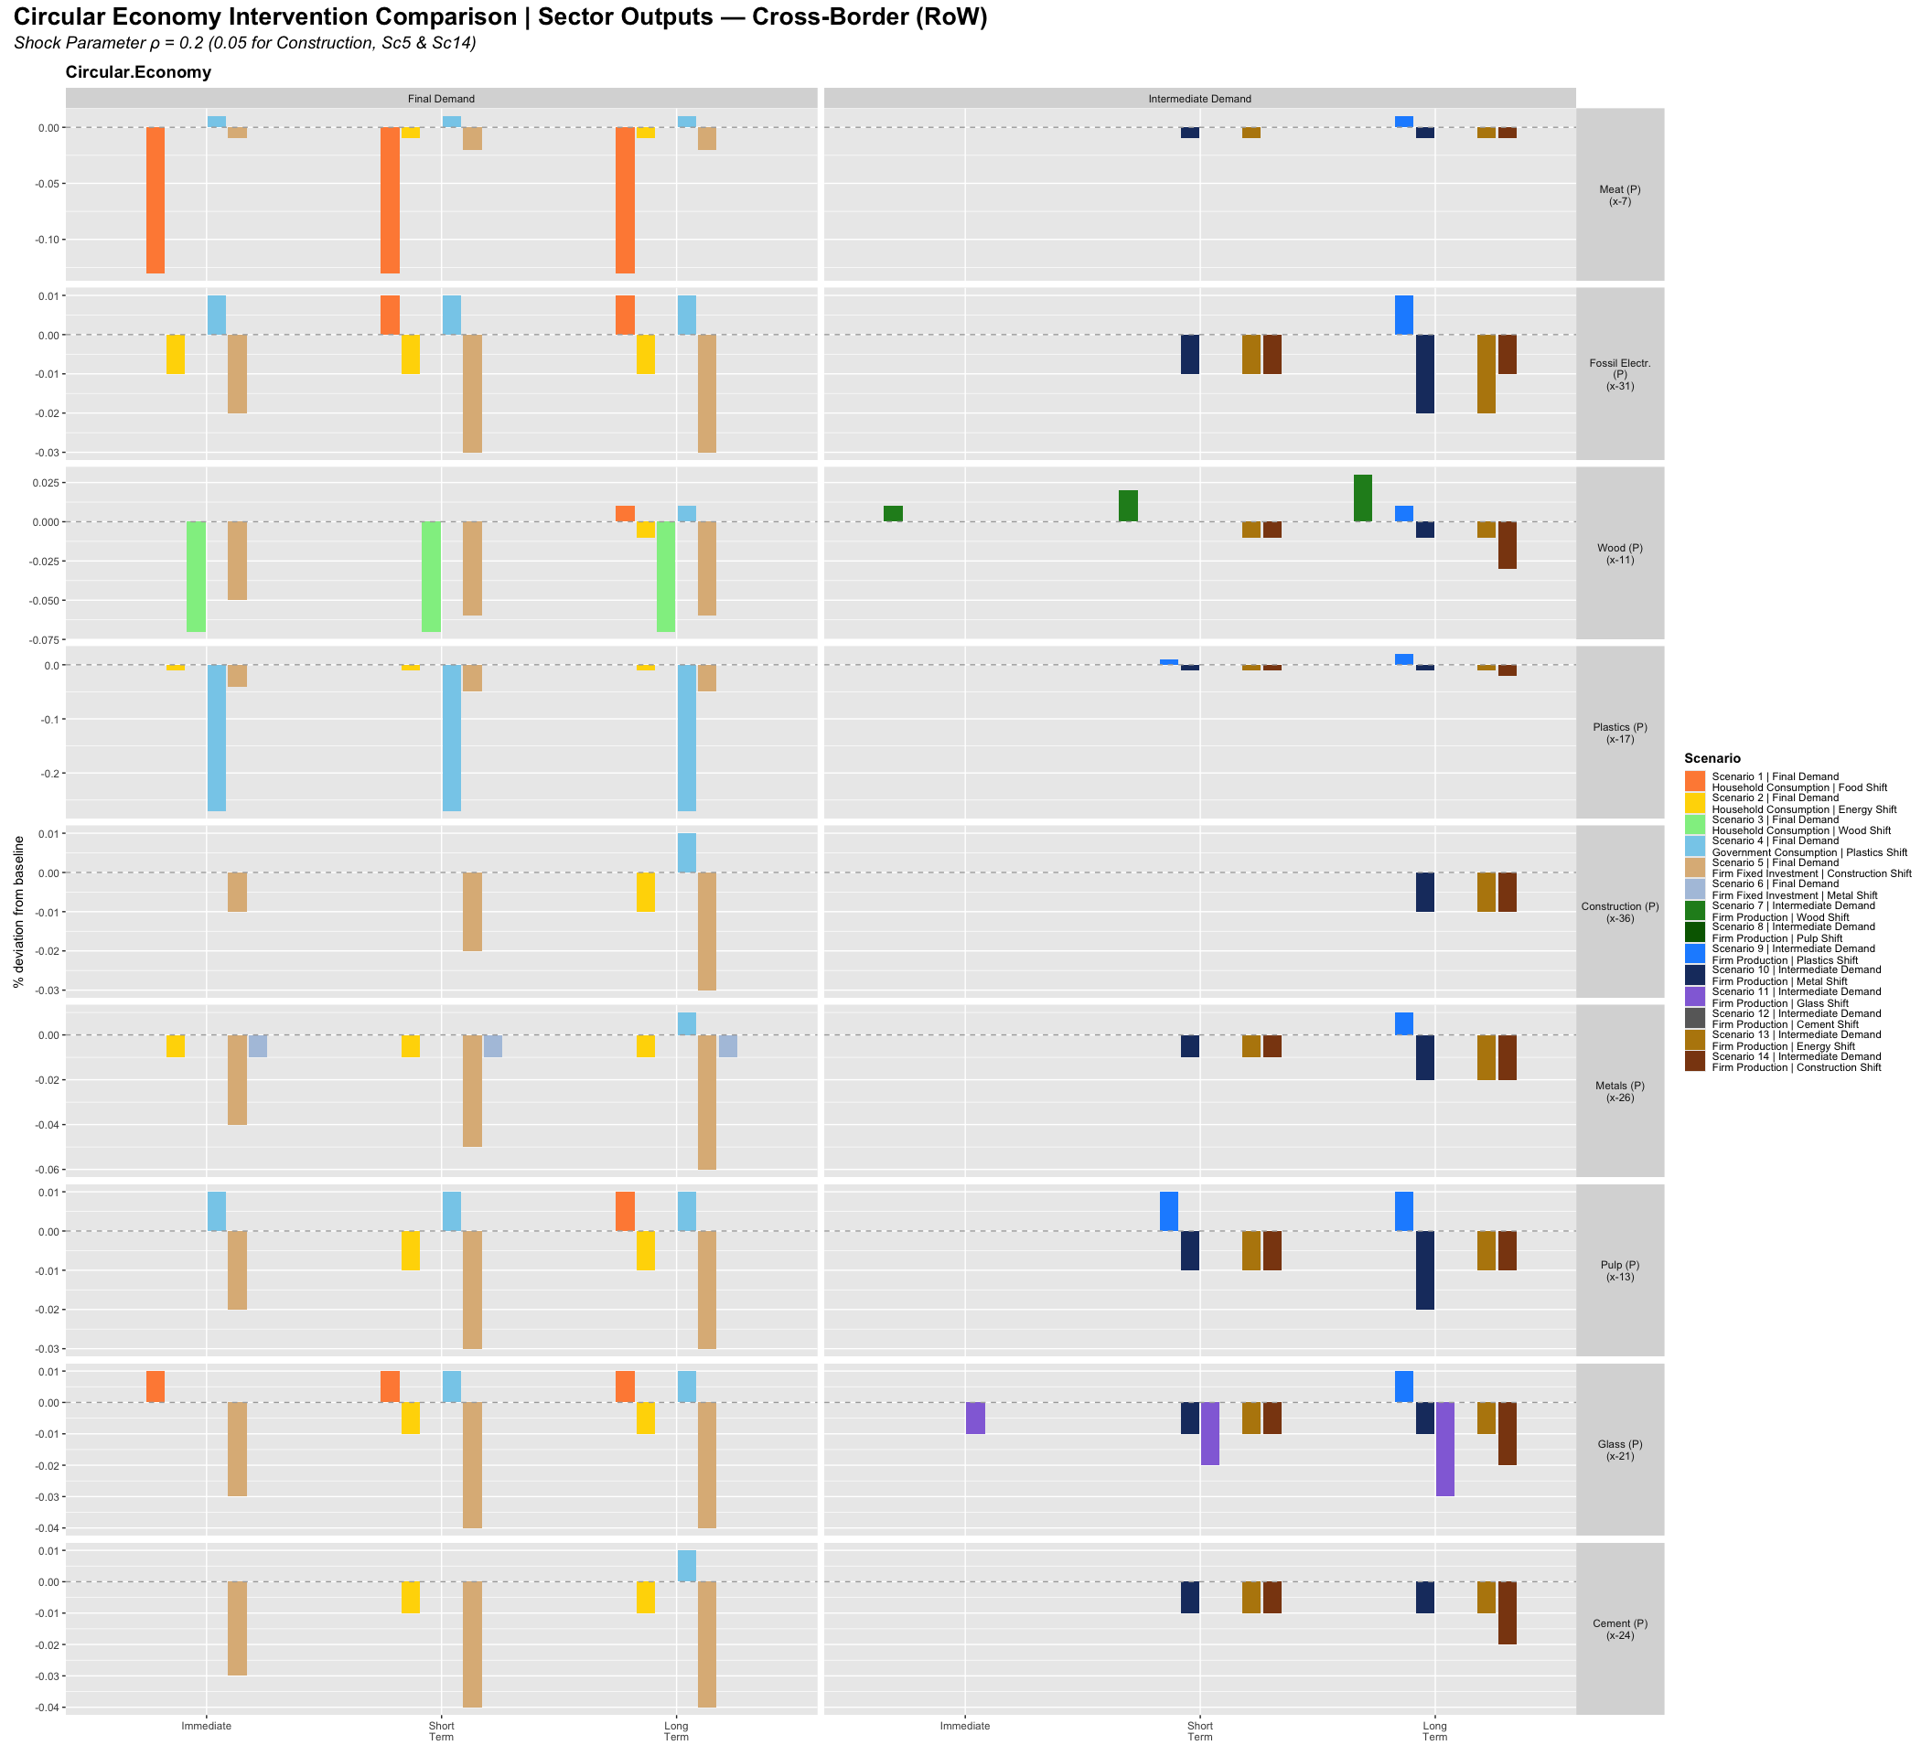
CE Sector Outputs — RoW: bar-chart comparison across all scenarios

Summary of Social, Ecological, and Macroeconomic Implications

The Portfolio Scale Principle
The most robust finding across all 14 scenarios is that the rank ordering of simulation outcomes is predicted by the absolute scale of the targeted demand channel, not by material-specific multiplier variation or sectoral emission intensity alone. The structural factor (l₁₂ − l₁₁) is approximately −1 across all material sectors, meaning the Leontief inverse differences between primary and secondary sectors are broadly comparable. What varies decisively across scenarios is the size of the demand portfolio that the policy instrument engages.
This generates a clear ranking:
- Food (Sc1) produces the largest final-demand effects because household food demand (23.7 billion EUR) is the largest household material channel in the scenario set.
- Household energy (Sc2) produces strong ecological effects disproportionate to its channel size (6.9 billion) because the emission intensity differential (ratio 3.3:1, ε₃₁ = 2,771 vs ε₃₂ = 843) amplifies the scale effect.
- Government plastics (Sc4) has disproportionate leverage among final-demand scenarios because the government procurement channel (11.9 billion) rivals the intermediate channel in absolute scale — unique among all materials.
- Energy production (Sc13) dominates among production scenarios because intermediate energy demand (14.8 billion) combined with the 3.3:1 intensity differential generates the largest product of scale × intensity in the set.
- Metals production (Sc10) produces the largest material savings among production scenarios because intermediate metal demand (20.9 billion) is the largest single intermediate material flow in the scenario set — though the emission rebound reverses the ecological gain on the CO₂ dimension.
The simulation ranking therefore validates the demand channel decomposition as an analytic prior: before running a simulation, the relative magnitude of outcomes can be predicted from the demand channel table with reasonable accuracy.

Two Transition Regimes
The 14 scenarios separate into two regimes distinguished by ecological leverage and macroeconomic direction, though the boundary is less sharp than a single-region analysis would suggest once cross-border transmission is accounted for.
Final-demand reallocation (Scenarios 1–6) is not a low-leverage regime. This characterisation — common in single-region IO analysis — understates the scale of several channels once bilateral MRIO demand flows are included. Scenario 1 (Food, HH) produces the largest employment contraction among all FD scenarios (Z1 n = −0.11% long-run) because household food demand (23.7 billion EUR) is the largest absolute household material channel and activates significant cross-border production. Scenario 2 (Energy, HH) generates ecological gains (emis −0.98%) disproportionate to its channel size because the 3.3:1 intensity differential amplifies scale into emission reduction. Scenario 4 (Gov Plastics) is structurally distinctive: government procurement (48.9% of plastics demand, 11.9 billion) rivals intermediate demand in absolute scale — unique among all materials — making public procurement circularity mandates a genuine first-order CE instrument. Scenario 5 (Construction FD) generates a larger fixed-investment effect than other FD scenarios because construction investment (66.7% of total demand, 88.7 billion) is the dominant material channel; even at ρ=0.05 the shock activates a substantial restructuring of capital formation. Final-demand CE instruments — behaviour change, procurement mandates, product standards — engage channels that are structurally primary for food, construction, and plastics, and cannot be treated as merely symbolic complements to production-side policy.
Intermediate production restructuring (Scenarios 7–13) delivers substantially higher ecological gains at the cost of modest macro-social contractions. Production scenarios consistently produce larger material and emission savings than their FD counterparts for the same material, in proportion to the intermediate channel’s dominance over household or government channels. Employment effects are negative (−0.01% to −0.02% long-run) across the intermediate production scenarios except Scenario 10, and wage shares are marginally compressed in the most intensive scenarios (Sc13). The production restructuring regime confirms the basic IO insight: where intermediate demand dominates sector activation, A-matrix interventions are the primary CE instrument.

The CE Trilemma
The cross-cutting finding is a structural CE trilemma: ecological improvement trades off against macroeconomic stability and distributional equity in the intermediate production scenarios, while final-demand scenarios avoid the trade-off by having minimal ecological effects to begin with.
Three scenarios define the boundaries of this trilemma.
Scenario 4 vs Scenario 9 (Plastics) demonstrates that the trilemma can be partially bypassed through public procurement. For plastics — uniquely among all materials — government consumption (48.9%, 11.9 billion) rivals intermediate demand (44.0%, 10.7 billion) in absolute scale. This means that government procurement circularity mandates (recycled content requirements in public contracts) are a genuine first-order CE instrument for plastics: not a symbolic complement to industrial regulation but a parallel lever of comparable scale. The two scenarios are complementary rather than substitutes; an effective plastics CE policy requires both instruments simultaneously. Neither alone captures a majority of total plastics demand.
Scenario 10 (Metals) is the most analytically anomalous outcome. It is the only production scenario showing expansionary macroeconomic effects (go = +0.04%, n = +0.03% long-run), driven by the lower A-matrix row-sum of secondary metals (0.238) versus primary metals (0.545): substituting secondary for primary frees intermediate resources economy-wide. Simultaneously, emissions increase (+0.34% long-run) — the clearest structural rebound in the set. The rebound mechanism is precisely identified: secondary metal production (EAF scrap-based steel) requires more fossil-fuel electricity upstream than primary production (blast furnace), and the high emission intensity of fossil energy (ε₃₁ = 2771) amplifies this into an emission increase even as material throughput falls. Metals CE satisfies the economic arm of the trilemma while failing the ecological arm, and requires complementary electricity decarbonisation to reverse the rebound.
Scenario 13 (Energy) represents maximum leverage and maximum asymmetry simultaneously. The ecological gains are the largest in the set (emis = −1.95%, rec = −3.87% long-run), driven by the combination of the largest intermediate channel (14.8 billion) and the largest intensity differential (3.3:1). The current account improvement (+2.26%) reflects EU fossil import dependency. But the scenario is distributionally regressive (wage share −0.10%, profit share +0.18%) and produces the largest RoW employment contraction (Z2 n = −0.02%). EU energy CE is the highest-leverage domestic CE intervention while being simultaneously the most asymmetric in its international consequences: reducing EU fossil fuel imports reduces income for RoW energy exporters. The distributional and geopolitical dimensions of this transition cannot be treated as secondary considerations.

Cross-Border Transmission: the MRIO Contribution
A key contribution of the MRIO-SFC framework is that it traces bilateral demand flows between EU (Z1) and RoW (Z2), making the cross-border consequences of CE policy directly visible. Across the 14 scenarios, four distinct cross-border transmission patterns emerge.
Symmetric contraction (most intermediate production scenarios). Scenarios 7–9, 11–12 produce broadly parallel responses in both regions: small negative effects on output and employment in Z1 and Z2, reflecting the global IO linkages through which EU production restructuring reduces demand for RoW intermediate inputs. The symmetry is not exact — EU effects are typically larger in absolute terms because the shock originates in the EU production system — but the sign is the same in both regions. These scenarios are not unilaterally regressive: the ecological gains are shared globally through reduced material throughput, while the macro-social costs are distributed across both regions in proportion to production integration.
Asymmetric sign reversal (Scenario 10, Metals). The most analytically striking cross-border pattern occurs in Scenario 10: EU output and employment expand (Z1 n = +0.03%, go = +0.04%) while RoW contracts (Z2 n = −0.02%). The mechanism is the A-matrix restructuring: secondary metal production has a lower row-sum (0.238 vs 0.545), freeing EU intermediate resources and creating an EU-relative competitive advantage. This is the only scenario in the set where CE transition generates genuinely asymmetric welfare effects — an EU benefit at RoW expense — making it geopolitically sensitive despite its apparent domestic appeal.
Fiscal dividend in energy scenarios (Sc2, Sc13). Both household energy (Sc2) and intermediate energy (Sc13) generate an improvement in EU government fiscal position (gdef improves, Z1 b_s falls), alongside a deterioration in RoW fiscal space (Z2 b_s rises). The mechanism is the import substitution channel: EU households and firms reducing fossil energy purchases shift spending toward domestically-produced renewables, increasing the EU tax base and reducing EU government borrowing. RoW energy-exporting governments lose export revenues, reducing their fiscal capacity. This fiscal asymmetry is particularly relevant given the composition of RoW energy exporters: economies highly dependent on hydrocarbon revenues face a structural fiscal shock from EU energy CE, independent of any direct sanctions or trade policy.
Current account and trade balance dynamics. Current account improvements (CAB) in EU energy scenarios (+2.26% in Sc13 long-run) reflect the bilateral trade flow directly: EU fossil imports from RoW fall, improving the EU trade balance at the direct cost of RoW export revenues. For the trade balance (tb), the effect is amplified in production scenarios relative to FD scenarios because intermediate energy inputs are embedded throughout the EU production system — reducing their import intensity has economy-wide CAB implications, not just the direct bilateral energy trade effect. This makes Sc13 (energy production) the scenario with the largest CAB gain and simultaneously the strongest negative external consequence for fossil-fuel-exporting economies in the RoW aggregate.
These cross-border transmission patterns establish that CE policy analysis cannot be conducted in a closed-economy framework without systematically mischaracterising the distributional consequences. The MRIO structure reveals that ecologically beneficial EU transitions impose real costs on specific categories of RoW economies — primarily energy exporters and metals processors — whose interests are typically absent from EU CE policy design. This asymmetry is the model’s primary empirical contribution relative to single-region IO approaches.

Policy Implications
Four policy implications follow directly from the simulation evidence.
First, production restructuring requires macroeconomic stabilisation. Production scenarios consistently contract aggregate demand modestly. In an economy operating below capacity, these effects may be self-correcting; at full employment, they imply a need for compensating public expenditure or investment. CE transitions in the production regime cannot be treated as costless structural adjustments — they require active macroeconomic management.
Second, final-demand reallocation alone is insufficient for the production regime, but is primary for specific channels. For most material sectors where intermediate demand dominates (metals, wood, glass, cement), FD instruments engage structurally secondary channels and cannot substitute for A-matrix restructuring. However, for construction (investment-dominated), food (household-dominated), and plastics (government-procurement-dominated), FD instruments engage the primary demand channel directly and are first-order CE instruments in their own right. Policy design must be channel-specific rather than applying a blanket production-vs-demand hierarchy.
Third, energy is the highest-leverage CE instrument in the current scenario set. Scenario 13 dominates all other production scenarios in ecological gains by a substantial margin, driven by the combination of the dominant intermediate channel and the 3.3:1 intensity differential. A 25% shift in intermediate energy inputs from fossil to renewable generates more aggregate emission reduction than all other material CE scenarios combined. Energy system transformation is therefore not merely a decarbonisation priority in its own right — it is the foundation on which other CE transitions (particularly metals, which requires decarbonised electricity to avoid the emission rebound) depend.
Fourth, metals CE requires electricity decarbonisation as a complement. Without a simultaneous shift to low-emission electricity, substituting secondary metal production for primary amplifies upstream emissions through the fossil energy link, producing a structural rebound that offsets material savings with emission increases. The policy interdependence between CE in metals and decarbonisation in electricity is not a contingent feature of the current energy mix but a structural feature of the Leontief IO system as calibrated on EU data.

Validation of the Descriptive Analytics
The simulation ranking matches the demand channel ranking predicted by the portfolio decomposition. Among final-demand scenarios, the ordering Food (mat −0.63%) > Energy (emis −0.98%) > Plastics (mat +0.02%, emis −0.06%) > Wood (effects near-zero) is consistent with the household and government channel scales (Food HH = 23.7b, Energy HH = 6.9b, Plastics Gov = 11.9b, Wood HH = 1.1b) weighted by intensity differentials. Among production scenarios, Energy > Metals (material) > Wood > Glass > Cement > Pulp is consistent with the intermediate channel scales (Energy = 14.8b, Metals = 20.9b, Wood = 7.4b, Glass = 1.9b, Cement = 8.9b) and the intensity differentials. The descriptive analytics’ prediction that portfolio scale — not material-specific multiplier variation — determines the simulation ordering is confirmed across all 14 scenarios.
done

