HS Code–EXIOBASE Concordance and Clean-Technology Use Shares
Oriol Vallès Codina — Net Zero Industrial Policy Lab (NZIPL), Johns Hopkins SAIS

HS Code–EXIOBASE Concordance and Clean-Technology Use Shares
Methodology, Coverage, and Results — v2 (revised May 2026)
Author
Oriol Vallès Codina — Net Zero Industrial Policy Lab (NZIPL), Johns Hopkins SAIS
Published
May 15, 2026
Show code
library(dplyr); library(readr); library(arrow); library(ggplot2)
library(knitr); library(kableExtra); library(tidyr); library(stringr); library(scales)
ROOT <- here::here()
gd <- read_csv(file.path(ROOT,"data","green_dict","green_dictionary.csv"),
show_col_types=FALSE) |>
mutate(code = formatC(as.integer(code), width=6, flag="0"))
shares <- read_parquet(file.path(ROOT,"data","exiobase","io_use_shares.parquet"))
concord <- read_csv(file.path(ROOT,"data","exiobase","hs_exiobase_concordance.csv"),
show_col_types=FALSE)
# Consistent universe for all results: raw/processed materials with EXIOBASE mapping
RAW_PROC <- c("Raw Material","Processed Material")
gd_rp <- gd |>
filter(role %in% RAW_PROC, !is.na(exiobase_product))
TECH_COLORS <- c(Solar="#eab308", Nuclear="#0ea5e9", Batteries="#f59e0b",
Transmission="#06b6d4", Wind="#3b82f6", Biofuel="#84cc16",
Electrolyzers="#a855f7", Geothermal="#ef4444",
`Heat Pumps`="#f97316", Magnets="#ec4899")

Note
Version 2 — May 2026. This version corrects two methodological issues identified in peer review (see §4), adds a second share metric (direct_use_share), and applies a consistent filter across all results tables and plots.

1 Background: The Multi-Use Problem
The NZIPL Clean Value Chain Explorer (CVCE) maps global trade in clean technology inputs using BACI bilateral trade data harmonised against a curated Green Dictionary of 605 HS-6 product codes across 10 technologies. Many of these products — copper ore, alumina, rare-earth oxides, silicon metal — are multi-use commodities: they flow into clean technology manufacturing but also into construction, electronics, automotive, and general industry.
Without correction, treating 100% of bilateral copper ore trade as “clean tech” inflates the apparent size of the clean industrial base. The IO use-share pipeline addresses this by asking:
What fraction of sector \(j\)’s actual output is induced by clean technology production?
We answer this with two complementary metrics derived from EXIOBASE, detailed below.

2 Data Sources

2.1 EXIOBASE 3.9.6 pxp (2019)
EXIOBASE 3 [@stadler2018] is a multi-regional supply-and-use table produced by the EXIOBASE consortium. We use the product-by-product (pxp) symmetric input-output table for the year 2019:
Attribute | Value
Countries | 44 + 5 rest-of-world regions (49 total)
Products | 200 industry/product categories
Matrix dimensions | 9,800 × 9,800 (49 × 200)
Unit | Millions of euros (basic prices, 2019)
Files used | A.txt (technical coefficients, 545 MB), x.txt (gross output, 1 MB)
The A matrix and gross output vector are extracted from the EXIOBASE zip archive using pymrio (scripts/build_data/10a_parse_exiobase.py).

2.2 NZIPL Green Dictionary
The Green Dictionary contains 605 HS-6 product codes curated by the NZIPL team, organised by technology, value-chain stage, and product role:
Show code
gd |>
count(tech, stage, role) |>
pivot_wider(names_from=stage, values_from=n, values_fill=0) |>
arrange(tech) |>
kbl(caption="Green Dictionary: codes by technology, stage, and role") |>
kable_styling(bootstrap_options=c("striped","condensed"), font_size=12)
Green Dictionary: codes by technology, stage, and role
tech | role | Downstream | Final Product | Midstream | Upstream
Batteries | Process Equipment | 32 | 0 | 6 | 0
Batteries | Product Component | 1 | 0 | 7 | 0
Batteries | Final Product | 0 | 3 | 0 | 0
Batteries | Processed Material | 0 | 0 | 27 | 0
Batteries | Raw Material | 0 | 0 | 0 | 13
Biofuel | Process Equipment | 10 | 0 | 5 | 0
Biofuel | Final Product | 0 | 4 | 0 | 0
Biofuel | Processed Material | 0 | 0 | 27 | 0
Biofuel | Raw Material | 0 | 0 | 0 | 23
Electrolyzers | Process Equipment | 16 | 0 | 1 | 0
Electrolyzers | Product Component | 10 | 0 | 2 | 0
Electrolyzers | Final Product | 0 | 1 | 0 | 0
Electrolyzers | Processed Material | 0 | 0 | 18 | 0
Electrolyzers | Raw Material | 0 | 0 | 0 | 6
Geothermal | Process Equipment | 18 | 0 | 9 | 0
Geothermal | Product Component | 10 | 0 | 12 | 0
Geothermal | Final Product | 0 | 9 | 0 | 0
Geothermal | Processed Material | 0 | 0 | 14 | 0
Geothermal | Raw Material | 0 | 0 | 0 | 14
Heat Pumps | Process Equipment | 5 | 0 | 3 | 0
Heat Pumps | Product Component | 7 | 0 | 5 | 0
Heat Pumps | Final Product | 0 | 4 | 0 | 0
Heat Pumps | Processed Material | 0 | 0 | 4 | 0
Heat Pumps | Raw Material | 0 | 0 | 0 | 5
Magnets | Process Equipment | 9 | 0 | 0 | 0
Magnets | Product Component | 1 | 0 | 0 | 0
Magnets | Final Product | 0 | 2 | 0 | 0
Magnets | Processed Material | 0 | 0 | 5 | 0
Magnets | Raw Material | 0 | 0 | 0 | 5
Nuclear | Process Equipment | 2 | 0 | 3 | 0
Nuclear | Product Component | 11 | 0 | 0 | 0
Nuclear | Final Product | 0 | 2 | 0 | 0
Nuclear | Processed Material | 0 | 0 | 11 | 1
Nuclear | Raw Material | 0 | 0 | 0 | 13
Solar | Process Equipment | 24 | 0 | 11 | 0
Solar | Product Component | 11 | 0 | 2 | 0
Solar | Final Product | 0 | 3 | 0 | 0
Solar | Processed Material | 0 | 0 | 18 | 0
Solar | Raw Material | 0 | 0 | 0 | 11
Transmission | Process Equipment | 9 | 0 | 6 | 0
Transmission | Product Component | 2 | 0 | 0 | 0
Transmission | Final Product | 0 | 8 | 0 | 0
Transmission | Processed Material | 0 | 0 | 6 | 0
Transmission | Raw Material | 0 | 0 | 0 | 5
Wind | Process Equipment | 8 | 0 | 7 | 0
Wind | Product Component | 13 | 0 | 32 | 0
Wind | Final Product | 0 | 1 | 0 | 0
Wind | Processed Material | 0 | 0 | 23 | 0
Wind | Raw Material | 0 | 0 | 0 | 9

3 Step 1: HS Code → EXIOBASE Product Concordance
BACI uses HS-6 product codes; EXIOBASE uses named product categories (e.g. “Copper ores and concentrates”, “Electrical machinery and apparatus n.e.c. (31)”). Bridging these requires a two-step concordance. Note that EXIOBASE categories are products (200 product-by-product flows), not ISIC/NACE sectors.

3.1 Priority 1: Direct HS6 Prefix Mapping
For ores and key processed materials — products with a clear, unique EXIOBASE counterpart — we constructed a direct lookup table of 40 HS6-prefix → EXIOBASE-product mappings covering:
- Chapter 26 metal ores (iron, copper, nickel, aluminium/bauxite, cobalt, REE, uranium, precious metals)
- Chapter 28 inorganic chemicals (alumina/Al₂O₃, lithium compounds, cobalt oxides, REE chlorides)
- Processed metals (copper wire/products, aluminium products, indium, bismuth, cadmium)
- Specialty materials (biofuel feedstocks, wood biomass, nuclear-specific compounds)
Show code
tibble::tribble(
~HS6, ~Name, ~EXIOBASE_product,
"260111/260112", "Iron ore", "Iron ores",
"260300", "Copper ore", "Copper ores and concentrates",
"260400", "Nickel ore", "Nickel ores and concentrates",
"260600", "Bauxite (aluminium ore)", "Aluminium ores and concentrates",
"260500/261000/261300", "Cobalt, chromium, molybdenum ores", "Other non-ferrous metal ores",
"261610/261690", "Precious metal ores (Ag, Au, Pt)", "Precious metal ores and concentrates",
"261210/261220", "Uranium ore", "Uranium and thorium ores (12)",
"262000", "Rare earth ores", "Other non-ferrous metal ores",
"280530", "REE metals (Sc, Y, La, Ce, Nd...)", "Precious metals",
"281820", "Alumina (Al₂O₃)", "Aluminium and aluminium products",
"283691", "Lithium carbonate/compounds", "Other non-ferrous metal products",
"740811/740819", "Copper wire", "Copper products",
"760120", "Unwrought aluminium", "Aluminium and aluminium products",
"811292", "Indium (solar thin-film)", "Other non-ferrous metal products",
"284610/284690", "REE chlorides", "Precious metals",
"440110/440130", "Wood pellets/chips (biofuel)", "Wood products",
"282611", "Lithium fluoride (nuclear moderator)", "Nuclear fuel"
) |>
kbl(caption="Selected direct HS6 → EXIOBASE product mappings (illustrative subset)",
col.names=c("HS6 Code(s)","Product Name","EXIOBASE Product")) |>
kable_styling(bootstrap_options=c("striped","condensed"), font_size=12)
Selected direct HS6 → EXIOBASE product mappings (illustrative subset)
HS6 Code(s) | Product Name | EXIOBASE Product
260111/260112 | Iron ore | Iron ores
260300 | Copper ore | Copper ores and concentrates
260400 | Nickel ore | Nickel ores and concentrates
260600 | Bauxite (aluminium ore) | Aluminium ores and concentrates
260500/261000/261300 | Cobalt, chromium, molybdenum ores | Other non-ferrous metal ores
261610/261690 | Precious metal ores (Ag, Au, Pt) | Precious metal ores and concentrates
261210/261220 | Uranium ore | Uranium and thorium ores (12)
262000 | Rare earth ores | Other non-ferrous metal ores
280530 | REE metals (Sc, Y, La, Ce, Nd...) | Precious metals
281820 | Alumina (Al₂O₃) | Aluminium and aluminium products
283691 | Lithium carbonate/compounds | Other non-ferrous metal products
740811/740819 | Copper wire | Copper products
760120 | Unwrought aluminium | Aluminium and aluminium products
811292 | Indium (solar thin-film) | Other non-ferrous metal products
284610/284690 | REE chlorides | Precious metals
440110/440130 | Wood pellets/chips (biofuel) | Wood products
282611 | Lithium fluoride (nuclear moderator) | Nuclear fuel

3.2 Priority 2: NACE4 Fallback
For HS codes not in the direct table, we fall back to the NACE Rev. 2 4-digit code assigned in the Green Dictionary (from the NAICS crosswalk pipeline). A lookup table maps 33 NACE4 codes to EXIOBASE product categories.
Show code
tibble::tribble(
~NACE4, ~Description, ~EXIOBASE_product,
"0710", "Iron ore mining", "Iron ores",
"2442", "Aluminium production", "Aluminium and aluminium products",
"2444", "Copper production", "Copper products",
"2445", "Other non-ferrous metals", "Other non-ferrous metal products",
"2011", "Basic chemicals", "Chemicals nec",
"2311/2312", "Flat/hollow glass", "Glass and glass products",
"2410", "Basic iron & steel", "Basic iron and steel",
"2446", "Nuclear fuel processing", "Nuclear fuel",
"2732", "Wiring/electrical apparatus", "Electrical machinery (31)"
) |>
kbl(caption="Selected NACE4 → EXIOBASE product fallback mappings",
col.names=c("NACE4","Description","EXIOBASE Product")) |>
kable_styling(bootstrap_options=c("striped","condensed"), font_size=12)
Selected NACE4 → EXIOBASE product fallback mappings
NACE4 | Description | EXIOBASE Product
0710 | Iron ore mining | Iron ores
2442 | Aluminium production | Aluminium and aluminium products
2444 | Copper production | Copper products
2445 | Other non-ferrous metals | Other non-ferrous metal products
2011 | Basic chemicals | Chemicals nec
2311/2312 | Flat/hollow glass | Glass and glass products
2410 | Basic iron & steel | Basic iron and steel
2446 | Nuclear fuel processing | Nuclear fuel
2732 | Wiring/electrical apparatus | Electrical machinery (31)

3.3 Coverage
Show code
cov_tbl <- gd |>
group_by(tech) |>
summarise(
total = n(),
raw_proc = sum(role %in% RAW_PROC),
mapped = sum(!is.na(exiobase_product) & role %in% RAW_PROC),
pct = round(mapped / pmax(raw_proc,1) * 100),
.groups = "drop"
)
cov_tbl |>
kbl(caption="EXIOBASE concordance coverage by technology (raw/processed materials only)",
col.names=c("Technology","Total HS6","Raw/Processed","Mapped","Coverage %")) |>
kable_styling(bootstrap_options=c("striped","condensed")) |>
column_spec(5, bold=TRUE)
EXIOBASE concordance coverage by technology (raw/processed materials only)
Technology | Total HS6 | Raw/Processed | Mapped | Coverage %
Batteries | 89 | 40 | 40 | 100
Biofuel | 69 | 50 | 50 | 100
Electrolyzers | 54 | 24 | 24 | 100
Geothermal | 86 | 28 | 28 | 100
Heat Pumps | 33 | 9 | 9 | 100
Magnets | 22 | 10 | 10 | 100
Nuclear | 43 | 25 | 25 | 100
Solar | 80 | 29 | 29 | 100
Transmission | 36 | 11 | 11 | 100
Wind | 93 | 32 | 32 | 100
100% of raw and processed material codes are mapped to an EXIOBASE product. Components, process equipment, and final products are not mapped — they receive leontief_use_share = direct_use_share = 1.0 by assumption (§4.4).

4 Step 2: Clean-Technology Product Definitions
For each of the 10 technologies, we define a set of EXIOBASE product categories representing its final-stage manufacturing output. These identify which columns of the Leontief inverse (or transaction matrix) correspond to clean-tech demand.
Show code
tech_sectors <- list(
Solar = c("Electricity by solar photovoltaic", "Electricity by solar thermal",
"Glass and glass products", "Electrical machinery (31)"),
Wind = c("Electricity by wind", "Machinery and equipment (29)",
"Basic iron and steel", "Fabricated metal products (28)"),
Batteries = c("Electrical machinery (31)", "Other non-ferrous metal products",
"Copper products", "Aluminium products", "Chemicals nec"),
Electrolyzers= c("Machinery (29)", "Electrical machinery (31)", "Fabricated metals (28)"),
Transmission = c("Transmission services of electricity", "Electrical machinery (31)",
"Copper products", "Aluminium products"),
Nuclear = c("Nuclear fuel", "Electricity by nuclear", "Machinery (29)"),
`Heat Pumps` = c("Machinery (29)", "Electrical machinery (31)", "Rubber and plastics"),
Geothermal = c("Electricity by Geothermal", "Machinery (29)"),
Magnets = c("Precious metals", "Precious metal ores", "Other non-ferrous metals",
"Electrical machinery (31)"),
Biofuel = c("Biogasoline", "Biodiesels", "Other Liquid Biofuels",
"Oil seeds", "Sugar cane, sugar beet")
)
do.call(rbind, lapply(names(tech_sectors), function(t)
data.frame(Technology=t,
`EXIOBASE clean-tech products`=paste(tech_sectors[[t]], collapse=" · "),
check.names=FALSE))) |>
kbl(caption="Clean-technology EXIOBASE product definitions") |>
kable_styling(bootstrap_options=c("striped","condensed"), font_size=11) |>
column_spec(2, width="60%")
Clean-technology EXIOBASE product definitions
Technology | EXIOBASE clean-tech products
Solar | Electricity by solar photovoltaic · Electricity by solar thermal · Glass and glass products · Electrical machinery (31)
Wind | Electricity by wind · Machinery and equipment (29) · Basic iron and steel · Fabricated metal products (28)
Batteries | Electrical machinery (31) · Other non-ferrous metal products · Copper products · Aluminium products · Chemicals nec
Electrolyzers | Machinery (29) · Electrical machinery (31) · Fabricated metals (28)
Transmission | Transmission services of electricity · Electrical machinery (31) · Copper products · Aluminium products
Nuclear | Nuclear fuel · Electricity by nuclear · Machinery (29)
Heat Pumps | Machinery (29) · Electrical machinery (31) · Rubber and plastics
Geothermal | Electricity by Geothermal · Machinery (29)
Magnets | Precious metals · Precious metal ores · Other non-ferrous metals · Electrical machinery (31)
Biofuel | Biogasoline · Biodiesels · Other Liquid Biofuels · Oil seeds · Sugar cane, sugar beet

Warning
Sector granularity limitation. EXIOBASE aggregates all machinery manufacturing into one category (“Machinery and equipment n.e.c. (29)”). Heat-pump or wind-turbine manufacturing is a small slice of global machinery output. Using this broad sector as a clean-tech proxy therefore understates the true share — the denominator (total machinery output) is large relative to the clean-tech-specific portion. This is a known limitation of 200-product IO tables and affects all technologies relying on machinery categories.

5 Step 3: Correct IO Aggregation
Before computing use shares, the 9,800-sector A matrix must be aggregated to 200 product categories. A previous version of this pipeline summed A coefficients directly, which is mathematically incorrect: since \(A_{ij} = Z_{ij}/x_j\) (transactions divided by output), adding coefficients from sectors of different sizes conflates the denominators.
Correct approach (v2):
\[ Z^{\text{prod}}_{ij} = \sum_{c}\sum_{c'} Z_{(c,i)(c',j)}, \quad x^{\text{prod}}_{j} = \sum_{c} x_{(c,j)}, \quad A^{\text{prod}}_{ij} = \frac{Z^{\text{prod}}_{ij}}{x^{\text{prod}}_{j}} \]
Since \(Z = A \cdot \text{diag}(\mathbf{x})\), we reconstruct transactions from A.txt and x.txt without needing to read Z.txt (682 MB) separately:
Z_raw <- sweep(A_raw, 2, x_raw, `*`) # Z[i,j] = A[i,j] * x[j]
Z_prod <- t(rowsum(t(rowsum(Z_raw, prod_names)), # sum over countries
prod_names))
x_prod <- rowsum(matrix(x_raw, ncol=1), prod_names) # sum output
A_prod <- sweep(Z_prod, 2, pmax(x_prod, 1e-12), `/`)# recompute A

6 Step 4: Use Share Computation
We compute two complementary metrics for each HS-6 raw/processed material code.

6.1 Metric 1: Leontief Upstream Use Share
The Leontief inverse \(\mathbf{L} = (\mathbf{I} - \mathbf{A})^{-1}\) captures total (direct + indirect) upstream requirements. Element \(L_{jk}\) is the total output of sector \(j\) required per unit of final demand for sector \(k\).
Corrected formula (v2): For raw material sector \(j\) and clean-tech column set \(\mathcal{C}_t\):
\[\text{leontief\_use\_share}_{j,t} = \frac{\displaystyle\sum_{k \in \mathcal{C}_t} L_{jk}}{x_j}\]
The denominator is sector \(j\)’s actual gross output \(x_j\) (millions EUR, from x.txt). A previous version divided by \(\sum_k L_{jk}\) (the total Leontief row sum), which is a per-unit-demand concept rather than an output-weighted share — this has been corrected.
compute_sector_shares <- function(clean_sector_codes) {
clean_cols <- which(grepl(clean_sector_codes, colnames(A_raw), fixed=TRUE))
row_to_clean <- rowSums(L[, clean_cols, drop=FALSE])
# Denominator: actual gross output x_j (not Leontief row sum)
ifelse(x_raw > 0, row_to_clean / x_raw, 0)
}
Interpretation: Total upstream Leontief requirements from sector \(j\) directed to clean tech, expressed as a fraction of \(j\)’s actual output. Values are small for bulk commodities (iron ore: ~0.004%) because their global output is vast relative to clean-tech demand; larger for specialised intermediates (REE compounds: ~0.5–2%).

6.2 Metric 2: Direct Use Share
The direct use share measures only first-order supply chain links — no indirect chains:
\[\text{direct\_use\_share}_{j,t} = \frac{\displaystyle\sum_{k \in \mathcal{C}_t} Z^{\text{prod}}_{jk}}{x^{\text{prod}}_j}\]
computed at the aggregated 200-product level. This is more intuitive as a direct fraction of output but understates total clean-tech dependence for materials deep in the supply chain.
compute_direct_shares <- function(clean_sector_codes) {
clean_cols <- which(grepl(clean_sector_codes, colnames(Z_prod), fixed=TRUE))
dir_use <- rowSums(Z_prod[, clean_cols, drop=FALSE])
ifelse(x_prod_vec > 0, dir_use / x_prod_vec, 0)
}

6.3 Mapping to HS6 Codes
Each HS6 code is matched to its EXIOBASE product (§3). Both share metrics are averaged over all 49 country-instances of that product:
\[\hat{s}_{\text{HS6}} = \frac{1}{|\{c\}|}\sum_{c:\,\text{product}(c) = \text{EXIO(HS6)}} s_{c,t}\]

6.4 Assignment Rules
Condition | leontief_use_share | direct_use_share
Raw/Processed Material, EXIOBASE mapped | \(\hat{s}^L_{j,t}\) (Leontief) | \(\hat{s}^D_{j,t}\) (direct)
Raw/Processed Material, unmapped | tech-mean fallback \(\bar{s}^L_t\) | tech-mean fallback \(\bar{s}^D_t\)
Product Component / Process Equipment / Final Product | \(1.0\) | \(1.0\)
The 1.0 assumption for downstream products: battery separators, solar module frames, wind turbine blades, and electrolyzer stacks are clean-technology-specific by curation. The 1.0 is an upper bound; in practice some process equipment HS codes may be multi-use.

7 Results
All plots and tables below use the same consistent universe: raw and processed materials with an EXIOBASE product mapping (role %in% c("Raw Material","Processed Material") & !is.na(exiobase_product)). The 1.0-assigned downstream products are excluded from distribution analysis.

7.1 Leontief Use Share Distribution
Show code
gd_rp |>
filter(leontief_use_share < 1) |>
mutate(tech = factor(tech, levels=names(TECH_COLORS))) |>
ggplot(aes(x=leontief_use_share, fill=tech)) +
geom_histogram(bins=30, colour="white", linewidth=0.2, alpha=0.9) +
scale_fill_manual(values=TECH_COLORS) +
scale_x_continuous(labels=percent_format(accuracy=0.01)) +
facet_wrap(~tech, ncol=5, scales="free_y") +
labs(title="Leontief upstream use share — raw/processed materials",
subtitle="Σ L[j, k∈C] / x_j · mapped codes only · excludes 1.0 downstream assignments",
x="Leontief use share", y="HS-6 codes") +
theme_dark() +
theme(legend.position="none", strip.text=element_text(size=8),
plot.background=element_rect(fill="#1a2030"),
panel.background=element_rect(fill="#0d1520"),
text=element_text(colour="#e2e8f0"),
axis.text=element_text(colour="#94a3b8"),
strip.background=element_rect(fill="#0f2518"))
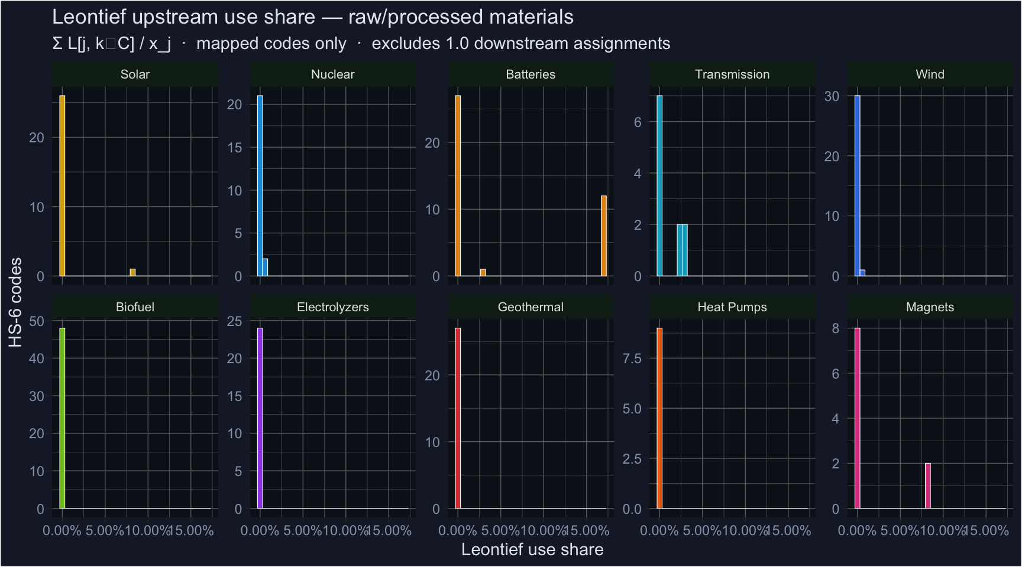

7.2 Direct Use Share Distribution
Show code
gd_rp |>
filter(direct_use_share < 1) |>
mutate(tech = factor(tech, levels=names(TECH_COLORS))) |>
ggplot(aes(x=direct_use_share, fill=tech)) +
geom_histogram(bins=30, colour="white", linewidth=0.2, alpha=0.9) +
scale_fill_manual(values=TECH_COLORS) +
scale_x_continuous(labels=percent_format(accuracy=1)) +
facet_wrap(~tech, ncol=5, scales="free_y") +
labs(title="Direct use share — raw/processed materials",
subtitle="Σ Z_prod[j, k∈C] / x_prod[j] · first-order transactions only · mapped codes only",
x="Direct use share", y="HS-6 codes") +
theme_dark() +
theme(legend.position="none", strip.text=element_text(size=8),
plot.background=element_rect(fill="#1a2030"),
panel.background=element_rect(fill="#0d1520"),
text=element_text(colour="#e2e8f0"),
axis.text=element_text(colour="#94a3b8"),
strip.background=element_rect(fill="#0f2518"))
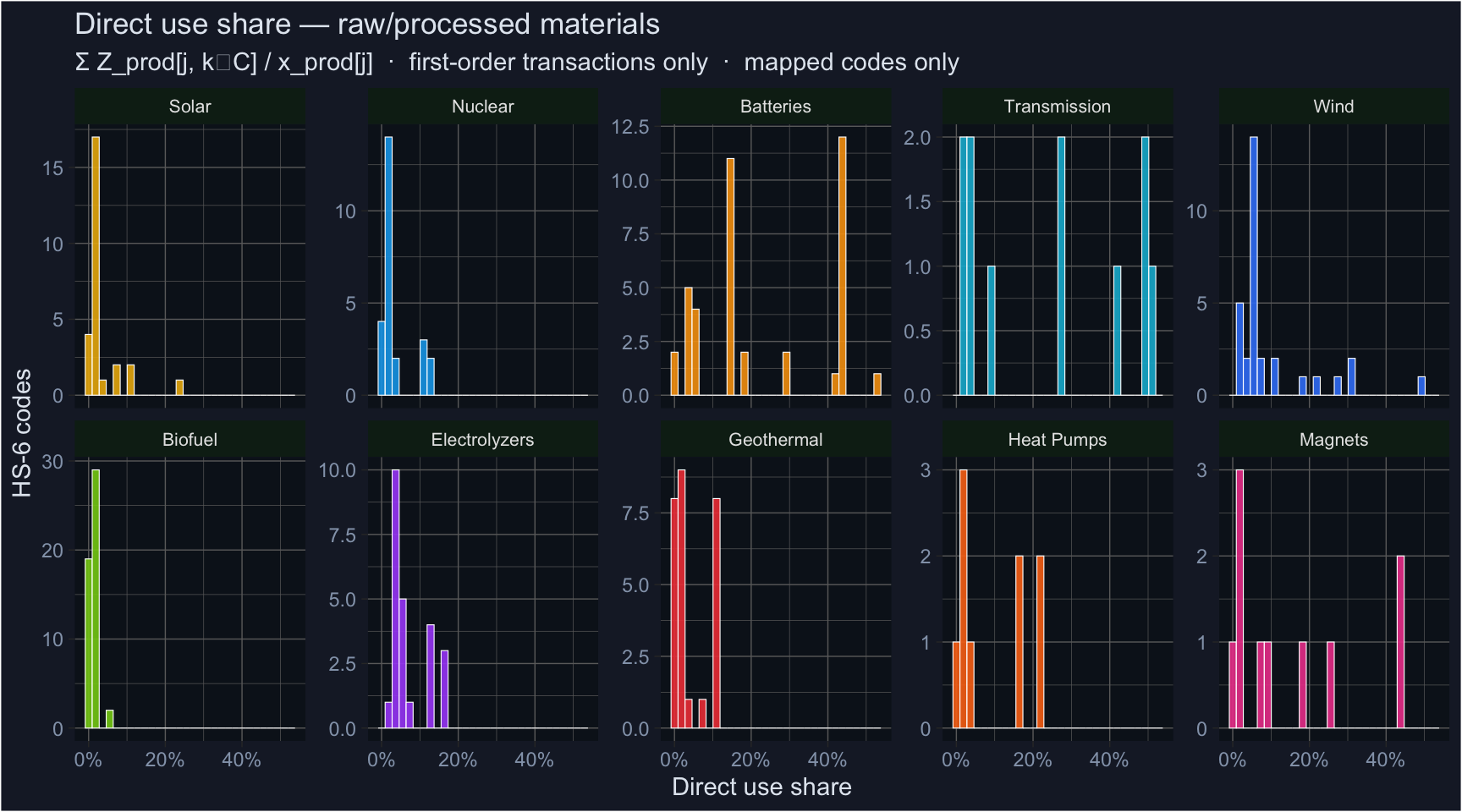

7.3 Top and Bottom Examples by Technology
Show code
base <- gd_rp |> filter(leontief_use_share < 1)
examples <- bind_rows(
base |> group_by(tech) |> slice_max(leontief_use_share, n=3, with_ties=FALSE),
base |> group_by(tech) |> slice_min(leontief_use_share, n=2, with_ties=FALSE)
) |>
ungroup() |>
distinct(tech, code, .keep_all=TRUE) |>
arrange(tech, desc(leontief_use_share)) |>
select(tech, code, name, exiobase_product, leontief_use_share, direct_use_share) |>
mutate(leontief_use_share = percent(leontief_use_share, accuracy=0.001),
direct_use_share = percent(direct_use_share, accuracy=0.1))
examples |>
kbl(caption="Top-3 and bottom-2 Leontief use shares by technology (raw/processed, mapped only)",
col.names=c("Tech","HS6","Product","EXIOBASE Product","Leontief share","Direct share")) |>
kable_styling(bootstrap_options=c("striped","condensed"), font_size=11) |>
column_spec(5:6, bold=TRUE)
Top-3 and bottom-2 Leontief use shares by technology (raw/processed, mapped only)
Tech | HS6 | Product | EXIOBASE Product | Leontief share | Direct share
Batteries | 282010 | CAM; Manganese Dioxide | Other non-ferrous metal products | 17.014% | 43.7%
Batteries | 282090 | CAM; Manganese Oxides | Other non-ferrous metal products | 17.014% | 43.7%
Batteries | 282200 | CAM; Electrolytic Cobalt, LCO (Lithium Cobalt Oxide) | Other non-ferrous metal products | 17.014% | 43.7%
Batteries | 392010 | Separator; Polymers of Ethylene, Non-Cellular | Rubber and plastic products (25) | 0.002% | 4.7%
Batteries | 392020 | Separator; Polymers of Propylene, Non-Cellular | Rubber and plastic products (25) | 0.002% | 4.7%
Biofuel | 260500 | Cobalt Ore | Other non-ferrous metal ores and concentrates | 0.007% | 1.2%
Biofuel | 261100 | Tungsten Ore | Other non-ferrous metal ores and concentrates | 0.007% | 1.2%
Biofuel | 261310 | Molybdenum Ore | Other non-ferrous metal ores and concentrates | 0.007% | 1.2%
Biofuel | 121292 | Feedstock Input; Sugar Cane | Crops nec | 0.001% | 0.1%
Biofuel | 121300 | Feedstock Input; Ag-Waste | Crops nec | 0.001% | 0.1%
Electrolyzers | 711011 | Catalyst; Platinum | Precious metals | 0.004% | 17.3%
Electrolyzers | 711021 | Catalyst; Palladium | Precious metals | 0.004% | 17.3%
Electrolyzers | 711041 | Catalyst; Iridium | Precious metals | 0.004% | 17.3%
Electrolyzers | 283324 | Catalyst; Nickel Sulfate | Chemicals nec | 0.001% | 4.1%
Electrolyzers | 283329 | Cobalt Sulfate | Chemicals nec | 0.001% | 4.1%
Geothermal | 710229 | Industrial Diamonds | Precious metals | 0.002% | 2.7%
Geothermal | 710510 | Diamond Powder | Precious metals | 0.002% | 2.7%
Geothermal | 720230 | Casing; Ferro-manganese | Basic iron and steel and of ferro-alloys and first products thereof | 0.002% | 10.7%
Geothermal | 252330 | Geothermal Wells; Cement | Cement, lime and plaster | 0.000% | 0.2%
Geothermal | 252100 | Limestone | Stone | 0.000% | 0.3%
Heat Pumps | 260600 | Bauxite Ore | Aluminium ores and concentrates | 0.003% | 2.9%
Heat Pumps | 281820 | Alumina | Aluminium and aluminium products | 0.003% | 21.6%
Heat Pumps | 740110 | Copper Mattes | Copper products | 0.003% | 17.0%
Heat Pumps | 261390 | Molybdenum Ore | Other non-ferrous metal ores and concentrates | 0.001% | 2.5%
Heat Pumps | 251910 | Magnesium Ore | Chemical and fertilizer minerals, salt and other mining and quarrying products n.e.c. | 0.001% | 1.4%
Magnets | 280530 | Rare-earth Metals, Scandium and Yttrium | Precious metals | 8.033% | 44.4%
Magnets | 284690 | Compounds, Mixes of Rare-earths, Yttrium, Scandium | Precious metals | 8.033% | 44.4%
Magnets | 261590 | Niobium, Tantalum and Vanadium Ores and Concentrates | Other non-ferrous metal ores and concentrates | 0.028% | 17.4%
Magnets | 260120 | Roasted Iron Pyrite | Chemicals nec | 0.001% | 1.0%
Magnets | 283324 | Nickel Sulfates | Chemicals nec | 0.001% | 1.0%
Nuclear | 260111 | Iron Ore (Non- Agglomerated) | Iron ores | 0.836% | 0.8%
Nuclear | 260112 | Iron Ore (Agglomerated) | Iron ores | 0.836% | 0.8%
Nuclear | 260300 | Copper Ore | Copper ores and concentrates | 0.067% | 0.7%
Nuclear | 380110 | Neutron Moderator; Artificial Graphite | Other non-metallic mineral products | 0.001% | 1.3%
Nuclear | 681099 | Hafnium; Control Rods | Other non-metallic mineral products | 0.001% | 1.3%
Solar | 700529 | Solar Glass; Glass Sheet Casing (Float) | Glass and glass products | 8.385% | 24.6%
Solar | 260600 | Solar Miscellaneous; Materials for Aluminum Coating | Aluminium ores and concentrates | 0.013% | 2.6%
Solar | 392010 | Solar Glass; Polymers of Ethylene for EVA Sheets | Rubber and plastic products (25) | 0.001% | 2.7%
Solar | 392030 | Solar Glass; Polymers of Styrene for EVA Sheets | Rubber and plastic products (25) | 0.001% | 2.7%
Transmission | 281820 | Alumina | Aluminium and aluminium products | 2.727% | 28.3%
Transmission | 760521 | Aluminum wire | Aluminium and aluminium products | 2.727% | 28.3%
Transmission | 740110 | Copper Mattes | Copper products | 2.606% | 49.5%
Transmission | 260120 | Iron (Roasted Iron Pyrites) | Chemicals nec | 0.001% | 4.0%
Transmission | 281290 | Sulfur Hexafluoride | Chemicals nec | 0.001% | 4.0%
Wind | 730110 | Tower; Sheets Iron & Steel | Basic iron and steel and of ferro-alloys and first products thereof | 0.661% | 49.8%
Wind | 820900 | Rotor; Materials for Use in Rotor (Sintered Metal) | Fabricated metal products, except machinery and equipment (28) | 0.035% | 21.9%
Wind | 281820 | Alumina | Aluminium and aluminium products | 0.007% | 31.7%
Wind | 290949 | Tower; Industrial Alcohols for Use in Tower | Chemicals nec | 0.001% | 4.4%
Wind | 350691 | Rotor; Adhesive for Use in Rotor | Chemicals nec | 0.001% | 4.4%

7.4 Summary Statistics
Show code
gd_rp |>
filter(leontief_use_share < 1) |>
group_by(tech) |>
summarise(
n_mapped = n(),
mean_leontief = percent(mean(leontief_use_share, na.rm=TRUE), accuracy=0.001),
max_leontief = percent(max(leontief_use_share, na.rm=TRUE), accuracy=0.001),
mean_direct = percent(mean(direct_use_share, na.rm=TRUE), accuracy=0.1),
max_direct = percent(max(direct_use_share, na.rm=TRUE), accuracy=0.1),
.groups="drop"
) |>
kbl(caption="Use-share summary by technology (raw/processed materials, mapped, excludes 1.0)",
col.names=c("Technology","N mapped","Mean Leontief","Max Leontief",
"Mean Direct","Max Direct")) |>
kable_styling(bootstrap_options=c("striped","condensed")) |>
column_spec(3:4, color="#60a5fa") |>
column_spec(5:6, color="#fb923c")
Use-share summary by technology (raw/processed materials, mapped, excludes 1.0)
Technology | N mapped | Mean Leontief | Max Leontief | Mean Direct | Max Direct
Batteries | 40 | 5.255% | 17.014% | 23.2% | 52.9%
Biofuel | 48 | 0.003% | 0.007% | 0.7% | 1.8%
Electrolyzers | 24 | 0.002% | 0.004% | 7.4% | 17.3%
Geothermal | 27 | 0.001% | 0.002% | 4.3% | 10.7%
Heat Pumps | 9 | 0.002% | 0.003% | 9.6% | 21.6%
Magnets | 10 | 1.615% | 8.033% | 15.4% | 44.4%
Nuclear | 23 | 0.084% | 0.836% | 2.8% | 10.7%
Solar | 27 | 0.315% | 8.385% | 3.7% | 24.6%
Transmission | 11 | 0.973% | 2.727% | 24.5% | 50.9%
Wind | 31 | 0.025% | 0.661% | 10.1% | 49.8%

7.5 Comparing the Two Metrics
Show code
gd_rp |>
filter(leontief_use_share < 1, direct_use_share < 1) |>
ggplot(aes(x=direct_use_share, y=leontief_use_share, colour=tech)) +
geom_point(alpha=0.6, size=1.8) +
scale_colour_manual(values=TECH_COLORS) +
scale_x_continuous(labels=percent_format(accuracy=1)) +
scale_y_continuous(labels=percent_format(accuracy=0.01)) +
facet_wrap(~tech, ncol=5, scales="free") +
labs(title="Direct vs Leontief use share per HS-6 code",
subtitle="Each point is one raw/processed material code · Leontief captures indirect chains",
x="Direct use share (Z/x)", y="Leontief use share (ΣL/x)") +
theme_dark() +
theme(legend.position="none", strip.text=element_text(size=8),
plot.background=element_rect(fill="#1a2030"),
panel.background=element_rect(fill="#0d1520"),
text=element_text(colour="#e2e8f0"),
axis.text=element_text(colour="#94a3b8"),
strip.background=element_rect(fill="#0f2518"))
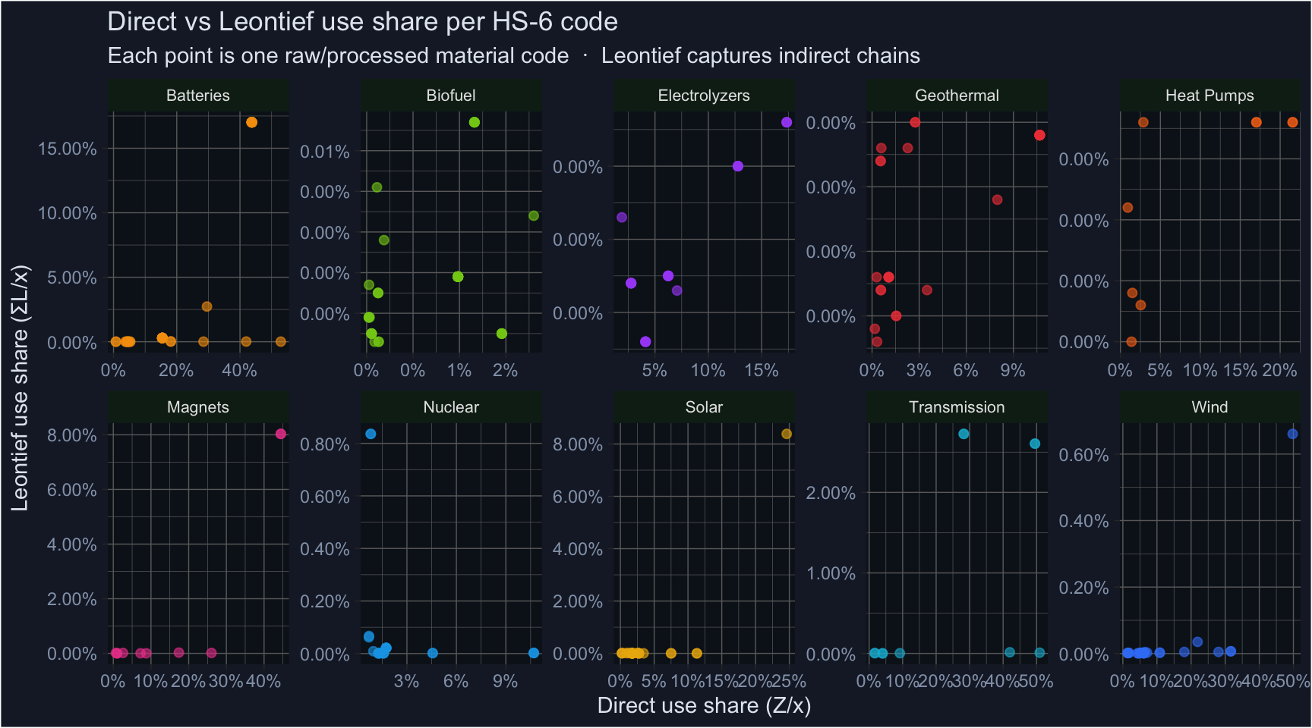

7.6 Economic Interpretation
Direct use share (orange in summary table) measures what fraction of a material’s global output flows directly into clean technology manufacturing. It ranges from near-zero for bulk commodities (iron ore goes mainly to steel for construction) to 30–50% for specialised intermediates (lithium battery compounds, REE processing).
Leontief use share (blue) captures the full upstream chain — all indirect requirements induced by one unit of clean-tech final demand. It is smaller in magnitude than the direct share for most materials because the denominator (\(x_j\)) counts all global output of sector \(j\), while clean-tech final demand per unit is modest relative to total global demand. This metric is more appropriate for materials several steps upstream of clean tech (e.g. iron ore → steel → turbine blade → wind electricity).
The direct share is generally larger because it captures concentrated, bilateral supply transactions. The Leontief share is more conservative and reflects the full economic footprint.

8 Limitations and Open Questions
- Monetary, not physical IO. EXIOBASE records flows in millions of euros. Relative prices distort the share of rare materials (REEs, cobalt) whose value density is much higher than bulk commodities. Physical MRIO tables (EXIOBASE MR-PSUT) would be preferable but are harder to work with.
- Single reference year (2019). Use shares reflect the structure of industrial demand before the post-IRA/CBAM clean energy investment wave. Battery and solar shares are likely understated for 2022–2024.
- 49-country coverage. ~140 remaining countries are pooled into 5 rest-of-world regions, diluting use shares for materials produced mainly in DRC (cobalt), Bolivia (lithium), Indonesia (nickel).
- Broad sector aggregation. EXIOBASE’s 200 product categories group diverse subsectors. “Machinery and equipment (29)” covers heat pumps, industrial turbines, and general machinery. The Leontief share for heat-pump materials is understated because the denominator includes all non-clean machinery output. This is a structural limitation of 200-product tables.
- Clean-tech column definition. We treat all output of the defined EXIOBASE products (e.g. all “Electrical machinery (31)”) as clean tech. This overstates the clean-tech share if the sector produces both clean and non-clean goods (see §2 callout).
- 1.0 assumption for downstream products. Some process equipment HS codes are multi-use. The 1.0 assignment is an upper bound.
- Tech-mean fallback for unmapped materials. The ~50% of raw/processed materials without a direct EXIOBASE mapping receive the technology average. This introduces measurement error for highly specific materials.

9 Files and Reproducibility
File | Description
scripts/build_data/10a_parse_exiobase.py | Extract A.txt + x.txt from EXIOBASE zip
scripts/build_data/10_build_io_use_shares.R | Z-based aggregation, Leontief + direct share computation
data/exiobase/hs_exiobase_concordance.csv | Per-HS6 concordance with both share metrics
data/exiobase/io_use_shares.parquet | Machine-readable shares (product_code, tech, leontief_use_share, direct_use_share)
data/green_dict/green_dictionary.csv | Green Dictionary + exiobase_product + leontief_use_share + direct_use_share
To reproduce:
# Step 1: extract A.txt + x.txt from EXIOBASE zip (requires IOT_2019_pxp.zip)
python3 scripts/build_data/10a_parse_exiobase.py 2019
# Step 2: compute use shares
IO_MODE=real IO_YEAR=2019 Rscript scripts/build_data/10_build_io_use_shares.R
# Step 3: render this report
quarto render qmd/report/hs_exiobase_use_shares_methodology.qmd
EXIOBASE data is available at exiobase.eu (registration required). The IOT_2019_pxp.zip (~500 MB) goes in data/exiobase/.

10 References

