NZIPL Predicted Competitiveness — ML Pipeline Review
NZIPL Clean Value Chain Explorer

NZIPL Predicted Competitiveness — ML Pipeline Review
Code
- Show All Code
- Hide All Code

- View Source
Random Forest · SHAP Feature Importance · Replication Roadmap
Author
NZIPL Clean Value Chain Explorer
Published
May 14, 2026

1 Executive Summary
This document reviews the Predicted Competitiveness (PC) machine learning pipeline developed by NZIPL for the Atlas of the Global Clean Industrial Base. The pipeline:
- Uses BACI bilateral trade data to compute Revealed Comparative Advantage (RCA) per country × HS6 product × year
- Trains a Random Forest classifier for each of the 10 clean technologies to predict whether a country will achieve RCA > 1 (i.e., become competitively specialised)
- Applies SHAP (SHapley Additive exPlanations) to extract which product-level RCA variables most drive each prediction
- Exports predicted_comp scores (0–1 probability) and per-feature shap_mean_z importance values — the two datasets now embedded in CVCE

On the SHAP ↔︎ Trade correlation
The scatter plots reveal a correlation between shap_mean_z (SHAP feature importance) and trade volumes. This is expected and correct, not a flaw. The SHAP values measure how much a product’s export RCA drives the prediction of technology competitiveness. Since both inputs and outputs are trade-derived, higher-volume products naturally have higher SHAP scores — the model is correctly learning that existing export strength in related sectors predicts future competitiveness. This encodes the product-space logic of economic complexity.

2 Notebook Inventory
The Python notebooks are located at: OneDrive/Bentley Allan's files - NZIPL/Projects/001 Industrial Base/Modeling -- ML
Code
notebooks <- tribble(
~Group, ~Notebook, ~Purpose,
"Core ML", "Analysis/RCA Batteries Analysis.ipynb", "RF model + SHAP + rankings (Batteries)",
"Core ML", "Analysis/RCA Solar Analysis.ipynb", "RF model + SHAP + rankings (Solar)",
"Core ML", "Analysis/RCA Wind Analysis.ipynb", "RF model + SHAP + rankings (Wind)",
"Core ML", "Analysis/RCA {Tech} Analysis.ipynb", "Same pattern for remaining 7 techs",
"Features", "RCA Construction/Battery/Batteries_Vars.ipynb", "Feature matrix: lagged RCA for 69 battery HS codes + 20 proximate + macro",
"Features", "RCA Construction/{Tech}/{Tech}_Vars.ipynb", "Same pattern for each of 10 techs",
"Data Prep", "RCA/Code + Cleaned Files/RCA.ipynb", "Base RCA calculation from BACI",
"Data Prep", "ML Code/Product Proximity Update.ipynb","Product proximity (phi) matrix calculation",
"Data Prep", "ML Data/Bentley_Backup/Imputation script.ipynb", "KNN imputation (k=3) for missing trade values",
"Data Prep", "ML Data/Trade Data/GTA code.ipynb", "Global Trade Alert policy intervention processing",
"Viz", "ML Code/Nature Paper Figures.ipynb", "Publication bubble charts (country × tech × score)",
"Viz", "ML Code/Old/Country Deep Dives.ipynb", "RCA time series per country",
"Utility", "FDI Methodology/Firm Names/Fuzzymatch.ipynb", "Fuzzy name matching for FDI firm data"
)
notebooks |>
kable(col.names = c("Group", "Notebook", "Purpose"),
caption = "NZIPL ML Pipeline — Notebook Inventory") |>
kable_styling(bootstrap_options = c("striped", "hover", "condensed"),
full_width = TRUE, font_size = 13) |>
column_spec(1, bold = TRUE, color = nzipl_green) |>
row_spec(0, bold = TRUE, background = nzipl_green, color = "white")
NZIPL ML Pipeline — Notebook Inventory
Group | Notebook | Purpose
Core ML | Analysis/RCA Batteries Analysis.ipynb | RF model + SHAP + rankings (Batteries)
Core ML | Analysis/RCA Solar Analysis.ipynb | RF model + SHAP + rankings (Solar)
Core ML | Analysis/RCA Wind Analysis.ipynb | RF model + SHAP + rankings (Wind)
Core ML | Analysis/RCA {Tech} Analysis.ipynb | Same pattern for remaining 7 techs
Features | RCA Construction/Battery/Batteries_Vars.ipynb | Feature matrix: lagged RCA for 69 battery HS codes + 20 proximate + macro
Features | RCA Construction/{Tech}/{Tech}_Vars.ipynb | Same pattern for each of 10 techs
Data Prep | RCA/Code + Cleaned Files/RCA.ipynb | Base RCA calculation from BACI
Data Prep | ML Code/Product Proximity Update.ipynb | Product proximity (phi) matrix calculation
Data Prep | ML Data/Bentley_Backup/Imputation script.ipynb | KNN imputation (k=3) for missing trade values
Data Prep | ML Data/Trade Data/GTA code.ipynb | Global Trade Alert policy intervention processing
Viz | ML Code/Nature Paper Figures.ipynb | Publication bubble charts (country × tech × score)
Viz | ML Code/Old/Country Deep Dives.ipynb | RCA time series per country
Utility | FDI Methodology/Firm Names/Fuzzymatch.ipynb | Fuzzy name matching for FDI firm data

3 Pipeline Architecture

3.1 End-to-end flow
┌──────────────────────────────────────────────────────────┐
│ 1. RAW DATA │
│ BACI bilateral trade (HS6, 2002–2023) │
│ FDI % GDP · Tariffs · Manufacturing % GDP │
└──────────────────────┬───────────────────────────────────┘
│
▼
┌──────────────────────────────────────────────────────────┐
│ 2. RCA CALCULATION (RCA.ipynb) │
│ │
│ RCA(c,p,y) = [X_cpy / X_c·] / [X_·p· / X_···] │
│ │
│ → rca_cyh.csv (all country-product-year RCAs) │
│ → phi_equal_year.csv (product proximity matrix) │
└──────────────────────┬───────────────────────────────────┘
│
▼
┌──────────────────────────────────────────────────────────┐
│ 3. FEATURE ENGINEERING ({Tech}_Vars.ipynb × 10) │
│ │
│ b_{HS6} (×60-90) : lagged RCA for tech HS codes │
│ nb_{HS6} (×15-25) : lagged RCA for proximate prods│
│ FDI, tariffs, manufacturing % GDP, trade openness │
│ │
│ → battery_trade.csv, solar_trade.csv, … (~90 cols) │
└──────────────────────┬───────────────────────────────────┘
│
▼
┌──────────────────────────────────────────────────────────┐
│ 4. KNN IMPUTATION (Imputation script.ipynb) │
│ k = 3 · fills missing export values │
│ → final_trade_df_imputed.csv │
└──────────────────────┬───────────────────────────────────┘
│
▼
┌──────────────────────────────────────────────────────────┐
│ 5. RANDOM FOREST CLASSIFICATION (Analysis notebooks) │
│ │
│ Target: y = int(RCA_tech > 1) │
│ Model: RFC(n_estimators=100, max_depth=10, │
│ random_state=28, test_size=0.25) │
│ │
│ → predicted_comp = predict_proba(X)[:, 1] │
│ (probability of competitive specialisation) │
└──────────────────────┬───────────────────────────────────┘
│
▼
┌──────────────────────────────────────────────────────────┐
│ 6. SHAP FEATURE IMPORTANCE (same Analysis notebooks) │
│ │
│ explainer = shap.TreeExplainer(rf_model) │
│ shap_vals = explainer.shap_values(X)[1] ← class 1 │
│ │
│ z-normalise by year: z = (x − μ_year) / σ_year │
│ shap_mean_z = mean(|z|) per feature │
│ │
│ → per-tech SHAP importance CSVs │
│ (now consolidated in data/pc/pc_features.csv) │
└──────────────────────────────────────────────────────────┘

3.2 Model specification
Code
specs <- tribble(
~Parameter, ~Value, ~Notes,
"Algorithm", "RandomForestClassifier", "scikit-learn; tree-based, scale-invariant",
"n_estimators", "100", "Number of decision trees",
"max_depth", "10", "Max tree depth; limits overfitting",
"random_state", "28", "Fixed for reproducibility across all techs",
"Train/test split", "75% / 25%", "Stratified random split",
"Cross-validation", "5-fold GridSearchCV", "Only for Solar & Wind; others use fixed params",
"Target variable", "int(RCA > 1)", "Binary: 1 = competitive, 0 = not",
"Output", "predict_proba[:, 1]", "Probability of competitiveness; range 0–1",
"Lag structure", "1-year lag on all IV features", "Avoids look-ahead bias",
"Missing data", "KNN (k=3)", "Pre-imputed before model training"
)
specs |>
kable(col.names = c("Parameter", "Value", "Notes"),
caption = "Random Forest Model Specification") |>
kable_styling(bootstrap_options = c("striped","hover","condensed"),
full_width = TRUE, font_size = 13) |>
column_spec(1, bold = TRUE) |>
row_spec(0, bold = TRUE, background = nzipl_green, color = "white")
Random Forest Model Specification
Parameter | Value | Notes
Algorithm | RandomForestClassifier | scikit-learn; tree-based, scale-invariant
n_estimators | 100 | Number of decision trees
max_depth | 10 | Max tree depth; limits overfitting
random_state | 28 | Fixed for reproducibility across all techs
Train/test split | 75% / 25% | Stratified random split
Cross-validation | 5-fold GridSearchCV | Only for Solar & Wind; others use fixed params
Target variable | int(RCA > 1) | Binary: 1 = competitive, 0 = not
Output | predict_proba[:, 1] | Probability of competitiveness; range 0–1
Lag structure | 1-year lag on all IV features | Avoids look-ahead bias
Missing data | KNN (k=3) | Pre-imputed before model training

4 SHAP Feature Importance — What We Have
The data/pc/pc_features.csv contains the SHAP mean |z-score| for each HS6 code × technology combination that passed the importance threshold.

4.1 Coverage
Code
feat |>
filter(!is.na(hs_code)) |>
group_by(tech) |>
summarise(
`HS codes` = n_distinct(hs_code),
`SHAP range` = paste0(round(min(shap_mean_z), 3), " – ",
round(max(shap_mean_z), 3)),
`Mean SHAP` = round(mean(shap_mean_z), 3),
`Top category` = {
df <- cur_data() |> group_by(category) |>
summarise(s = mean(shap_mean_z)) |> slice_max(s, n = 1)
df$category[1]
},
.groups = "drop"
) |>
rename(Technology = tech) |>
kable(caption = "SHAP feature coverage per technology") |>
kable_styling(bootstrap_options = c("striped","hover","condensed"),
full_width = TRUE, font_size = 13) |>
row_spec(0, bold = TRUE, background = nzipl_green, color = "white")
SHAP feature coverage per technology
Technology | HS codes | SHAP range | Mean SHAP | Top category
Batteries | 31 | 0.504 – 0.656 | 0.565 | Machinery
Biofuel | 66 | 0.512 – 0.811 | 0.645 | Machinery
Electrolyzers | 42 | 0.504 – 0.717 | 0.576 | Chemicals
Geothermal | 54 | 0.502 – 0.725 | 0.601 | Electronics
Heat Pumps | 26 | 0.515 – 0.822 | 0.644 | Machinery
Magnets | 8 | 0.529 – 0.667 | 0.583 | Chemicals
Nuclear | 22 | 0.506 – 0.699 | 0.556 | Machinery
Solar | 34 | 0.504 – 0.672 | 0.554 | Machinery
Transmission | 24 | 0.55 – 0.817 | 0.696 | Industrial Materials
Wind | 50 | 0.501 – 0.696 | 0.558 | Chemicals

4.2 SHAP distribution by category
Code
feat |>
filter(!is.na(hs_code)) |>
mutate(tech = factor(tech, levels = names(TECH_COLORS))) |>
ggplot(aes(x = shap_mean_z, y = reorder(category, shap_mean_z),
color = category)) +
geom_jitter(height = 0.2, alpha = 0.6, size = 1.5) +
stat_summary(fun = mean, geom = "point", size = 3.5, shape = 18, color = "black") +
facet_wrap(~ tech, ncol = 5, scales = "free_x") +
scale_color_brewer(palette = "Dark2", guide = "none") +
labs(title = "SHAP Importance Distribution by Category and Technology",
subtitle = "Each dot = one HS6 code · Diamond = category mean",
x = "SHAP mean |z-score|", y = NULL) +
theme_nzipl()
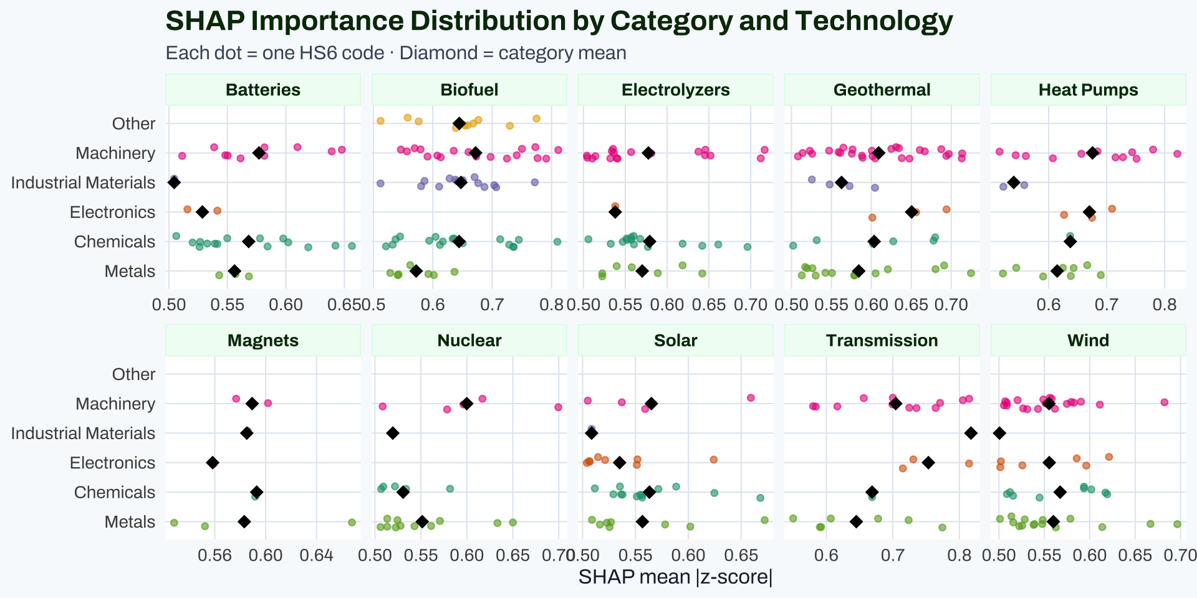

4.3 Top-10 SHAP features per technology
Code
feat |>
filter(!is.na(hs_code)) |>
group_by(tech) |>
slice_max(shap_mean_z, n = 10) |>
ungroup() |>
mutate(hs_code = formatC(as.integer(hs_code), width = 6, flag = "0"),
shap_mean_z = round(shap_mean_z, 4)) |>
select(Technology = tech, `HS Code` = hs_code,
Description = description, Category = category,
`SHAP mean |z|` = shap_mean_z) |>
kable(caption = "Top-10 SHAP features per technology (by mean |z-score|)") |>
kable_styling(bootstrap_options = c("striped","hover","condensed"),
full_width = TRUE, font_size = 11) |>
row_spec(0, bold = TRUE, background = nzipl_green, color = "white") |>
collapse_rows(columns = 1, valign = "middle")
Top-10 SHAP features per technology (by mean |z-score|)
Technology | HS Code | Description | Category | SHAP mean &#124;z&#124;
Batteries | 391190 | Polysulphides, polysulphones and similar products of chemical synthesis n.e.s. in chapter 39; in primary forms | Chemicals | 0.6565
 | 847990 | Machines and mechanical appliances; parts, of those having individual functions | Machinery | 0.6478
 | 370130 | Photographic plates and film; in the flat, sensitised, unexposed, with any side exceeding 225mm, of any materials other than paper, paperboard or textiles | Chemicals | 0.6424
 | 903190 | Instruments, appliances and machines; parts and accessories for those measuring or checking devices of heading no. 9031 | Machinery | 0.6392
 | 282540 | Nickel oxides and hydroxides | Chemicals | 0.6192
 | 902790 | Microtomes and parts and accessories thereof | Machinery | 0.6099
 | 291030 | Epoxides, epoxyalcohols, epoxyphenols and epoxyethers; with a three-membered ring and their halogenated, sulphonated, nitrated or nitrosated derivatives, 1-chloro-2,3-epoxypropane (epichlorohydrin) | Chemicals | 0.6020
 | 282200 | Cobalt oxides and hydroxides; commercial cobalt oxides | Chemicals | 0.5977
 | 382490 | Chemical products, preparations and residual products of the chemical or allied industries, n.e.s. or included in heading no. 3824 | Chemicals | 0.5843
 | 903180 | Instruments, appliances and machines; for measuring or checking n.e.s. in chapter 90 | Machinery | 0.5817
Biofuel | 940390 | Furniture; parts | Machinery | 0.8113
 | 381590 | Reaction initiators, reaction accelerators and catalytic preparations, unsupported, n.e.s. or included | Chemicals | 0.8098
 | 844190 | Machinery; parts of machinery for making up paper pulp, paper or paperboard, including cutting machines of all kinds | Machinery | 0.7910
 | 841939 | Dryers; for products n.e.s. in heading no. 8419, not used for domestic purposes | Machinery | 0.7764
 | 121299 | Vegetable products (including unroasted chicory roots, chicorium intybus sativum variety); n.e.s. in chapter 12, fresh, chilled, frozen or dried, ground or unground, primarily for human consumption | Other | 0.7746
 | 841381 | Pumps and liquid elevators; n.e.s. in heading no. 8413 | Machinery | 0.7726
 | 441520 | Wood; pallets, box pallets and other load boards; pallet collars | Industrial Materials | 0.7718
 | 842121 | Machinery; for filtering or purifying water | Machinery | 0.7502
 | 281122 | Silicon dioxide | Chemicals | 0.7448
 | 841410 | Pumps; vacuum | Machinery | 0.7413
Electrolyzers | 845610 | Machine-tools; operated by laser or other light or photon beam process | Machinery | 0.7167
 | 841480 | Pumps and compressors; for air, vacuum or gas, n.e.s. in heading no. 8414 | Machinery | 0.7120
 | 390710 | Polyacetals; in primary forms | Chemicals | 0.6961
 | 381512 | Catalysts, supported; reaction initiators, reaction accelerators and catalytic preparations, with precious metal or precious metal compounds as the active substance, n.e.s. or included | Chemicals | 0.6612
 | 842121 | Machinery; for filtering or purifying water | Machinery | 0.6519
 | 841370 | Pumps; centrifugal, n.e.s. in heading no. 8413, for liquids | Machinery | 0.6458
 | 841490 | Pumps and compressors; parts, of air or vacuum pumps, air or other gas compressors and fans, ventilating or recycling hoods incorporating a fan | Machinery | 0.6453
 | 381519 | Catalysts, supported; reaction initiators, reaction accelerators and catalytic preparations, with an active substance other than nickel or precious metals or their compounds, n.e.s. or included | Chemicals | 0.6421
 | 711021 | Metals; palladium, unwrought or in powder form | Metals | 0.6421
 | 842139 | Machinery; for filtering or purifying gases, other than intake air filters for internal combustion engines | Machinery | 0.6374
Geothermal | 722490 | Steel, alloy; semi-finished products | Metals | 0.7247
 | 842199 | Machinery; parts for filtering or purifying liquids or gases | Machinery | 0.7138
 | 845931 | Machine-tools; for boring-milling by removing metal, numerically controlled | Machinery | 0.7132
 | 845891 | Lathes; for removing metal, numerically controlled, other than horizontal lathes | Machinery | 0.6970
 | 851580 | Welding machines and apparatus; n.e.s. in heading no. 8515, whether or not capable of cutting | Electronics | 0.6941
 | 845811 | Lathes; for removing metal, horizontal, numerically controlled | Machinery | 0.6938
 | 720270 | Ferro-alloys; ferro-molybdenum | Metals | 0.6911
 | 842139 | Machinery; for filtering or purifying gases, other than intake air filters for internal combustion engines | Machinery | 0.6876
 | 730721 | Steel, stainless; tube or pipe fittings, flanges, of stainless steel | Metals | 0.6804
 | 401693 | Rubber; vulcanised (other than hard rubber), gaskets, washers and other seals, of non-cellular rubber | Chemicals | 0.6800
Heat Pumps | 841410 | Pumps; vacuum | Machinery | 0.8217
 | 841430 | Compressors; of a kind used in refrigerating equipment | Machinery | 0.7803
 | 841590 | Air conditioning machines; with motor driven fan and elements for temperature control, parts thereof | Machinery | 0.7517
 | 846241 | Machine-tools; punching or notching machines (including presses), including combined punching and shearing machines, numerically controlled, for working metal | Machinery | 0.7439
 | 841490 | Pumps and compressors; parts, of air or vacuum pumps, air or other gas compressors and fans, ventilating or recycling hoods incorporating a fan | Machinery | 0.7278
 | 841899 | Refrigerating or freezing equipment; parts thereof, other than furniture | Machinery | 0.7152
 | 853400 | Circuits; printed | Electronics | 0.7095
 | 820720 | Tools, interchangeable; (for machine or hand tools, whether or not power-operated), dies for drawing or extruding metal | Metals | 0.6900
 | 841582 | Air conditioning machines; containing a motor driven fan, other than window or wall types, incorporating a refrigerating unit | Machinery | 0.6842
 | 854121 | Electrical apparatus; transistors, (other than photosensitive), with a dissipation rate of less than 1W | Electronics | 0.6747
Magnets | 820720 | Tools, interchangeable; (for machine or hand tools, whether or not power-operated), dies for drawing or extruding metal | Metals | 0.6669
 | 847982 | Machines; for mixing, kneading, crushing, grinding, screening, sifting, homogenising, emulsifying or stirring | Machinery | 0.6036
 | 283324 | Sulphates; of nickel | Chemicals | 0.5930
 | 680421 | Millstones, grindstones, grinding wheels and the like; of agglomerated synthetic or natural diamond | Industrial Materials | 0.5852
 | 847990 | Machines and mechanical appliances; parts, of those having individual functions | Machinery | 0.5751
 | 851440 | Heating equipment; for the heat treatment of materials by induction or dielectric loss, industrial or laboratory, other than furnaces and ovens | Electronics | 0.5583
 | 260300 | Copper ores and concentrates | Metals | 0.5537
 | 260600 | Aluminium ores and concentrates | Metals | 0.5289
Nuclear | 841940 | Distilling or rectifying plant; not used for domestic purposes | Machinery | 0.6995
 | 721922 | Steel, stainless; flat-rolled, width 600mm or more, hot-rolled, (not in coils), of a thickness of 4.75mm or more but not exceeding 10mm | Metals | 0.6501
 | 720270 | Ferro-alloys; ferro-molybdenum | Metals | 0.6333
 | 841989 | Machinery, plant and laboratory equipment; for treating materials by change of temperature, other than for making hot drinks or cooking or heating food | Machinery | 0.6170
 | 840420 | Boilers; condensers, for steam or other vapour power units | Machinery | 0.5963
 | 282520 | Lithium oxide and hydroxide | Chemicals | 0.5817
 | 840690 | Turbines; parts of steam and other vapour turbines | Machinery | 0.5785
 | 261390 | Molybdenum ores and concentrates; other than roasted | Metals | 0.5707
 | 722790 | Steel, alloy; bars and rods, hot-rolled, in irregularly wound coils, n.e.s. in heading no. 7227 | Metals | 0.5611
 | 722011 | Steel, stainless; flat-rolled, width less than 600mm, hot-rolled, of a thickness of 4.75mm or more | Metals | 0.5430
Solar | 830249 | Mountings, fittings and similar articles; suitable for other than buildings or furniture, of base metal | Metals | 0.6722
 | 321490 | Mastics; n.e.s. in heading no. 3214 | Chemicals | 0.6681
 | 940390 | Furniture; parts | Machinery | 0.6591
 | 392350 | Plastics; stoppers, lids, caps and other closures, for the conveyance or packing of goods | Chemicals | 0.6246
 | 851430 | Furnaces and ovens; industrial or laboratory, other than those functioning by induction, dielectric loss or resistance heated | Electronics | 0.6240
 | 760429 | Aluminium; alloys, bars, rods and profiles, other than hollow | Metals | 0.6019
 | 392010 | Plastics; plates, sheets, film, foil and strip, of polymers of ethylene, non-cellular and not reinforced, laminated, supported or similarly combined with other materials | Chemicals | 0.5885
 | 730890 | Iron or steel; structures and parts thereof, n.e.s. in heading no. 7308 | Metals | 0.5780
 | 320890 | Paints and varnishes; based on polymers n.e.s. in heading no. 3208, dispersed or dissolved in a non-aqueous medium | Chemicals | 0.5717
 | 841989 | Machinery, plant and laboratory equipment; for treating materials by change of temperature, other than for making hot drinks or cooking or heating food | Machinery | 0.5591
Transmission | 270900 | Oils; petroleum oils and oils obtained from bituminous minerals, crude | Industrial Materials | 0.8174
 | 847990 | Machines and mechanical appliances; parts, of those having individual functions | Machinery | 0.8147
 | 850490 | Electrical transformers, static converters and inductors; parts thereof | Electronics | 0.8145
 | 847981 | Machines and mechanical appliances; for treating metal, including electric wire coil-winders | Machinery | 0.8052
 | 722611 | Steel, alloy; flat-rolled, width less than 600mm, of silicon-electrical steel, grain-oriented | Metals | 0.7743
 | 847989 | Machines and mechanical appliances; n.e.s. in item no. 8479.8, having individual functions | Machinery | 0.7709
 | 846241 | Machine-tools; punching or notching machines (including presses), including combined punching and shearing machines, numerically controlled, for working metal | Machinery | 0.7643
 | 842890 | Lifting machinery; handling, loading or unloading machinery n.e.s. in heading no. 8428 | Machinery | 0.7355
 | 850300 | Electric motors and generators; parts suitable for use solely or principally with the machines of heading no. 8501 or 8502 | Electronics | 0.7307
 | 845811 | Lathes; for removing metal, horizontal, numerically controlled | Machinery | 0.7247
Wind | 730799 | Iron or steel; tube or pipe fittings, n.e.s. in item no. 7307.9, other than stainless steel | Metals | 0.6965
 | 903180 | Instruments, appliances and machines; for measuring or checking n.e.s. in chapter 90 | Machinery | 0.6823
 | 732690 | Iron or steel; articles n.e.s. in heading no. 7326 | Metals | 0.6669
 | 850431 | Electrical transformers; n.e.s. in item no. 8504.2, having a power handling capacity not exceeding 1kVA | Electronics | 0.6213
 | 401693 | Rubber; vulcanised (other than hard rubber), gaskets, washers and other seals, of non-cellular rubber | Chemicals | 0.6193
 | 401699 | Rubber; vulcanised (other than hard rubber), articles n.e.s. in heading no. 4016, of non-cellular rubber | Chemicals | 0.6173
 | 732399 | Iron or steel; table, kitchen and other household articles and parts thereof, of iron or steel n.e.s. in heading no. 7323 | Metals | 0.6138
 | 871690 | Trailers, semi-trailers and other vehicles not mechanically propelled; parts thereof for heading no. 8716 | Machinery | 0.6111
 | 321490 | Mastics; n.e.s. in heading no. 3214 | Chemicals | 0.6017
 | 854460 | Insulated electric conductors; for a voltage exceeding 1000 volts | Electronics | 0.5962

5 Predicted Competitiveness Scores — What We Have

5.1 Country × Technology coverage
Code
pc_top3 <- pc |>
group_by(tech) |>
filter(year == max(year)) |>
slice_max(pc_score, n = 3, with_ties = FALSE) |>
summarise(Top3 = paste(iso3, collapse = ", "), .groups = "drop")
pc |>
group_by(tech) |>
summarise(
Countries = n_distinct(iso3),
Years = paste0(min(year), "–", max(year)),
`Mean PC` = round(mean(pc_score, na.rm = TRUE), 3),
.groups = "drop"
) |>
left_join(pc_top3, by = "tech") |>
rename(Technology = tech, `Top 3 (latest yr)` = Top3) |>
kable(caption = "Predicted competitiveness coverage") |>
kable_styling(bootstrap_options = c("striped","hover","condensed"),
full_width = TRUE, font_size = 13) |>
row_spec(0, bold = TRUE, background = nzipl_green, color = "white")
Predicted competitiveness coverage
Technology | Countries | Years | Mean PC | Top 3 (latest yr)
Batteries | 155 | 2003–2024 | 0.050 | KOR, CHN, JPN
Biofuel | 155 | 2003–2024 | 0.209 | NLD, ZAF, UGA
Electrolyzers | 155 | 2003–2024 | 0.078 | ITA, CHN, KOR
Geothermal | 155 | 2003–2024 | 0.130 | DEU, ITA, POL
Heat Pumps | 155 | 2003–2024 | 0.142 | CHN, THA, ITA
Magnets | 155 | 2003–2024 | 0.049 | CHN, JPN, MYS
Nuclear | 155 | 2003–2024 | 0.063 | USA, RUS, CZE
Solar | 155 | 2003–2024 | 0.059 | JPN, CHN, MYS
Transmission | 155 | 2003–2024 | 0.207 | DNK, AUT, CHN
Wind | 155 | 2003–2024 | 0.049 | CHN, DNK, IND

5.2 PC score evolution for key countries
Code
focus <- c("CHN","USA","DEU","IND","KOR","JPN","BRA","VNM","CHL","AUS")
pc |>
filter(iso3 %in% focus) |>
mutate(tech = factor(tech, levels = names(TECH_COLORS))) |>
ggplot(aes(x = year, y = pc_score, color = iso3, group = iso3)) +
geom_line(linewidth = 0.7, alpha = 0.85) +
geom_point(data = ~ filter(.x, year == max(year)),
size = 2) +
facet_wrap(~ tech, ncol = 5) +
scale_color_brewer(palette = "Paired", name = "Country") +
scale_y_continuous(limits = c(0, 1), labels = scales::percent) +
labs(title = "Predicted Competitiveness Scores — Selected Countries",
subtitle = "Probability of achieving RCA > 1 in each clean technology",
x = NULL, y = "Predicted Competitiveness") +
theme_nzipl() +
theme(legend.position = "bottom",
legend.key.size = unit(0.4, "cm"))
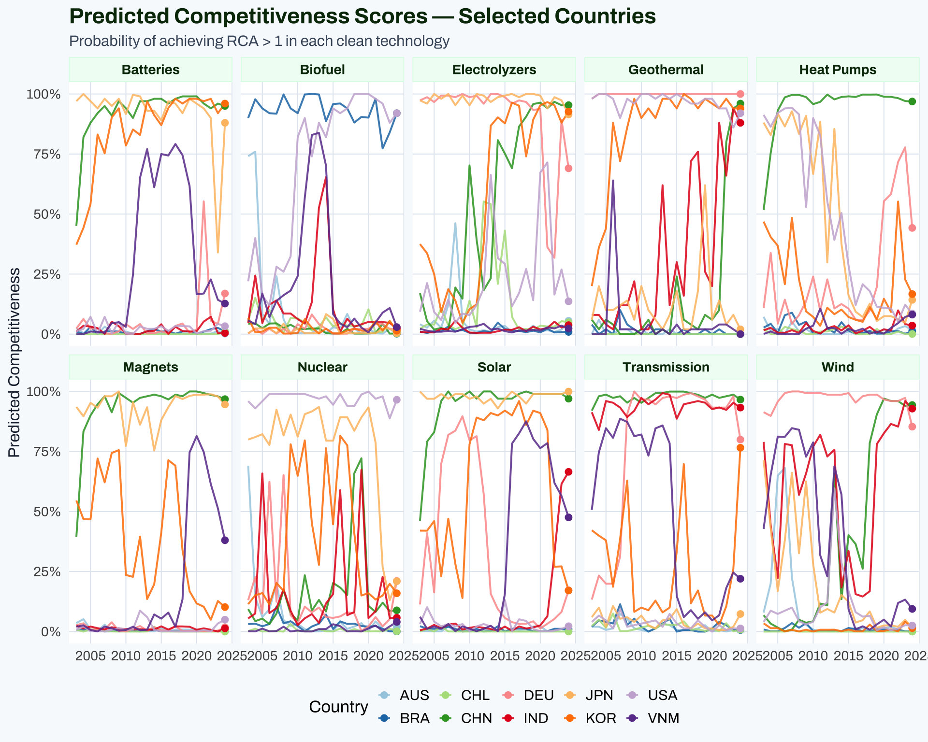

5.3 2023 Rankings heatmap
Code
top_countries <- pc |>
filter(year == max(year)) |>
group_by(iso3) |>
summarise(avg_pc = mean(pc_score, na.rm = TRUE), .groups = "drop") |>
slice_max(avg_pc, n = 30) |>
pull(iso3)
pc |>
filter(year == max(year), iso3 %in% top_countries) |>
mutate(
country = if_else(is.na(country) | country == "", iso3, country),
tech = factor(tech, levels = names(TECH_COLORS))
) |>
ggplot(aes(x = tech, y = reorder(country, pc_score, mean),
fill = pc_score)) +
geom_tile(color = "white", linewidth = 0.4) +
geom_text(aes(label = round(pc_score, 2)),
size = 3.2, color = "white", fontface = "bold",
family = "Archivo") +
scale_fill_gradientn(
colors = c("#f8fafc", "#d1fae5", "#6ee7b7", "#059669", nzipl_green),
limits = c(0, 1),
name = "PC Score",
labels = scales::percent
) +
labs(title = "Predicted Competitiveness — Top 30 Countries (latest year)",
subtitle = paste0("Year: ", max(pc$year),
" · Score = P(RCA > 1)"),
x = NULL, y = NULL) +
theme_nzipl() +
theme(axis.text.x = element_text(angle = 35, hjust = 1, size = 11),
legend.position = "right")
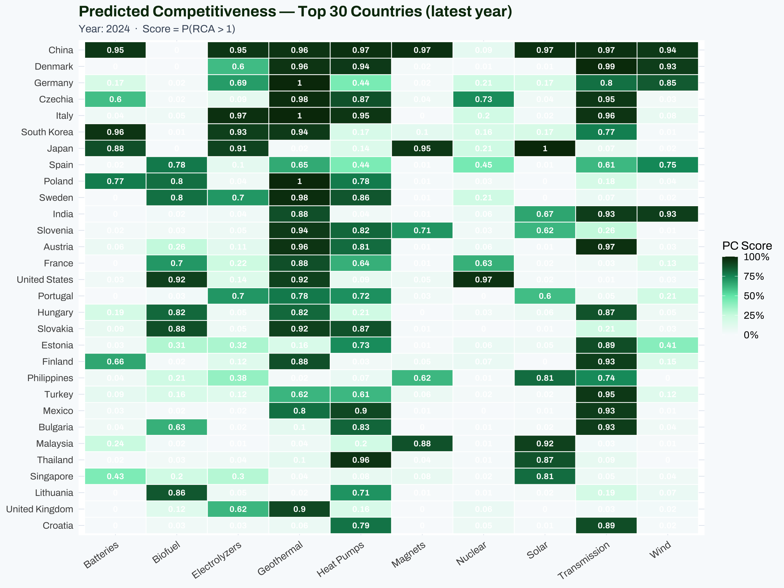

6 RCA Data — Input to the Model
The pc_rca.parquet file contains the actual RCA values used as model features.
Code
rca_latest <- rca_all |>
filter(year == max(year)) |>
group_by(tech, iso3, country, region) |>
summarise(mean_rca = mean(rca, na.rm = TRUE), .groups = "drop")
top30 <- rca_latest |>
group_by(iso3) |> summarise(m = mean(mean_rca),.groups="drop") |>
slice_max(m, n = 25) |> pull(iso3)
rca_latest |>
filter(iso3 %in% top30) |>
mutate(country = if_else(is.na(country) | country == "", iso3, country),
tech = factor(tech, levels = names(TECH_COLORS))) |>
ggplot(aes(x = tech, y = reorder(country, mean_rca, mean),
fill = pmin(mean_rca, 3))) +
geom_tile(color = "white", linewidth = 0.4) +
scale_fill_gradientn(
colors = c("#f8fafc", "#fef3c7", "#f59e0b", "#b45309", "#7c2d12"),
name = "RCA\n(capped at 3)",
limits = c(0, 3)
) +
labs(title = "Mean RCA Across Product Categories — Top 25 Countries",
subtitle = paste0("Year: ", max(rca_all$year),
" · RCA > 1 = Competitive specialisation"),
x = NULL, y = NULL) +
theme_nzipl() +
theme(axis.text.x = element_text(angle = 35, hjust = 1))
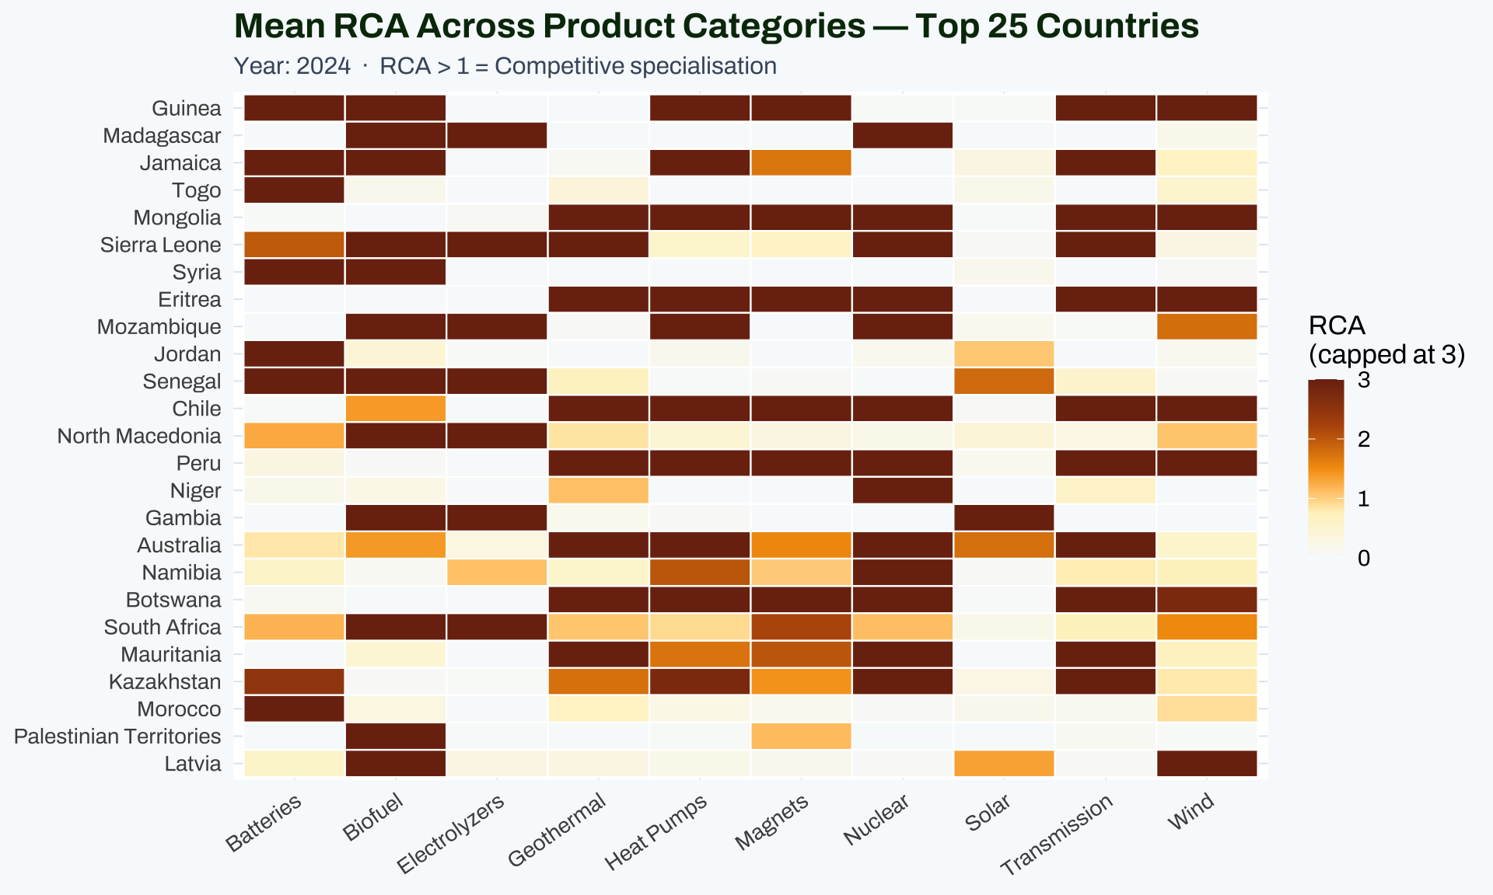

7 Why SHAP Correlates with Trade — and What It Means

7.1 The causal logic

Product-space theory
The NZIPL model is grounded in economic complexity theory (Hidalgo & Hausmann 2009). Products that are “proximate” — meaning countries tend to export them together — share underlying productive capabilities (skilled labour, specialised equipment, supply chain infrastructure). The Random Forest is learning this capability-sharing structure: countries that already have RCA in upstream/related products are more likely to develop RCA in the target technology.
SHAP measures the contribution of each input RCA variable to the model’s prediction. High-SHAP products are the most informative capability proxies for the target technology.

7.2 Observed correlation is not circularity
Code
feat |>
filter(!is.na(hs_code)) |>
group_by(tech, category) |>
summarise(
n = n(),
mean_shap = round(mean(shap_mean_z), 4),
sd_shap = round(sd(shap_mean_z), 4),
.groups = "drop"
) |>
rename(Technology = tech, Category = category,
`N codes` = n, `Mean SHAP |z|` = mean_shap,
`SD SHAP` = sd_shap) |>
arrange(Technology, desc(`Mean SHAP |z|`)) |>
kable(caption = "Average SHAP importance by technology × SHAP category") |>
kable_styling(bootstrap_options = c("striped","hover","condensed"),
full_width = TRUE, font_size = 12) |>
row_spec(0, bold = TRUE, background = nzipl_green, color = "white") |>
collapse_rows(columns = 1, valign = "middle")
Average SHAP importance by technology × SHAP category
Technology | Category | N codes | Mean SHAP &#124;z&#124; | SD SHAP
Batteries | Machinery | 10 | 0.5770 | 0.0442
 | Chemicals | 15 | 0.5682 | 0.0471
 | Metals | 3 | 0.5561 | 0.0127
 | Electronics | 2 | 0.5286 | 0.0181
 | Industrial Materials | 1 | 0.5044 | NA
Biofuel | Machinery | 18 | 0.6721 | 0.0884
 | Industrial Materials | 14 | 0.6474 | 0.0641
 | Other | 10 | 0.6446 | 0.0787
 | Chemicals | 17 | 0.6442 | 0.0871
 | Metals | 7 | 0.5721 | 0.0394
Electrolyzers | Chemicals | 15 | 0.5791 | 0.0520
 | Machinery | 19 | 0.5777 | 0.0690
 | Metals | 7 | 0.5702 | 0.0474
 | Electronics | 1 | 0.5380 | NA
Geothermal | Electronics | 3 | 0.6505 | 0.0467
 | Machinery | 27 | 0.6092 | 0.0620
 | Chemicals | 6 | 0.6035 | 0.0740
 | Metals | 14 | 0.5842 | 0.0708
 | Industrial Materials | 4 | 0.5627 | 0.0340
Heat Pumps | Machinery | 12 | 0.6756 | 0.0994
 | Electronics | 3 | 0.6703 | 0.0416
 | Chemicals | 1 | 0.6373 | NA
 | Metals | 8 | 0.6147 | 0.0587
 | Industrial Materials | 2 | 0.5398 | 0.0253
Magnets | Chemicals | 1 | 0.5930 | NA
 | Machinery | 2 | 0.5894 | 0.0202
 | Industrial Materials | 1 | 0.5852 | NA
 | Metals | 3 | 0.5832 | 0.0736
 | Electronics | 1 | 0.5583 | NA
Nuclear | Machinery | 5 | 0.5999 | 0.0690
 | Metals | 11 | 0.5515 | 0.0490
 | Chemicals | 5 | 0.5307 | 0.0305
 | Industrial Materials | 1 | 0.5194 | NA
Solar | Machinery | 4 | 0.5651 | 0.0665
 | Chemicals | 13 | 0.5632 | 0.0426
 | Metals | 8 | 0.5566 | 0.0570
 | Electronics | 8 | 0.5350 | 0.0408
 | Industrial Materials | 1 | 0.5085 | NA
Transmission | Industrial Materials | 1 | 0.8174 | NA
 | Electronics | 3 | 0.7534 | 0.0535
 | Machinery | 12 | 0.7043 | 0.0807
 | Chemicals | 1 | 0.6687 | NA
 | Metals | 7 | 0.6450 | 0.0819
Wind | Chemicals | 9 | 0.5674 | 0.0467
 | Metals | 15 | 0.5599 | 0.0571
 | Electronics | 6 | 0.5554 | 0.0520
 | Machinery | 19 | 0.5552 | 0.0436
 | Industrial Materials | 1 | 0.5007 | NA
Interpretation guide:
SHAP | z
> 0.75 | Critical: direct industrial prerequisite for this technology
0.60 – 0.75 | High: closely related capability or upstream material
0.50 – 0.60 | Moderate: broader industrial base indicator
< 0.50 | Low: weak signal, general economic complexity proxy
The narrow observed range (0.50–0.82) across all products indicates that all features in the final dataset passed a threshold filter — only above-threshold features were exported to CSV. The absolute scale is less important than the relative ranking within a technology.

8 Replication Roadmap in CVCE (R)

8.1 Feasibility assessment
Code
components <- tribble(
~Component, ~Original, ~R_equivalent, ~Status, ~Difficulty,
"RCA calculation", "pandas/numpy", "Already in CVCE pipeline (bilateral_ds)", "✅ Done", "Easy",
"Product proximity (φ)", "Custom scipy/pandas", "Compute from bilateral_ds with dplyr", "🔲 Missing", "Hard",
"Feature matrix", "10 per-tech Python notebooks", "New 11_build_ml_features.R", "🔲 Missing", "Medium",
"KNN imputation", "sklearn KNNImputer", "VIM::kNN() or missForest", "🔲 Missing", "Easy",
"Random Forest", "sklearn RandomForestClassifier", "ranger (faster, same accuracy)", "🔲 Missing", "Easy",
"SHAP values", "shap.TreeExplainer", "fastshap or treeshap", "🔲 Missing", "Easy",
"PC scores export", "predict_proba[:,1]", "ranger predictions", "🔲 Missing", "Easy",
"Model validation", "GridSearchCV 5-fold", "caret or tidymodels", "🔲 Missing", "Medium"
)
components |>
kable(col.names = c("Component", "Original (Python)", "R Equivalent",
"Status", "Difficulty"),
caption = "CVCE replication roadmap: Python → R") |>
kable_styling(bootstrap_options = c("striped","hover","condensed"),
full_width = TRUE, font_size = 13) |>
column_spec(4, bold = TRUE) |>
row_spec(0, bold = TRUE, background = nzipl_green, color = "white")
CVCE replication roadmap: Python → R
Component | Original (Python) | R Equivalent | Status | Difficulty
RCA calculation | pandas/numpy | Already in CVCE pipeline (bilateral_ds) | ✅ Done | | asy |
Product proximity (φ) | Custom scipy/pandas | Compute from bilateral_ds with dplyr | 🔲 Missing | | ard |
Feature matrix | 10 per-tech Python notebooks | New 11_build_ml_features.R | 🔲 Missing | | edium |
KNN imputation | sklearn KNNImputer | VIM::kNN() or missForest | 🔲 Missing | | asy |
Random Forest | sklearn RandomForestClassifier | ranger (faster, same accuracy) | 🔲 Missing | | asy |
SHAP values | shap.TreeExplainer | fastshap or treeshap | 🔲 Missing | | asy |
PC scores export | predict_proba[:,1] | ranger predictions | 🔲 Missing | | asy |
Model validation | GridSearchCV 5-fold | caret or tidymodels | 🔲 Missing | | edium |

8.2 Proposed R implementation
The replication would add one new build script to the CVCE pipeline:
# scripts/build_data/11_build_ml_pc.R (proposed)
#
# Replicates the Python NZIPL ML pipeline in R:
# 1. Compute RCA matrix from bilateral_ds
# 2. Build product proximity (phi) using co-export correlation
# 3. Construct per-tech feature matrices (lagged RCA + macro)
# 4. Train ranger Random Forest (equivalent to sklearn RFC)
# 5. Compute SHAP values via fastshap
# 6. Export pc_scores.parquet + pc_features.csv (replacing datawheel inputs)
library(ranger) # RF: similar to sklearn RFC
library(fastshap) # SHAP values for any ML model
library(VIM) # KNN imputation
Key advantage of replication: - Re-run with each BACI update (currently 2024 data available, model trained on 2023) - Add new features: ORBIS firm counts, patent data, supply chain distance - Extend to new technologies or product-type subsets - Produce SHAP values at the country-year level (not just aggregated)

8.3 The one hard piece: Product Proximity
The phi matrix (product-product proximity, used to identify which non-technology products to include as features) is the only component that requires significant new code. The formula is:
φ(p,p') = min[ P(RCA_p | RCA_p'), P(RCA_p' | RCA_p) ]
= min[ (countries with RCA>1 in both) / (countries with RCA>1 in p),
(countries with RCA>1 in both) / (countries with RCA>1 in p') ]
This can be computed from the existing bilateral data in R, but requires iterating over ~5,000 HS6 pairs, which is computationally intensive (~2–4 hours for full matrix, or ~10 min for the green tech subset).

9 Known Limitations
Code
limits <- tribble(
~Issue, ~Description, ~Severity,
"Survivorship bias", "Only countries with continuous trade records included; sparse traders dropped", "Medium",
"Forward SHAP bias", "SHAP computed on full dataset, not temporally held-out test set", "High",
"Lag depth", "1-year lag may be insufficient for policy impacts (typically 2–3 years)", "Low",
"Hyperparameter tuning", "Fixed params (n=100, depth=10) across all techs; Solar/Wind only ones with GridSearchCV", "Medium",
"Class imbalance", "Not handled; ~10-40% of country-years are 'competitive' depending on tech", "Medium",
"RCA volatility", "Single extreme trade events can spike RCA for one year", "Low",
"Target variable scope", "RCA > 1 on any category; not distinguishing manufacturing vs raw material competitiveness", "Medium",
"SHAP range compression", "Only above-threshold features exported; absolute z-scores not comparable across techs", "Low"
)
limits |>
kable(col.names = c("Issue", "Description", "Severity"),
caption = "Known model limitations") |>
kable_styling(bootstrap_options = c("striped","hover","condensed"),
full_width = TRUE, font_size = 13) |>
column_spec(3,
color = ifelse(limits$Severity == "High", "#dc2626",
ifelse(limits$Severity == "Medium", "#d97706", "#16a34a")),
bold = TRUE) |>
row_spec(0, bold = TRUE, background = nzipl_green, color = "white")
Known model limitations
Issue | Description | Severity
Survivorship bias | Only countries with continuous trade records included; sparse traders dropped | Medium
Forward SHAP bias | SHAP computed on full dataset, not temporally held-out test set | High
Lag depth | 1-year lag may be insufficient for policy impacts (typically 2–3 years) | Low
Hyperparameter tuning | Fixed params (n=100, depth=10) across all techs; Solar/Wind only ones with GridSearchCV | Medium
Class imbalance | Not handled; ~10-40% of country-years are 'competitive' depending on tech | Medium
RCA volatility | Single extreme trade events can spike RCA for one year | Low
Target variable scope | RCA > 1 on any category; not distinguishing manufacturing vs raw material competitiveness | Medium
SHAP range compression | Only above-threshold features exported; absolute z-scores not comparable across techs | Low

10 Data Files Summary
Code
tribble(
~File, ~Rows, ~Columns, ~Source,
"data/pc/pc_features.csv", paste0(nrow(feat), " (", sum(!is.na(feat$hs_code)), " with HS code)"),
"tech, hs_code, description, category, shap_mean_z",
"Consolidated from 10 per-tech SHAP CSVs",
"data/pc/pc_scores.parquet", format(nrow(pc), big.mark=","),
"year, iso3, tech, pc_score, country, region",
"predicted_competitiveness sheet of nzipl_data_20251006.xlsx",
"data/pc/pc_rca.parquet", format(nrow(rca_all), big.mark=","),
"iso3, category, tech, year, rca, country, region",
"rca_{tech} sheets of nzipl_data_20251006.xlsx",
"data/pc/pc_countries.csv", format(nrow(ctry), big.mark=","),
"iso3, country, region",
"country sheet of nzipl_data_20251006.xlsx"
) |>
kable(col.names = c("File", "Rows", "Columns", "Source"),
caption = "CVCE data/pc/ file inventory") |>
kable_styling(bootstrap_options = c("striped","hover","condensed"),
full_width = TRUE, font_size = 12) |>
column_spec(1, monospace = TRUE, bold = TRUE) |>
row_spec(0, bold = TRUE, background = nzipl_green, color = "white")
CVCE data/pc/ file inventory
File | Rows | Columns | Source
data/pc/pc_features.csv | 402 (357 with HS code) | tech, hs_code, description, category, shap_mean_z | Consolidated from 10 per-tech SHAP CSVs
data/pc/pc_scores.parquet | 34,100 | year, iso3, tech, pc_score, country, region | predicted_competitiveness sheet of nzipl_data_20251006.xlsx
data/pc/pc_rca.parquet | 171,120 | iso3, category, tech, year, rca, country, region | rca_{tech} sheets of nzipl_data_20251006.xlsx
data/pc/pc_countries.csv | 155 | iso3, country, region | country sheet of nzipl_data_20251006.xlsx

Generated by NZIPL Clean Value Chain Explorer · May 14, 2026

